**Baku Higher Oil School**

**Process Automation Department**

**Lecturer: Khayyam H. Masiyev**

**Course Name: Software engineering**

**Aynura Israfilzade**

**StudentID:210104017**

**Report (Inventory Management System)**

Table of Contents

Introduction 2

Preliminary Investigation Report 4

Fishbone diagram: 4

Interview: 4

Project scope and constraints: 6

Project Scope: 6

Constraints: 7

Evaluate feasibility: 7

Operational feasibility: 7

Technical feasibility: 8

Economic feasibility: 8

Schedule feasibility: 9

Project Request form: 10

Description of the project: 10

Requested features: 10

Main objective of the project: 10

Requirements analysis: 11

Work Breakdown Structure (WBS) 11

List of requirements: 14

Risk Assessment 54

Agile parts 102

User Stories 102

Backlog 106

UML diagrams 135

Threat modeling and Design review Functional design: 135

Use Case diagram: 173

Activity diagram: 184

Sequence diagram: 185

Class diagram: 201

ER diagram: 202

Cryptography (encryption methods) 202

Testing 203

Unit testing 203

Integration test: 215

Penetration test: 223

Automated testing: 227

Screenshots of application 232

Source Code 236

Links 239

References 240

# Introduction

In the dynamic landscape of retail, effective product management is crucial for the success of any clothing store. Product management in the context of a clothing store involves overseeing the entire lifecycle of the merchandise, from conceptualization to delivery, ensuring that the right products are available to meet customer demands while maximizing profitability.

One of the primary goals of product management in a clothing store is to understand the market trends and consumer preferences to create a diverse and appealing product assortment. This entails conducting thorough market research, analyzing sales data, and staying abreast of the latest fashion trends. By leveraging data analytics and consumer insights, product managers can make informed decisions about which products to introduce, promote, or phase out.

Real Case Sample:

For instance, let's consider a clothing store specializing in athleisure wear. The product manager conducts market research and identifies a growing demand for sustainable activewear among environmentally conscious consumers. Based on this insight, the product manager collaborates with designers to develop a new line of eco-friendly athleisure wear made from recycled materials. Through effective product management, the store successfully taps into this emerging market segment, driving sales and enhancing its brand image as an environmentally responsible retailer.

However, effective product management goes beyond just selecting the right products. It also involves managing inventory levels, pricing strategies, and merchandising techniques to optimize sales and minimize costs. Product managers must strike a balance between offering a wide variety of products to cater to diverse customer preferences while ensuring that inventory turnover remains efficient.

Security Gaps:

While product management focuses on enhancing the customer experience and maximizing revenue, it's also essential to address security gaps that may threaten the integrity of the business. For instance, in the realm of online retail, data security is paramount to safeguard customer information such as payment details and personal data. Product managers need to work closely with IT and cybersecurity teams to implement robust security measures to protect against data breaches and cyber-attacks.

Moreover, physical security within the store premises is equally important to prevent theft and shrinkage. Product managers should collaborate with store managers to implement effective security protocols, such as surveillance systems, inventory tracking technologies, and employee training programs to deter theft and ensure the safety of both customers and staff.

# Preliminary Investigation Report

## Fishbone diagram:

The given fishbone diagram reveals primary categories contributing to challenges within the overall inventory management system. In the process realm, issues include subpar order processing, ineffective demand forecasting, inefficient order fulfillment, and a lack of automation in tracking inventory. People-related concerns involve inadequate staff training, insufficient communication between departments, and the negative impact of staff turnover on continuity. The technology dimension outlines problems such as outdated inventory management software, compatibility issues among different software tools, and hardware failures leading to data accuracy issues. Policy-related challenges encompass inconsistent inventory control policies, a lack of contingency plans for disruptions, and inadequate security measures for inventory data. Lastly, within the equipment category, poorly maintained tracking devices are identified as a contributing factor to the overall difficulties in the inventory management system.

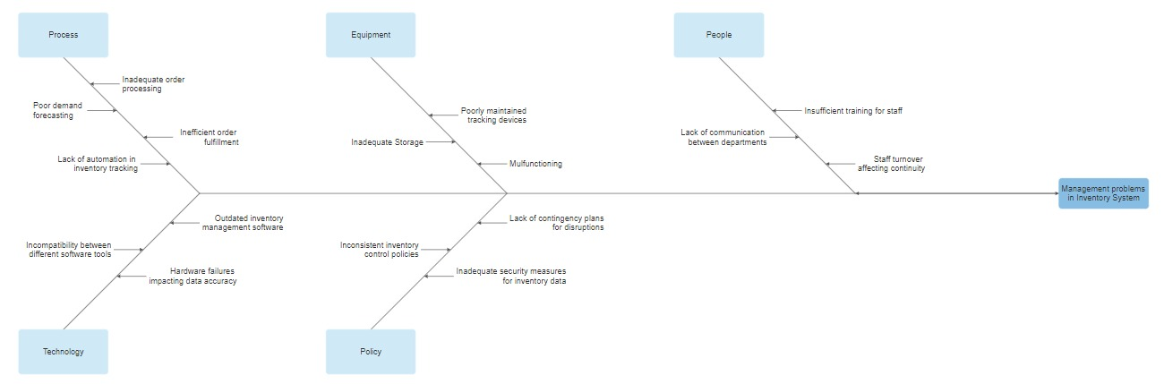

## Interview:

During the interview with the sales manager of Stradivarius at the Ganjlik branch, it became evident that managing the inventory of clothing poses multifaceted challenges in the dynamic retail environment. The manager highlighted several overarching difficulties faced in their day-to-day operations. Firstly, keeping track of a diverse range of clothing items spanning different styles, sizes, and colors presents a significant challenge. With a constantly evolving inventory and seasonal trends, maintaining accurate records of stock levels becomes crucial yet daunting. Moreover, the unpredictable nature of customer preferences and demand fluctuations further complicates inventory management. Ensuring optimal stock levels to meet customer demands while minimizing overstock or stockouts requires a delicate balance that often proves elusive. Additionally, the manager emphasized the challenge of efficiently replenishing stock and coordinating with suppliers to ensure timely deliveries. The intricate logistics involved in managing inbound shipments and coordinating with multiple suppliers add another layer of complexity to the inventory management process. Furthermore, the manager highlighted the importance of effective inventory visibility and reporting mechanisms to monitor stock movements and make informed decisions. Despite these challenges, the manager expressed a commitment to enhancing the inventory management system to improve operational efficiency and customer satisfaction. They emphasized the need for a comprehensive solution that addresses these challenges while offering scalability and adaptability to accommodate future growth and evolving market dynamics.

Here we provide full questions of the interview:

* How do you currently track incoming and outgoing products?

We use barcode scanning technology to track incoming and outgoing clothing products. Each item is assigned a unique barcode, which we scan upon receipt or sale to update our inventory management system in real-time.

* What are the biggest challenges you face in managing your clothing inventory?

There are several issues we have been facing.One of our biggest challenges is maintaining accurate inventory records. With a large volume of clothing items and frequent sales, it's difficult to keep track of stock levels accurately. This often leads to discrepancies between our records and the actual inventory on hand. Coordinating with suppliers and managing inbound shipments can also be challenging. Delays in deliveries or discrepancies in orders can disrupt our inventory management process and impact our ability to meet customer demand.Additionally, reliance on manual inventory management processes contributes to inefficiencies and errors. Tasks such as data entry, stock counts, and order processing are time-consuming and prone to human error, hindering our ability to manage inventory effectively.

* How do you monitor the availability of different clothing items?

Our point-of-sale (POS) system plays a crucial role in monitoring the availability of clothing items. When a sale is made, the system automatically updates our inventory records to reflect the reduced stock levels, allowing us to track item availability in real-time.

* Are there any specific pain points or inefficiencies in your current inventory management system?

Despite the automated inventory updates, manual data entry errors remain a concern. Mistakes in recording incoming shipments or sales transactions can result in inaccuracies in our inventory records, leading to stockouts or overstock situations. While the POS system provides real-time updates on inventory levels, it lacks advanced analytics capabilities. As a result, we have limited visibility into stock trends, making it challenging to anticipate demand fluctuations and plan inventory replenishment effectively. Our POS system operates in isolation, without integration with other business systems such as accounting or customer relationship management (CRM) software. This lack of integration hinders data sharing and collaboration across departments, leading to inefficiencies in inventory management. As our business grows, scalability issues have emerged with our current inventory management system. The system struggles to handle increasing transaction volumes and inventory complexity, leading to performance issues and decreased reliability.

* What kind of reports or insights would be most valuable for you to make informed decisions about your inventory?

Comprehensive sales performance reports detailing the performance of each clothing item, including sales volume, revenue generated, and profitability, would be invaluable. These reports would help us identify top-selling items, assess the effectiveness of promotions, and optimize our product assortment. Demand forecasting insights, such as forecasts of future demand trends based on historical sales data and market trends, would be highly valuable. These insights would enable us to anticipate demand fluctuations, plan inventory replenishment more effectively, and minimize stockouts or overstock situations. Automated alerts for stockouts or overstock situations would allow us to address inventory imbalances promptly. Real-time notifications when stock levels fall below or exceed predefined thresholds would help us avoid lost sales opportunities and excess inventory holding costs.

* What features or functionalities would you expect to see in the user interface of the inventory management system?

A dashboard providing an overview of key inventory metrics and KPIs briefly would be valuable. This could include real-time stock levels, sales performance, pending orders, and alerts for stockouts or overstock situations; tools for managing inventory, such as adding new products, updating stock levels, transferring inventory between locations, and conducting stock counts, should be easily accessible from the user interface.

## Project scope and constraints:

### Project Scope:

The Inventory Management System (IMS) project aims to enhance organizational efficiency by improving accuracy in inventory tracking, streamlining order processing, and facilitating overall operational effectiveness. Key objectives include real-time monitoring of stock levels, automated updates for inventory adjustments, and the identification of low-stock items triggering reordering alerts.

The system's functionalities encompass comprehensive order management, including the creation, modification, and cancellation of orders, along with order status tracking and integration with the customer relationship management (CRM) system. Robust reporting features enable the generation of various inventory reports, historical data analysis for informed decision-making, and customizable reporting options.

User roles are defined to establish secure access controls, including administrator roles for system configuration and user roles for order processing, inventory management, and reporting.

Usability considerations involve the creation of intuitive user interfaces to facilitate easy navigation, supported by comprehensive training materials for system users. The project's inclusions cover the development of core IMS features, system testing, quality assurance, user training, and documentation. Exclusions specify items not within the project's scope, such as the integration with financial accounting systems, which is considered a separate project.

Deliverables: The ultimate deliverable for this project is the Inventory Managements System App itself. The developed app will encompass all the security features, integration capabilities, and compliance measures defined within the scope.

Stakeholders: Suppliers, supply chain managers, inventory managers and staff, management, and executives.

## Constraints:

The project has a three-month time constraint, and this period must consider the complexity of the evaluation and the requirement for a thorough analysis. Due to financial constraints, the inquiry must stay within the budget allotted for research, tools, and any possible external expertise. To ensure compatibility with the distinct environments and security tools for the chosen system, it is also critical to account for technological restrictions. It's also important to consider potential risks, such as data loss, security breaches, and legal issues arising from compliance audits. Additionally, the integration of third-party applications hosted on cloud platforms, infrastructure and hosting choices, and adherence to evolving compliance and regulatory updates can further impact the project. Together, these numerous restrictions set the project's boundaries.

## Evaluate feasibility:

### Operational feasibility:

Operational feasibility not only evaluates the integration of the inventory management system with current business procedures but also examines its impact on overall organizational workflows. This assessment includes analyzing potential alterations in workflows to accommodate the new system, ensuring that it aligns with organizational goals and objectives. Additionally, operational feasibility assesses user acceptance by considering factors such as ease of use, user interface design, and the system's ability to meet user requirements and preferences. Furthermore, it evaluates the availability of resources for training and assistance to ensure that employees receive adequate support in adapting to and effectively utilizing the new system. By considering these aspects comprehensively, operational feasibility aims to ensure a smooth transition to the new inventory management system without disrupting everyday operations.

**SWOT analysis**

* Strengths: The system can streamline inventory processes, such as tracking stock levels, managing orders, and automating replenishment, leading to increased operational efficiency.
* Weaknesses: Reliance on technology means that system failures or technical glitches could disrupt operations and lead to downtime if not adequately addressed.
* Opportunities: Enhanced customer happiness and productivity can be attained through optimized procedures, which also encourage staff empowerment and engagement.
* Threats: The market for inventory management systems is highly competitive, with numerous vendors offering similar solutions, increasing price competition and putting pressure on profit margins.

### Technical feasibility:

Technical feasibility also involves an in-depth analysis of the compatibility between the proposed inventory management system and the existing technology infrastructure within the organization. This assessment includes evaluating whether the system can seamlessly integrate with other software applications and databases already in use, minimizing the need for extensive modifications or upgrades to the existing IT environment. Furthermore, technical feasibility assesses the scalability of the system, ensuring that it can accommodate future growth in data volume and user demands without significant performance degradation or resource constraints. Additionally, the evaluation of performance metrics such as response time, throughput, and system availability are crucial to guaranteeing that the system meets the organization's operational requirements and user expectations.

**SWOT analysis**

* Strengths: The project benefits from access to modern technology, a skilled technical team, and potential seamless integration with existing systems.
* Weaknesses: Challenges may arise due to dependency on specific technologies, potential technical hurdles during implementation, and risks associated with compatibility issues with legacy systems.
* Opportunities: There's the potential to leverage emerging technologies for enhanced functionality, foster innovation, and differentiation in the market, and continually improve based on technological advancements.
* Threats: Risks include rapid technological obsolescence, competition from alternative technologies offering superior solutions, and susceptibility to cyber threats and security breaches.

### Economic feasibility:

Economic feasibility examines the financial aspects of the inventory management system project, including the initial investment costs, ongoing maintenance expenses, and the potential return on investment. It also considers factors such as revenue growth opportunities, cost savings, and the impact of the system on overall business profitability. Market trends and demand play a crucial role in assessing the economic feasibility of an inventory management system project. Evaluating current market trends and demand for inventory management solutions provides insights into the potential profitability of the project. Understanding market dynamics, such as the growth of e-commerce or shifting consumer preferences, helps assess the system's relevance and marketability. Additionally, examining the competitive landscape, including competitors' offerings and pricing strategies, informs decisions regarding pricing models and competitive positioning. Identifying market gaps or areas where the system can offer unique value enhances its economic viability by capitalizing on opportunities for differentiation and market penetration.

**SWOT analysis**

* Strengths: It enhances operational efficiency by streamlining inventory processes and achieves substantial cost reduction through automation and optimization. Additionally, the system provides real-time data on inventory levels, enabling timely decision-making, and its scalability ensures adaptability to business growth without incurring significant additional costs.
* Weaknesses: There are challenges such as high initial investment costs, uncertainty in forecasting future benefits and costs, and the inherent risk of budget overruns or unexpected expenses.
* Opportunities: Despite these challenges, the project presents opportunities for revenue growth through increased sales or market expansion, the potential to gain a competitive advantage through cost leadership or product differentiation, and access to funding or financing options to support its implementation.
* Threats: Nonetheless, threats such as economic downturns impacting budget availability, potential cost escalation due to unforeseen circumstances, and the risk of failing to achieve projected benefits leading to financial losses must be carefully considered and mitigated.

### Schedule feasibility:

Schedule feasibility examines whether the project timeline is realistic and achievable. It involves defining key milestones and deadlines, allocating resources effectively, and identifying potential risks that could impact the project schedule.

**SWOT analysis**

* Strengths: The project benefits from a well-planned timeline, clear milestones, and sufficient resource allocation.
* Weaknesses: External dependencies, unforeseen delays, and potential inaccuracies in project duration estimates pose challenges.
* Opportunities: The project offers potential advantages such as seizing time-sensitive market opportunities, gaining a competitive edge through early delivery, and flexibility to adapt to changing circumstances.
* Threats: Risks include delays affecting project milestones, increased costs due to extended timelines, and diminished stakeholder confidence.

## Project Request form:

### Description of the project:

The Inventory Management System project is a pivotal initiative aimed at revolutionizing the way inventory management processes are conducted within the organization. The core objective is to architect and deploy a robust, end-to-end solution that not only streamlines but also optimizes every facet of inventory management. By leveraging cutting-edge technology and industry best practices, this system will serve as a cornerstone for enhancing operational efficiency, mitigating risks, and catalyzing sustainable growth.

### Requested features:

Here we provide requested features:

* **Inventory Tracking and Tracing**: Implement a sophisticated tracking and tracing mechanism to monitor the entire lifecycle of inventory items, from procurement to consumption, facilitating traceability and quality control.
* **Order Management Excellence**: Revolutionize order management processes by automating order placement, fulfillment, and delivery tracking, thereby enhancing order accuracy, timeliness, and customer satisfaction.
* **Supplier Relationship Management**: Cultivate mutually beneficial relationships with suppliers by centralizing supplier data, negotiating favorable terms, and optimizing procurement processes for enhanced reliability and efficiency.
* **Warehouse Optimization**: Optimize warehouse operations by leveraging advanced warehouse management techniques, such as slotting optimization, inventory segmentation, and dynamic storage allocation, to maximize space utilization and minimize handling costs.
* **Advanced Analytics and Reporting**: Harness the power of advanced analytics and predictive modeling to generate actionable insights, trend analysis, and performance metrics, facilitating data-driven decision-making and continuous improvement.
* **User-Centric Interface**: Develop an intuitive, user-centric interface designed to cater to the diverse needs of users across various departments, ensuring ease of use, accessibility, and adoption.

### Main objective of the project:

The Inventory Management System is designed to streamline operations through seamless integration of workflows, automating tasks, and removing bottlenecks for operational fluidity. Leveraging advanced tracking mechanisms, it offers real-time visibility into inventory movements, enabling stakeholders to monitor stock levels, track assets, and anticipate demand fluctuations. With precise inventory control mechanisms, decision-makers can exercise granular control, minimizing overstocking and associated wastage. Predictive analytics optimize resource allocation, maximizing efficiency and minimizing costs. Robust compliance frameworks ensure adherence to regulations, mitigating risks and safeguarding against fraud. Comprehensive reporting and analytics empower stakeholders with actionable insights, facilitating informed decisions and opportunities for growth.

# Requirements analysis:

## Work Breakdown Structure (WBS)

App-based:

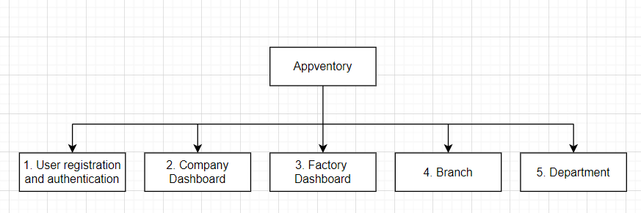

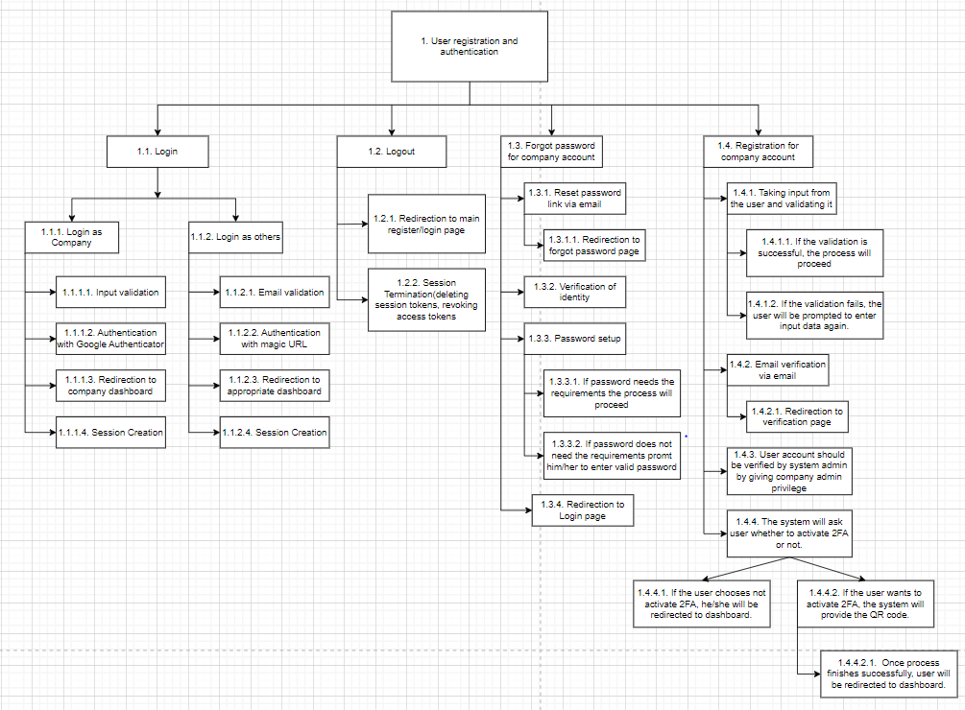

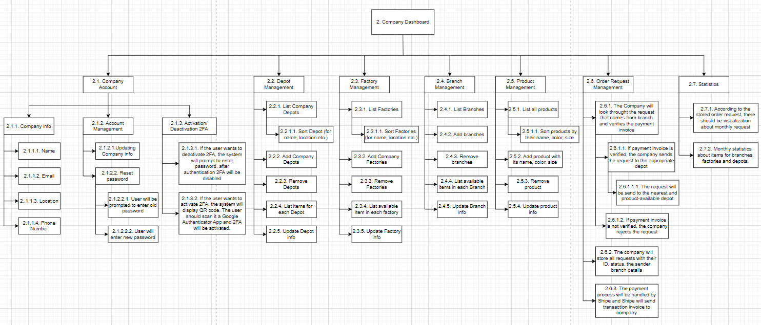

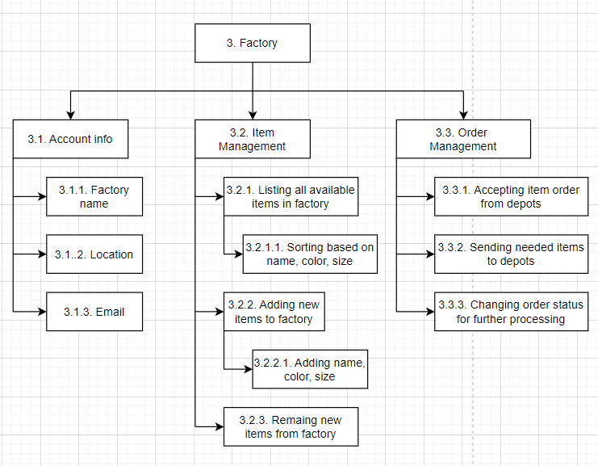

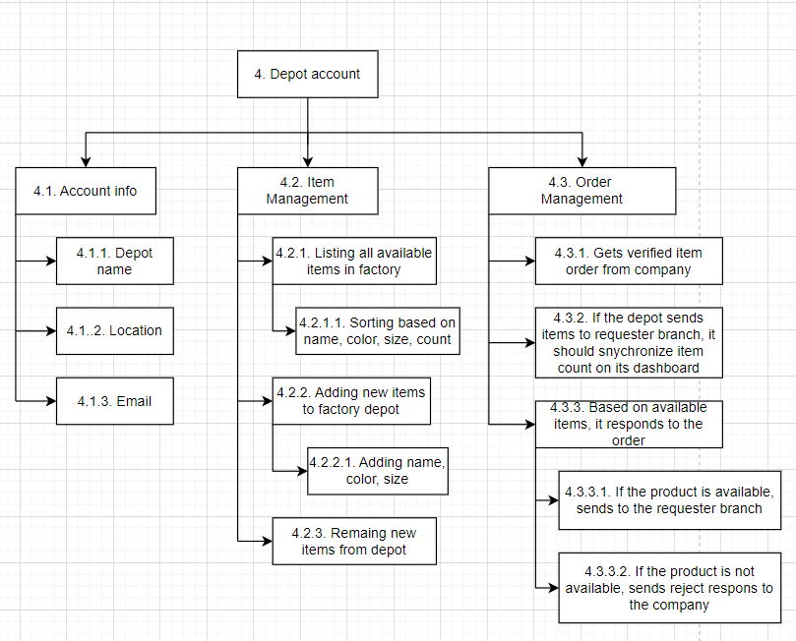

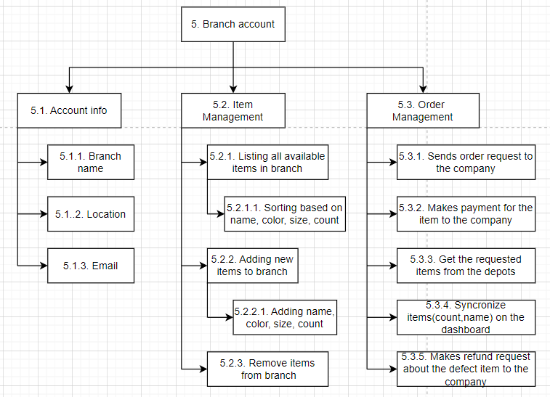

## List of requirements:

1.New users(companies) will be added to the database of system whenever they get registered by entering valid information about themselves. (U.R.1)

Secure requirement:

* strong password policies should be implemented
* all communication between the user's browser and the server should be encrypted using HTTPS to protect data during transmission.
* Filling out some company-related information such as company name, phone number, email address and password,country are needed (S.R.):
* Once the user has submitted the form all the data should be stored in the database. (F.R.)

-Secure functional: a firewall specifically designed for databases should be implemented to monitor and control incoming and outgoing traffic. This can help detect and prevent unauthorized access and suspicious activities.

* Passwords should be stored in hashed form in the database. (N.F.R)

-Secure non-functional: strong cryptographic hashing algorithms such as bcrypt, Argon2, or scrypt should be used to hash passwords.

- Secure non-functional: a unique salt for each password should be used before hashing.

* Once the registration process (submitting the form, validation) has finished, the user should be directed to the company dashboard. (F.R.)
* -Secure functional: security headers, such as Content Security Policy (CSP), X-Content-Type-Options, X-Frame-Options, and X-XSS-Protection, should be used to mitigate various web security threats, such as XSS (Cross-Site Scripting) and clickjacking attacks.
* The system should implement validation process on the entered email address (S.R.):
* The system integrates with a third-party email validation service that provides APIs or SDKs for real-time email address validation. (F.R.)

-Secure functional: API errors and exceptions should be handled gracefully to prevent information leakage and improve the system's resilience.

* When a user enters their email address in the registration form, the system can trigger an API request to the email validation service with the provided email address. (F.R.)

-Secure functional: necessary information should be sent to the email validation service. Sending additional user data or personally identifiable information (PII) should be avoided.

* The email verification service responds to the system with the results of the checks. It typically provides a status indicating whether the email address is valid. (F.R.)

-Secure functional: security headers such as Content Security Policy (CSP) should be implemented to control which external resources can be loaded by the application.

* Based on the verification results, the system can provide real-time feedback to the user. For example, if the email address is invalid, the system can display an error message, prompting the user to enter a valid email address. (F.R.)

-Secure functional: feedback messages should be properly encoded to prevent injection attacks such as cross-site scripting (XSS).

* The system can prevent users from proceeding with registration if they provide an email address that fails the verification process. (F.R.)
* -Secure functional: If the email address fails verification, the user should be prevented from proceeding with the registration process. The form submission button should be disabled a with message indicating that registration cannot proceed until a valid email address is provided.
* The system should validate the user-provided phone number to ensure it meets the required criteria. (S.R.)
* The system should integrate the phone number validation service. (F.R.)

-Secure functional: the phone number format should be validated on both the client-side and server-side to ensure it follows the expected format. This helps prevent injection attacks and ensures that only valid phone numbers are sent for validation.

* When a user provides their phone number during registration or input, the application sends a validation request to the third-party service. This request includes the phone number to be validated. (F.R.)

-Secure functional: necessary information should be sent to the validation service. Additional user data or personally identifiable information (PII) should be avoided.

* The third-party service processes the validation request in real-time. It checks whether the phone number is valid. (F.R)

-Secure functional: the validation request and response should be transmitted over a secure connection using HTTPS.

* Based on the validation response, the application can provide real-time feedback to the user. For example, if the phone number is valid, the user can proceed with registration. If it's invalid, the app can prompt the user to correct the phone number. (F.R.)

-Secure functional: revealing sensitive information should be avoided in the feedback messages that could be exploited by attackers. Generic error messages without disclosing details about the specific validation checks performed or the internal workings of the validation process should be provided.

* The user should be able to enter the password and the system should check user password (S.R):
* The app should determine the password criteria which includes a minimum length of 8 characters, the use of both uppercase and lowercase letters, numbers, and special characters. (F.R.)

-Secure functional: user input should be sanitised to prevent injection attacks or malicious input. The password validation should be ensured that process properly handles special characters and does not execute arbitrary code or expose vulnerabilities in the application.

* The app should check the password in real-time to ensure it meets the established criteria with the help of regular expressions or custom validation functions to perform these checks. (F.R.)

-Secure functional: custom validation functions on both the client and server should be implemented to perform checks beyond simple regular expressions. For example, the password should be validated against common or known weak passwords, dictionary words, or patterns frequently used in brute-force attacks.

-Secure functional: client-side validation should be implemented using regular expressions or custom JavaScript functions to check password criteria in real-time as users type. This provides immediate feedback to users and reduces unnecessary server requests.

* The app should check that the password does not contain any part of company name or other details provided in the form.(F.R.)

-Secure fucntional: Before performing the validation, the company name and other sensitive details provided in the form should be tokenized. This involves breaking down the strings into smaller components (tokens) such as words or characters. Then, ensure that the password does not contain any of these tokens.

* The system should provide immediate feedback to the user based on the validation results. If the password meets the criteria, it can show a success message. If not, it provides specific instructions on what's missing or incorrect. For instance, you can inform the user that their password should include a upper case character or be longer. (F.R.)

-Secure functional: While providing feedback, revealing specific details about the password validation process that could aid attackers should be avoided. For example, avoid indicating whether a specific character is present or absent in the password.

* Once the user submits the registration form, the application creates a new user account in the system's database but marks it as "unconfirmed" or "pending" for implementing confirmation process (S.R.):
* The application sends an email to the user's provided email address. The email contains a link or button with the confirmation token, which the user needs to click or follow to confirm their account.(F.R.)

-Secure functional: a cryptographically secure random token generator should be used to create the confirmation token. The tokens should be sufficiently long and complex to prevent guessing or brute-force attacks.

* The user receives the confirmation email and clicks the link. This action takes them to the application's confirmation page.(F.R.)

-Secure functional: the confirmation page should be served over HTTPS to encrypt the data exchanged between the user's browser and the application server.

* On the confirmation page, the application verifies the confirmation token provided in the URL against the one stored in the database.If the tokens match and the confirmation link is used within the specified time frame, the user's account status is updated to "confirmed" in the database.(F.R.)

-Secure functional: confirmation tokens should be stored securely in the database using strong cryptographic hashing algorithms.

* The app should display a success message to the user confirming that their account is now active and they can log in.(F.R.)

-Secure functional: a general success message confirming the activation of the user's account should be generated without disclosing sensitive details or specific information about the activation process. account-specific information should be avoided that could be used by attackers.

* If the user doesn't confirm their account within the specified time frame, the app can consider allowing them to request a new confirmation email or retriggering the confirmation process.(F.R.)

-Secure functional: rate limiting should be implemented on requests for new confirmation emails or retriggering the confirmation process to prevent abuse and protect against denial-of-service (DoS) attacks. the number of requests should be limited per user or IP address within a specific timeframe to deter malicious actors.

* Once the users fill the form and submit it, the system should ask the users whether they would like to activate 2FA or not (S.R.):
* The system should display the question “Do you want to activate 2FA for your account?” on the register page after submitting the form (F.R.)

-Secure functional: a concise and clear explanation of what Two-Factor Authentication (2FA) is and why it's beneficial for enhancing account security should be provided to users.

* + If the users choose the answer “Yes”, the server generates a QR code containing the secret key and other configuration details, which users scan using the Google Authenticator app on their mobile device. (F.R.)

-Secure functional: a cryptographically secure random number generator should be used to generate the secret key for 2FA.

* + The system then prompts the user to scan the QR code using the Google Authenticator app on their mobile device. (F.R.)

-Secure functional: an expiration time for the QR code should be set to limit the window of opportunity for attackers to intercept and misuse it.

* + The Google Authenticator app registers the account by associating it with the secret key and begins generating time-based one-time passwords (TOTPs) using the shared secret key. (F.R.)

-Secure functional: users should confirm their intention to register the account with the Google Authenticator app and generate TOTPs using the secret key. Users should be required to explicitly consent to the registration process before proceeding with the association of the secret key.

* If the users choose to answer “No” for 2FA activation, the system should conclude the registration process for either redirecting to login page or dashboard. (F.R.)

-Secure functional: the registration process should conclude securely, regardless of the user's choice regarding 2FA activation. Users should be redirected to either the login page or the dashboard using secure HTTPS connections to protect against interception and tampering.

2.Registered companies should be able to login the with the credentials (email and password (U.R.):

Secure requirement:

-account lockout mechanisms should be implemented to prevent brute-force attacks.

* The system should provide a user login form where users can input their credentials (email and password).(S.R.)
* Company users should choose “Login as company” option from login page (F.R.)

-Secure functional: all actions related to the "Login as company" should be logged for auditing and monitoring purposes.

* Users can login by filling out the login form.(F.R.)

-Secure functional: the login form should be served over HTTPS to encrypt data transmission between the user's browser and the server.

* The login form should be user-friendly and accessible, with clear instructions and user assistance.(N.F.R)

-Secure non-functional: informative error messages that clearly indicate what went wrong if users encounter login errors, such as incorrect credentials or account lockouts without revealing sensitive data related to source code and server-side structure.

* Once the users enters email and password,the app should implement client-side validation for email address with the help of third-party email verification service.If the email address is invalid,the integrated service should display real-time error info.(F.R.)

- Secure functional: all communications between the client and the server, as well as with the third-party email verification service, should be encrypted.

* Once the user fills the login form and submits the credentials,the server-side validation should start.The app should check the email and password with the email and password hash in the database.Before checking similarity entered password should be sent in hashed version(F.R.)

-Secure functional: the hashed password retrieved from the database with the hashed version of the password entered by the user should be compared. A secure comparison function that mitigates timing attacks, such as constant-time comparison, to prevent attackers from exploiting timing differences to guess the password should be used

* If the credentials are not the same with the ones in the database, the app should display error message for the user and offer retry login(F.R.)

-Secure functional: generic error messages should be provided to users for failed login attempts, such as "Invalid email or password", instead of specifying which credential was incorrect.

* If the entered login credentials are the same with the ones in the database and if the user did not activate 2FA,the system should redirect the users to dashboard(F.R.)

-Secure functional: Before redirecting users to the dashboard, the system should perform an authorization check to verify that the user has the necessary permissions to access the dashboard.

* If the entered login credentials are the same with the ones in the database and if the user activated 2FA,the app should authenticate their account with Google Authenticator(S.R)or with the help of magic URL:
  + Once the login credentials are correct, the system should prompt company users with Google Authenticator input field. (F.R.)

-Secure functional: client-side validation on the Google Authenticator input field should ensure that the input conforms to the expected format and requirements.

* + Users open the Google Authenticator app on their mobile device to view current TOTP and enter the current verification code displayed in their Google Authenticator app into the login interface. (F.R.)

-Secure functional: TOTP tokens should be invalidated after they expire to prevent their reuse.

* + The server receives the entered verification code and compares it with the expected TOTP generated using the secret key associated with the user’s account. (F.R.)

-Secure functional: Secret keys associated with user accounts should be stored securely on the server side. Industry-standard cryptographic mechanisms should be used to protect the confidentiality of secret keys and prevent unauthorized access.

* + If the entered verification code matches the expected TOTP, the user is granted, and the login process considered successful. (F.R.)

-Secure functional: Device recognition mechanisms should be implemented to detect and flag unusual or unrecognized devices attempting to log in with TOTP verification codes. It should prompt users to verify their identity through additional authentication steps if their device is not recognized.

* + Upon successful authentication, the server establishes a session for the user, granting them access to their account dashboard. (F.R.)

-Secure functional: a reasonable session timeout period should be set to automatically invalidate sessions after a period of inactivity. Users should be prompted to re-authenticate or refresh their session if their session has timed out.

* + If the verification code does not match or has expired, the user is denied access, and the login attempt fails. (F.R.)

-Secure functional: clear and informative error messages should displayed to users when the verification code does not match or has expired. Disclosing sensitive information about the reason for the failure should be avoided to prevent potential attackers from exploiting it.

3.Added branches, factories and depots should be able to login with only their added email (U.R.):

Secure requirement:

-The system should allow login with only the verified email address associated with the branch, factory, or depot. Validate the entered email address against the list of registered and verified emails before granting access.

-secure session management techniques should be implemented to generate and manage session tokens for authenticated users.

* The system should provide a user login form where users can input their credentials,namely email address(S.R.)
  + The user, whether it's a branch, factory, or depot personnel, navigates to the login page provided by the system. (F.R.)

-Secure functional: security headers such as Content Security Policy (CSP), HTTP Strict Transport Security (HSTS), and X-Content-Type-Options should be implemented to protect against common web security vulnerabilities such as cross-site scripting (XSS) and content sniffing attacks.

* + On the login page, the user chooses “Login as others” and inputs their registered email address into the designated field. (F.R.)

-Secure functional: the format and syntax of email addresses entered on the login page should be checked to prevent injection attacks or other forms of malicious input.

* + After entering the email address, the user clicks on the "Request Magic Link" or similar button to initiate the login process. (F.R.)

-Secure functional: a unique and time-limited magic link should be used that contains a secure token that will authenticate the user when clicked. each magic link should be unique to prevent replay attacks.

* + Upon receiving the email address, the system generates a unique and time-limited magic link associated with the user's email. (F.R.)

-Secure functional: a cryptographically secure random number generator (CSPRNG) should be used to generate unique and unpredictable tokens for each magic link. It should be ensured that the tokens have sufficient entropy to resist guessing attacks.

* + The system sends an email to the provided email address containing the generated magic link. (F.R.)

-Secure functional: the email containing the magic link should be crafted carefully to prevent it from being flagged as spam or phishing. The system should clearly identify the sender (e.g., the application name) and include instructions for the user to recognize and safely use the magic link.

The user accesses their email inbox and opens the email received from the system. They click on the magic link provided within the email to authenticate their login.(F.R.)

-Secure functional: all email authentication activities and magic link usage should be logged for auditing and monitoring purposes. unusual patterns or suspicious activities, such as multiple failed login attempts should be monitored and administrators should be alerted promptly.

* + When the user clicks on the magic link, the system verifies the authenticity of the link and extracts a unique token embedded within it. (F.R.)

-Secure functional: the token embedded within the magic link should be encrypted to add an extra layer of security.

* + The system validates the extracted token to ensure its integrity and authenticity. (F.R.)

-Secure functional: a mechanism should be implemented to revoke tokens that have been compromised or are no longer needed.

* + If the token is valid and within the designated time limit, the system proceeds with the login process. (F.R.)

-Secure functional: Token rotation mechanisms should be implemented to limit the lifespan of session tokens and prevent session fixation attacks. Rotate session tokens periodically or upon significant events, such as successful login or access to sensitive resources.

* + Upon successful token validation, the system initializes a user session, granting access to the corresponding dashboard or user interface. (F.R.)

-Secure functional: the user-agent (browser) information should be verified during session initialization, and it should be validated against subsequent requests. Any changes in the user-agent could indicate a potential security threat, such as session hijacking.

* + The user is redirected to their respective dashboard or landing page, providing access to the features and functionalities available to their user role. (F.R.)

-Secure functional: a strict CSP should be implemented to mitigate the risk of XSS attacks by restricting the sources from which scripts can be executed. Define a whitelist of trusted sources for scripts, stylesheets, and other resources loaded by the page.

* + If the token is invalid, the user starts the login process again (F.R.)

-Secure functional: clear and concise error messages should be provided to the user indicating that their token is invalid. The system should avoid providing detailed information about why the token is invalid to prevent potential attackers from exploiting this information.

4.Users should be provided with “Forgot Password” feature for resetting their password on the “Login as company” page (U.R.):

Secure requirements:

-rate limiting on password reset requests should be integrated to prevent abuse and mitigate the risk of denial-of-service attacks.

* The system should provide easy-to-handle password reset process with the help of confirmation email(S.R.):
* Users should be able to start password reset process by clicking a "Forgot Password?" or "Reset Password" button.(F.R.)

-Secure functional: all passwords reset requests and related activities should be logged for auditing and monitoring purposes.

* The system prompts the user to enter their registered email address.(F.R.)

-Secure functional: the user-provided email address input should be validated on both the client and server sides to ensure it conforms to the expected format of an email address. This prevents injection attacks and ensures that only properly formatted email addresses are accepted.

* If the user password is not found in the database,the system should display error message that email has not registered in the system.(F.R.)

-Secure functional: a generic error message such as "Invalid email address or password" should be displayed instead of specifically mentioning whether the email or password is incorrect. This prevents attackers from confirming the existence of valid email addresses in the system.

* If the email address is valid, the system generates a unique, time-limited token or code and sends it to the user's registered email address. This token is typically in the form of a link in an email.(F.R.)

- Secure functional: cryptographically secure random number generators (CSPRNGs) should be used to generate unique tokens or codes. The system should ensure that the tokens are sufficiently long and unpredictable to resist brute-force or guessing attacks.

* The user receives the password reset email containing a message explaining that they've requested a password reset. The email provides a link to proceed.(F.R.)

-Secure functional: the password reset link should be presented in plain text format within the email body instead of embedding it in HTML. This reduces the risk of HTML-based phishing attacks and makes it easier for users to verify the authenticity of the link.

* Once user clicks on the link provided in the email, the system validates the link to ensure its authenticity and checks if it has expired. (F.R.)

-Secure functional: strong validation mechanisms to verify the authenticity and integrity of the password reset link. Check for tampering or manipulation attempts, such as URL parameter modifications or injection attacks.

* If the link is invalid or has expired, the user may receive an error message indicating that the password reset link is no longer valid and offer retry password reset option(F.R.)

-Secure functional: The system should generate a generic error message such as "The password reset link is invalid or has expired. Please try again." This prevents attackers from discerning whether a specific email address is registered in the system.

* If the link is valid, the user is directed to a password reset form. The form typically allows the user to enter a new password.(F.R.)

-Secure functional: the system should ensure that the password reset link/token is single-use only. Once the user accesses the password reset form using the link, invalidate the token to prevent replay attacks.

* The user enters a new password and confirms it in the password reset form.(F.R.)

-Secure functional: anti-CSRF (Cross-Site Request Forgery) tokens in the password reset form should be implemented to prevent unauthorized form submissions. Include a unique token in each form submission that is validated on the server-side to ensure that the request originated from the legitimate user.

* The system should check password according to password policy(min 8 characters lenght,should contain uppercase and lowercase letters,special characters and numbers) with the help of regex or functions in the source code.(N.F.R)

-Secure non-functional: The system should store the user’s previous 5 passwords, if the user enters passwords that are the same or similar to those passwords, it should prompt user to enter different password.

* If the password does not compatible with password policy,the system prompts user to enter password again.(F.R.)

-Secure functional: the password should be validated again on the server-side to ensure consistency and prevent bypassing of client-side validation. This protects against malicious users who might attempt to circumvent client-side checks.

* Once the new password is successfully submitted, the system updates the user's password in the database by storing hash version of new password.(F.R.)

-Secure functional: the system should hash the new password using a strong cryptographic hashing algorithm such as bcrypt, Argon2, or scrypt and should add salts.

* Once the process ends,the system should redirect user to login page.(F.R.)

-Secure functional: any existing session data or tokens associated with the user's previous session should be cleared after completing the password reset process. This prevents potential session fixation attacks and ensures that users start with a fresh session upon logging in.

5. Once user logged in or registered to the system, they should be able to logout from the app (U.R.):

Secure requirement:

* Upon logout, the system should ensure that all session data associated with the user's session is cleared from the server-side.
* A secure logout endpoint or action should be implemented that performs the logout operation. It ensures that this endpoint is protected against Cross-Site Request Forgery (CSRF) attacks and other forms of exploitation.
* User should be able to click “logout” button on the user profile or navigation menu(S.R.):
* When the user clicks on the "Log Out" or equivalent button, the client-side application sends a request to the server to initiate the logout process.(F.R.)

-Secure functional: The system should validate and sanitize logout requests on the server-side to ensure that they conform to expected formats and do not contain malicious or unexpected content. It should reject any malformed or suspicious requests to prevent injection attacks.

* The server receives the logout request and begins the server-side logout process.(F.R.)

-Secure functional: The system should protect against Cross-Site Request Forgery (CSRF) attacks by including CSRF tokens in the logout request. It should verify the CSRF token on the server-side to ensure that the request originates from a legitimate and authorized source.

* The server clears the user's session data. This includes removing any session cookies, tokens, or data associated with the user's session. By doing this, the user is effectively logged out, as their session data no longer exists on the server.(F.R.)

-Secure functional: The system should perform session data clearance operations atomically to ensure consistency and avoid race conditions. Use transactional mechanisms or locking mechanisms to guarantee that session data is cleared reliably without conflicts.

* The server also revokes the user's authentication. This means that the user's authentication token or session token, which was used to validate their identity, is invalidated. As a result, the user's future requests to protected resources will no longer be authenticated.(N.F.R.)

-Secure functional: Before revoking authentication, the system should verify the signature of the token to ensure its integrity and authenticity. It should validate the token's signature against the server's secret key or public key to prevent tampering or forgery of tokens.

* After clearing the session and revoking authentication, the server redirects the user to a login/register page.(F.R.)

-Secure functional: The system should Guard against open redirection vulnerabilities by validating the redirection URL on the server-side. It should be Ensured that the redirection URL is within the application's domain and does not allow arbitrary redirection to external sites controlled by attackers.

6. Once the company administrator logged in to their account successfully, they could be able to activate or deactivate 2FA (U.R.):

Secure requirement:

* All 2FA activation and deactivation events should be logged for auditing and monitoring purposes. The system should record details such as the timestamp of the action, the administrator's identifier, and the outcome of the action.
* If the user does not have 2FA activated, they should be able to activate 2FA from the account dashboard (S.R.)
* User navigates to the account settings section of the company dashboard and selects the option to enable two-factor authentication (2FA) and chooses Google Authenticator as the preferred method. (F.R.)

-secure functional: The system should require the user to confirm their identity before enabling 2FA. This could involve entering their password.

* System generates a QR code containing a secret key associated with the user's account. (F.R.)

-Secure functional: The system should ensure that secret keys used for 2FA are generated with sufficient entropy and randomness to resist brute-force attacks.

* Users open the Google Authenticator app on their mobile device and scans the QR code displayed on the dashboard and Google Authenticator app automatically adds the account and starts generating time-based one-time passwords (TOTPs). (F.R.)

-Secure functional: mechanisms should be implemented to verify the integrity of the QR code when it is scanned by the user's device. Use checksums or digital signatures to detect tampering or manipulation of QR code data.

* User enters the current TOTP generated by the Google Authenticator app into the corresponding field on the dashboard. (F.R.)

-Secure functional: The system should ensure that the system's clock is synchronized with the Google Authenticator app's clock to prevent discrepancies in TOTP validation. U Network Time Protocol (NTP) or similar time synchronization mechanisms should be used to keep the clocks in sync.

* System verifies the entered TOTP to ensure successful setup. (F.R.)

-Secure functional: The system should Perform TOTP verification on the server-side rather than relying solely on client-side validation. This prevents potential manipulation of TOTP validation logic on the client-side.

* Upon successful verification, the system activates two-factor authentication (2FA) using Google Authenticator for the user's account. (F.R.)

-Secure functional: the activation of 2FA should be logged for auditing and monitoring purposes.

* If the user has 2FA activated, they could deactivate 2FA from the account dashboard. (S.R.):
* User selects the option to disable two-factor authentication (2FA) that is currently enabled. (F.R)

-Secure functional: It should be ensured that the disabling process occurs over a secure connection (HTTPS) to protect sensitive information from interception or tampering.

* System prompts the user to confirm their intention to deactivate 2FA for their account. (F.R.)

-Secure functional: The system should require the user to enter a confirmation code or token before proceeding with the deactivation of 2FA. This code could be sent to the user's registered email address or mobile phone number. The user would need to input this code into the system to validate their intention to disable 2FA.

* Users enter their account credentials (e.g., password) to authenticate their identity. (F.R.)

-Secure functional: The password input should be sanitized for avoiding injection attacks

* Upon successful authentication, the system disables two-factor authentication (2FA) for the user's account. (F.R.)

-Secure functional: The system Notify the user via email or in-app notifications whenever changes are made to their security settings, including the disabling of 2FA.

* System confirms the deactivation of 2FA and updates the user's account settings accordingly. (F.R.)

-Secure functional: all actions related to the enabling or disabling of 2FA, including timestamps, user identifiers, and the outcome of the action should be logged

7.Company administrators should be able to reset their password on their account dashboard (U.R.):

Security requirement:

* Before allowing a password reset, the app should ensure that the user is authenticated.
* The account dashboard should provide reset password feature with proper button (S.R.):
* The company administrator navigates to the account settings section of the company dashboard and selects reset password option. (F.R.)

-Secure functional: Redirection process should happen over HTTPS

* The system prompts the administrator to verify their identity before proceeding with the password reset process. This verification step may involve entering the current password or providing additional authentication factors such as email verification or security questions. (F.R.)

-Secure functional: The system should apply rate limiting on verification attempts to prevent brute-force attacks. It should limit the number of verifications attempts within a specific time window to deter malicious actors from repeatedly trying to bypass the verification process.

* After successful verification, the system allows the administrator to enter a new password. The password entry field may include requirements such as minimum length, special characters, or a combination of uppercase and lowercase letters for password strength. (F.R.)

-Secure functional: The system should ensure that the entered password are not similar or the same the previous 5 password. Additionally, it should check that the entered password is not in the list of well-known passwords.

* The administrator confirms the new password by entering it again in a designated field to ensure accuracy. (F.R.)

-Secure functional: The system should Mask the characters of the password as it is entered to prevent unauthorized individuals from viewing the password on-screen. This helps maintain confidentiality and prevents shoulder surfing attacks.

* Once the new password is entered and confirmed, the administrator submits the changes. (F.R.)

-Secure functional: it should be ensured that the password change request is transmitted securely over HTTPS to prevent interception or tampering of sensitive data during transmission.

* The system displays a confirmation message indicating that the password reset was successful. (N.F.R)

-Secure non-functional: providing detailed information about the password reset in the confirmation message should be avoided. Instead, a generic message such as "Your password has been successfully reset" without revealing specific details that could potentially aid attackers should be generated.

* The system should store the new password in hashed version in database. (F.R)

-Secure functional: a strong cryptographic hashing algorithm such as bcrypt, Argon2, or PBKDF2 for hashing passwords should be utilized.

8.Company admins should be able to update company-related data in company account dashboard (U.R.):

Secure requirement:

* input validation on all data submitted by company administrator should be implemented s to prevent injection attacks.
* robust error handling mechanisms should be implemented to provide informative error messages to company administrators in case of invalid inputs or unexpected errors.
* The system should provide users account info form where they could add or modify their data (S.R.):
* The administrator navigates to the settings or profile section specifically designated for managing company-related data. (F.R.)

-Secure functional: The system should implement security headers, such as Content Security Policy (CSP) and X-Content-Type-Options, to protect against common web vulnerabilities and enhance the overall security posture of the application.

* The administrator identifies the type of company-related data they wish to update, such as company name, address, contact information, or any other relevant details and enters new information or updates the existing data (F.R.)

-Secure functional: whitelist input validation techniques should be used to allow only expected characters or formats for each type of company-related data. Any input that does not conform to the expected format should be rejected to prevent injection attacks or data manipulation.

* Once finished and satisfied with the updates, the administrator selects the option to save or update the changes. (F.R.)

-Secure functional: Before saving or updating the changes, the app should prompt the administrator to confirm their action. This helps prevent accidental updates and ensures that the administrator intends to proceed with the modification.

* The system displays a confirmation message indicating that the changes have been successfully saved. (F.R.)

-Secure functional: The system should Avoid generic messages and instead specify the exact modifications applied to the data.

9.Company admins should be able to manage depots on their account dashboard (U.R.):

Secure requirement:

* The system should manage user sessions securely to prevent unauthorized access to depot management functionalities.
* Data should be encrypted in transit to protect it from interception or tampering by malicious actors, especially when managing sensitive information related to depots.
* The system should allow users to add depots to company inventory where added depots should be stored in database (S.R.):
* Company admins navigate to the depot management section within their account dashboard. (F.R.)

Secure functional: It should be ensured that access to the depot management section requires proper authentication.

* Admins select the option to add a new depot, typically through a button or link provided in the depot management interface. (F.R.)

-Secure functional: The system should implement anti-CSRF (Cross-Site Request Forgery) tokens to prevent CSRF attacks during depot creation. Generate unique tokens for each session and include them in the request parameters.

* Admins enter the necessary details for the new depot, including its email address, password, location. (F.R.)

-Secure functional: all inputs provided by admins during depot creation should be validated and sanitized to prevent injection attacks, such as SQL injection or cross-site scripting (XSS).

* The system validates the entered depot details to ensure accuracy and completeness. It should check for duplicate entries or missing required fields. (F.R.)

-Secure functional: The system should implement thorough data validation checks to verify the accuracy and completeness of the entered depot details. Validate each input field to ensure it conforms to the expected format, data type, and length.

* After validation, admins submit the depot details, and the system saves the new depot information to the database. (F.R.)

-Secure functional: The system should Encrypt sensitive depot information stored in the database to protect it from unauthorized access or data breaches. Encryption mechanisms should be implemented, such as Transparent Data Encryption (TDE) or field-level encryption, to encrypt data at rest and mitigate the impact of potential database compromises.

* The displays a confirmation message indicating that the depot has been successfully added. (N.F.R)

-Secure non-functional: It should be ensured that the confirmation message does not reveal any sensitive information about the depot or the system's internal workings.

* The system should allow users to list all depots along with depot-related data (S.R.):
* Company admins navigate to the depot management section within their account dashboard and selects the option to list all existing depots, typically through a button in the depot management interface. (F.R.)

-Secure functional: The system should Implement pagination and limit the number of depots displayed per page when listing existing depots. This prevents overwhelming the system with many depot listings and reduces the risk of performance degradation or denial-of-service attacks.

* The system retrieves the list of depots from the database along with their respective details such as name, email address, and location. (F.R.)

-Secure functional: The system should use parameterized queries or prepared statements when retrieving depot information from the database to prevent SQL injection attacks. This technique ensures that user input is treated as data rather than executable code.

* The system displays the list of depots in a user-friendly format, such as a table or list, on the depot management interface. (N.F.R)

-Secure non-functional: The system should encode all depot details displayed in the user interface to prevent Cross-Site Scripting (XSS) attacks. appropriate encoding methods such as HTML entity encoding, or JavaScript escaping should be used to render user input as harmless text.

* Admins should have options to filter, search, or sort the depot list based on specific criteria to facilitate navigation and management. (F.R.)

-Secure functional: Strict input validation and sanitization for user-provided criteria used for filtering, searching, or sorting depots should be implemented. The system should validate and sanitize input parameters to prevent injection attacks such as SQL injection or Cross-Site Scripting (XSS).

* The system should allow company admins to remove depot from the database (S.R.):
* Company admins navigate to the depot management section within their account dashboard and select the option to remove a depot, typically by clicking on a corresponding delete or remove button next to the depot they wish to delete. (F.R.)

-Secure functional: Before allowing a depot to be removed, the system should ensure that the company admin is authenticated and authorized to perform this action. The system could require re-authentication.

* The system prompts admins to confirm their intention to remove the depot, ensuring that the action is intentional. (N.F.R.)

-Secure non-functional: The system should introduce a time delay between the initial click on the delete button and the display of the confirmation prompt. During this delay, it should provide a message reminding the admin to carefully consider their decision. This prevents impulsive actions and allows admins to reconsider before proceeding with the deletion.

* Admins confirm the removal, and the system proceeds to delete the depot from the database. (F.R.)

-Secure functional: When executing the deletion operation on the server-side, the server should use parameterized queries or prepared statements to interact with the database. It should Avoid constructing SQL queries dynamically using user-provided input to prevent SQL injection attacks.

* The system displays a confirmation message indicating that the depot has been successfully removed. (N.F.R.)

-Secure non-functional: The system should Refrain from disclosing sensitive information about the depot or the deletion process in the confirmation message. Instead, It should provide a generic acknowledgment that the removal request has been processed successfully without revealing any confidential details.

10. Company admins should be able to manage factories on their account dashboard (U.R.):

Secure requirement:

* The system should manage user sessions securely to prevent unauthorized access to factory management functionalities.
* Data should be encrypted in transit to protect it from interception or tampering by malicious actors, especially when managing sensitive information related to factories.
* The system should allow users to add factories to company inventory where added factories should be stored in database (S.R.):
* Company admins navigate to the factory management section within their account dashboard. (F.R.)
* Secure functional: It should be ensured that access to the factory management section requires proper authentication.
* Admins select the option to add a new factory, typically through a button or link provided in the factory management interface. (F.R.)

-Secure functional: The system should implement anti-CSRF (Cross-Site Request Forgery) tokens to prevent CSRF attacks during factory creation. Generate unique tokens for each session and include them in the request parameters.

* Admins enter the necessary details for the new factory, including its email address, password, location. (F.R.)

-Secure functional: all inputs provided by admins during factory creation should be validated and sanitized to prevent injection attacks, such as SQL injection or cross-site scripting (XSS).

* The system validates the entered depot details to ensure accuracy and completeness. It should check for duplicate entries or missing required fields. (F.R.)

-Secure functional: The system should implement thorough data validation checks to verify the accuracy and completeness of the entered depot details. Validate each input field to ensure it conforms to the expected format, data type, and length.

* After validation, admins submit the factory details, and the system saves the new depot information to the database. (F.R.)

-Secure functional: The system should Encrypt sensitive factory information stored in the database to protect it from unauthorized access or data breaches. Encryption mechanisms should be implemented, such as Transparent Data Encryption (TDE) or field-level encryption, to encrypt data at rest and mitigate the impact of potential database compromises.

* The displays a confirmation message indicating that the factory has been successfully added. (N.F.R)

Secure non-functional: It should be ensured that the confirmation message does not reveal any sensitive information about the factory or the system's internal workings.

* The system should allow users to list all factories along with factory-related data (S.R.):
* Company admins navigate to the factory management section within their account dashboard and select the option to list all existing factories, typically through a button in the factory management interface. (F.R.)

-Secure functional: The system should Implement pagination and limit the number of factories displayed per page when listing existing depots. This prevents overwhelming the system with many factories listings and reduces the risk of performance degradation or denial-of-service attacks.

* The system retrieves the list of factories from the database along with their respective details such as name, email address, and location. (F.R.)

-Secure functional: The system should use parameterized queries or prepared statements when retrieving factory information from the database to prevent SQL injection attacks. This technique ensures that user input is treated as data rather than executable code.

* The system displays the list of factories in a user-friendly format, such as a table or list, on the factory management interface. (N.F.R)

-Secure non-functional: The system should encode all factory details displayed in the user interface to prevent Cross-Site Scripting (XSS) attacks.  appropriate encoding methods such as HTML entity encoding or JavaScript escaping should be used to render user input as harmless text.

* Admins should have options to filter, search, or sort the factories list based on specific criteria to facilitate navigation and management. (F.R.)

-Secure functional: Strict input validation and sanitization for user-provided criteria used for filtering, searching, or sorting factories should be implemented. The system should validate and sanitize input parameters to prevent injection attacks such as SQL injection or Cross-Site Scripting (XSS).

* The system should allow company admins to remove factory from the database (S.R.):
* Company admins navigate to the factory management section within their account dashboard. (F.R.) and selects the option to remove a factory, typically by clicking on a corresponding delete or remove button next to the factory they wish to delete. (F.R.)

-Secure functional: Before allowing a factory to be removed, the system should ensure that the company admin is authenticated and authorized to perform this action. The system could require re-authentication.

* The system prompts admins to confirm their intention to remove the factory, ensuring that the action is intentional. (N.F.R.)

-Secure non-functional: The system should introduce a time delay between the initial click on the delete button and the display of the confirmation prompt. During this delay, it should provide a message reminding the admin to carefully consider their decision. This prevents impulsive actions and allows admins to reconsider before proceeding with the deletion.

* Admins confirm the removal, and the system proceeds to delete the factory from the database. (F.R.)

-Secure functional: When executing the deletion operation on the server-side, the server should use parameterized queries or prepared statements to interact with the database. It should Avoid constructing SQL queries dynamically using user-provided input to prevent SQL injection attacks.

* The system displays a confirmation message indicating that the factory has been successfully removed. (N.F.R.)

-Secure non-functional: The system should Refrain from disclosing sensitive information about the depot or the deletion process in the confirmation message. Instead, It should provide a generic acknowledgment that the removal request has been processed successfully without revealing any confidential details.

11. Company admins should be able to manage stores(branches) on their account dashboard (U.R.):

Secure requirement:

-       The system should manage user sessions securely to prevent unauthorized access to store management functionalities.

-       Data should be encrypted in transit to protect it from interception or tampering by malicious actors, especially when managing sensitive information related to stores.

* The system should allow users to add stores to company inventory where added stores should be stored in database (S.R.):
* Company admins navigate to the branch management section within their account dashboard. (F.R.)

-Secure functional: It should be ensured that access to the store management section requires proper authentication.

* Admins select the option to add a new branch, typically through a button or link provided in the branch management interface. (F.R.)

-Secure functional: The system should implement anti-CSRF (Cross-Site Request Forgery) tokens to prevent CSRF attacks during store creation. Generate unique tokens for each session and include them in the request parameters.

* Admins enter the necessary details for the new branch, including its email address, password, location. (F.R.)

-Secure functional: all inputs provided by admins during store creation should be validated and sanitized to prevent injection attacks, such as SQL injection or cross-site scripting (XSS).

* The system validates the entered branch details to ensure accuracy and completeness. It should check for duplicate entries or missing required fields. (F.R.)

-Secure functional: The system should implement thorough data validation checks to verify the accuracy and completeness of the entered depot details. Validate each input field to ensure it conforms to the expected format, data type, and length.

* After validation, admins submit the branch details, and the system saves the new branch information to the database. (F.R.)

-Secure functional: The system should Encrypt sensitive store information stored in the database to protect it from unauthorized access or data breaches. It should be implemented encryption mechanisms, such as Transparent Data Encryption (TDE) or field-level encryption, to encrypt data at rest and mitigate the impact of potential database compromises.

* The displays a confirmation message indicating that the branch has been successfully added. (N.F.R)

-Secure non-functional: It should be ensured that the confirmation message does not reveal any sensitive information about the depot or the system's internal workings.

* The system should allow users to list all factories along with factory-related data (S.R.):
* Company admins navigate to the branch management section within their account dashboard and selects the option to list all existing branches, typically through a button in the branch management interface. (F.R.)

-Secure functional: The system should Implement pagination and limit the number of stores displayed per page when listing existing depots. This prevents overwhelming the system with many store listings and reduces the risk of performance degradation or denial-of-service attacks.

* The system retrieves the list of branches from the database along with their respective details such as name, email address, and location. (F.R.)

-Secure functional: The system should use parameterized queries or prepared statements when retrieving depot information from the database to prevent SQL injection attacks. This technique ensures that user input is treated as data rather than executable code.

* The system displays the list of branches in a user-friendly format, such as a table or list, on the branch management interface. (N.F.R)

-Secure non-functional: The system should encode all store details displayed in the user interface to prevent Cross-Site Scripting (XSS) attacks.  appropriate encoding methods such as HTML entity encoding or JavaScript escaping should be used to render user input as harmless text.

* Admins should have options to filter, search, or sort the branches list based on specific criteria to facilitate navigation and management. (F.R.)

-secure functional: Strict input validation and sanitization for user-provided criteria used for filtering, searching, or sorting stores should be implemented. The system should validate and sanitize input parameters to prevent injection attacks such as SQL injection or Cross-Site Scripting (XSS).

* The system should allow company admins to remove branch from the database (S.R.):
* Company admins navigate to the branch management section within their account dashboard and select the option to remove a branch, typically by clicking on a corresponding delete or remove button next to the factory they wish to delete. (F.R.)

-Secure functional: Before allowing a store to be removed, the system should ensure that the company admin is authenticated and authorized to perform this action. The system could require re-authentication.

The system prompts admins to confirm their intention to remove the branch, ensuring that the action is intentional. (N.F.R.)

-Secure non-functional: The system should introduce a time delay between the initial click on the delete button and the display of the confirmation prompt. During this delay, it should provide a message reminding the admin to carefully consider their decision. This prevents impulsive actions and allows admins to reconsider before proceeding with the deletion.

* Admins confirm the removal, and the system proceeds to delete the branch from the database. (F.R.)

-Secure functional: When executing the deletion operation on the server-side, the server should use parameterized queries or prepared statements to interact with the database. It should Avoid constructing SQL queries dynamically using user-provided input to prevent SQL injection attacks.

* The system displays a confirmation message indicating that the branch has been successfully removed. (N.F.R.)

-Secure non-functional: The system should Refrain from disclosing sensitive information about the store or the deletion process in the confirmation message. Instead, It should provide a generic acknowledgment that the removal request has been processed successfully without revealing any confidential details.

12.Company admins should be able to manage their products on their account dashboard (U.R.):

Secure requirement:

-       The system should manage user sessions securely to prevent unauthorized access to product management functionalities.

-       Data should be encrypted in transit to protect it from interception or tampering by malicious actors, especially when managing sensitive information related to stores.

* The system should allow users to add products to company inventory where added products should be stored in database with their attributes (color, size, name) (S.R.):
* Company admins navigate to the product management section within their account dashboard with redirection link (F.R.)

-Secure functional: It should be ensured that access to the product management section requires proper authentication.

* Add select the option to add a new product, typically through a button or link provided in the product management interface. (F.R.)

-secure functional: The system should implement anti-CSRF (Cross-Site Request Forgery) tokens to prevent CSRF attacks during product creation. Generate unique tokens for each session and include them in the request parameters.

* Admins enter the necessary details for the new product, including its name, size, color, and any other relevant information. (F.R.)

-secure functional: all inputs provided by admins during product creation should be validated and sanitized to prevent injection attacks, such as SQL injection or cross-site scripting (XSS).

* The system validates the entered product details to ensure accuracy and completeness. It may check for duplicate entries or missing required fields. (N.F.R)

-Secure non-functional: The system should implement thorough data validation checks to verify the accuracy and completeness of the entered depot details. Validate each input field to ensure it conforms to the expected format, data type, and length.

* After validation, admins submit the product details, and the system saves the new product information to the database. (F.R.)

-secure functional: the system should Encrypt sensitive store information stored in the database to protect it from unauthorized access or data breaches. Encryption mechanisms should be implemented, such as Transparent Data Encryption (TDE) or field-level encryption, to encrypt data at rest and mitigate the impact of potential database compromises.

* The system displays a confirmation message indicating that the product has been successfully added. Admins may be redirected back to the product management section. (N.F.R.)

Secure non-functional: It should be ensured that the confirmation message does not reveal any sensitive information about the product or the system's internal workings.

* The system should allow users to list all products along with color, name, size (S.R.):
* Admins select the option to list all existing products, typically through a button or link provided in the product management interface and the system retrieves the list of products from the database along with their respective details such as name, size, color, and other relevant information. (F.R.)

Secure functional: The system should Implement pagination and limit the number of products displayed per page when listing existing products. This prevents overwhelming the system with many store listings and reduces the risk of performance degradation or denial-of-service attacks.

* The system displays the list of products in a user-friendly format, such as a table or list, on the product management interface. (N.F.R)

-secure non-functional: The system should encode all product details displayed in the user interface to prevent Cross-Site Scripting (XSS) attacks.  appropriate encoding methods such as HTML entity encoding or JavaScript escaping should be used to render user input as harmless text.

* Admins may have options to filter, search, or sort the product list based on specific criteria to facilitate navigation and management. (F.R.)

-secure functional: Strict input validation and sanitization for user-provided criteria used for filtering, searching, or sorting prodcuts should be implemented. The system should validate and sanitize input parameters to prevent injection attacks such as SQL injection or Cross-Site Scripting (XSS).

* The system should allow company admins to remove products from the database (S.R.):
* Company admins navigate to the product management section within their account dashboard and select the option to remove a product, typically by clicking on a corresponding delete or remove button next to the product they wish to delete. (F.R.)

-secure functional: Before allowing a product to be removed, the system should ensure that the company admin is authenticated and authorized to perform this action. The system could require re-authentication.

* The system prompts admins to confirm their intention to remove the product, ensuring that the action is intentional. (N.F.R)

-secure non-functional: The system should introduce a time delay between the initial click on the delete button and the display of the confirmation prompt. During this delay, it should provide a message reminding the admin to carefully consider their decision. This prevents impulsive actions and allows admins to reconsider before proceeding with the deletion.

* Admins confirm the removal, and the system proceeds to delete the product from the database. (F.R.)

-secure functional: When executing the deletion operation on the server-side, the server should use parameterized queries or prepared statements to interact with the database. It should Avoid constructing SQL queries dynamically using user-provided input to prevent SQL injection attacks.

* The system displays a confirmation message indicating that the product has been successfully removed. (N.F.R)

-secure non-functional: The system should Refrain from disclosing sensitive information about the product  or the deletion process in the confirmation message. Instead, It should provide a generic acknowledgment that the removal request has been processed successfully without revealing any confidential details.

13.From the branch dashboard, each branch should see the list of products, along with their counts in the given branch (U.R.):

Secure requirement:

* Only authenticated branch users with the appropriate permissions can access the branch dashboard and view the list of products with their counts.
* The system should track the count of each product within individual branches, reflecting the quantity available at each branch. (S.R.):
* The system maintains a centralized product database where all product information is stored, including details such as product name, size, color, and available counts. (F.R.)

- Secure functional: the system should enable auditing and logging features in the database management system to track all database activities and changes. It should maintain detailed logs of database accesses, modifications, and administrative actions to detect unauthorized access attempts or suspicious activities.

* Each branch within the organization is uniquely identified within the system, typically through a branch ID or code. (F.R.)

-secure functional: It should be ensured that branch IDs or codes are generated using a secure method that makes it difficult for attackers to predict or guess valid branch identifiers. cryptographic techniques or strong random number generators could be used to generate unique branch IDs.

* When products are received or distributed at a branch, the system automatically updates the product counts in real-time, reflecting the quantity available at each branch according to their id within the company (F.R.)

-secure functional: dual verification or approval for critical product transactions, such as large-scale product distributions or adjustments to product counts should be required

* Product count updates occur through inventory transactions such as receiving shipments and selling products. (F.R.)

-secure functional: the system should Encrypt sensitive data related to inventory transactions, such as product counts, shipment details, and customer information, both in transit and at rest.

* The system integrates with branch dashboards, providing branch-specific views of product lists along with their counts. (N.F.R)

-secure non-functional: the dashboard should not provide explicit data about the product that can lead to the system being hacked

* Upon accessing the branch dashboard, the system retrieves product information from the centralized database, including product names, sizes, colors, and corresponding counts. (F.R.)

-secure functional: the system should ensure that data transmitted between the centralized database and the branch dashboard is encrypted using secure protocols such as HTTPS.

14.Once authenticated, the depot dashboard should list the available products in the given depot according to their name, size, and color (U.R.):

Secure requirement:

* Only authenticated depot users with the appropriate permissions can access the branch dashboard and view the list of products with their counts.
* The depot product management module should integrate with the centralized product database to access and update product information. (S.R.):
* Users select the option to list products available in the depot. (F.R.)
* The system retrieves product information from the centralized database, including product name, size, color, and quantity available in the depot. (F.R.)

-secure functional: The system should minimize the amount of sensitive information included in the product listings to only include the necessary details required for depot operations.

* Product information is displayed in a tabular format on the depot product management interface. (N.F.R)

-secure non-functional: a Content Security Policy (CSP) should be implemented to mitigate the risk of XSS attacks by specifying trusted sources for loading scripts, stylesheets, and other resources.

* Users can immediately see the updated product information without the need for manual synchronization. (F.R.)

-secure functional: The app should Implement mechanisms to verify the integrity of transmitted product information. The system should use cryptographic hash functions to generate checksums or hashes of the data before transmission and verify these hashes upon receipt to ensure that the data has not been tampered with during transit.

15. Once authenticated, the factory dashboard should list the available products in the given factory according to their name, size, and color (U.R.):

Secure requirement:

* only authenticated factory users with the appropriate permissions can access the branch dashboard and view the list of products with their counts
* The factory product management module should integrate with the centralized product database to access and update product information. (S.R.):
* Users select the option to list products available in the factory. (F.R.)
* The system retrieves product information from the centralized database, including product name, size, color, and quantity available in the factory. (F.R.)

-secure functional: The system should minimize the amount of sensitive information included in the product listings to only include the necessary details required for depot operations.

* Product information is displayed in a tabular format on the factory product management interface. (N.F.R)

-secure non-functional: a Content Security Policy (CSP) should be implemented to mitigate the risk of XSS attacks by specifying trusted sources for loading scripts, stylesheets, and other resources.

* Users can immediately see the updated product information without the need for manual synchronization. (F.R.)

-secure functional: The app should Implement mechanisms to verify the integrity of transmitted product information. The system should use cryptographic hash functions to generate checksums or hashes of the data before transmission and verify these hashes upon receipt to ensure that the data has not been tampered with during transit.

16.The system should be able to handle product requests coming from branches. (U.R.):

Secure requirement:

* robust authentication mechanisms should be implemented to verify the identity of users accessing the branch and company dashboards.
* the system should Implement real-time transaction monitoring and fraud detection mechanisms to detect suspicious activities such as unusual payment patterns or unauthorized access attempts.
* There should be seamless integration between the branch dashboard and the company dashboard to transmit product requests for further processing. (S.R.):
* A branch initiates a product request by submitting details such as product name, color, size, and quantity through the branch dashboard. (F.R.)

-secure functional: the system should Validate all input fields submitted by the branch, including product name, color, size, and quantity, to prevent injection attacks such as SQL injection or cross-site scripting (XSS).

* The product request is transmitted from the branch dashboard to the company dashboard for further processing. (F.R.)

-secure functional: the system Utilize secure communication protocols such as HTTPS to encrypt data transmitted between the branch dashboard and the backend server.

* The system should support secure payment processing mechanisms to facilitate transactions for requested products. It should handle various payment methods, such as credit/debit cards, bank transfers, or other payment gateways. (S.R.)
* When a branch initiates a payment for requested products through the company dashboard, the system triggers the payment process. (F.R.)

-secure functional: the system should Integrate with reputable payment gateways that comply with industry-standard security practices and regulations such as the Payment Card Industry Data Security Standard (PCI DSS).

* The branch selects the desired payment method, which may include credit/debit card, bank transfer, or other options. (F.R.)

-select functional: sensitive payment method information such as credit/debit card details or bank account numbers should be encrypted during transmission and storage.

* The system integrates with Stripe, a third-party payment processing platform, to facilitate secure online payments. (F.R.)

-secure functional: strong authentication mechanisms should be implemented for accessing and interacting with Stripe's APIs, such as API keys or OAuth tokens.

* Branches provide their payment details, including card information, through a payment form integrated with Stripe's API. (F.R.)

-secure functional: The app should implement client-side validation to validate user input before submitting the payment form.

* Stripe tokenizes the payment information provided by the branch, replacing sensitive card details with a unique token. This ensures that sensitive data is securely transmitted and stored. (N.F.R)

-secure non-functional: It is recommended to utilize Stripe's built-in fraud detection tools and features, such as Radar, to identify and prevent fraudulent transactions.

* Once the branch submits the payment details, the system sends the payment request to Stripe for processing. (F.R.)

-secure functional: The system should set up real-time transaction monitoring systems to monitor payment transactions as they occur, configure alerts to notify administrators or fraud prevention teams of suspicious transactions for immediate investigation and action.

* Stripe communicates with the bank associated with the branch's card to authorize the payment transaction. (F.R.)

-secure functional: It should be ensured that all communication between Stripe and the bank is encrypted using strong cryptographic protocols such as TLS (Transport Layer Security).

* The verifies the availability of funds and approves or declines the transaction based on the account status and available balance. (F.R.)

-secure functional: The system could apply behavioral analysis techniques to identify deviations from normal spending patterns or account behavior.

* Upon successful authorization, Stripe sends a payment confirmation to the system (including company and branch), indicating that the payment has been approved. (F.R.)

-secure functional: The system should store payment confirmation messages securely in your system's database using encryption and access controls. It should limit access to sensitive payment data only to authorized personnel and restrict unnecessary exposure of payment information.

* The system receives the payment confirmation from Stripe and updates the payment status for the branch request and notes the request as “Request Received (F.R.)

-secure functional: The system should maintain comprehensive audit logs of all actions related to updating payment status, including details such as user identity, timestamp, and the nature of the change made.

* The payment status is updated to reflect that the payment has been successfully verified and approved. (F.R.)
* Stripe maintains detailed records of the payment transaction, including transaction ID, amount, date/time, and status. (F.R.)

-secure functional: Only collect and retain the minimum amount of data necessary for transaction processing and compliance purposes.

* If the payment authorization fails, Stripe communicates the reason for the failure to the system. (F.R.)

-secure functional: the system should implement robust error handling mechanisms within your system to securely process and log error messages received from Stripe.

* The system updates the payment status accordingly and notifies the branch about the failed transaction, providing instructions for resolving the issue. (F.R.)

-secure functional: The system should provide only essential information to the branch in the notification message. It should avoid disclosing sensitive details about the failed transaction, such as specific error codes or payment card details, unless necessary for troubleshooting.

* The system may initiate automatic retries for failed payments, following predefined retry policies. (F.R.)

-secure functional: the system should implement limits on the number of automatic retry attempts for failed payments to prevent potential abuse or exploitation by malicious actors. It is needed to Define a reasonable threshold for the maximum number of retries within a specified time frame to mitigate the risk of unauthorized access or repeated attempts to process fraudulent transactions.

* If retries are unsuccessful, the branch is prompted to provide alternative payment methods or address any issues with their payment account. (F.R.)

-secure functional: the system continuously monitors transaction activities and account interactions associated with the branch's payment account to detect suspicious behavior or potential fraud indicators.

* The system should handle the product request according to the location of the requester branch and depots (S.R.):
* The system retrieves the geographical location of the requester branch, typically based on address data stored in the system or using GPS coordinates. (F.R.)

-secure functional: the system should implement geofencing mechanisms to define virtual boundaries or geographical zones around branches' physical locations. It should be recommended to Use geofencing technologies to enforce location-based access controls or security policies, ensuring that system interactions or transactions originating from branches occur within predefined geographic boundaries.

* The system maintains a database of depot locations, including their geographical coordinates (latitude and longitude). (F.R.)

-secure functional: the system should Encrypt the geographical coordinates (latitude and longitude) stored in the database to protect them from unauthorized access or tampering.

* Using the geographical coordinates of the requester branch and the depots, the system calculates the distance between each depot and the requester branch. Distance calculation is typically based on algorithms such as the Haversine formula, which calculates the great-circle distance between two points on the Earth's surface. (F.R.)

-secure functional: the system should perform additional validation of geographical coordinates on the server-side to verify their integrity and authenticity. It should reject any requests containing suspicious or malformed coordinates to prevent potential security vulnerabilities or manipulation attempts.

* The system identifies the depot with the shortest distance to the requester branch as the nearest depot. Alternatively, the system may consider factors such as transportation routes, traffic conditions, or delivery time estimates in addition to distance. (F.R.)

-secure functional: The system should evaluate the security of the algorithms used for determining the nearest depot and transportation route optimization. It should be ensured that the algorithms are resistant to common attacks such as spoofing, tampering, or manipulation of input data.

* Once the nearest depot is determined, the system assigns this depot to handle the fulfillment of the product request from the requester branch and changes request status to “Processing” (F.R.)

-secure functional: The system should implement data integrity checks to verify the authenticity and integrity of the data used in depot assignment. cryptographic techniques, such as digital signatures or hash functions should be used to ensure that the input data, including geographical coordinates and depot information, has not been tampered with or altered during transit or storage.

* The company account should maintain accurate and up-to-date inventory records for products across all branches, depots, and factories. It should track product availability in real-time to fulfill requests promptly for processing by sending them to appropriate depots (S.R.):
* Once the system determines the nearest depot, it forwards the product request, including details such as product name, color, size, and quantity, to the selected depot for processing and changes request status to “Processing” (F.R.)

-secure functional: the system should Encrypt communication channels between the depot and the system components responsible for depot assignment.

* Upon receiving the product request, the selected depot queries its inventory database to check the availability of the requested product. (F.R.)

-secure functional: The system should deploy database activity monitoring (DAM) solutions to monitor and analyze database activity in real-time. DAM systems can detect unusual patterns or anomalies in database access, such as unauthorized queries or excessive data retrieval, and trigger alerts for further investigation.

* The depot retrieves the relevant product record from its inventory database based on the product details provided in the request. (F.R.)

-secure functional: the communication should be implemented over HTTPS

* The depot verifies whether the available quantity of the requested product in its inventory meets or exceeds the requested quantity. (F.R.)

-secure functional: The system should implement real-time monitoring of inventory transactions and quantity updates. It is recommended to Utilize intrusion detection systems (IDS) or database activity monitoring (DAM) tools to monitor inventory data changes and detect suspicious activities, such as unauthorized modifications to product quantities.

* If the requested quantity is available, the product is considered in stock and ready for fulfillment and changes request status to “Fulfilled” (F.R.)

-secure functional: The system should Implement validation checks to ensure that only valid and authorized requests can be marked as "Fulfilled. “It should Verify that the request being fulfilled corresponds to an existing and legitimate product request. Perform sanity checks to ensure that the requested quantity is available in inventory before updating the status.

* If the requested product is not available in the required quantity at the selected depot, the system may trigger a search for alternative depots with the desired product in stock. (F.R.)

-secure functional: the system should ensure that communication between the system and depots when querying for product availability is conducted over secure channels.

* The system repeats the product availability check process for alternative depots until a suitable option is found. (F.R.)

-secure functional: the system should implement rate limiting mechanisms to prevent excessive or malicious search requests.

* Once the availability of the requested product is confirmed at the selected depot or an alternative depot, the system updates the product status as available for fulfillment and changes request status to “Fulfilled” (F.R.)

-secure functional: the communication should be implemented over HTTPS

* If none of the company's depots have the requested product, the company selects the nearest depot (F.R.)

-secure functional: the system should Validate the geolocation data used to determine the nearest depot to ensure its accuracy and integrity. It should Implement checks to verify that the geolocation data provided is within acceptable ranges and not tampered with or manipulated.

* The selected depot sends a request to the factory for the product with the requested amount. (F.R.)

-secure functional: the communication between the depot and the factory is encrypted using secure protocols such as HTTPS.

* The factory sends the product to the selected depot. (F.R.)
* The depot receives the product from the factory and prepares it for shipment to the branch changes request status to “Fulfilled” (F.R.)

-secure functional: the communication between the depot and the factory is encrypted using secure protocols such as HTTPS.

* This information is communicated back to the company dashboard and subsequently to the requester branch, indicating that the product is ready for delivery or pickup and changes request status to “Done” (F. R)

-secure functional: the system should Use cryptographic techniques such as digital signatures to ensure the integrity of status update messages sent from the depot to the company dashboard and then to the requester branch.

* The amount of the requested product is synchronized across the depot, factory, and branch inventory systems to ensure accurate tracking of product availability. (F.R.)

-secure functional: the system should Encrypt the synchronized data during transmission between systems to prevent unauthorized access or interception.

17. Company administrators should be provided with statistics-related data on the company dashboard, focusing on payments, product counts, and requests made from branches monthly (U.R.):

Secure requirement:

* The system should Ensure that the company dashboard and its handling of statistical data comply with relevant data protection regulations, such as the General Data Protection Regulation (GDPR)
* statistical data both at rest and in transit should be encrypted to prevent unauthorized access or interception.
* Company administrators should get monthly payment statistics with the help of Stripe’s transaction history (S.R.):
* As the system records the timestamp of each payment transaction, indicating when the payment was processed, the system categorizes payments by month to facilitate monthly analysis. (F.R.)

-secure functional: the system should Store payment transaction data securely in a protected database or storage environment.

* The system calculates the total amount of payments received for each month by summing up the amounts of individual payment transactions. (F.R.)

-secure functional: the system should Validate the integrity and accuracy of payment transaction data before performing calculations. Implement data validation checks to verify that payment amounts are within expected ranges and formats, and that they have not been altered or corrupted.

* The system analyzes the distribution of payment methods used (e.g., credit card, bank transfer) for each month. (F.R.)

-secure functional: payment method data should be encrypted both in transit and at rest.

* The system identifies trends and patterns in payment data over time, such as seasonal variations or changes in payment volume. (F.R.)

-secure functional: The app should Deploy anomaly detection algorithms to identify unusual or suspicious patterns in payment data that may indicate fraudulent activity. Monitor for unexpected deviations from typical payment behavior and investigate any anomalies promptly.

* Payment statistics, including total payments and payment method breakdowns, are presented on the company dashboard on user-friendly manner (N.F.R)

-secure non-functional: the data should be fetched from server-side over HTTPS.

* Interactive features, such as filters or date selectors, allow administrators to tailor the analysis according to their requirements. (F.R.)

-secure functional: The system should Use parameterized queries or prepared statements when interacting with databases to execute dynamic SQL queries based on user inputs. This helps prevent SQL injection attacks by separating SQL logic from user input data.

* Administrators access payment statistics through the company dashboard using secure login credentials. (F.R.)

-secure functional: strong authentication mechanisms, such as multi-factor authentication (MFA) should be implemented to ensure that only authorized administrators can access payment statistics.

* With the help of distributed database, where all the product-related data for branches, depots and factories are stored, the system should provide statistics about the product count monthly (S.R.):
* The system retrieves data on product counts distributed to depots and branches. This information comes from inventory management systems or shipment records. Distribution records contain information on the quantity of each product sent to each depot and branch. (F.R.)

-secure functional: the system should transfer data in encrypted format.

* The system categorizes product counts based on various attributes, including product type (e.g., shirt, pants), size (e.g., small, medium, large), and color (e.g., red, blue, green) over factories, branches and depots. (F.R.)

-secure functional: the system should Implement a robust content security policy to mitigate the risk of XSS attacks by restricting the sources from which scripts can be executed. It should Enforce strict policies to only allow scripts from trusted sources and prevent inline script execution.

* The system aggregates product count data monthly for factories, branches and depots each. It groups production and distribution records by month to facilitate monthly analysis. (F.R.)

-secure functional: the system should Utilize security headers such as X-Content-Type-Options, X-Frame-Options, and X-XSS-Protection to enhance the security of interactive features. Set appropriate header configurations to mitigate common web security vulnerabilities and protect against malicious attacks.

* With the help of inventory records, company dashboard should provide statistics about handled requests (S.R.):
* The system collects data on product requests made by branches and handled by depots and companies. This data includes details such as the product name, size, color, quantity, and timestamp of the request. (F.R.)

-secure functional: the system should transfer data in encrypted format.

* The system aggregates the collected request data monthly. It groups requests by month to analyze trends and patterns over time. (F.R.)

-secure functional: the system should Encrypt the aggregated request data both in transit and at rest to protect it from unauthorized access or interception.

* Each request is categorized based on its timestamp, from which branch the request has been made and which depots handled this request to ensure proper attribution to the corresponding month. (F.R.)

-secure functional: the system should Validate and sanitize all input data, including timestamps, branch identifiers, and depot information, to prevent injection attacks and ensure data integrity. Implement input validation routines to check for valid formats and ranges, rejecting any data that doesn't meet predefined criteria.

* For each month, the system calculates the total number of product requests received from branches. This involves summing up the individual request counts for all products across all branches. (F.R.)

-secure functional: sensitive data, such as branch identifiers and product request counts should be encrypted both in transit and at rest.

18.The system should be able to handle defect products by handling refund requests coming from branches (U.R.):

Secure requirement:

* The app should implement anti-fraud measures to detect and prevent fraudulent refund requests, Monitor refund patterns, transaction histories, and user behavior for anomalies or suspicious activities.
* The system should Implement an approval workflow for refund requests, where requests must be reviewed and approved by authorized personnel before processing.
* The branch should trigger refund request with the help of system’s request handler and refund process should be handled by Stripe (S.R.):
* When a branch identifies a defective product in its inventory, it initiates a refund request through the company dashboard. (F.R.)

-secure functional: the system should Require branch staff to authenticate themselves using secure credentials (e.g., username/password, MFA) before initiating a refund request.

* The branch provides details about the defective product, including the product name, size, color, quantity, and reason for the refund. (F.R.)

-secure functional: the system should validate input data whether they are in accessible data format or not, to prevent injection.

* The branch sends this refund request to the company (F.R.)

-secure functional: the data transmitted in encrypted and hashed form.

* The company dashboard sends the refund request to the company's backend system for processing. (F.R.)

-secure functional: the system is responsible for the integrity of the request by checking its hashed version and sending the data over HTTPS.

* The request is transmitted securely, ensuring that sensitive information is protected during transmission with the help of encryption (N.F.R)

-secure non-functional: The system should utilize strong encryption algorithm for transmitting like SSL, TLS

* Upon receiving the refund request, the company reviews the provided details to verify the validity of the request and the eligibility for a refund. (F.R.)
* The company may inspect the product details and review any relevant documentation provided by the branch. (N.F.R.)

-secure non-functional: the system should implement a robust document verification process to ensure the authenticity and validity of documents provided by branches. Use techniques such as watermark verification document metadata analysis to detect tampering or forgery attempts.

* If the refund request is approved, the company initiates the refund process through Stripe, the payment processing platform. (F.R.)

-secure functional: The system should Maintain detailed audit logs of all refund initiation activities, including user actions, timestamps, and transaction details.

* The refund amount is calculated based on the quantity of defective products and the original purchase price per unit. (F.R.)
* The company uses the Stripe API to process the refund transaction securely. (F.R.)

-secure functional: the system should integrate Stripe API with OAuth token for improving security.

* The company's backend system sends a request to the Stripe API, specifying the details of the refund, such as the transaction ID, amount to be refunded, and currency. (F.R)

-secure functional: The system should validate all refund requests submitted to the Stripe API to ensure that they meet predefined criteria and are free from tampering or injection attacks. Verify the integrity of request parameters, such as transaction IDs, refund amounts, and currency codes, before sending them to Stripe for processing.

* Stripe verifies the authenticity of the refund request and checks if the transaction is eligible for a refund based on its status and other criteria. (F.R.)

-secure functional: The system should Implement risk assessment and fraud detection mechanisms to analyze refund requests for signs of suspicious behavior or potentially fraudulent activity.

* If the refund request is valid, Stripe authorizes the refund transaction. (F.R.)
* Once authorized, Stripe processes the refund transaction by transferring the refunded amount from the company's Stripe account to the branch's payment account. (F.R.)

-secure functional: The transaction should be implemented over HTTPS.

* After processing the refund, Stripe sends a notification to the company's backend system to confirm the completion of the refund transaction. (N.F.R.)

-secure non-functional: The message should avoid disclosing the structure of the service. It should only contain generic message.

* Upon successful refund processing, the company may communicate with the branch to notify them of the refund status and provide any relevant details, such as the refunded amount and the expected timeline for the funds to be credited back to their account. (F.R.)

-secure functional: the system should Utilize encrypted communication channels, such as secure email protocols (e.g., SMTP over TLS) or secure messaging platforms, to transmit refund status and details to the branch.

* As part of the refund processing workflow, the company's backend system triggers an update to the branch dashboard to synchronize the product count and reflect the reduction in inventory due to the refunded products. (F.R.)

-secure functional: The system should Implement strong authentication mechanisms, such as API keys or OAuth tokens, to authenticate requests sent from the company's backend system to the branch dashboard. It should Verify the identity of the sender before allowing access to sensitive endpoints related to product count synchronization.

* The branch dashboard receives the updated product count data from the company's system and displays the revised inventory level to branch personnel. (N.F.R.)

Secure non-functional: the system should Implement a robust authentication mechanism for accessing the branch dashboard.

Secure non-functional: the system should Encrypt sensitive inventory data stored on the branch dashboard's servers to protect it from unauthorized access in case of data breaches or physical theft.

## Risk Assessment

* New users (companies) will be added to the database of the system whenever they get registered by entering valid information about themselves. (UR1)

**Potential Security Risks: **

1. **Unauthorized Access: **(risk 1)

- **Likelihood: ** Medium

The likelihood of unauthorized access is assessed as medium because while the system may have security measures in place, such as authentication and access controls, there is still a possibility of vulnerabilities being exploited by attackers. New users (companies) being added to the system introduce potential entry points for attackers to exploit, such as through weak passwords, phishing attacks, or exploitation of software vulnerabilities. However, with proper security measures and regular updates, the likelihood can be mitigated but not completely eliminated.

- **Impact: ** High

The impact of unauthorized access is assessed as high because it can lead to significant consequences such as data breaches, loss of sensitive information, financial losses, damage to reputation, and legal liabilities. For example, unauthorized access to the database can result in the theft or manipulation of company and user data, leading to financial fraud, identity theft, or regulatory penalties. The impact extends beyond just the affected user or company to potentially impact the entire system and its users.

- **Risk Level: ** High

Considering the combination of medium likelihood and high impact, the overall risk level is assessed as high. This means that while unauthorized access may not occur frequently, the potential consequences of such an event are severe enough to warrant significant attention and mitigation efforts. The system needs robust security measures and proactive risk management strategies to address the potential risks effectively.

- **Mitigation Strategies: **

- Implement strong authentication mechanisms such as multi-factor authentication (MFA).

- Regularly update and patch software to prevent vulnerabilities.

- **Recommendations: **

- Enforce strict access controls based on roles and permissions.

- Monitor user activities and implement intrusion detection systems.

- **Action Plan: **

- Conduct regular security audits and penetration testing to identify vulnerabilities.

- Establish incident response procedures to address any breaches.

2. **Data Breach: **(risk 2)

- **Likelihood: ** Medium

The likelihood of a data breach is assessed as medium because while the system may have security measures in place to protect against unauthorized access and data breaches, there is still a possibility of vulnerabilities being exploited by attackers. Factors contributing to the likelihood include the presence of potential entry points for attackers, such as user accounts, databases, and network connections, as well as the evolving nature of cybersecurity threats and techniques used by attackers. However, with proper security measures, including encryption, access controls, and monitoring, the likelihood can be mitigated but not eliminated.

- **Impact: ** High

The impact of a data breach is assessed as high because it can lead to significant consequences such as unauthorized access to sensitive data, loss of customer trust, financial losses, legal liabilities, and reputational damage. For example, a data breach can result in the exposure of personal and confidential information, such as customer records, financial data, and intellectual property, leading to identity theft, fraud, regulatory penalties, and lawsuits. The impact extends beyond just the affected organization to potentially impact customers, partners, and other stakeholders.

- **Risk Level: ** High

Considering the combination of medium likelihood and high impact, the overall risk level is assessed as high. This means that while a data breach may not occur frequently, the potential consequences of such an event are severe enough to warrant significant attention and mitigation efforts. The system needs robust security measures, proactive monitoring, and incident response procedures to address the potential risks effectively.

- **Mitigation Strategies: **

- Encrypt sensitive data both in transit and at rest.

- Implement proper data anonymization and pseudonymization techniques.

- **Recommendations: **

- Regularly assess and update data protection policies and procedures.

- Educate employees and users about the importance of data security and privacy.

- **Action Plan: **

- Establish a data breach response team and protocol for immediate action in case of a breach.

- Notify relevant authorities and affected users promptly in case of a data breach.

3. **Injection Attacks (e.g., SQL Injection): **(risk 3)

- **Likelihood: ** Low

The likelihood of SQL injection attacks is assessed as low because modern web development practices and frameworks often incorporate security measures to prevent such vulnerabilities (such as using ORMs). However, the possibility of SQL injection attacks cannot be completely ruled out.

- **Impact: ** High

The impact of SQL injection attacks is assessed as high because they can lead to severe consequences such as unauthorized access to databases, theft of sensitive data, data manipulation, and potentially complete compromise of the application or system. Depending on the nature of the application and the data stored, the impact could extend to financial losses, reputational damage, legal liabilities, and regulatory penalties. Therefore, any successful SQL injection attack can have significant ramifications for the organization and its stakeholders.

- **Risk Level: ** Medium

Considering the combination of low likelihood and high impact, the overall risk level is assessed as medium. While SQL injection attacks may not occur frequently due to preventive measures in place, the potential impact of a successful attack warrants attention. It indicates that while the risk is not imminent, it still requires proactive measures to mitigate effectively.

- **Mitigation Strategies: **

- Use parameterized queries and prepared statements to prevent SQL injection attacks.

- Implement input validation and sanitization techniques.

- **Recommendations: **

- Conduct regular security training for developers to raise awareness about common vulnerabilities.

- Employ web application firewalls (WAFs) to filter and block malicious traffic.

- **Action Plan: **

- Perform regular code reviews and security testing to identify and fix vulnerabilities.

- Monitor database logs for suspicious activities indicative of injection attacks.

**Threat Modeling: **

1. **Threats: **

- Malicious actors attempting unauthorized access to the system.

- Hackers exploiting vulnerabilities to perform data breaches.

- Attackers executing injection attacks to manipulate or extract data.

2. **Vulnerabilities: **

- Weak authentication mechanisms.

- Lack of proper access controls.

- Inadequate data encryption and protection measures.

- Vulnerable code susceptible to injection attacks.

* Registered companies should be able to log in with their credentials (email and password). (UR2)

**Potential Security Risks: **

1. **Password-based Attacks: **(risk 1)

- **Likelihood: ** High

The likelihood of password-based attacks is assessed as high because passwords are a common target for attackers due to their widespread use and the prevalence of weak or reused passwords among users. Attackers employ various techniques such as brute force attacks, dictionary attacks, and credential stuffing to compromise passwords.

- **Impact: ** High

The impact of password-based attacks is assessed as high because successful compromise of passwords can lead to unauthorized access to sensitive systems, data breaches, financial losses, and reputational damage for the affected organization.

- **Risk Level: ** High

Considering the combination of high likelihood and high impact, the overall risk level is assessed as high. Password-based attacks pose a significant threat to the security of systems and data, requiring immediate attention and robust mitigation measures to mitigate effectively.

- **Mitigation Strategies: **

- Implement strong password policies, including requirements for length, complexity, and regular password changes.

- Enforce password hashing and salting to protect stored passwords from unauthorized access.

- **Recommendations: **

- Educate users on creating and maintaining secure passwords and the risks associated with password reuse.

- Implement multi-factor authentication (MFA) to add an additional layer of security beyond just passwords.

- **Action Plan: **

- Regularly audit password storage mechanisms to ensure compliance with security best practices.

- Monitor for password-related anomalies such as brute force attacks or suspicious login attempts.

2. **Credential Stuffing Attacks: **(risk 2)

- **Likelihood: ** Medium

The likelihood of credential stuffing attacks is assessed as medium. While these attacks are automated and widespread, their success largely depends on the availability of leaked credentials from data breaches or other sources. The prevalence of credential reuse among users and the constant stream of leaked credentials contribute to the medium likelihood of such attacks.

- **Impact: ** High

The impact of credential stuffing attacks is assessed as high. Successful credential stuffing attacks can lead to unauthorized access to user accounts, compromising sensitive data, financial loss, and reputational damage for both the affected users and the company. Depending on the nature of the compromised accounts, the impact can range from personal privacy violations to financial fraud or identity theft.

- **Risk Level: ** High

Considering the combination of medium likelihood and high impact, the overall risk level is assessed as high. Credential stuffing attacks pose a significant threat to the security of user accounts and the integrity of the system. Without proper mitigation measures, such attacks can result in severe consequences for both users and the organization.

- **Mitigation Strategies: **

- Implement account lockout mechanisms to prevent automated credential stuffing attacks.

- Utilize CAPTCHA or similar techniques to deter automated login attempts.

- **Recommendations: **

- Encourage users to use unique passwords for each service to mitigate the impact of credential stuffing attacks.

- Implement anomaly detection systems to identify unusual login patterns indicative of credential stuffing attempts.

- **Action Plan: **

- Regularly review and update login mechanisms to incorporate new security features and protections against emerging threats.

- Provide user education on recognizing and reporting suspicious login attempts.

**Threat Modeling: **

1. **Threats: **

- Malicious actors attempting to gain unauthorized access to company accounts by guessing or stealing login credentials.

- Automated bots performing credential stuffing attacks using leaked or stolen credentials from other breaches.

- Insiders with access to company credentials abusing their privileges to compromise company accounts.

2. **Vulnerabilities: **

- Weak or reused passwords making it easier for attackers to guess or brute force login credentials.

- Lack of rate limiting or account lockout mechanisms enabling attackers to perform automated login attempts without detection.

- Inadequate monitoring and alerting systems making it difficult to detect and respond to suspicious login activities.

* Added branches, factories, and depots should be able to log in with only their added email. (UR3)

**Potential Security Risks: **

1. **Email Spoofing and Phishing: **(risk1)

- **Likelihood: ** Medium

The likelihood of email spoofing and phishing attacks targeting added branches, factories, and depots is assessed as medium. While email spoofing and phishing attacks are prevalent and relatively easy to execute, the specific targeting of added email addresses within the system may require some level of reconnaissance or knowledge about the organization's structure. However, given the increasing sophistication of attackers and the availability of automated tools for phishing campaigns, the likelihood remains medium.

- **Impact: ** High

The impact of email spoofing and phishing attacks can be significant, assessed as high. If successful, attackers can gain unauthorized access to sensitive information, compromise accounts, and potentially disrupt business operations. Additionally, phishing attacks can lead to reputation damage and financial loss for the organization, as well as legal and regulatory consequences if customer or employee data is compromised.

- **Risk Level: ** High

Considering the combination of medium likelihood and high impact, the overall risk level is assessed as high. Email spoofing and phishing pose a significant threat to the security and integrity of the organization's systems and data. Without adequate mitigation measures, such attacks can result in severe consequences for the organization and its stakeholders.

- **Mitigation Strategies: **

- Implement email authentication mechanisms such as SPF, DKIM, and DMARC to prevent email spoofing.

- Provide user education on recognizing phishing attempts and encourage caution when clicking on links or providing login credentials.

- **Recommendations: **

- Regularly remind users to verify the sender's email address and exercise caution when responding to emails requesting login information.

- Implement email filtering and scanning tools to detect and block phishing attempts before they reach users' inboxes.

- **Action Plan: **

- Monitor for suspicious login attempts or unusual activity following email-based communications to identify potential phishing attacks.

- Implement incident response procedures to promptly address and mitigate the impact of successful phishing incidents.

2. **Unauthorized Access via Email Compromise: **(risk2)

- **Likelihood: ** Low

The likelihood of unauthorized access via email compromise is assessed as low. While email compromise incidents, such as account takeover or unauthorized access to email accounts, do occur, they often require sophisticated techniques or targeted attacks. Additionally, the specific targeting of added email addresses within the system may be less common compared to more widespread or generic email compromise campaigns.

- **Impact: ** High

The impact of unauthorized access via email compromise is considered high. If attackers gain access to email accounts associated with added branches, factories, or depots, they could potentially exploit sensitive information, manipulate system settings, or conduct fraudulent activities. This could result in reputational damage, financial loss, and operational disruptions for the organization.

- **Risk Level: ** Medium

Given the combination of low likelihood and high impact, the overall risk level is assessed as medium. While the likelihood of email compromise incidents targeting added email addresses may be low, the potential impact of such incidents is significant enough to warrant attention and mitigation efforts.

- **Mitigation Strategies: **

- Implement strong authentication mechanisms, such as multi-factor authentication (MFA), to verify the identity of users accessing the system via email.

- Encrypt sensitive information in transit and at rest to prevent unauthorized access in case of email compromise.

- **Recommendations: **

- Educate users on the importance of securing their email accounts with strong passwords and enabling additional security features such as two-step verification.

- Monitor for unusual login patterns or access attempts originating from unfamiliar locations or devices.

- **Action Plan: **

- Regularly review and update security policies and procedures related to email account security and access controls.

- Implement automated alerts for suspicious login attempts or unauthorized access to sensitive information.

**Threat Modeling: **

1. **Threats: **

- Malicious actors attempting to compromise email accounts associated with branches, factories, or depots to gain unauthorized access to the system.

- External attackers conducting phishing attacks to trick users into divulging their login credentials or other sensitive information.

- Insiders with access to company email accounts abusing their privileges to gain unauthorized access to the system or sensitive data.

2. **Vulnerabilities: **

- Weak email authentication mechanisms or lack of email security measures exposing users to the risk of email spoofing and phishing attacks.

- Insufficient user awareness and training regarding email security best practices, making users more susceptible to social engineering attacks.

- Inadequate monitoring and response mechanisms to detect and mitigate unauthorized access attempts or security incidents originating from compromised email accounts.

* Users should be provided with a "Forgot Password" feature for resetting their password on the "Login as Company" page. (UR4)

**Potential Security Risks: **

1. **Account Hijacking via Forgot Password: **(RISK1)

- **Likelihood: ** Medium

The likelihood of account hijacking via the "Forgot Password" feature is assessed as medium. While this feature provides a legitimate means for users to regain access to their accounts if they forget their passwords, it also presents an avenue for attackers to attempt unauthorized access by exploiting vulnerabilities or weaknesses in the password reset process.

- **Impact: ** High

The impact of account hijacking through the "Forgot Password" feature is considered high. If attackers successfully reset a user's password, they could gain unauthorized access to sensitive information, manipulate account settings, or conduct fraudulent activities. This could result in reputational damage, financial loss, and legal consequences for both the affected user and the organization.

- **Risk Level: ** High

Given the combination of medium likelihood and high impact, the overall risk level is assessed as high. While the likelihood of successful account hijacking may not be as frequent as other security threats, the potential impact of such incidents is significant enough to warrant attention and mitigation efforts.

- **Mitigation Strategies: **

- Implement email verification or additional identity verification steps during the password reset process.

- Enforce strong password requirements and educate users on creating secure passwords.

- **Recommendations: **

- Encourage users to set up multi-factor authentication (MFA) to add an extra layer of security to their accounts.

- Monitor for suspicious password reset attempts, such as multiple requests from the same IP address.

- **Action Plan: **

- Regularly review and update the password reset process to incorporate additional security measures as needed.

- Provide clear instructions and guidance to users on how to securely reset their passwords.

2. **Privacy Violation through Email Exposure: **(risk2)

- **Likelihood: ** Low

The likelihood of privacy violation through email exposure is evaluated as low. This is because the exposure of sensitive information via email typically occurs due to specific vulnerabilities or malicious actions rather than inherent flaws in the password reset process itself. While email communications can be intercepted or compromised, the likelihood of such incidents is relatively low compared to other security threats.

- **Impact: ** Medium

The impact of privacy violation through email exposure is considered medium. If sensitive information, such as password reset links or account details, is exposed to unauthorized individuals, it could lead to unauthorized access to user accounts, compromise of personal data, and potential reputational damage for both users and the organization.

- **Risk Level: ** Medium

Given the combination of low likelihood and medium impact, the overall risk level is assessed as medium. While the probability of privacy violation incidents occurring may be relatively low, the potential consequences for affected users and the organization justify attention and mitigation efforts.

- **Mitigation Strategies: **

- Implement secure communication channels for sending password reset links, such as encrypted emails or secure messaging platforms.

- Limit the amount of personal information revealed in password reset emails to prevent exposure of sensitive data.

- **Recommendations: **

- Educate users on the importance of securing their email accounts and treating password reset emails with caution.

- Implement mechanisms to automatically expire or invalidate password reset links after a certain period to minimize the risk of unauthorized access.

- **Action Plan: **

- Conduct regular audits of email communication practices related to password resets to ensure compliance with privacy regulations.

- Monitor for unauthorized access or misuse of password reset links and take appropriate action if suspicious activity is detected.

**Threat Modeling: **

1. **Threats: **

- Malicious actors attempting to exploit vulnerabilities in the password reset process to gain unauthorized access to user accounts.

- Insider threats exploiting their access to user information or email accounts to compromise user accounts or steal sensitive data.

- External attackers targeting users' email accounts or intercepting password reset communications to hijack accounts.

2. **Vulnerabilities: **

- Weaknesses in the password reset process, such as insufficient identity verification measures, exposing user accounts to unauthorized access.

- Lack of secure communication channels for sending password reset links, leading to the exposure of sensitive information in email communications.

- Inadequate monitoring and response mechanisms to detect and mitigate unauthorized access or misuse of password reset features.

* Once a user is logged in or registered to the system, they should be able to logout from the app. (UR5)

**Potential Security Risks: **

1. **Session Hijacking: **(risk 1)

- **Likelihood: ** Medium

The likelihood of session hijacking is assessed as medium. While session hijacking attacks do occur, they often require specific vulnerabilities or weaknesses in session management mechanisms to exploit. Therefore, while not as common as some other security threats, session hijacking remains a credible risk that organizations should address.

- **Impact: ** High

The impact of session hijacking is considered high. If an attacker successfully hijacks a user's session, they may gain unauthorized access to sensitive information or perform malicious actions on behalf of the compromised user. This can lead to data breaches, financial losses, reputational damage, and other adverse consequences for both users and the organization.

- **Risk Level: ** High

Given the combination of medium likelihood and high impact, the overall risk level is assessed as high. While the likelihood of session hijacking attacks may not be as frequent as some other threats, the potential impact of a successful attack justifies significant attention and mitigation efforts to prevent or minimize the risk.

- **Mitigation Strategies: **

- Implement secure session management techniques such as using session tokens with short expiration times.

- Encrypt session data to prevent eavesdropping and tampering.

- **Recommendations: **

- Encourage users to log out after each session and avoid using public or unsecured networks for accessing the application.

- Implement multi-factor authentication (MFA) to add an extra layer of security to user sessions.

- **Action Plan: **

- Regularly review session management mechanisms for vulnerabilities and apply patches or updates as necessary.

- Monitor for unauthorized access or unusual activity within user sessions and take appropriate action if detected.

2. **Account Takeover via Session Persistence: **(risk 2)

- **Likelihood: ** Low

The likelihood of account takeover via session persistence is evaluated as low. This type of attack typically requires an attacker to obtain and maintain access to a user's session token after they have logged out, which can be challenging to accomplish due to security measures in place to invalidate session tokens upon logout.

- **Impact: ** High

The impact of account takeover via session persistence is deemed high. If an attacker successfully hijacks a user's session after they have logged out, they may gain unauthorized access to sensitive information, perform unauthorized actions on behalf of the user, or even take control of the user's account. This can lead to significant financial losses, data breaches, reputational damage, and other adverse consequences.

- **Risk Level: ** Medium

Considering the low likelihood and high impact, the overall risk level is assessed as medium. While the likelihood of this specific attack vector may be low, the potential impact justifies attention and mitigation efforts to prevent or minimize the risk.

- **Mitigation Strategies: **

- Invalidate session tokens upon logout to prevent reuse.

- Implement mechanisms to detect and invalidate sessions that are inactive for an extended period.

- **Recommendations: **

- Educate users on the importance of logging out from shared or public devices and the risks associated with leaving sessions active.

- Implement strong authentication mechanisms to prevent unauthorized access even if a session token is compromised.

- **Action Plan: **

- Monitor for abnormal or suspicious session activity, such as simultaneous logins from multiple locations, and investigate any anomalies promptly.

- Implement automated session expiration mechanisms to reduce the risk of account takeover via persistent sessions.

**Threat Modeling: **

1. **Threats: **

- Malicious actors attempting to hijack active user sessions to gain unauthorized access to sensitive data or perform malicious actions.

- Insider threats exploiting their access to user accounts to perform unauthorized actions or exfiltrate sensitive information.

- External attackers targeting session tokens or session management mechanisms to compromise user accounts or escalate privileges.

2. **Vulnerabilities: **

- Weaknesses in session management mechanisms, such as session fixation or session prediction, exposing user sessions to hijacking or takeover.

- Insecure transmission of session tokens or sensitive session data over unencrypted channels, allowing attackers to intercept and exploit user sessions.

- Inadequate monitoring and response capabilities to detect and mitigate session-related security incidents or anomalies.

* Once the company administrator logs in to their account successfully, they should be able to activate or deactivate 2FA. (UR6)

**Potential Security Risks: **

1. **Account Takeover Due to 2FA Deactivation: **(risk 1)

- **Likelihood: ** Low

The likelihood of an account takeover due to 2FA deactivation is assessed as low. This type of attack typically requires the compromise of the company administrator's login credentials or access to their account management interface. Given the security measures in place to protect administrative access, such as strong passwords and restricted access controls, the likelihood of unauthorized individuals gaining control over an administrator's account to deactivate 2FA is low.

- **Impact: ** High

The impact of an account takeover due to 2FA deactivation is considered high. If an attacker successfully deactivates 2FA on an administrator's account, they may gain full access to sensitive company data, user accounts, and other critical resources. This could result in significant financial losses, reputational damage, and regulatory penalties, as well as the compromise of confidential information and business operations.

- **Risk Level: ** Medium

Considering the low likelihood and high impact, the overall risk level is assessed as medium. While the likelihood of this specific attack vector may be low, the potential impact justifies attention and mitigation efforts to prevent or minimize the risk.

- **Mitigation Strategies: **

- Implement strict authentication requirements before allowing 2FA activation or deactivation, such as re-entering the password or providing a secondary verification code.

- Enforce a waiting period or confirmation step before 2FA deactivation to allow the legitimate account owner time to detect and prevent unauthorized changes.

- **Recommendations: **

- Educate company administrators on the importance of maintaining 2FA protection and the risks associated with deactivating it.

- Implement logging and monitoring mechanisms to track 2FA activation and deactivation events and detect suspicious activity.

- **Action Plan: **

- Monitor for unusual patterns or spikes in 2FA deactivation requests and investigate any suspicious activity promptly.

- Implement automated alerts for 2FA deactivation attempts to notify administrators of potential security breaches.

2. **Unauthorized Access Due to 2FA Deactivation by Malicious Actors: **(risk 2)

- **Likelihood: ** Low

The likelihood of unauthorized access due to 2FA deactivation by malicious actors is assessed as low. This type of attack requires both knowledge of the administrator's login credentials and the ability to bypass or deactivate 2FA. Given the security measures typically in place to protect administrative access, such as strong passwords, restricted access controls, and potentially additional security layers like MFA, the likelihood of successful unauthorized access through 2FA deactivation is low.

- **Impact: ** High

The impact of unauthorized access due to 2FA deactivation is considered high. If malicious actors gain control over an administrator's account and deactivate 2FA, they may gain unfettered access to sensitive company data, user accounts, and critical resources. This could lead to significant financial losses, reputational damage, regulatory penalties, and the compromise of confidential information and business operations.

- **Risk Level: ** Medium

Considering the low likelihood and high impact, the overall risk level is assessed as medium. While the likelihood of this specific attack vector may be low, the potential impact justifies attention and mitigation efforts to prevent or minimize the risk.

- **Mitigation Strategies: **

- Implement multi-factor authentication (MFA) for sensitive actions such as 2FA activation or deactivation.

- Utilize strong authentication mechanisms such as biometric verification or hardware tokens for additional security.

- **Recommendations: **

- Implement strict access controls and role-based permissions to limit the number of users who can activate or deactivate 2FA.

- Conduct regular security training for company administrators to raise awareness about the risks of unauthorized 2FA deactivation.

- **Action Plan: **

- Regularly review access logs and audit trails for suspicious activity related to 2FA management and take appropriate action if unauthorized access is detected.

- Implement periodic access reviews to ensure that only authorized individuals have the necessary permissions to manage 2FA settings.

**Threat Modeling: **

1. **Threats: **

- Malicious insiders attempting to deactivate 2FA to gain unauthorized access to sensitive company data or systems.

- External attackers targeting company administrators' accounts to deactivate 2FA and compromise the security of the organization.

- Accidental or unintentional deactivation of 2FA by company administrators due to lack of awareness or understanding of the security implications.

2. **Vulnerabilities: **

- Weak authentication mechanisms or insufficient access controls allowing unauthorized individuals to deactivate 2FA for company administrators' accounts.

- Lack of monitoring and auditing capabilities making it difficult to detect and respond to unauthorized changes to 2FA settings.

- Inadequate user training or awareness regarding the importance of maintaining 2FA protection and the risks associated with deactivation.

* Company administrators should be able to reset their password on their account dashboard. (UR7)

**Potential Security Risks: **

1. **Unauthorized Password Resets: **(risk 1)

- **Likelihood: ** Medium

The likelihood of unauthorized password resets is assessed as medium. While password reset functionality is a common feature in authentication systems, unauthorized individuals may attempt to exploit this functionality through various means, such as social engineering, phishing attacks, or exploiting vulnerabilities in the password reset process. While such attempts may not be frequent, they are not uncommon and can pose a significant risk if successful.

- **Impact: ** High

The impact of unauthorized password resets is considered high. If an attacker successfully resets a company administrator's password, they could gain unauthorized access to sensitive company data, user accounts, and critical resources. This could result in financial losses, reputational damage, regulatory non-compliance, and the compromise of confidential information and business operations.

- **Risk Level: ** High

Considering the medium likelihood and high impact, the overall risk level is assessed as high. While unauthorized password resets may not occur frequently, the potential consequences of a successful attack justify attention and mitigation efforts to prevent or minimize the risk.

- **Mitigation Strategies: **

- Implement strict identity verification measures before allowing password resets, such as security questions, multi-factor authentication (MFA), or email verification.

- Enforce strong password policies to ensure that the new password chosen by the administrator meets security standards.

- **Recommendations: **

- Educate company administrators on the importance of maintaining strong and unique passwords.

- Implement monitoring mechanisms to detect unusual patterns or spikes in password reset requests.

- **Action Plan: **

- Regularly review and update the password reset process to incorporate additional security measures as necessary.

- Implement automated alerts for multiple or suspicious password reset attempts to prompt further investigation.

2. **Account Takeover Due to Compromised Password Resets: **(risk 2)

- **Likelihood: ** Low

The likelihood of account takeover due to compromised password resets is assessed as low. While password reset processes may be susceptible to interception or tampering, successful exploitation of such vulnerabilities is less common compared to other attack vectors. However, the possibility still exists, particularly if adequate security measures are not in place.

- **Impact: ** High

The impact of account takeover resulting from compromised password resets is considered high. If an attacker successfully intercepts or tampers with the password reset process, they could gain unauthorized access to the account and potentially compromise sensitive data, perform unauthorized actions, or disrupt business operations. The consequences of such unauthorized access can be severe, leading to financial losses, reputational damage, and regulatory non-compliance.

- **Risk Level: ** Medium

Considering the low likelihood and high impact, the overall risk level is assessed as medium. While the likelihood of successful exploitation may be low, the potential impact of compromised password resets justifies attention and mitigation efforts to prevent or minimize the risk.

- **Mitigation Strategies: **

- Encrypt password reset links and tokens to prevent interception or tampering during transmission.

- Implement session management controls to invalidate existing sessions and require re-authentication after a password reset.

- **Recommendations: **

- Implement mechanisms to detect and block suspicious login attempts following a password reset, such as unusual login times or locations.

- Provide guidance to company administrators on recognizing and reporting suspicious activity related to their accounts.

- **Action Plan: **

- Monitor for abnormal or suspicious activity following password resets and take appropriate action, such as locking the account or initiating an investigation.

- Implement automated alerts for unauthorized access attempts or unusual login patterns following a password reset.

**Threat Modeling: **

1. **Threats: **

- Malicious actors attempting to compromise company administrator accounts by exploiting vulnerabilities in the password reset process.

- External attackers targeting password reset mechanisms to gain unauthorized access to sensitive company data or systems.

- Insider threats abusing their privileges to reset passwords for unauthorized access or malicious purposes.

2. **Vulnerabilities: **

- Weaknesses in identity verification measures allowing unauthorized individuals to reset passwords for company administrator accounts.

- Lack of encryption or secure transmission mechanisms for password reset links or tokens, exposing them to interception or tampering.

- Inadequate monitoring and response capabilities to detect and mitigate unauthorized access following password resets.

* Company administrators should be able to update company-related data in the company account dashboard. (UR8)

**Potential Security Risks: **

1. **Unauthorized Data Modification: **(risk 1)

- **Likelihood: ** Medium

The likelihood of unauthorized data modification is assessed as medium. While proper access controls and authentication mechanisms may reduce the likelihood of unauthorized access, the risk still exists due to potential vulnerabilities in the system, such as weak authentication mechanisms or insider threats. Additionally, human error or oversight could also contribute to the likelihood of unauthorized data modification.

- **Impact: ** High

The impact of unauthorized data modification is considered high. Unauthorized changes to company-related data can lead to significant disruptions to business operations, loss of confidential information, reputational damage, and financial losses. Depending on the nature of the modifications, the impact could extend to regulatory non-compliance or legal consequences, further exacerbating the severity of the impact.

- **Risk Level: ** High

Considering the medium likelihood and high impact, the overall risk level is assessed as high. The potential consequences of unauthorized data modification warrant attention and proactive measures to mitigate the risk effectively.

- **Mitigation Strategies: **

- Implement role-based access control (RBAC) to ensure that only authorized administrators can update company-related data.

- Encrypt sensitive data to prevent unauthorized access or tampering.

- **Recommendations: **

- Enforce strong authentication mechanisms, such as multi-factor authentication (MFA), to verify the identity of administrators performing data updates.

- Implement audit trails and logging mechanisms to track changes to company-related data and detect unauthorized modifications.

- **Action Plan: **

- Regularly review and update access control policies to ensure that only necessary personnel have permission to update company data.

- Monitor for unusual or unauthorized data modification activities and investigate any suspicious changes promptly.

2. **Data Integrity Issues: **(risk 2)

- **Likelihood: ** Low

The likelihood of data integrity issues occurring is assessed as low. Proper implementation of data validation checks, version control mechanisms, and user training can help minimize the likelihood of unintentional or unauthorized updates that may compromise data integrity. However, despite these measures, the risk of data integrity issues cannot be eliminated due to factors such as human error, system malfunctions, or external threats.

- **Impact: ** Medium

The impact of data integrity issues is considered medium. While data integrity issues may not directly lead to immediate security breaches or financial losses, they can significantly impact business operations, decision-making processes, and stakeholder trust. Inaccurate or incomplete data can result in misinformed decisions, regulatory non-compliance, reputational damage, and operational inefficiencies, which can have lasting consequences for the organization.

- **Risk Level: ** Medium

Given the low likelihood and medium impact, the overall risk level is assessed as medium. Although the likelihood of data integrity issues is relatively low, the potential impact on business operations and stakeholder trust warrants attention and proactive measures to mitigate the risk effectively.

- **Mitigation Strategies: **

- Implement data validation checks to ensure that only valid and authorized updates are accepted.

- Utilize version control mechanisms to track changes and revert to previous versions in case of data integrity issues.

- **Recommendations: **

- Provide training to company administrators on proper data update procedures and the importance of data integrity.

- Implement automated data validation checks to prevent common errors or inconsistencies.

- **Action Plan: **

- Conduct regular data integrity checks and audits to identify and address any anomalies or discrepancies.

- Establish protocols for resolving data integrity issues and communicating updates to relevant stakeholders.

**Threat Modeling: **

1. **Threats: **

- Malicious insiders attempting to modify company data for personal gain or to cause harm to the organization.

- External attackers targeting company data for manipulation or sabotage, such as data deletion or alteration.

- Human error or unintentional actions leading to accidental data modifications or integrity issues.

2. **Vulnerabilities: **

- Weak access controls or authentication mechanisms allowing unauthorized individuals to access or modify company data.

- Lack of data validation checks or input sanitization making the system vulnerable to injection attacks or data corruption.

- Inadequate monitoring and auditing capabilities making it difficult to detect and respond to unauthorized data modifications or integrity issues.

* Company admins should be able to manage depots on their account dashboard. (UR9)

**Potential Security Risks: **

1. **Unauthorized Access to Depots: **(risk1)

- **Likelihood: ** Medium

The likelihood of unauthorized access to depots is assessed as medium. While proper authentication and authorization mechanisms can significantly reduce the risk of unauthorized access, factors such as weak credentials, insider threats, or vulnerabilities in access control mechanisms may increase the likelihood of unauthorized individuals gaining access to depot management functionalities.

- **Impact: ** High

The impact of unauthorized access to depots is considered high. Depot management functionalities typically involve critical operations such as inventory management, product distribution, and logistics coordination. Unauthorized access to these functionalities can lead to disruptions in supply chain operations, loss of inventory, financial losses, and reputational damage. Additionally, unauthorized access may result in data breaches, regulatory non-compliance, and legal liabilities, further exacerbating the impact on the organization.

- **Risk Level: ** High

Given the medium likelihood and high impact, the overall risk level is assessed as high. While the likelihood of unauthorized access may vary based on the effectiveness of security controls and the diligence of personnel, the potential impact of unauthorized access to depot management functionalities warrants significant attention and proactive measures to mitigate the risk effectively.

- **Mitigation Strategies: **

- Implement strong authentication and authorization mechanisms to ensure that only authorized administrators can access and manage depots.

- Utilize role-based access control (RBAC) to restrict access to depot management functionalities based on job roles and responsibilities.

- **Recommendations: **

- Regularly review and update access control policies to align with changes in organizational structure or personnel.

- Conduct periodic access audits to identify and remove any unauthorized access permissions.

- **Action Plan: **

- Monitor for unusual or unauthorized access attempts to depot management functionalities and investigate any suspicious activity promptly.

- Implement automated alerts for unauthorized access attempts or suspicious behavior related to depot management.

2. **Data Integrity Issues in Depot Management: **(risk 2)

- **Likelihood: ** Low

The likelihood of data integrity issues occurring in depot management is assessed as low. Proper data validation checks, version control mechanisms, and user training can significantly reduce the likelihood of data integrity issues. However, the possibility of human error, system glitches, or malicious activities may still pose some risk to data integrity, albeit at a lower likelihood compared to other security risks.

- **Impact: ** Medium

The impact of data integrity issues in depot management is considered medium. Data integrity issues can lead to inaccurate inventory records, shipment errors, logistical disruptions, and financial losses. While the impact may not be as severe as certain security risks with high impact, such as data breaches or service outages, data integrity issues can still result in significant operational inefficiencies and reputational damage to the organization.

- **Risk Level: ** Medium

Given the low likelihood and medium impact, the overall risk level is assessed as medium. While the likelihood of data integrity issues occurring may be relatively low, the potential impact on depot management operations and organizational effectiveness warrants proactive measures to mitigate the risk effectively.

- **Mitigation Strategies: **

- Implement data validation checks to ensure that only valid and authorized data modifications are allowed in depot management operations.

- Utilize version control mechanisms to track changes and revert to previous versions in case of data integrity issues.

- **Recommendations: **

- Provide training to company administrators on proper depot management procedures and the importance of data integrity.

- Implement automated data validation checks to prevent common errors or inconsistencies.

- **Action Plan: **

- Conduct regular data integrity checks and audits to identify and address any anomalies or discrepancies in depot management data.

- Establish protocols for resolving data integrity issues and communicating updates to relevant stakeholders.

**Threat Modeling: **

1. **Threats: **

- Malicious insiders attempting to manipulate depot data for personal gain or to cause harm to the organization.

- External attackers targeting depot data for manipulation or sabotage, such as inventory theft or tampering.

- Human error or unintentional actions leading to accidental data modifications or integrity issues in depot management.

2. **Vulnerabilities: **

- Weak access controls or authentication mechanisms allowing unauthorized individuals to access or modify depot data.

- Lack of data validation checks or input sanitization making the system vulnerable to injection attacks or data corruption.

- Inadequate monitoring and auditing capabilities making it difficult to detect and respond to unauthorized depot management activities or data integrity issues.

* Company admins should be able to manage factories on their account dashboard. (UR10)

**Potential Security Risks: **

1. **Unauthorized Access to Factory Management: **(risk 1)

- **Likelihood: ** Medium

The likelihood of unauthorized access to factory management functionalities is assessed as medium. While proper authentication and authorization mechanisms can significantly reduce the risk of unauthorized access, the possibility of unauthorized individuals gaining access through various means, such as exploiting vulnerabilities or insider threats, poses a moderate level of risk.

- **Impact: ** High

The impact of unauthorized access to factory management functionalities is considered high. Factory management functionalities typically involve critical operations, such as production scheduling, inventory management, and quality control. Unauthorized access and manipulation of these functionalities can lead to disruptions in production, inventory inaccuracies, quality control issues, and financial losses, resulting in significant adverse effects on business operations and reputation.

- **Risk Level: ** High

Given the medium likelihood and high impact, the overall risk level is assessed as high. The potential consequences of unauthorized access to factory management functionalities warrant proactive measures to mitigate the risk effectively and prevent potential disruptions to manufacturing operations and supply chain activities.

- **Mitigation Strategies: **

- Implement strong authentication and authorization mechanisms to ensure that only authorized administrators can access and manage factories.

- Utilize role-based access control (RBAC) to restrict access to factory management functionalities based on job roles and responsibilities.

- **Recommendations: **

- Regularly review and update access control policies to align with changes in organizational structure or personnel.

- Conduct periodic access audits to identify and remove any unauthorized access permissions.

- **Action Plan: **

- Monitor for unusual or unauthorized access attempts to factory management functionalities and investigate any suspicious activity promptly.

- Implement automated alerts for unauthorized access attempts or suspicious behavior related to factory management.

2. **Data Integrity Issues in Factory Management: **(risk 2)

- **Likelihood: ** Low

The likelihood of data integrity issues in factory management operations is assessed as low. With proper data validation checks and version control mechanisms in place, the risk of unauthorized or erroneous modifications to factory management data is minimized. However, the possibility of data integrity issues cannot be entirely ruled out, as human error, software bugs, or external threats could still lead to data inconsistencies or inaccuracies.

- **Impact: ** Medium

The impact of data integrity issues in factory management is considered medium. Factory management data typically includes critical information such as production schedules, inventory levels, and quality control metrics. Any discrepancies or inaccuracies in this data could lead to disruptions in production, inventory shortages or overages, quality control issues, and potential financial losses. While the impact may not be as severe as other high-risk scenarios, such as unauthorized access or data breaches, data integrity issues can still have significant adverse effects on manufacturing operations and overall business performance.

- **Risk Level: ** Medium

Given the low likelihood and medium impact, the overall risk level is assessed as medium. While the likelihood of data integrity issues occurring is relatively low, the potential impact on factory management operations and business continuity warrants proactive measures to mitigate the risk effectively and ensure the integrity of factory management data.

- **Mitigation Strategies: **

- Implement data validation checks to ensure that only valid and authorized data modifications are allowed in factory management operations.

- Utilize version control mechanisms to track changes and revert to previous versions in case of data integrity issues.

- **Recommendations: **

- Provide training to company administrators on proper factory management procedures and the importance of data integrity.

- Implement automated data validation checks to prevent common errors or inconsistencies.

- **Action Plan: **

- Conduct regular data integrity checks and audits to identify and address any anomalies or discrepancies in factory management data.

- Establish protocols for resolving data integrity issues and communicating updates to relevant stakeholders.

**Threat Modeling: **

1. **Threats: **

- Malicious insiders attempting to manipulate factory data for personal gain or to cause harm to the organization.

- External attackers targeting factory data for manipulation or sabotage, such as production disruption or intellectual property theft.

- Human error or unintentional actions leading to accidental data modifications or integrity issues in factory management.

2. **Vulnerabilities: **

- Weak access controls or authentication mechanisms allowing unauthorized individuals to access or modify factory data.

- Lack of data validation checks or input sanitization making the system vulnerable to injection attacks or data corruption.

- Inadequate monitoring and auditing capabilities making it difficult to detect and respond to unauthorized factory management activities or data integrity issues.

* Company admins should be able to manage stores on their account dashboard. (UR11)

**Potential Security Risks: **

1. **Unauthorized Access to Store Management: **(risk 1)

- **Likelihood: ** Medium

The likelihood of unauthorized access to store management functionalities is assessed as medium. While access controls and authentication mechanisms are in place to prevent unauthorized access, there is still a risk of exploitation through various means such as credential theft, insider threats, or vulnerabilities in the authentication process. The likelihood is not considered high as strong authentication and authorization mechanisms are implemented, but there remains a moderate level of risk due to potential gaps or weaknesses in security measures.

- **Impact: ** High

The impact of unauthorized access to store management functionalities is considered high. Store management functionalities typically involve critical operations such as inventory management, sales tracking, and financial transactions. Unauthorized access to these functionalities can lead to data breaches, financial losses, reputational damage, and regulatory non-compliance. The potential impact on business operations and overall security posture is significant, warranting heightened vigilance and mitigation efforts.

- **Risk Level: ** High

Given the medium likelihood and high impact, the overall risk level is assessed as high. While the likelihood of unauthorized access is not considered imminent, the potential consequences of such an event are severe enough to warrant immediate attention and proactive mitigation measures. It is crucial to address any vulnerabilities or gaps in access controls promptly to mitigate the risk effectively and protect sensitive store management data and operations.

- **Mitigation Strategies: **

- Implement strong authentication and authorization mechanisms to ensure that only authorized administrators can access and manage stores.

- Utilize role-based access control (RBAC) to restrict access to store management functionalities based on job roles and responsibilities.

- **Recommendations: **

- Regularly review and update access control policies to align with changes in organizational structure or personnel.

- Conduct periodic access audits to identify and remove any unauthorized access permissions.

- **Action Plan: **

- Monitor for unusual or unauthorized access attempts to store management functionalities and investigate any suspicious activity promptly.

- Implement automated alerts for unauthorized access attempts or suspicious behavior related to store management.

2. **Data Integrity Issues in Store Management: **(risk 2)

- **Likelihood: ** Low

The likelihood of data integrity issues occurring in store management operations is assessed as low. While there is always a potential for data integrity issues due to human error, software bugs, or malicious activities, the implementation of robust data validation checks and version control mechanisms can significantly mitigate the risk. Additionally, with proper training and oversight, administrators can adhere to best practices to minimize the likelihood of data integrity issues.

- **Impact: ** Medium

The impact of data integrity issues in store management operations is considered medium. Store management data typically includes critical information such as inventory records, sales transactions, and customer information. Any unauthorized modifications or errors in this data can lead to inaccuracies in inventory tracking, financial reporting, and customer service, impacting business operations, customer satisfaction, and regulatory compliance. While the impact may not be as severe as in high-impact scenarios, it still poses significant risks to business operations and reputation.

- **Risk Level: ** Medium

Given the low likelihood and medium impact, the overall risk level is assessed as medium. While the likelihood of data integrity issues occurring is relatively low, the potential impact on business operations and data accuracy warrants attention and mitigation efforts. It is essential to implement proactive measures to prevent data integrity issues and establish protocols for addressing any anomalies or discrepancies promptly.

- **Mitigation Strategies: **

- Implement data validation checks to ensure that only valid and authorized data modifications are allowed in store management operations.

- Utilize version control mechanisms to track changes and revert to previous versions in case of data integrity issues.

- **Recommendations: **

- Provide training to company administrators on proper store management procedures and the importance of data integrity.

- Implement automated data validation checks to prevent common errors or inconsistencies.

- **Action Plan: **

- Conduct regular data integrity checks and audits to identify and address any anomalies or discrepancies in store management data.

- Establish protocols for resolving data integrity issues and communicating updates to relevant stakeholders.

**Threat Modeling: **

1. **Threats: **

- Malicious insiders attempting to manipulate store data for personal gain or to cause harm to the organization.

- External attackers targeting store data for manipulation or sabotage, such as inventory theft or disruption of sales operations.

- Human error or unintentional actions leading to accidental data modifications or integrity issues in store management.

2. **Vulnerabilities: **

- Weak access controls or authentication mechanisms allowing unauthorized individuals to access or modify store data.

- Lack of data validation checks or input sanitization making the system vulnerable to injection attacks or data corruption.

- Inadequate monitoring and auditing capabilities making it difficult to detect and respond to unauthorized store management activities or data integrity issues.

* Company admins should be able to manage their products on their account dashboard. (UR12)

**Potential Security Risks: **

1. **Unauthorized Access to Product Management: **(risk 1)

- **Likelihood: ** Medium

The likelihood of unauthorized access to product management functionalities is assessed as medium. While robust authentication and authorization mechanisms are in place to control access, there is still a potential for unauthorized access due to factors such as weak credentials, insider threats, or exploitation of vulnerabilities in the authentication process. Additionally, the dynamic nature of organizational structures and personnel changes may introduce complexities in maintaining access controls effectively, increasing the likelihood of unauthorized access.

- **Impact: ** High

The impact of unauthorized access to product management functionalities is considered high. Product management functionalities typically involve critical tasks such as adding, modifying, or deleting product information, pricing, and inventory levels. Unauthorized access to these functionalities can result in data breaches, tampering with product information, inventory discrepancies, and financial losses. Furthermore, unauthorized changes to product data can damage the organization's reputation, erode customer trust, and lead to regulatory non-compliance, resulting in significant financial and reputational damage.

- **Risk Level: ** High

Given the medium likelihood and high impact, the overall risk level is assessed as high. While the likelihood of unauthorized access may not be as frequent as other risks, the potential impact on business operations, data integrity, and reputation warrants significant attention and mitigation efforts. It is crucial to implement robust security measures and proactive monitoring to mitigate the risk of unauthorized access to product management functionalities effectively.

- **Mitigation Strategies: **

- Implement strong authentication and authorization mechanisms to ensure that only authorized administrators can access and manage products.

- Utilize role-based access control (RBAC) to restrict access to product management functionalities based on job roles and responsibilities.

- **Recommendations: **

- Regularly review and update access control policies to align with changes in organizational structure or personnel.

- Conduct periodic access audits to identify and remove any unauthorized access permissions.

- **Action Plan: **

- Monitor for unusual or unauthorized access attempts to product management functionalities and investigate any suspicious activity promptly.

- Implement automated alerts for unauthorized access attempts or suspicious behavior related to product management.

2. **Data Integrity Issues in Product Management: **(risk 2)

- **Likelihood: ** Low

The likelihood of data integrity issues in product management operations is assessed as low. This is because data validation checks and version control mechanisms are typically implemented to prevent unauthorized or erroneous modifications. unintentional errors or inconsistencies.

- **Impact: ** Medium

The impact of data integrity issues in product management can be moderate. While the direct financial impact may not be as severe as other security risks, such as data breaches, data integrity issues can still have significant repercussions. Inaccurate or inconsistent product data can lead to customer dissatisfaction, operational inefficiencies, inventory discrepancies, and regulatory non-compliance. Furthermore, if left unresolved, data integrity issues can erode trust in the organization's products and brand reputation over time.

- **Risk Level: ** Medium

Given the low likelihood and moderate impact, the overall risk level is assessed as medium. While data integrity issues may not occur frequently, their potential impact on operational effectiveness, customer satisfaction, and regulatory compliance warrants attention and proactive mitigation efforts. It is essential to implement robust measures to ensure the accuracy, consistency, and reliability of product data to mitigate the risk effectively.

- **Mitigation Strategies: **

- Implement data validation checks to ensure that only valid and authorized data modifications are allowed in product management operations.

- Utilize version control mechanisms to track changes and revert to previous versions in case of data integrity issues.

- **Recommendations: **

- Provide training to company administrators on proper product management procedures and the importance of data integrity.

- Implement automated data validation checks to prevent common errors or inconsistencies.

- **Action Plan: **

- Conduct regular data integrity checks and audits to identify and address any anomalies or discrepancies in product management data.

- Establish protocols for resolving data integrity issues and communicating updates to relevant stakeholders.

**Threat Modeling: **

1. **Threats: **

- Malicious insiders attempting to manipulate product data for personal gain or to cause harm to the organization.

- External attackers targeting product data for manipulation or sabotage, such as tampering with product specifications or pricing.

- Human error or unintentional actions leading to accidental data modifications or integrity issues in product management.

2. **Vulnerabilities: **

- Weak access controls or authentication mechanisms allowing unauthorized individuals to access or modify product data.

- Lack of data validation checks or input sanitization making the system vulnerable to injection attacks or data corruption.

- Inadequate monitoring and auditing capabilities making it difficult to detect and respond to unauthorized product management activities or data integrity issues.

* From the branch dashboard, each branch should see the list of products, along with their counts in the given branch. (UR13)

**Potential Security Risks: **

1. **Unauthorized Access to Product Data: **(risk 1)

- **Likelihood: ** Medium

The likelihood is considered Medium because unauthorized access to product data may occur due to various factors such as inadequate access control mechanisms, weak authentication processes, or insider threats. While efforts can be made to prevent unauthorized access, there is still a moderate possibility of security breaches.

- **Impact: ** High

The impact is evaluated as High because unauthorized access to product data could result in significant consequences, such as exposure of sensitive information, compromise of proprietary data, or regulatory non-compliance. This could lead to reputational damage, financial loss, or legal implications for the organization, thus having a high impact on the business.

- **Risk Level: ** High

Considering both the likelihood and impact, the overall risk level is assessed as High. The combination of a medium likelihood of unauthorized access and a high impact on the organization's operations and reputation elevates the risk level to a significant level. It indicates the importance of implementing robust mitigation strategies to prevent unauthorized access to product data effectively.

- **Mitigation Strategies: **

- Implement strong authentication and authorization mechanisms to ensure only authorized users can access product data.

- Utilize role-based access control (RBAC) to restrict access to product data based on user roles.

- **Recommendations: **

- Regularly review access control lists to ensure they align with security policies and user roles.

- Implement logging and monitoring mechanisms to track access to sensitive product data.

2. **Data Integrity Issues: **(risk 2)

- **Likelihood: ** Medium

The likelihood is considered Medium because data integrity issues, such as inaccuracies in product counts, may occur due to various factors such as human error, system malfunctions, or malicious activities. While measures can be implemented to mitigate these risks, there is still a moderate possibility of data integrity issues arising.

- **Impact: ** High

The impact is evaluated as High because data integrity issues concerning product counts could lead to significant consequences, such as incorrect inventory management, stockouts, overstocking, or financial discrepancies. These issues can adversely affect business operations, customer satisfaction, and financial performance, thus having a high impact on the organization.

- **Risk Level: ** High

Considering both the likelihood and impact, the overall risk level is assessed as High. The combination of a medium likelihood of data integrity issues and a high impact on business operations and financial performance elevates the risk level to a significant level. It underscores the importance of implementing robust mitigation strategies to maintain the integrity of product counts effectively.

- **Mitigation Strategies: **

- Implement data validation checks to ensure accurate product count updates.

- Utilize encryption mechanisms to protect product data during transmission and storage.

- **Recommendations: **

- Conduct regular audits of inventory transactions to detect and mitigate data integrity issues.

- Implement checksums or hashing algorithms to verify data integrity during product count updates.

3. **Data Leakage: **(risk 3)

- **Likelihood: ** Low to Medium

The likelihood is considered Low to Medium because while measures like access controls and encryption are implemented to mitigate the risk, there still exists a moderate possibility of data leakage. Human error, insider threats, or sophisticated external attacks could potentially lead to data leakage, but the likelihood is not considered high due to implemented security measures.

- **Impact: ** High

The impact is evaluated as High because data leakage of sensitive product data could have severe consequences, including loss of competitive advantage, reputational damage, regulatory non-compliance, and financial losses. Such incidents could significantly impact the organization's operations, relationships with customers and partners, and overall business performance.

- **Risk Level: ** Medium to High

Considering both the likelihood and impact, the overall risk level is assessed as Medium to High. While the likelihood of data leakage is not extremely high, the potential impact of such an event is significant enough to elevate the risk level. It underscores the importance of implementing robust mitigation strategies to prevent and mitigate the risk of data leakage effectively.

- **Mitigation Strategies: **

- Implement access controls to restrict access to product data to authorized users and roles.

- Encrypt sensitive product data to prevent unauthorized access.

- **Recommendations: **

- Educate employees about the importance of data confidentiality and proper handling of sensitive information.

- Implement data loss prevention (DLP) mechanisms to monitor and prevent unauthorized data transfers.

**Threat Modeling: **

1. **Threats: **

- Unauthorized access: Attackers may attempt to gain unauthorized access to product data to manipulate counts or steal sensitive information.

- Data tampering: Malicious insiders or external attackers may attempt to modify product counts to create discrepancies or disrupt operations.

- Data leakage: Unauthorized disclosure of product data may occur due to inadequate access controls or insecure data transmission mechanisms.

2. **Vulnerabilities: **

- Weak authentication: Inadequate authentication mechanisms may allow attackers to bypass login credentials and gain unauthorized access to product data.

- Lack of access controls: Insufficient access controls may permit unauthorized users to view or modify product data.

- Insecure data transmission: Product data transmitted between the server and client may be intercepted or manipulated if not properly encrypted.

* Once authenticated, the depot dashboard should list the available products in the given depot according to their name, size, and color. (UR14)

**Potential Security Risks: **

1. **Unauthorized Access to Product Data: **(risk 1)

- **Likelihood: ** Medium

The likelihood is assessed as Medium because while strong authentication mechanisms and role-based access control (RBAC) are implemented to mitigate unauthorized access, there still exists a moderate possibility of unauthorized access attempts. Despite security measures, factors such as insider threats, human error, or vulnerabilities in authentication mechanisms could contribute to unauthorized access attempts.

- **Impact: ** High

The impact is considered High because unauthorized access to product data could lead to significant consequences. This includes compromising the confidentiality of product information, loss of competitive advantage, reputational damage, regulatory non-compliance, and potential financial losses. The impact could affect the organization's operations, relationships with stakeholders, and overall business performance.

- **Risk Level: ** High

Considering both the likelihood and impact, the overall risk level is assessed as High. While security measures are in place to mitigate unauthorized access, the potential impact of unauthorized access to product data is significant enough to elevate the risk level. It underscores the importance of continuously monitoring and updating access control mechanisms to prevent unauthorized access effectively.

- **Mitigation Strategies: **

- Implement strong authentication mechanisms to prevent unauthorized access to product data.

- Utilize role-based access control (RBAC) to restrict access to product data based on user roles.

- **Recommendations: **

- Regularly review access control policies to ensure they align with security requirements.

- Monitor unauthorized access attempts and implement automated alerting systems.

2. **Data Leakage: **(risk 2)

- **Likelihood: ** Low to Medium

The likelihood is assessed as Low to Medium because while measures such as encryption and access controls are implemented to prevent data leakage, there remains a possibility of incidents occurring due to factors such as human error, insider threats, or vulnerabilities in security controls. While these incidents may not happen frequently, they cannot be entirely ruled out.

- **Impact: ** High

The impact is considered High because data leakage, especially of sensitive product data, can lead to significant consequences. This includes compromising the confidentiality of product information, loss of competitive advantage, reputational damage, regulatory non-compliance, and potential financial losses. The impact could adversely affect the organization's operations, relationships with stakeholders, and overall business performance.

- **Risk Level: ** Medium to High

Considering both the likelihood and impact, the overall risk level is assessed as Medium to High. While the likelihood of data leakage incidents may not be very high, the potential impact of such incidents is significant enough to elevate the risk level. It underscores the importance of implementing robust measures to prevent data leakage and continuously educating employees on data confidentiality and proper handling.

- **Mitigation Strategies: **

- Encrypt sensitive product data to prevent unauthorized access.

- Implement access controls to restrict access to product data to authorized users and roles.

- **Recommendations: **

- Educate employees about the importance of data confidentiality and proper handling of sensitive information.

- Implement data loss prevention (DLP) mechanisms to monitor and prevent unauthorized data transfers.

3. **Data Integrity Issues: **(risk 3)

- **Likelihood: ** Medium  
The likelihood is assessed as Medium because while measures such as data validation checks and encryption are implemented to maintain data integrity, there remains a moderate probability of incidents occurring due to factors such as software bugs, human error, or malicious activities. These incidents may not be frequent but are not entirely improbable either.

- **Impact: ** High

The impact is considered High because data integrity issues can lead to significant consequences such as inaccurate product information, misinformed decision-making, customer dissatisfaction, financial losses, and reputational damage. The impact could adversely affect the organization's credibility, operational efficiency, and customer trust, leading to long-term consequences.

- **Risk Level: ** High

Considering both the likelihood and impact, the overall risk level is assessed as High. While the likelihood of data integrity issues may not be extremely high, the potential impact of such incidents is significant enough to classify it as a high-risk concern. It underscores the importance of implementing robust measures to maintain data integrity and regularly auditing product data to detect and mitigate any issues promptly.

- **Mitigation Strategies: **

- Implement data validation checks to ensure accurate product information retrieval.

- Utilize encryption mechanisms to protect product data during transmission and storage.

- **Recommendations: **

- Conduct regular audits of product data to detect and mitigate data integrity issues.

- Implement checksums or hashing algorithms to verify data integrity during product information retrieval.

**Threat Modeling: **

1. **Threats: **

- Unauthorized access: Attackers may attempt to gain unauthorized access to product data to manipulate information or steal sensitive data.

- Data leakage: Unauthorized disclosure of product data may occur due to inadequate access controls or insecure data transmission mechanisms.

- Data tampering: Malicious insiders or external attackers may attempt to modify product information to create discrepancies or disrupt operations.

2. **Vulnerabilities: **

- Weak authentication: Inadequate authentication mechanisms may allow attackers to bypass login credentials and gain unauthorized access to product data.

- Lack of access controls: Insufficient access controls may permit unauthorized users to view or modify product data.

- Insecure data transmission: Product data transmitted between the server and client may be intercepted or manipulated if not properly encrypted.

* Once authenticated, the factory dashboard should list the available products in the given factory according to their name, size, and color. (UR15)

**Potential Security Risks: **

1. **Unauthorized Access to Product Data: **(risk 1)

- **Likelihood: ** Medium

The likelihood is assessed as Medium because while strong authentication mechanisms and role-based access control are implemented to prevent unauthorized access, there remains a moderate probability of incidents occurring due to factors such as vulnerabilities in authentication mechanisms, insider threats, or human error in access control configurations. While these incidents may not occur frequently, they are not entirely improbable either.

- **Impact: ** High

* The impact is considered High because unauthorized access to product data can lead to significant consequences such as data breaches, theft of intellectual property, compromised competitive advantage, regulatory non-compliance, financial losses, and reputational damage. The impact could adversely affect the organization's credibility, market position, and legal standing.

- **Risk Level: ** High

* Considering both the likelihood and impact, the overall risk level is assessed as High. While the likelihood of unauthorized access to product data may not be extremely high, the potential impact of such incidents is significant enough to classify it as a high-risk concern. It underscores the importance of implementing robust authentication mechanisms, access controls, and monitoring systems to prevent unauthorized access and safeguard product data.

- **Mitigation Strategies: **

- Implement strong authentication mechanisms to prevent unauthorized access to product data.

- Utilize role-based access control (RBAC) to restrict access to product data based on user roles.

- **Recommendations: **

- Regularly review access control policies to ensure they align with security requirements.

- Monitor for unauthorized access attempts and implement automated alerting systems.

2. **Data Leakage: **(risk 2)

- **Likelihood: ** Low to Medium

The likelihood is assessed as Low to Medium because while measures such as encryption and access controls are implemented to prevent data leakage, there is still a possibility of incidents occurring due to factors such as human error, insider threats, or vulnerabilities in security controls. While these incidents may not occur frequently, they are not entirely improbable either, hence the range in likelihood.

- **Impact: ** High

The impact is considered High because data leakage can result in significant consequences such as loss of sensitive information, regulatory non-compliance, financial losses, reputational damage, and legal liabilities. The impact could adversely affect the organization's operations, credibility, and relationships with stakeholders, leading to long-term repercussions.

- **Risk Level: ** Medium to High

Considering both the likelihood and impact, the overall risk level is assessed as Medium to High. While the likelihood of data leakage may vary from Low to Medium, the potential impact of such incidents is significant enough to classify it as a medium to high-risk concern. It emphasizes the importance of implementing robust data protection measures, employee education, and monitoring systems to mitigate the risk of data leakage.

- **Mitigation Strategies: **

- Encrypt sensitive product data to prevent unauthorized access.

- Implement access controls to restrict access to product data to authorized users and roles.

- **Recommendations: **

- Educate employees about the importance of data confidentiality and proper handling of sensitive information.

- Implement data loss prevention (DLP) mechanisms to monitor and prevent unauthorized data transfers.

3. **Data Integrity Issues: **(risk 3)

- **Likelihood: ** Medium

The likelihood is assessed as Medium because data integrity issues can occur due to various factors such as software bugs, human error, system failures, or malicious attacks. While preventive measures can reduce the likelihood of such incidents, there is still a moderate probability of them occurring, especially in complex systems or environments with frequent data interactions.

- **Impact: ** High

The impact is considered High because data integrity issues can lead to significant consequences such as incorrect decision-making, financial losses, operational disruptions, regulatory non-compliance, reputational damage, and legal liabilities. The impact could adversely affect the organization's credibility, customer trust, and competitive position, making it a critical concern.

- **Risk Level: ** High

Considering both the likelihood and impact, the overall risk level is assessed as High. The combination of a moderate likelihood of occurrence and a high potential impact elevates the risk level to high significance. It underscores the importance of implementing robust measures to ensure data integrity and minimize the risk of integrity-related incidents.

- **Mitigation Strategies: **

- Implement data validation checks to ensure accurate product information retrieval.

- Utilize encryption mechanisms to protect product data during transmission and storage.

- **Recommendations: **

- Conduct regular audits of product data to detect and mitigate data integrity issues.

- Implement checksums or hashing algorithms to verify data integrity during product information retrieval.

**Threat Modeling: **

1. **Threats: **

- Unauthorized access: Attackers may attempt to gain unauthorized access to product data to manipulate information or steal sensitive data.

- Data leakage: Unauthorized disclosure of product data may occur due to inadequate access controls or insecure data transmission mechanisms.

- Data tampering: Malicious insiders or external attackers may attempt to modify product information to create discrepancies or disrupt operations.

2. **Vulnerabilities: **

- Weak authentication: Inadequate authentication mechanisms may allow attackers to bypass login credentials and gain unauthorized access to product data.

- Lack of access controls: Insufficient access controls may permit unauthorized users to view or modify product data.

- Insecure data transmission: Product data transmitted between the server and client may be intercepted or manipulated if not properly encrypted.

* Requirement: System should handle product requests coming from branches. (UR16)

**1. Seamless Integration between Branch and Company Dashboards: **(risk 1)

- **Likelihood: ** Medium

The likelihood is assessed as Medium because while integration between systems is a common requirement, the complexity involved in ensuring seamless and secure data transmission between branch and company dashboards can introduce potential vulnerabilities. Factors such as the sophistication of integration mechanisms, the effectiveness of security measures, and the diligence in implementation contribute to the likelihood of security incidents.

- **Impact: ** High

The impact is considered High because any compromise in the integration between branch and company dashboards can lead to serious consequences, including unauthorized access to sensitive data, manipulation of product requests, disruption of business operations, reputational damage, and financial losses. The impact could affect the confidentiality, integrity, and availability of critical information and services, making it a significant concern.

- **Risk Level: ** High

Considering both the likelihood and impact, the overall risk level is assessed as High. The combination of a moderate likelihood of occurrence and a high potential impact elevates the risk level to high significance. It underscores the importance of implementing robust measures to ensure the secure integration between branch and company dashboards and mitigate the risk of integration-related security incidents.

- **Mitigation Strategies: **

- Implement secure data transmission protocols (e.g., HTTPS) between branch and company dashboards.

- Utilize encryption mechanisms for transmitting sensitive product request data.

- Implement robust authentication and authorization mechanisms to ensure only authorized users can submit product requests.

- **Recommendations: **

- Conduct regular security audits and vulnerability assessments to identify and address integration vulnerabilities.

- Implement intrusion detection systems to monitor for suspicious activities during data transmission.

**2. Unsecure Payment Processing Mechanisms: **(risk 2)

- **Likelihood: ** Medium

The likelihood is assessed as Medium because unsecure payment processing mechanisms pose a significant risk due to the prevalence of cyber threats targeting financial transactions. While security measures are available to protect payment processing systems, vulnerabilities may still exist if proper security measures are not implemented. Factors such as outdated software, misconfigurations, and inadequate security practices contribute to the likelihood of security incidents.

- **Impact: ** High

The impact is considered High because any compromise in payment processing mechanisms can lead to severe consequences, including financial losses, reputational damage, regulatory penalties, and loss of customer trust. The impact could affect the confidentiality, integrity, and availability of financial data and transactions, making it a critical concern for organizations.

- **Risk Level: ** High

Considering both the likelihood and impact, the overall risk level is assessed as High. The combination of a medium likelihood of occurrence and a high potential impact on financial and organizational security elevates the risk level to high significance. It emphasizes the importance of implementing robust security measures to ensure the integrity and security of payment processing mechanisms and mitigate the risk of payment-related security incidents.

- **Mitigation Strategies: **

- Utilize PCI DSS compliant payment gateways such as Stripe.

- Implement tokenization for handling payment information securely.

- Implement multi-factor authentication for verifying payment transactions.

- **Recommendations: **

- Regularly update payment processing systems to mitigate known vulnerabilities.

- Conduct penetration testing to identify potential weaknesses in payment processing mechanisms.

**3. Handling Product Requests According to Location: **(risk 3)

- **Likelihood: ** Medium

The likelihood is assessed as Medium because while geolocation technology is widely available and reliable, there is still a possibility of inaccuracies or manipulation of location data. Factors such as GPS signal interference, spoofing attacks, or errors in geolocation services could contribute to the likelihood of inaccuracies in location-based processing.

- **Impact: ** High

The impact is considered High because inaccurate handling of product requests based on location could lead to significant disruptions in supply chain operations, delays in product delivery, and potential financial losses. Customers may experience dissatisfaction if products are not delivered to the correct locations, impacting the organization's reputation and customer trust.

- **Risk Level: ** High

Considering both the likelihood and impact, the overall risk level is assessed as High. The combination of a medium likelihood of inaccuracies in location-based processing and a high potential impact on supply chain operations and customer satisfaction elevates the risk level to high significance.

- **Mitigation Strategies: **

- Implement robust geolocation validation mechanisms to ensure accurate determination of depot locations.

- Use trusted geolocation services and APIs to retrieve branch and depot coordinates.

- **Recommendations: **

- Implement redundancy measures to account for inaccuracies in geolocation data.

- Monitor for anomalies in location-based processing to detect potential security threats.

**4. Maintaining Accurate Inventory Records: **(risk 4)

- **Likelihood: ** Medium

The likelihood is assessed as Medium because while efforts are made to maintain accurate inventory records, there is still a possibility of errors or discrepancies occurring due to factors such as human error, technical glitches, or theft. Despite implementing real-time inventory tracking mechanisms, there may be occasional challenges in ensuring the accuracy of inventory records.

- **Impact: ** High

The impact is considered High because inaccurate inventory records can lead to significant operational disruptions, stockouts, overstocking, loss of revenue, and reputational damage. Inaccurate inventory data may result in delayed or failed order fulfillments, customer dissatisfaction, and financial losses. Thus, the impact on business operations and customer satisfaction is substantial.

- **Risk Level: ** High

Considering both the likelihood and impact, the overall risk level is assessed as High. The combination of a medium likelihood of inaccuracies in maintaining inventory records and a high potential impact on business operations and customer satisfaction elevates the risk level to high significance. It emphasizes the critical importance of implementing robust inventory management practices and security measures.

- **Mitigation Strategies: **

- Implement real-time inventory tracking mechanisms.

- Utilize data encryption and access controls to protect inventory records.

- **Recommendations: **

- Implement regular data backups and disaster recovery plans to mitigate risks of data loss.

- Conduct periodic inventory audits to reconcile physical and digital inventory records.

**Threat Modeling: **

- **Threats: **

- Unauthorized access to product request data during transmission.

- Payment fraud or unauthorized transactions.

- Manipulation of product request data or inventory records.

- **Vulnerabilities: **

- Insecure data transmission channels.

- Weaknesses in payment processing mechanisms.

- Lack of validation and authentication in product request handling.

* Company administrators should be provided with statistics-related data on the company dashboard, focusing on payments, product counts, and requests made from branches monthly. (UR17)

**Risk Assessment: **

1. **Monthly Payment Statistics: **(risk 1)

- **Likelihood: ** Low

The likelihood is assessed as Low because unauthorized access to monthly payment statistics is less likely to occur due to the implementation of robust access controls and encryption measures. With proper security measures in place, the probability of unauthorized access is significantly reduced.

- **Impact: ** Medium

The impact is considered Medium as unauthorized access to payment statistics could result in financial losses, reputational damage, and legal implications. While the impact is not as severe as a high impact event, it could still have significant consequences for the organization, especially if sensitive payment data is exposed or compromised.

- **Risk Level: ** Medium

Considering both the low likelihood and medium impact, the overall risk level is assessed as Medium. While the likelihood of unauthorized access is low due to the implemented security measures, the potential impact of such an event on the organization warrants attention. Therefore, it is essential to maintain vigilance and continuously monitor for any potential security threats or vulnerabilities.

- **Mitigation Strategies: **

- Implement robust access controls to ensure only authorized administrators can access payment statistics.

- Encrypt sensitive payment data both in transit and at rest to prevent unauthorized access.

- Regularly monitor access logs and audit trails to detect any suspicious activities related to payment data.

- **Recommendations: **

- Conduct regular security training sessions for administrators to educate them on handling sensitive payment information securely.

- Implement multi-factor authentication for accessing payment statistics to add an extra layer of security.

- **Threat Modeling: **

- Threats: Unauthorized access to payment data, data breaches, insider threats.

- Vulnerabilities: Weak access controls, lack of encryption, inadequate monitoring.

2. **Monthly Product Count Statistics: **(risk 2)

- **Likelihood: ** Low

* The likelihood is assessed as Low because unauthorized access to monthly product count statistics is less probable due to the implementation of role-based access controls and encryption measures. With proper security measures in place, the probability of unauthorized access is significantly reduced.

- **Impact: ** Medium

* The impact is considered Medium as unauthorized access to product count statistics could result in potential disruptions to inventory management processes and decisions. While the impact is not as severe as a high impact event, it could still lead to operational inefficiencies and inaccuracies in inventory records.

- **Risk Level: ** Medium

* Considering both the low likelihood and medium impact, the overall risk level is assessed as Medium. While the likelihood of unauthorized access is low due to the implemented security measures, the potential impact of such an event on inventory management processes warrants attention.

- **Mitigation Strategies: **

- Implement role-based access controls to restrict access to product count statistics based on user roles.

- Regularly review and update access permissions to ensure only authorized personnel can view product count data.

- Encrypt product count data to prevent unauthorized access or tampering.

- **Recommendations: **

- Implement logging and auditing mechanisms to track access to product count statistics and detect any unauthorized access attempts.

- Conduct periodic security assessments to identify and address any vulnerabilities in the system's access controls.

- **Threat Modeling: **

- Threats: Unauthorized access, data manipulation, insider threats.

- Vulnerabilities: Weak access controls, lack of encryption, inadequate logging and auditing.

3. **Monthly Handled Request Statistics: **(risk 3)

- **Likelihood: ** Low

* The likelihood is assessed as Low because the probability of unauthorized access to monthly handled request statistics is low due to implemented encryption measures and secure communication protocols. These security measures significantly reduce the likelihood of unauthorized access to request data.

- **Impact: ** Medium

* The impact is considered Medium as unauthorized access or tampering with monthly handled request statistics could potentially disrupt operations and decision-making processes related to request handling. While the impact is not as severe as a high-impact event, it could still lead to operational inefficiencies and compromised data integrity.

- **Risk Level: ** Medium

* Considering both the low likelihood and medium impact, the overall risk level is assessed as Medium. While the likelihood of unauthorized access is low due to the implemented security measures, the potential impact of such an event on request handling processes warrants attention.

-**Mitigation Strategies: **

- Implement encryption for request data to ensure confidentiality and integrity.

- Utilize secure communication protocols for transmitting request data between branches, depots, and the company dashboard.

- Implement anomaly detection mechanisms to identify any unusual patterns or activities related to request handling.

- **Recommendations: **

- Regularly review and update request handling processes to incorporate any changes in security best practices.

- Provide regular security awareness training to personnel involved in request handling to mitigate risks associated with insider threats.

- **Threat Modeling: **

- Threats: Data breaches, unauthorized access, data tampering.

- Vulnerabilities: Insecure communication channels, inadequate access controls, lack of encryption.

**Overall Recommendations: **

- Implement robust encryption mechanisms for sensitive data.

- Utilize strong access controls and authentication mechanisms.

- Regularly update and patch the system to address any known vulnerabilities.

- Conduct regular security assessments and audits to identify and mitigate potential risks.

- Provide comprehensive security training to all personnel involved in handling sensitive data.

- Establish incident response procedures to effectively respond to security incidents if they occur.

* The system should be able to handle defective products by handling refund requests coming from branches. (UR18)

**Risk Assessment: **

1. **Handling Refund Requests: **(risk 1)

- **Likelihood: ** Medium

The likelihood is assessed as Medium because refund requests are relatively common in business operations, and there is a moderate probability of encountering various types of refund-related incidents, including unauthorized refund requests or fraudulent refund transactions.

- **Impact: ** High

The impact is considered High as improper handling of refund requests can lead to financial losses, damage to the company's reputation, and legal implications. Unauthorized or fraudulent refund transactions can result in direct financial losses, while mishandling of legitimate refund requests may lead to customer dissatisfaction and loss of trust.

- **Risk Level: ** High

Considering both the medium likelihood and High impact, the overall risk level is assessed as High. The moderate probability of encountering refund-related incidents coupled with their significant potential impact on financial and reputational aspects poses a substantial risk to the organization. Therefore, it is crucial to implement effective mitigation strategies to address this risk adequately.

- **Mitigation Strategies: **

- Implement robust authentication and authorization mechanisms to ensure that only authorized personnel can initiate and process refund requests.

- Encrypt sensitive refund request data during transmission to prevent interception by unauthorized parties.

- Implement thorough validation checks on refund requests to verify the authenticity and eligibility of the request, reducing the risk of fraudulent requests.

- **Recommendations: **

- Conduct regular training sessions for branch personnel on identifying and reporting defective products to minimize the occurrence of invalid refund requests.

- Implement real-time monitoring and alerting systems to detect suspicious refund activities and unusual patterns that may indicate fraudulent behavior.

- **Threat Modeling: **

- Threats: Unauthorized refund requests, fraudulent refund transactions, interception of sensitive refund data during transmission.

- Vulnerabilities: Weak authentication mechanisms, lack of encryption, inadequate validation checks on refund requests.

2. **Integration with Stripe for Refund Processing: **(risk 2)

- **Likelihood: ** Low

The likelihood is assessed as Low because integrations with reputable payment processors like Stripe typically involve well-established protocols and security measures. Such integrations are designed to handle refund processing securely, and the likelihood of encountering security incidents within the Stripe integration itself is relatively low.

- **Impact: ** High

The impact is considered High as any security breach or unauthorized access to the Stripe integration could lead to significant financial losses, reputational damage, and legal consequences. Unauthorized refund transactions or the exposure of sensitive payment data could result in direct financial losses for the organization and damage its reputation among customers and partners.

- **Risk Level: ** Medium

Considering the Low likelihood and High impact, the overall risk level is assessed as Medium. While the likelihood of encountering security incidents within the Stripe integration itself is low, the potential impact of such incidents is significant. Therefore, although the risk is not as prevalent, it remains substantial due to its potential consequences.

- **Mitigation Strategies: **

- Use strong encryption and secure communication protocols when integrating with Stripe to protect sensitive payment data during refund processing.

- Implement strict access controls and authentication mechanisms to restrict access to the Stripe integration module and prevent unauthorized transactions.

- Regularly monitor transaction logs and audit trails to detect any unauthorized access or suspicious activities related to refund processing.

- **Recommendations: **

- Implement multi-factor authentication for accessing the Stripe integration module to enhance security and prevent unauthorized access.

- Establish clear policies and procedures for handling refund transactions, including verification steps and approval workflows, to minimize the risk of fraudulent activities.

- **Threat Modeling: **

- Threats: Unauthorized access to Stripe integration, fraudulent refund transactions, interception of sensitive payment data during transmission.

- Vulnerabilities: Weak access controls, lack of encryption, inadequate monitoring of transaction activities.

3. **Data Synchronization and Dashboard Updates: **(risk 3)

- **Likelihood: ** Medium

The likelihood is assessed as Medium because data synchronization processes and dashboard updates involve complex interactions between different systems and databases. There is a moderate chance of encountering issues such as data discrepancies, synchronization errors, or dashboard update failures during routine operations or system upgrades.

- **Impact: ** Medium

The impact is considered Medium as any inaccuracies or failures in data synchronization and dashboard updates could lead to confusion, inefficiencies, and potential errors in decision-making processes for branch personnel. While the impact is not as severe as a high-impact event, it still poses significant operational risks and may affect the reliability and usability of the branch dashboard for monitoring product counts and inventory levels.

- **Risk Level: ** Medium

Considering the Medium likelihood and medium impact, the overall risk level is assessed as Medium. Although the likelihood of encountering issues with data synchronization and dashboard updates is moderate, the potential impact on operational efficiency and decision-making processes for branch personnel warrants attention. Therefore, proactive measures are necessary to mitigate this risk effectively.

- **Mitigation Strategies: **

- Implement data validation checks and error handling mechanisms to ensure the accuracy and integrity of product count updates on the branch dashboard.

- Use secure APIs and communication channels for transmitting updated product count data between the company's backend system and the branch dashboard.

- Conduct regular testing and validation of dashboard update functionalities to identify and address any potential vulnerabilities or data synchronization issues.

- **Recommendations: **

- Implement automated monitoring and alerting systems to notify administrators of any discrepancies or errors in product count updates on the branch dashboard.

- Provide training to branch personnel on interpreting and verifying updated product count data to ensure they can rely on the information displayed on the dashboard.

- **Threat Modeling: **

- Threats: Data inconsistency, unauthorized access to dashboard update functionalities, data manipulation.

- Vulnerabilities: Insecure communication channels, lack of data validation checks, inadequate monitoring of dashboard update processes.

**Overall Recommendations: **

- Implement strong authentication and authorization mechanisms.

- Use encryption and secure communication protocols for transmitting sensitive data.

- Regularly monitor and audit transaction activities and dashboard updates.

- Provide comprehensive training to personnel involved in refund processing and dashboard management.

- Conduct regular security assessments and vulnerability scans to identify and mitigate potential risks.

# Agile parts

## User Stories

Below, you'll find a detailed set of user stories aimed at enhancing the user experience and system functionalities. The user stories encompass critical aspects such as user registration, login processes, account management, integration features, and more. Each user story is supported by specific scenarios illustrating expected user interactions, error handling, and system responses. These scenarios provide a deeper understanding of user expectations and system behavior, guiding development and testing phases for optimal implementation.

1. User Registration

U.R.1.1. New users(companies) will be added to the database of system whenever they get registered by entering valid information about themselves.

Scenario 1: For our company to easily integrate into the system and utilize its capabilities, I, as a system user, wish to register my company by supplying accurate information.   
Scenario 2: To ensure prompt review and database integration, I, as the system administrator, would like to be notified each time a new company registers with accurate information.

U.R.1.2. Users(companies) will be added to the database of system whenever they get registered by entering valid information about themselves.

Scenario 1: I want to register my company as a system user by giving accurate information so that it is easily added to the database of the system.

Scenario 2: As the system administrator, I want newly registered businesses to have their information automatically added to the system's database.

2. User Authentication for Registered Companies

U.R.2.1. Registered companies should be able to login with the credentials (email and password).

Scenario 1: As a registered company, I want the ability to authenticate my employees' access using their email and password, ensuring secure entry into the system.

Scenario 2: As a registered company, I want to ensure that only authorized individuals can access our system by requiring login credentials.

3. Email-based Login for Branches, Factories, and Depots

U.R.3.1. Added branches, factories and depots should be able to login with only their added email.

Scenario 1: As a branch, factory, or depot user, I want to log in using only the email address I provided during registration, so I can access the system securely and conveniently.

Scenario 2: As a system administrator, I want to ensure that only users with registered email addresses associated with branches, factories, or depots can log in, to maintain security and control access to the system.

4. Forgot Password Feature for Company Login

U.R.4.1. Users should be provided with “Forgot Password” feature for resetting their password on the “Login as company.”

Scenario 1: As a user logging in as a company, I want the option to reset my password directly from the login page by clicking on "Forgot Password," so I can regain access to my account if I forget my password.

Scenario 2: As a system administrator, I want to implement a "Forgot Password" feature on the company login page to facilitate password recovery for users and ensure a seamless login experience.

5. Logout Functionality

U.R.5.1. Once user logged in or registered to the system, they should be able to logout from the app. (U.R.):

Scenario 1: As a logged-in user, I want the ability to log out from the app securely, ensuring that my session is terminated, and my account remains protected.

Scenario 2: As a system developer, I need to implement a logout feature within the application to allow users to securely exit their sessions and maintain the integrity of their accounts.

6. 2FA Activation/Deactivation for Company Administrators

U.R.6.1. Once the company administrator logged in to their account successfully, they could be able to activate or deactivate 2FA.

Scenario 1: As a company administrator, I want the capability to activate or deactivate Two-Factor Authentication (2FA) for added security after successfully logging into my account.

Scenario 2: As a system developer, I need to implement functionality that allows company administrators to manage Two-Factor Authentication (2FA) settings post-login, enabling them to enhance account security based on their preferences.

7. Password Reset Functionality for Company Administrators

U.R.7.1. Company administrators should be able to reset their password on their account dashboard.

Scenario 1: As a company administrator, I want the ability to reset my password directly from my account dashboard, ensuring a convenient and efficient process for regaining access to my account if needed.

Scenario 2: As a system developer, I need to implement a password reset feature within the company administrator's account dashboard to facilitate password recovery and ensure a seamless user experience.

8. Company Data Management in Admin Dashboard

U.R.8.1. Company admins should be able to update company-related data in the company account dashboard.

Scenario 1: As a company administrator, I want the capability to update company-related data, such as contact information and address, directly from the company account dashboard, ensuring accurate and up-to-date information within the system.

Scenario 2: As a system developer, I need to provide company administrators with the functionality to edit and manage company-related data within their account dashboard, enabling them to maintain the accuracy and relevance of company information stored in the system.

9. Depot Management in Admin Dashboard

U.R.9.1. Company admins should be able to manage depots on their account dashboard.

Scenario 1: As a company administrator, I want the ability to manage depots directly from my account dashboard, enabling me to add, edit, or remove depots as needed to accurately reflect our operational setup.

Scenario 2: As a system developer, I need to implement depot management functionality within the company administrator's account dashboard, allowing them to efficiently oversee and maintain depot information within the system.

10. Factory Management in Admin Dashboard

U.R.10.1. Company admins should be able to manage factories on their account dashboard.

Scenario 1: As a system developer, I need to integrate factory management features into the company administrator's account dashboard, empowering them to efficiently oversee and maintain factory information within the system.

Scenario 2: As a company administrator, I want the capability to manage factories conveniently from my account dashboard, facilitating tasks such as adding, editing, or removing factories to ensure accurate representation of our manufacturing facilities.

11. Store (Branch) Management in Admin Dashboard

U.R.11.1. Company admins should be able to manage stores(branches) on their account dashboard.

Scenario 1: As a company administrator, I want the ability to manage stores (branches) directly from my account dashboard, enabling me to add, edit, or remove branches as necessary to ensure accurate representation of our retail locations.

Scenario 2: As a system developer, I need to implement store (branch) management functionality within the company administrator's account dashboard, providing them with the tools to efficiently oversee and maintain branch information within the system.

12. Product Management in Admin Dashboard

U.R.12.1. Company admins should be able to manage their products on their account dashboard.

Scenario 1: As a company administrator, I want the capability to manage our products directly from my account dashboard, allowing me to add, edit, or remove products as needed to keep our inventory up to date.

Scenario 2: As a system developer, I need to incorporate product management features into the company administrator's account dashboard, empowering them to efficiently oversee and maintain product information within the system.

13. Product Inventory Display for Branches

U.R.13.1. From the branch dashboard, each branch should see the list of products, along with their counts in the given branch.

Scenario 1: As a branch user, I want to view a list of products on my dashboard, showing the available count of each product within my branch, allowing me to manage inventory effectively.

Scenario 2: As a system developer, I need to implement a feature that displays the list of products along with their respective counts in each branch, ensuring branches have visibility into their inventory levels for efficient stock management.

14. Product Listing in Depot Dashboard

U.R.14.1. Once authenticated, the depot dashboard should list the available products in the given depot according to their name, size, and color.

Scenario 1: As a depot user, I want to access the dashboard and view a comprehensive list of available products categorized by name, size, and color within the depot, facilitating efficient inventory management.

Scenario 2: As a system developer, I need to ensure that upon authentication, the depot dashboard displays the list of available products, organized by name, size, and color, providing clear visibility into depot inventory for effective stock monitoring.

15. Product Listing in Factory Dashboard

U.R.15.1. Once authenticated, the factory dashboard should list the available products in the given factory according to their name, size, and color.

Scenario 1: As a factory user, upon authentication, I expect to see a detailed inventory list of available products categorized by name, size, and color within the factory dashboard, facilitating streamlined production planning and management.

Scenario 2: As a system developer, it is imperative to ensure that upon authentication, the factory dashboard displays a comprehensive list of available products, organized by name, size, and color, enabling efficient inventory tracking and production optimization.

16. Handling Product Requests from Branches

U.R.16.1. The system should be able to handle product requests coming from branches.

Scenario 1: As a branch user, I want to submit product requests to the system, specifying the quantity and details of required products, to ensure timely fulfillment of branch inventory needs.

Scenario 2: As a system developer, I need to implement functionality to process product requests originating from branches, enabling efficient management of inventory distribution, and ensuring prompt response to branch demands.

17. Statistics Dashboard for Company Administrators

U.R.17.1. Company administrators should be provided with statistics-related data on the company dashboard, focusing on payments, product counts, and requests made from branches monthly.

Scenario 1: As a company administrator, I want access to comprehensive statistics on the company dashboard, including payment data, product counts, and branch requests made monthly, to facilitate informed decision-making and strategic planning.

Scenario 2: As a system developer, I need to integrate statistics-related data visualization features into the company dashboard, enabling company administrators to monitor and analyze payment trends, product inventory levels, and branch requests monthly, thereby enhancing operational insights and performance tracking.

18. Handling Defective Product Refund Requests from Branches

U.R.18.1. The system should be able to handle defective products by handling refund requests coming from branches.

Scenario 1: As a branch user, I want to submit refund requests for defective products to the system, providing details and documentation, to ensure prompt resolution and reimbursement for faulty items.

Scenario 2: As a system developer, I need to implement functionality to process refund requests for defective products originating from branches, enabling efficient handling of product defects and ensuring satisfactory resolution for branch users.

## Backlog

|  |  |
| --- | --- |
| Backlog | User Stories |
| User Registration  Description:  Implement all user stories including storing form data, implementing database firewall, securely storing passwords, directing users to the dashboard upon registration, implementing security headers, integrating email and phone number validation services, handling API errors, validating password criteria, sending confirmation emails, verifying confirmation tokens, serving confirmation pages securely, managing 2FA activation, and implementing rate limiting for confirmation emails.  Priority: High | Once the user has submitted the form all the data should be stored in the database. |
| A firewall specifically designed for databases should be implemented to monitor and control incoming and outgoing traffic. |
| Passwords should be stored in hashed form in the database. |
| strong cryptographic hashing algorithms such as bcrypt, Argon2, or scrypt should be used to hash passwords. |
| A unique salt for each password should be used before hashing. |
| Once the registration process (submitting the form, validation) has  finished, the user should be directed to the company dashboard. |
| security headers, such as Content Security Policy (CSP), X-Content-Type-Options, X-Frame-Options, and X-XSS-Protection, should be used to mitigate various web security threats, such as XSS (Cross-Site Scripting) and clickjacking attacks. |
| The system integrates with a third-party email validation service that provides APIs or SDKs for real-time email address validation. |
| API errors and exceptions should be handled gracefully to prevent  information leakage and improve the system's resilience. |
| When a user enters their email address in the registration form, the system can trigger an API request to the email validation service with the provided email address. |
| Necessary information should be sent to the email validation service. Sending additional user data or personally identifiable information (PII) should be avoided. |
| The email verification service responds to the system with the results of the checks. It typically provides a status indicating whether the email address is valid. |
| Security headers such as Content Security Policy (CSP) should be  implemented to control which external resources can be loaded by the  application. |
| Based on the verification results, the system can provide real-time feedback to the user. |
| Secure functional: feedback messages should be properly encoded to prevent injection attacks such as cross-site scripting (XSS). |
| The system can prevent users from proceeding with registration if they provide an email address that fails the verification process. |
| If the email address fails verification, the user should be prevented  from proceeding with the registration process. The form submission  button should be disabled a with message indicating that registration  cannot proceed until a valid email address is provided. |
| The system should integrate the phone number validation service |
| The phone number format should be validated on both the client-side and server-side to ensure it follows the expected format. |
| When a user provides their phone number during registration or input, the application sends a validation request to the third-party service. This request includes the phone number to be validated. |
| The third-party service processes the validation request in real-time. It checks whether the phone number is valid. |
| The validation request and response should be transmitted over a  secure connection using HTTPS. |
| Based on the validation response, the application can provide real-time feedback to the user. |
| Revealing sensitive information should be avoided in the feedback  messages that could be exploited by attackers. Generic error messages  without disclosing details about the specific validation checks performed  or the internal workings of the validation process should be provided. |
| The app should determine the password criteria which includes a minimum length of 8 characters, the use of both uppercase and lowercase letters, numbers, and special characters. |
| User input should be sanitised to prevent injection attacks or malicious input. The password validation should be ensured that process properly handles special characters and does not execute arbitrary code or expose vulnerabilities in the application. |
| The app should check the password in real-time to ensure it meets the established criteria with the help of regular expressions or custom validation functions to perform these checks. |
| Custom validation functions on both the client and server should be implemented to perform checks beyond simple regular expressions. |
| Client-side validation should be implemented using regular expressions or custom JavaScript functions to check password criteria in real-time as users type. |
| The app should check that the password does not contain any part of company name or other details provided in the form. |
| Before performing the validation, the company name and other sensitive details provided in the form should be tokenized. This involves breaking down the strings into smaller components (tokens) such as words or characters. Then, ensure that the password does not contain any of these tokens. |
| The system should provide immediate feedback to the user based on the validation results. If the password meets the criteria, it can show a success message. If not, it provides specific instructions on what's missing or incorrect. For instance, you can inform the user that their password should include a upper case character or be longer. |
| While providing feedback, revealing specific details about the password validation process that could aid attackers should be avoided. |
| The application sends an email to the user's provided email address. The email contains a link or button with the confirmation token, which the user needs to click or follow to confirm their account. |
| A cryptographically secure random token generator should be used to create the confirmation token. The tokens should be sufficiently long and complex to prevent guessing or brute-force attacks. |
| The user receives the confirmation email and clicks the link. This action takes them to the application's confirmation page. |
| The confirmation page should be served over HTTPS to encrypt the data exchanged between the user's browser and the application server. |
| On the confirmation page, the application verifies the confirmation token provided in the URL against the one stored in the database. If the tokens match and the confirmation link is used within the specified time frame, the user's account status is updated to "confirmed" in the database. |
| Confirmation tokens should be stored securely in the database using strong cryptographic hashing algorithms. |
| The app should display a success message to the user confirming that their account is now active and they can log in. |
| A general success message confirming the activation of the user's account should be generated without disclosing sensitive details or specific information about the activation process. account-specific information should be avoided that could be used by attackers. |
| If the user doesn't confirm their account within the specified time frame, the app can consider allowing them to request a new confirmation email or retriggering the confirmation process |
| Rate limiting should be implemented on requests for new confirmation emails or retriggering the confirmation process to prevent abuse and protect against denial-of-service (DoS) attacks. the number of requests should be limited per user or IP address within a specific timeframe to deter malicious actors. |
| The system should display the question “Do you want to activate 2FA for your account?” on the register page after submitting the form |
| A concise and clear explanation of what Two-Factor Authentication (2FA) is and why it's beneficial for enhancing account security should be provided to users. |
| If the users choose the answer “Yes”, the server generates a QR code containing the secret key and other configuration details, which users scan using the Google Authenticator app on their mobile device. |
| A cryptographically secure random number generator should be used to generate the secret key for 2FA. |
| The system then prompts the user to scan the QR code using the Google Authenticator app on their mobile device. |
| An expiration time for the QR code should be set to limit the window of opportunity for attackers to intercept and misuse it. |
| The Google Authenticator app registers the account by associating it with the secret key and begins generating time-based one-time passwords (TOTPs) using the shared secret key. |
| Users should confirm their intention to register the account with the Google Authenticator app and generate TOTPs using the secret key. |
| If the users choose to answer “No” for 2FA activation, the system should conclude the registration process for either redirecting to login page or dashboard. |
| The registration process should conclude securely, regardless of the user's choice regarding 2FA activation. |
| User Authentication for Registered Companies  Description:  Implement all login-related functionalities including "Login as company" option, logging actions for auditing, user-friendly login form served over HTTPS, informative error messages, client-side validation for email addresses, encryption of communications, server-side validation for login credentials, secure password comparison, generic error messages for failed login attempts, authorization check before redirecting to dashboard, prompt for Google Authenticator input, client-side validation for Google Authenticator, TOTP token expiration, secure storage of secret keys, device recognition mechanisms, session timeout, and clear error messages for failed TOTP verification.  Priority: High | Company users should choose “Login as company” option from login page. |
| All actions related to the "Login as company" should be logged for auditing and monitoring purposes. |
| Users can login by filling out the login form. |
| The login form should be served over HTTPS to encrypt data transmission between the user's browser and the server. |
| The login form should be user-friendly and accessible, with clear instructions and user assistance. |
| Informative error messages that clearly indicate what went wrong if users encounter login errors. |
| Once the users enter their email and password, the app should implement client-side validation for email addresses with the help of a third-party email verification service. If the email address is invalid, the integrated service should display real-time error info. |
| All communications between the client and the server, as well as with the third-party email verification service, should be encrypted. |
| Once the user fills the login form and submits the credentials,the server-side validation should start.The app should check the email and password with the email and password hash in the database. Before checking similarity entered password should be sent in hashed version. |
| The hashed password retrieved from the database with the hashed version of the password entered by the user should be compared. A secure comparison function that mitigates timing attacks, such as constant-time comparison, to prevent attackers from exploiting timing differences to guess the password should be used. |
| If the credentials are not the same with the ones in the database, the app should display error message for the user and offer retry login. |
| Generic error messages should be provided to users for failed login attempts, such as "Invalid email or password", instead of specifying which credential was incorrect. |
| If the entered login credentials are the same with the ones in the database and if the user did not activate 2FA, the system should redirect the users to dashboard. |
| Before redirecting users to the dashboard, the system should perform an authorization check to verify that the user has the necessary permissions to access the dashboard. |
| Once the login credentials are correct, the system should prompt company users with Google Authenticator input field. |
| Client-side validation on the Google Authenticator input field should be ensured that the input conforms to the expected format and requirements. |
| Users open the Google Authenticator app on their mobile device to view current TOTP and enters the current verification code displayed in their Google Authenticator app into the login interface. |
| TOTP tokens should be invalidated after they expire to prevent their reuse. |
| The server receives the entered verification code and compares it with the expected TOTP generated using the secret key associated with the user’s account. |
| Secret keys associated with user accounts should be stored securely on the server side. Industry-standard cryptographic mechanisms should be used to protect the confidentiality of secret keys and prevent unauthorized access. |
| If the entered verification code matches the expected TOTP, the user is granted, and the login process considered successful. |
| Device recognition mechanisms should be implemented to detect and flag unusual or unrecognized devices attempting to log in with TOTP verification codes. It should prompt users to verify their identity through additional authentication steps if their device is not recognized. |
| Upon successful authentication, the server establishes a session for the user, granting them access to their account dashboard. |
| A reasonable session timeout period should be set to automatically invalidate sessions after a period of inactivity. Users should be prompted to re-authenticate or refresh their session if their session has timed out. |
| If the verification code does not match or has expired, the user is denied access, and the login attempt fails. |
| Clear and informative error messages should display to users when the verification code does not match or has expired. Disclosing sensitive information about the reason for the failure should be avoided to prevent potential attackers from exploiting it. |
| Email-based Login for Branches, Factories, and Depots  Description:  Implement login functionality allowing users to log in as others using a magic link authentication method. This includes implementing security headers (CSP, HSTS, X-Content-Type-Options), checking email format and syntax, generating unique and time-limited magic links, sending emails with magic links, logging authentication activities, verifying magic link authenticity, token encryption and validation, token revocation mechanism, token rotation mechanism, user-agent verification, strict CSP implementation, handling invalid tokens, and providing clear error messages.  Priority: High | The user, whether it's a branch, factory, or depot personnel, navigates to the login page provided by the system. |
| Security headers such as Content Security Policy (CSP), HTTP Strict Transport Security (HSTS), and X-Content-Type-Options should be implemented to protect against common web security vulnerabilities such as cross-site scripting (XSS) and content sniffing attacks. |
| On the login page, the user chooses “Login as others” and inputs their registered email address into the designated field. |
| The format and syntax of email addresses entered on the login page should be checked to prevent injection attacks or other forms of malicious input. |
| After entering the email address, the user clicks on the "Request Magic Link" or similar button to initiate the login process. |
| A unique and time-limited magic link should be used that contains a secure token that will authenticate the user when clicked. each magic link should be unique to prevent replay attacks. |
| Upon receiving the email address, the system generates a unique and time-limited magic link associated with the user's email. |
| A cryptographically secure random number generator (CSPRNG) should be used to generate unique and unpredictable tokens for each magic link. It should be ensured that the tokens have sufficient entropy to resist guessing attacks. |
| The system sends an email to the provided email address containing the generated magic link. |
| The email containing the magic link should be crafted carefully to prevent it from being flagged as spam or phishing. The system should clearly identify the sender (e.g., the application name) and include instructions for the user to recognize and safely use the magic link. |
| The user accesses their email inbox and opens the email received from the system. They click on the magic link provided within the email to authenticate their login. |
| All email authentication activities and magic link usage should be logged for auditing and monitoring purposes. unusual patterns or suspicious activities, such as multiple failed login attempts should be monitored, and administrators should be alerted promptly. |
| When the user clicks on the magic link, the system verifies the authenticity of the link and extracts a unique token embedded within it. |
| The token embedded within the magic link should be encrypted to add an extra layer of security. |
| The system validates the extracted token to ensure its integrity and authenticity. |
| A mechanism should be implemented to revoke tokens that have been compromised or are no longer needed. |
| If the token is valid and within the designated time limit, the system proceeds with the login process. |
| Token rotation mechanisms should be implemented to limit the lifespan of session tokens and prevent session fixation attacks. Rotate session tokens periodically or upon significant events, such as successful login or access to sensitive resources. |
| Upon successful token validation, the system initializes a user session, granting access to the corresponding dashboard or user interface. |
| The user-agent (browser) information should be verified during session initialization, and it should be validated against subsequent requests. Any changes in the user-agent could indicate a potential security threat, such as session hijacking. |
| The user is redirected to their respective dashboard or landing page, providing access to the features and functionalities available to their user role. |
| A strict CSP should be implemented to mitigate the risk of XSS attacks by restricting the sources from which scripts can be executed. Define a whitelist of trusted sources for scripts, stylesheets, and other resources loaded by the page. |
| If the token is invalid, the user starts login process again. |
| Clear and concise error messages should be provided to the user indicating that their token is invalid. The system should avoid providing detailed information about why the token is invalid to prevent potential attackers from exploiting this information. |
| Forgot Password Feature for Company Login  Description:  We're adding a feature where users can reset their password by clicking a button. This logs all reset requests for monitoring. We check if the email entered is valid, and if not, we show an error message. Valid emails receive a unique code to reset their password, sent to their email. We make sure this code is secure. Users get an email with a link to reset their password. If the link is wrong or expired, we let them know. Clicking the link takes them to a form to reset their password.  Priority: High | Users should be able to start password reset process by clicking a "Forgot Password?" or "Reset Password" button. |
| All passwords reset requests and related activities should be logged for auditing and monitoring purposes. |
| The system prompts the user to enter their registered email address. |
| The user-provided email address input should be validated on both the client and server sides to ensure it conforms to the expected format of an email address. This prevents injection attacks and ensures that only properly formatted email addresses are accepted. |
| If the user password is not found in the database, the system should display error message that email has not registered in the system. |
| A generic error message such as "Invalid email address or password" should be displayed instead of specifically mentioning whether the email or password is incorrect. This prevents attackers from confirming the existence of valid email addresses in the system. |
| If the email address is valid, the system generates a unique, time-limited token or code and sends it to the user's registered email address. This token is typically in the form of a link in an email. |
| Cryptographically secure random number generators (CSPRNGs) should be used to generate unique tokens or codes. The system should ensure that the tokens are sufficiently long and unpredictable to resist brute-force or guessing attacks. |
| The user receives the password reset email containing a message explaining that they've requested a password reset. The email provides a link to proceed. |
| The password reset link should be presented in plain text format within the email body instead of embedding it in HTML. This reduces the risk of HTML-based phishing attacks and makes it easier for users to verify the authenticity of the link. |
| Once user clicks on the link provided in the email, the system validates the link to ensure its authenticity and checks if it has expired. |
| Strong validation mechanisms to verify the authenticity and integrity of the password reset link. Check for tampering or manipulation attempts, such as URL parameter modifications or injection attacks. |
| If the link is invalid or has expired, the user may receive an error message indicating that the password reset link is no longer valid and offer retry password reset option |
| The system should generate a generic error message such as "The password reset link is invalid or has expired. Please try again." This prevents attackers from discerning whether a specific email address is registered in the system. |
| If the link is valid, the user is directed to a password reset form. The form typically allows the user to enter a new password. |
| The system should ensure that the password reset link/token is single use only. Once the user accesses the password reset form using the link, invalidate the token to prevent replay attacks. |
| The user enters a new password and confirms it in the password reset form. |
| Anti-CSRF (Cross-Site Request Forgery) tokens in the password reset form should be implemented to prevent unauthorized form submissions. Include a unique token in each form submission that is validated on the server-side to ensure that the request originated from the legitimate user. |
| The system should check password according to password policy (min 8 characters length, should contain uppercase and lowercase letters, special characters and numbers) with the help of regex or functions in the source code. |
| The system should store the user’s previous 5 passwords, if the user enters passwords that is the same or like those passwords, it should prompt user to enter different password. |
| If the password does not compatible with password policy, the system prompts user to enter password again. |
| The password should be validated again on the server-side to ensure consistency and prevent bypassing of client-side validation. This protects against malicious users who might attempt to circumvent client-side checks. |
| Once the new password is successfully submitted, the system updates the user's password in the database by storing hash version of new password. |
| The system should hash the new password using a strong cryptographic hashing algorithm such as bcrypt, Argon2, or scrypt and should add salts. |
| Once the process ends, the system should redirect user to login page. |
| Any existing session data or tokens associated with the user's previous session should be cleared after completing the password reset process. This prevents potential session fixation attacks and ensures that users start with a fresh session upon logging in. |
| Logout Functionality  Description:  Develop server-side logic to securely handle logout requests, including validation, session clearance, token revocation, and redirection.  Priority: High | When the user clicks on the "Log Out" or equivalent button, the client-side application sends a request to the server to initiate the logout process. |
| The system should validate and sanitize logout requests on the server-side to ensure that they conform to expected formats and do not contain malicious or unexpected content. It should reject any malformed or suspicious requests to prevent injection attacks. |
| The server receives the logout request and begins the server-side logout process. |
| The system should protect against Cross-Site Request Forgery (CSRF) attacks by including CSRF tokens in the logout request. It should verify the CSRF token on the server-side to ensure that the request originates from a legitimate and authorized source. |
| The server clears the user's session data. This includes removing any session cookies, tokens, or data associated with the user's session. By doing this, the user is effectively logged out, as their session data no longer exists on the server. |
| The system should perform session data clearance operations atomically to ensure consistency and avoid race conditions. Use transactional mechanisms or locking mechanisms to guarantee that session data is cleared reliably without conflicts. |
| The server also revokes the user's authentication. This means that the user's authentication token or session token, which was used to validate their identity, is invalidated. As a result, the user's future requests to protected resources will no longer be authenticated. |
| Before revoking authentication, the system should verify the signature of the token to ensure its integrity and authenticity. It should validate the token's signature against the server's secret key or public key to prevent tampering or forgery of tokens. |
| After clearing the session and revoking authentication, the server redirects the user to a login/register page. |
| The system should Guard against open redirection vulnerabilities by validating the redirection URL on the server-side. It should be Ensured that the redirection URL is within the application's domain and does not allow arbitrary redirection to external sites controlled by attackers. |
| 2FA Activation/Deactivation for Company Administrators  Description:  Implement options to enable and disable 2FA in account settings. Require user confirmation of identity (e.g., password) for both actions. Generate QR code with secret key for Google Authenticator during 2FA setup. Ensure sufficient entropy in secret key generation and implement QR code integrity verification mechanisms. Perform TOTP verification on the server-side for setup and deactivation. Activate 2FA upon successful setup and disable it upon successful deactivation. Log activation and deactivation actions for auditing. Require confirmation code for deactivation validation sent via email or SMS. Sanitize password input for authentication during deactivation. Notify users of changes in security settings.  Priority: | User navigates to the account settings section of the company dashboard and selects the option to enable two-factor authentication (2FA) and chooses Google Authenticator as the preferred method. |
| The system should require the user to confirm their identity before enabling 2FA. This could involve entering their password. |
| System generates a QR code containing a secret key associated with the user's account. |
| The system should ensure that secret keys used for 2FA are generated with sufficient entropy and randomness to resist brute-force attacks. |
| User opens the Google Authenticator app on their mobile device and scans the QR code displayed on the dashboard and Google Authenticator app automatically adds the account and starts generating time-based one-time passwords (TOTPs). |
| Mechanisms should be implemented to verify the integrity of the QR code when it is scanned by the user's device. Use checksums or digital signatures to detect tampering or manipulation of QR code data. |
| User enters the current TOTP generated by the Google Authenticator app into the corresponding field on the dashboard. |
| The system should ensure that the system's clock is synchronized with the Google Authenticator app's clock to prevent discrepancies in TOTP validation. U Network Time Protocol (NTP) or similar time synchronization mechanisms should be used to keep the clocks in sync. |
| System verifies the entered TOTP to ensure successful setup. |
| The system should Perform TOTP verification on the server-side rather than relying solely on client-side validation. This prevents potential manipulation of TOTP validation logic on the client-side. |
| Upon successful verification, the system activates two-factor authentication (2FA) using Google Authenticator for the user's account. |
| The activation of 2FA should be logged for auditing and monitoring purposes. |
| User selects the option to disable two-factor authentication (2FA) that is currently enabled. |
| It should be ensured that the disabling process occurs over a secure connection (HTTPS) to protect sensitive information from interception or tampering. |
| System prompts the user to confirm their intention to deactivate 2FA for their account. |
| The system should require the user to enter a confirmation code or token before proceeding with the deactivation of 2FA. This code could be sent to the user's registered email address or mobile phone number. The user would need to input this code into the system to validate their intention to disable 2FA. |
| User enters their account credentials (e.g., password) to authenticate their identity. |
| The password input should be sanitized for avoiding injection attacks. |
| Upon successful authentication, the system disables two-factor authentication (2FA) for the user's account. |
| The system Notify the user via email or in-app notifications whenever changes are made to their security settings, including the disabling of 2FA. |
| System confirms the deactivation of 2FA and updates the user's account settings accordingly. |
| All actions related to the enabling or disabling of 2FA, including timestamps, user identifiers, and the outcome of the action should be logged. |
| Password Reset Functionality for Company Administrators  Description:  Implement password reset option in the account settings section of the company dashboard. Ensure redirection process occurs over HTTPS. Prompt administrator for identity verification before proceeding. Apply rate limiting on verification attempts to deter brute-force attacks. Allow entry of new password with specified requirements and confirm accuracy. Mask password entry to maintain confidentiality. Transmit password change request securely over HTTPS. Display generic confirmation message upon successful password reset. Store new password securely in hashed version in database using strong cryptographic hashing algorithm.  Priority: High | The company administrator navigates to the account settings section of the company dashboard and selects reset password option. |
| Redirection process should happen over HTTPS. |
| The system prompts the administrator to verify their identity before proceeding with the password reset process. This verification step may involve entering the current password or providing additional authentication factors such as email verification or security questions. |
| The system should apply rate limiting on verification attempts to prevent brute-force attacks. It should limit the number of verifications attempts within a specific time window to deter malicious actors from repeatedly trying to bypass the verification process. |
| After successful verification, the system allows the administrator to enter a new password. The password entry field may include requirements such as minimum length, special characters, or a combination of uppercase and lowercase letters for password strength. |
| The system should ensure that entered password are not similar or the same the previous 5 password. Additionally, it should check that the entered password is not in the list of well-known passwords. |
| The administrator confirms the new password by entering it again in a designated field to ensure accuracy. |
| The system should Mask the characters of the password as it is entered to prevent unauthorized individuals from viewing the password on-screen. This helps maintain confidentiality and prevents shoulder surfing attacks. |
| Once the new password is entered and confirmed, the administrator submits the changes. |
| It should be ensured that the password change request is transmitted securely over HTTPS to prevent interception or tampering of sensitive data during transmission. |
| The system displays a confirmation message indicating that the password reset was successful. |
| Providing detailed information about the password reset in the confirmation message should be avoided. Instead, a generic message such as "Your password has been successfully reset" without revealing specific details that could potentially aid attackers should be generated. |
| The system should store new password in hashed version in database. |
| A strong cryptographic hashing algorithm such as bcrypt, Argon2, or PBKDF2 for hashing passwords should be utilized. |
| Company Data Management in Admin Dashboard  Description:  Develop a secure module for managing company-related data within the settings or profile section. Implement security headers like CSP and X-Content-Type-Options for enhanced security. Provide options to update company name, address, contact information, etc. Utilize whitelist input validation techniques to reject unauthorized input. Prompt administrators to confirm their action before saving updates to prevent accidental modifications. Display specific confirmation messages indicating the changes saved.  Priority: High | The administrator navigates to the settings or profile section specifically designated for managing company-related data. |
| The system should implement security headers, such as Content Security Policy (CSP) and X-Content-Type-Options, to protect against common web vulnerabilities and enhance the overall security posture of the application. |
| The administrator identifies the type of company-related data they wish to update, such as company name, address, contact information, or any other relevant details and enters new information or updates the existing data. |
| Whitelist input validation techniques should be used to allow only expected characters or formats for each type of company-related data. any input that does not conform to the expected format should be rejected to prevent injection attacks or data manipulation. |
| Once finished and satisfied with the updates, the administrator selects the option to save or update the changes. |
| Before saving or updating the changes, the app should prompt the administrator to confirm their action. This helps prevent accidental updates and ensures that the administrator intends to proceed with the modification. |
| The system displays a confirmation message indicating that the changes have been successfully saved. |
| The system should Avoid generic messages and instead specify the exact modifications applied to the data. |
| Depot Management in Admin Dashboard  Description:  Develop a secure depot management module within the admin dashboard. Implement proper authentication for access. Include options to add, list, and remove depots. Utilize anti-CSRF tokens to prevent CSRF attacks during depot creation. Validate and sanitize user inputs to prevent injection attacks. Encrypt sensitive depot information stored in the database. Implement pagination and filtering for depot listing. Ensure proper authorization before allowing depot removal. Use time delays and confirmation prompts to prevent accidental deletions. Encrypt communications to protect sensitive data.  Priority: High | Company admins navigate to the depot management section within their account dashboard. |
| It should be ensured that access to the depot management section requires proper authentication. |
| Admins select the option to add a new depot, typically through a button or link provided in the depot management interface. |
| The system should implement anti-CSRF (Cross-Site Request Forgery) tokens to prevent CSRF attacks during depot creation. Generate unique tokens for each session and include them in the request parameters. |
| Admins enter the necessary details for the new depot, including its email address, password, location. |
| All inputs provided by admins during depot creation should be validated and sanitized to prevent injection attacks, such as SQL injection or cross-site scripting (XSS). |
| The system validates the entered depot details to ensure accuracy and completeness. It should check for duplicate entries or missing required fields. |
| The system should implement thorough data validation checks to verify the accuracy and completeness of the entered depot details. Validate each input field to ensure it conforms to the expected format, data type, and length. |
| After validation, admins submit the depot details, and the system saves the new depot information to the database. |
| The system should Encrypt sensitive depot information stored in the database to protect it from unauthorized access or data breaches. It should be implemented encryption mechanisms, such as Transparent Data Encryption (TDE) or field-level encryption, to encrypt data at rest and mitigate the impact of potential database compromises. |
| The displays a confirmation message indicating that the depot has been successfully added. |
| It should be ensured that the confirmation message does not reveal any sensitive information about the depot or the system's internal workings. |
| Company admins navigate to the depot management section within their account dashboard and selects the option to list all existing depots, typically through a button in the depot management interface. |
| The system should Implement pagination and limit the number of depots displayed per page when listing existing depots. This prevents overwhelming the system with many depot listings and reduces the risk of performance degradation or denial-of-service attacks. |
| The system retrieves the list of depots from the database along with their respective details such as name, email address, and location. |
| The system should use parameterized queries or prepared statements when retrieving depot information from the database to prevent SQL injection attacks. This technique ensures that user input is treated as data rather than executable code. |
| The system displays the list of depots in a user-friendly format, such as a table or list, on the depot management interface. |
| The system should encode all depot details displayed in the user interface to prevent Cross-Site Scripting (XSS) attacks. appropriate encoding methods such as HTML entity encoding, or JavaScript escaping should be used to render user input as harmless text. |
| Admins should have options to filter, search, or sort the depot list based on specific criteria to facilitate navigation and management. |
| Strict input validation and sanitization for user-provided criteria used for filtering, searching, or sorting depots should be implemented. The system should validate and sanitize input parameters to prevent injection attacks such as SQL injection or Cross-Site Scripting (XSS). |
| Company admins navigate to the depot management section within their account dashboard and selects the option to remove a depot, typically by clicking on a corresponding delete or remove button next to the depot they wish to delete. |
| Before allowing a depot to be removed, the system should ensure that the company admin is authenticated and authorized to perform this action. The system could require re-authentication. |
| The system prompts admins to confirm their intention to remove the depot, ensuring that the action is intentional. |
| The system should introduce a time delay between the initial click on the delete button and the display of the confirmation prompt. During this delay, it should provide a message reminding the admin to carefully consider their decision. This prevents impulsive actions and allows admins to reconsider before proceeding with the deletion. |
| Admins confirm the removal, and the system proceeds to delete the depot from the database. |
| When executing the deletion operation on the server-side, the server should use parameterized queries or prepared statements to interact with the database. It should Avoid constructing SQL queries dynamically using user-provided input to prevent SQL injection attacks. |
| The system displays a confirmation message indicating that the depot has been successfully removed. |
| The system should Refrain from disclosing sensitive information about the depot or the deletion process in the confirmation message. Instead, it should provide a generic acknowledgment that the removal request has been processed successfully without revealing any confidential details. |
| Factory Management in Admin Dashboard  Description:  Develop a secure factory management module within the admin dashboard. Implement proper authentication for access. Include options to add, list, and remove factories. Utilize anti-CSRF tokens to prevent CSRF attacks during factory creation. Validate and sanitize user inputs to prevent injection attacks. Encrypt sensitive factory information stored in the database. Implement pagination and filtering for factory listing. Ensure proper authorization before allowing factory removal. Use time delays and confirmation prompts to prevent accidental deletions. Encrypt communications to protect sensitive data.  Priority: High | Company admins navigate to the factory management section within their account dashboard. |
| It should be ensured that access to the factory management section requires proper authentication. |
| Admins select the option to add a new factory, typically through a button or link provided in the factory management interface. |
| The system should implement anti-CSRF (Cross-Site Request Forgery) tokens to prevent CSRF attacks during factory creation. Generate unique tokens for each session and include them in the request parameters. |
| Admins enter the necessary details for the new factory, including its email address, password, location. |
| All inputs provided by admins during factory creation should be validated and sanitized to prevent injection attacks, such as SQL injection or cross-site scripting (XSS). |
| The system validates the entered depot details to ensure accuracy and completeness. It should check for duplicate entries or missing required fields. |
| The system should implement thorough data validation checks to verify the accuracy and completeness of the entered depot details. Validate each input field to ensure it conforms to the expected format, data type, and length. |
| After validation, admins submit the factory details, and the system saves the new depot information to the database. |
| The system should Encrypt sensitive factory information stored in the database to protect it from unauthorized access or data breaches. It should be implemented encryption mechanisms, such as Transparent Data Encryption (TDE) or field-level encryption, to encrypt data at rest and mitigate the impact of potential database compromises. |
| The displays a confirmation message indicating that the factory has been successfully added. |
| It should be ensured that the confirmation message does not reveal any sensitive information about the factory or the system's internal workings. |
| Company admins navigate to the factory management section within their account dashboard and select the option to list all existing factory, typically through a button in the factory management interface. |
| The system should Implement pagination and limit the number of factories displayed per page when listing existing depots. This prevents overwhelming the system with many factories listings and reduces the risk of performance degradation or denial-of-service attacks. |
| The system retrieves the list of factories from the database along with their respective details such as name, email address, and location. |
| The system should use parameterized queries or prepared statements when retrieving factory information from the database to prevent SQL injection attacks. This technique ensures that user input is treated as data rather than executable code. |
| The system displays the list of factories in a user-friendly format, such as a table or list, on the factory management interface. |
| The system should encode all factory details displayed in the user interface to prevent Cross-Site Scripting (XSS) attacks.  appropriate encoding methods such as HTML entity encoding, or JavaScript escaping should be used to render user input as harmless text. |
| Admins should have options to filter, search, or sort the factories list based on specific criteria to facilitate navigation and management. |
| Strict input validation and sanitization for user-provided criteria used for filtering, searching, or sorting factories should be implemented. The system should validate and sanitize input parameters to prevent injection attacks such as SQL injection or Cross-Site Scripting (XSS). |
| Company admins navigate to the factory management section within their account dashboard and selects the option to remove a factory, typically by clicking on a corresponding delete or remove button next to the factory they wish to delete. |
| : Before allowing a factory to be removed, the system should ensure that the company admin is authenticated and authorized to perform this action. The system could require re-authentication. |
| The system prompts admins to confirm their intention to remove the factory, ensuring that the action is intentional. |
| The system should introduce a time delay between the initial click on the delete button and the display of the confirmation prompt. During this delay, it should provide a message reminding the admin to carefully consider their decision. This prevents impulsive actions and allows admins to reconsider before proceeding with the deletion. |
| Admins confirm the removal, and the system proceeds to delete the factory from the database. |
| When executing the deletion operation on the server-side, the server should use parameterized queries or prepared statements to interact with the database. It should Avoid constructing SQL queries dynamically using user-provided input to prevent SQL injection attacks. |
| The system displays a confirmation message indicating that the factory has been successfully the system should Refrain from disclosing sensitive information about the depot or the deletion process in the confirmation message. Instead, it should provide a generic acknowledgment that the removal request has been processed successfully without revealing any confidential details. removed. |
| Store (Branch) Management in Admin Dashboard  Description:  Develop a secure branch management module within the admin dashboard. Implement proper authentication for access. Include options to add, list, and remove branches. Utilize anti-CSRF tokens to prevent CSRF attacks during branch creation. Validate and sanitize user inputs to prevent injection attacks. Encrypt sensitive branch information stored in the database. Implement pagination and filtering for branch listing. Ensure proper authorization before allowing branch removal. Use time delays and confirmation prompts to prevent accidental deletions. Encrypt communications to protect sensitive data.  Priority: High | Company admins navigate to the branch management section within their account dashboard. |
| It should be ensured that access to the store management section requires proper authentication. |
| Admins select the option to add a new branch, typically through a button or link provided in the branch management interface. |
| The system should implement anti-CSRF (Cross-Site Request Forgery) tokens to prevent CSRF attacks during store creation. Generate unique tokens for each session and include them in the request parameters. |
| Admins enter the necessary details for the new branch, including its email address, password, location. |
| All inputs provided by admins during store creation should be validated and sanitized to prevent injection attacks, such as SQL injection or cross-site scripting (XSS). |
| The system validates the entered branch details to ensure accuracy and completeness. It should check for duplicate entries or missing required fields. |
| The system should implement thorough data validation checks to verify the accuracy and completeness of the entered depot details. Validate each input field to ensure it conforms to the expected format, data type, and length. |
| After validation, admins submit the branch details, and the system saves the new branch information to the database. |
| The system should Encrypt sensitive store information stored in the database to protect it from unauthorized access or data breaches. It should be implemented encryption mechanisms, such as Transparent Data Encryption (TDE) or field-level encryption, to encrypt data at rest and mitigate the impact of potential database compromises. |
| The displays a confirmation message indicating that the branch has been successfully added. |
| It should be ensured that the confirmation message does not reveal any sensitive information about the depot or the system's internal workings. |
| Company admins navigate to the branch management section within their account dashboard and selects the option to list all existing branch, typically through a button in the branch management interface. |
| The system should Implement pagination and limit the number of stores displayed per page when listing existing depots. This prevents overwhelming the system with many store listings and reduces the risk of performance degradation or denial-of-service attacks. |
| The system retrieves the list of branches from the database along with their respective details such as name, email address, and location. |
| The system should use parameterized queries or prepared statements when retrieving depot information from the database to prevent SQL injection attacks. This technique ensures that user input is treated as data rather than executable code. |
| The system displays the list of branches in a user-friendly format, such as a table or list, on the branch management interface. |
| The system should encode all store details displayed in the user interface to prevent Cross-Site Scripting (XSS) attacks.  appropriate encoding methods such as HTML entity encoding, or JavaScript escaping should be used to render user input as harmless text. |
| Admins should have options to filter, search, or sort the branches list based on specific criteria to facilitate navigation and management. |
| Strict input validation and sanitization for user-provided criteria used for filtering, searching, or sorting stores should be implemented. The system should validate and sanitize input parameters to prevent injection attacks such as SQL injection or Cross-Site Scripting (XSS). |
| Company admins navigate to the branch management section within their account dashboard and selects the option to remove a branch, typically by clicking on a corresponding delete or remove button next to the factory they wish to delete. |
| Before allowing a store to be removed, the system should ensure that the company admin is authenticated and authorized to perform this action. The system could require re-authentication. The system prompts admins to confirm their intention to remove the branch, ensuring that the action is intentional. |
| The system should introduce a time delay between the initial click on the delete button and the display of the confirmation prompt. During this delay, it should provide a message reminding the admin to carefully consider their decision. This prevents impulsive actions and allows admins to reconsider before proceeding with the deletion. |
| Admins confirm the removal, and the system proceeds to delete the branch from the database. |
| When executing the deletion operation on the server-side, the server should use parameterized queries or prepared statements to interact with the database. It should Avoid constructing SQL queries dynamically using user-provided input to prevent SQL injection attacks. |
| The system displays a confirmation message indicating that the branch has been successfully removed. |
| The system should Refrain from disclosing sensitive information about the store or the deletion process in the confirmation message. instead, it should provide a generic acknowledgment that the removal request has been processed successfully without revealing any confidential details. |
| Product Management in Admin Dashboard  Description:  Develop a secure product management module within the admin dashboard. Implement proper authentication for access. Include options to add, list, and remove products. Utilize anti-CSRF tokens to prevent CSRF attacks during product creation. Validate and sanitize user inputs to prevent injection attacks. Encrypt sensitive product information stored in the database. Implement pagination and filtering for product listing. Ensure proper authorization before allowing product removal. Use time delays and confirmation prompts to prevent accidental deletions. Encrypt communications to protect sensitive data.  Priority: High | Company admins navigate to the product management section within their account dashboard with redirection link |
| It should be ensured that access to the product management section requires proper authentication. |
| Adding select the option to add a new product, typically through a button or link provided in the product management interface. |
| The system should implement anti-CSRF (Cross-Site Request Forgery) tokens to prevent CSRF attacks during product creation. Generate unique tokens for each session and include them in the request parameters. |
| Admins enter the necessary details for the new product, including its name, size, color, and any other relevant information. |
| All inputs provided by admins during product creation should be validated and sanitized to prevent injection attacks, such as SQL injection or cross-site scripting (XSS). |
| The system validates the entered product details to ensure accuracy and completeness. It may check for duplicate entries or missing required fields. |
| The system should implement thorough data validation checks to verify the accuracy and completeness of the entered depot details. Validate each input field to ensure it conforms to the expected format, data type, and length. |
| After validation, admins submit the product details, and the system saves the new product information to the database. |
| The system should Encrypt sensitive store information stored in the database to protect it from unauthorized access or data breaches. It should be implemented encryption mechanisms, such as Transparent Data Encryption (TDE) or field-level encryption, to encrypt data at rest and mitigate the impact of potential database compromises. |
| The system displays a confirmation message indicating that the product has been successfully added. Admins may be redirected back to the product management section. |
| It should be ensured that the confirmation message does not reveal any sensitive information about the product or the system's internal workings. |
| Admins select the option to list all existing products, typically through a button or link provided in the product management interface and the system retrieves the list of products from the database along with their respective details such as name, size, color, and other relevant information. |
| The system should Implement pagination and limit the number of products displayed per page when listing existing products. This prevents overwhelming the system with many store listings and reduces the risk of performance degradation or denial-of-service attacks. |
| The system displays the list of products in a user-friendly format, such as a table or list, on the product management interface. |
| The system should encode all product details displayed in the user interface to prevent Cross-Site Scripting (XSS) attacks.  appropriate encoding methods such as HTML entity encoding, or JavaScript escaping should be used to render user input as harmless text. |
| Admins may have options to filter, search, or sort the product list based on specific criteria to facilitate navigation and management. |
| Strict input validation and sanitization for user-provided criteria used for filtering, searching, or sorting products should be implemented. The system should validate and sanitize input parameters to prevent injection attacks such as SQL injection or Cross-Site Scripting (XSS). |
| Company admins navigate to the product management section within their account dashboard and selects the option to remove a product, typically by clicking on a corresponding delete or remove button next to the product they wish to delete. |
| Before allowing a product to be removed, the system should ensure that the company admin is authenticated and authorized to perform this action. The system could require re-authentication. |
| The system prompts admins to confirm their intention to remove the product, ensuring that the action is intentional. |
| The system should introduce a time delay between the initial click on the delete button and the display of the confirmation prompt. During this delay, it should provide a message reminding the admin to carefully consider their decision. This prevents impulsive actions and allows admins to reconsider before proceeding with the deletion. |
| Admins confirm the removal, and the system proceeds to delete the product from the database. |
| When executing the deletion operation on the server-side, the server should use parameterized queries or prepared statements to interact with the database. It should Avoid constructing SQL queries dynamically using user-provided input to prevent SQL injection attacks. |
| The system displays a confirmation message indicating that the product has been successfully removed. |
| The system should Refrain from disclosing sensitive information about the product  or the deletion process in the confirmation message. instead, it should provide a generic acknowledgment that the removal request has been processed successfully without revealing any confidential details. |
| Product Inventory Display for Branches  Description:  Develop a single database to store all product details like name, size, color, and availability. Enable logging for tracking changes and activities. Generate unique branch IDs securely. Update product counts in real-time for each branch. Require dual verification for critical transactions. Encrypt sensitive data during transmission and storage. Integrate database with branch dashboards securely.  Priority: High | The system maintains a centralized product database where all product information is stored, including details such as product name, size, color, and available counts. |
| The system should enable auditing and logging features in the database management system to track all database activities and changes. It should maintain detailed logs of database accesses, modifications, and administrative actions to detect unauthorized access attempts or suspicious activities. |
| Each branch within the organization is uniquely identified within the system, typically through a branch ID or code. |
| It should be ensured that branch IDs or codes are generated using a secure method that makes it difficult for attackers to predict or guess valid branch identifiers. cryptographic techniques or strong random number generators could be used to generate unique branch IDs. |
| When products are received or distributed at a branch, the system automatically updates the product counts in real-time, reflecting the quantity available at each branch according to their id within the company. |
| Dual verification or approval for critical product transactions, such as large-scale product distributions or adjustments to product counts should be required. |
| Product count updates occur through inventory transactions such as receiving shipments, selling products. |
| the system should Encrypt sensitive data related to inventory transactions, such as product counts, shipment details, and customer information, both in transit and at rest. |
| The system integrates with branch dashboards, providing branch-specific views of product lists along with their counts. |
| The dashboard should not provide explicit data about the product that can lead to the system being hacked. |
| Upon accessing the branch dashboard, the system retrieves product information from the centralized database, including product names, sizes, colors, and corresponding counts. |
| The system should ensure that data transmitted between the centralized database and the branch dashboard is encrypted using secure protocols such as HTTPS. |
| Product Listing in Depot Dashboard  Description:  Develop functionality for users to list products available in the depot, retrieving product information from the centralized database including name, size, color, and quantity. Display product information in a tabular format on the depot product management interface while ensuring that only necessary details for depot operations are included to minimize sensitive information exposure. Implement a Content Security Policy (CSP) to mitigate XSS attacks by specifying trusted sources for loading resources. Enable immediate visibility of updated product information without manual synchronization. Additionally, implement mechanisms to verify the integrity of transmitted product information using cryptographic hash functions to generate checksums or hashes of the data before transmission and verify these hashes upon receipt to ensure data integrity during transit.  Priority: High | Users select the option to list products available in the depot. |
| The system retrieves product information from the centralized database, including product name, size, color, and quantity available in the depot. |
| The system should minimize the amount of sensitive information included in the product listings to only include the necessary details required for depot operations. |
| Product information is displayed in a tabular format on the depot product management interface. |
| A Content Security Policy (CSP) should be implemented to mitigate the risk of XSS attacks by specifying trusted sources for loading scripts, stylesheets, and other resources. |
| User can immediately see the updated product information without the need for manual synchronization. |
| The app should Implement mechanisms to verify the integrity of transmitted product information. The system should use cryptographic hash functions to generate checksums or hashes of the data before transmission and verify these hashes upon receipt to ensure that the data has not been tampered with during transit. |
| Product Listing in Factory Dashboard  Description:  Implement functionality for users to list products available in the factory, retrieving product information from the centralized database including name, size, color, and quantity. Display product information in a tabular format on the factory product management interface. Additionally, implement security measures such as a Content Security Policy (CSP) to mitigate XSS attacks by specifying trusted sources for loading resources, and mechanisms to verify the integrity of transmitted product information using cryptographic hash functions.  Priority: High | Users select the option to list products available in the factory. |
| The system retrieves product information from the centralized database, including product name, size, color, and quantity available in the factory. |
| The system should minimize the amount of sensitive information included in the product listings to only include the necessary details required for depot operations. |
| Product information is displayed in a tabular format on the factory product management interface. |
| A Content Security Policy (CSP) should be implemented to mitigate the risk of XSS attacks by specifying trusted sources for loading scripts, stylesheets, and other resources. |
| Users can immediately see the updated product information without the need for manual synchronization. |
| The app should Implement mechanisms to verify the integrity of transmitted product information. The system should use cryptographic hash functions to generate checksums or hashes of the data before transmission and verify these hashes upon receipt to ensure that the data has not been tampered with during transit. |
| Handling Product Requests from Branches  Description:  Implement secure and efficient product request and payment processing system, including validating input fields, transmitting data securely between dashboards, integrating with Stripe for payments, implementing strong authentication mechanisms, tokenizing payment information, monitoring transaction activities, geolocation-based depot assignment, inventory availability checks, alternative depot search, communication with factories, status updates, and inventory synchronization across systems.  Priority: High | A branch initiates a product request by submitting details such as product name, color, size, and quantity through the branch dashboard. |
| The system should Validate all input fields submitted by the branch, including product name, color, size, and quantity, to prevent injection attacks such as SQL injection or cross-site scripting (XSS). |
| The product request is transmitted from the branch dashboard to the company dashboard for further processing. |
| The system Utilize secure communication protocols such as HTTPS to encrypt data transmitted between the branch dashboard and the backend server. |
| When a branch initiates a payment for requested products through the company dashboard, the system triggers the payment process. |
| The system should Integrate with reputable payment gateways that comply with industry-standard security practices and regulations such as the Payment Card Industry Data Security Standard (PCI DSS). |
| The branch selects the desired payment method, which may include credit/debit card, bank transfer, or other options. |
| sensitive payment method information such as credit/debit card details or bank account numbers should be encrypted during transmission and storage. |
| The system integrates with Stripe, a third-party payment processing platform, to facilitate secure online payments. |
| Strong authentication mechanisms should be implemented for accessing and interacting with Stripe's APIs, such as API keys or OAuth tokens. |
| Branches provide their payment details, including card information, through a payment form integrated with Stripe's API. |
| The app should implement client-side validation to validate user input before submitting the payment form. |
| Stripe tokenizes the payment information provided by the branch, replacing sensitive card details with a unique token. This ensures that sensitive data is securely transmitted and stored |
| It is recommended to utilize Stripe's built-in fraud detection tools and features, such as Radar, to identify and prevent fraudulent transactions. |
| Once the branch submits the payment details, the system sends the payment request to Stripe for processing. |
| The system should set up real-time transaction monitoring systems to monitor payment transactions as they occur, configure alerts to notify administrators or fraud prevention teams of suspicious transactions for immediate investigation and action. |
| Stripe communicates with the bank associated with the branch's card to authorize the payment transaction. |
| It should be ensured that all communication between Stripe and the bank is encrypted using strong cryptographic protocols such as TLS (Transport Layer Security). |
| The verifies the availability of funds and approves or declines the transaction based on the account status and available balance. |
| The system could apply behavioral analysis techniques to identify deviations from normal spending patterns or account behavior. |
| Upon successful authorization, Stripe sends a payment confirmation to the system (including company and branch), indicating that the payment has been approved. |
| The system should store payment confirmation messages securely in your system's database using encryption and access controls. It should limit access to sensitive payment data only to authorized personnel and restrict unnecessary exposure of payment information. |
| The system receives the payment confirmation from Stripe and updates the payment status for the branch request and notes the request as “Request Received. |
| The system should maintain comprehensive audit logs of all actions related to updating payment status, including details such as user identity, timestamp, and the nature of the change made. |
| The payment status is updated to reflect that the payment has been successfully verified and approved. |
| Stripe maintains detailed records of the payment transaction, including transaction ID, amount, date/time, and status. |
| Only collect and retain the minimum amount of data necessary for transaction processing and compliance purposes. |
| If the payment authorization fails, Stripe communicates the reason for the failure to the system. |
| The system should implement robust error handling mechanisms within your system to securely process and log error messages received from Stripe. |
| The system updates the payment status accordingly and notifies the branch about the failed transaction, providing instructions for resolving the issue. |
| The system should provide only essential information to the branch in the notification message. It should avoid disclosing sensitive details about the failed transaction, such as specific error codes or payment card details, unless necessary for troubleshooting. |
| The system may initiate automatic retries for failed payments, following predefined retry policies. |
| The system should implement limits on the number of automatic retry attempts for failed payments to prevent potential abuse or exploitation by malicious actors. It is needed to Define a reasonable threshold for the maximum number of retries within a specified time frame to mitigate the risk of unauthorized access or repeated attempts to process fraudulent transactions. |
| If retries are unsuccessful, the branch is prompted to provide alternative payment methods or address any issues with their payment account. |
| The system continuously monitors transaction activities and account interactions associated with the branch's payment account to detect suspicious behavior or potential fraud indicators. |
| The system retrieves the geographical location of the requester branch, typically based on address data stored in the system or using GPS coordinates. |
| The system should implement geofencing mechanisms to define virtual boundaries or geographical zones around branches' physical locations. It should be recommended to Use geofencing technologies to enforce location-based access controls or security policies, ensuring that system interactions or transactions originating from branches occur within predefined geographic boundaries. |
| The system maintains a database of depot locations, including their geographical coordinates (latitude and longitude). |
| The system should Encrypt the geographical coordinates (latitude and longitude) stored in the database to protect them from unauthorized access or tampering. |
| Using the geographical coordinates of the requester branch and the depots, the system calculates the distance between each depot and the requester branch. Distance calculation is typically based on algorithms such as the Haversine formula, which calculates the great-circle distance between two points on the Earth's surface. |
| The system should perform additional validation of geographical coordinates on the server-side to verify their integrity and authenticity. It should reject any requests containing suspicious or malformed coordinates to prevent potential security vulnerabilities or manipulation attempts. |
| The system identifies the depot with the shortest distance to the requester branch as the nearest depot. Alternatively, the system may consider factors such as transportation routes, traffic conditions, or delivery time estimates in addition to distance. |
| The system should evaluate the security of the algorithms used for determining the nearest depot and transportation route optimization. It should be ensured that the algorithms are resistant to common attacks such as spoofing, tampering, or manipulation of input data. |
| Once the nearest depot is determined, the system assigns this depot to handle the fulfillment of the product request from the requester branch and changes request status to “Processing”. |
| The system should implement data integrity checks to verify the authenticity and integrity of the data used in depot assignment. cryptographic techniques, such as digital signatures or hash functions should be used to ensure that the input data, including geographical coordinates and depot information, has not been tampered with or altered during transit or storage. |
| Once the system determines the nearest depot, it forwards the product request, including details such as product name, color, size, and quantity, to the selected depot for processing and changes request status to “Processing”. |
| The system should Encrypt communication channels between the depot and the system components responsible for depot assignment. |
| Upon receiving the product request, the selected depot queries its inventory database to check the availability of the requested product. |
| The system should deploy database activity monitoring (DAM) solutions to monitor and analyze database activity in real-time. DAM systems can detect unusual patterns or anomalies in database access, such as unauthorized queries or excessive data retrieval, and trigger alerts for further investigation. |
| The depot retrieves the relevant product record from its inventory database based on the product details provided in the request. |
| The communication should be implemented over HTTPS. |
| The depot verifies whether the available quantity of the requested product in its inventory meets or exceeds the requested quantity. |
| The system should implement real-time monitoring of inventory transactions and quantity updates. It is recommended to Utilize intrusion detection systems (IDS) or database activity monitoring (DAM) tools to monitor inventory data changes and detect suspicious activities, such as unauthorized modifications to product quantities. |
| If the requested quantity is available, the product is considered in stock and ready for fulfillment and changes request status to “Fulfilled”. |
| The system should Implement validation checks to ensure that only valid and authorized requests can be marked as "Fulfilled. “It should Verify that the request being fulfilled corresponds to an existing and legitimate product request. Perform sanity checks to ensure that the requested quantity is available in inventory before updating the status. |
| If the requested product is not available in the required quantity at the selected depot, the system may trigger a search for alternative depots with the desired product in stock. |
| The system should ensure that communication between the system and depots when querying for product availability is conducted over secure channels. |
| The system repeats the product availability check process for alternative depots until a suitable option is found. |
| The system should implement rate limiting mechanisms to prevent excessive or malicious search requests. |
| Once the availability of the requested product is confirmed at the selected depot or an alternative depot, the system updates the product status as available for fulfillment and changes request status to “Fulfilled”. |
| The communication should be implemented over HTTPS. |
| If none of the company's depots have the requested product, the company selects the nearest depot. |
| The system should Validate the geolocation data used to determine the nearest depot to ensure its accuracy and integrity. It should Implement checks to verify that the geolocation data provided is within acceptable ranges and not tampered with or manipulated. |
| The selected depot sends a request to the factory for the product with the requested amount. |
| The communication between the depot and the factory is encrypted using secure protocols such as HTTPS. |
| The factory sends the product to the selected depot |
| The depot receives the product from the factory and prepares it for shipment to the branch changes request status to “Fulfilled”. |
| The communication between the depot and the factory is encrypted using secure protocols such as HTTPS. |
| This information is communicated back to the company dashboard and subsequently to the requester branch, indicating that the product is ready for delivery or pickup and changes request status to “Done”. |
| The system should Use cryptographic techniques such as digital signatures to ensure the integrity of status update messages sent from the depot to the company dashboard and then to the requester branch. |
| The amount of the requested product is synchronized across the depot, factory, and branch inventory systems to ensure accurate tracking of product availability. |
| The system should Encrypt the synchronized data during transmission between systems to prevent unauthorized access or interception. |
| Statistics Dashboard for Company Administrators  Description:  Implement secure and efficient payment and product count analysis system, including storing payment transaction data securely, calculating total payments per month, analyzing payment method distribution, identifying trends and anomalies, presenting statistics on company dashboard, retrieving encrypted product count data, categorizing product counts, aggregating product request data, categorizing and calculating total product requests per month, and implementing security measures such as parameterized queries, strong authentication, and encryption for data transfer and storage.  Priority: High | As the system records the timestamp of each payment transaction, indicating when the payment was processed, the system categorizes payments by month to facilitate monthly analysis. |
| The system should Store payment transaction data securely in a protected database or storage environment. |
| The system calculates the total amount of payments received for each month by summing up the amounts of individual payment transactions. |
| The system should Validate the integrity and accuracy of payment transaction data before performing calculations. Implement data validation checks to verify that payment amounts are within expected ranges and formats, and that they have not been altered or corrupted. |
| The system analyzes the distribution of payment methods used (e.g., credit card, bank transfer) for each month. |
| Payment method data should be encrypted both in transit and at rest. |
| The system identifies trends and patterns in payment data over time, such as seasonal variations or changes in payment volume. |
| The app should Deploy anomaly detection algorithms to identify unusual or suspicious patterns in payment data that may indicate fraudulent activity. Monitor for unexpected deviations from typical payment behavior and investigate any anomalies promptly. |
| Payment statistics, including total payments and payment method breakdowns, are presented on the company dashboard on user-friendly manner. |
| The data should be fetched from server-side over HTTPS. |
| Interactive features, such as filters or date selectors, allow administrators to tailor the analysis according to their requirements. |
| The system should Use parameterized queries or prepared statements when interacting with databases to execute dynamic SQL queries based on user inputs. This helps prevent SQL injection attacks by separating SQL logic from user input data. |
| Administrators access payment statistics through the company dashboard using secure login credentials. |
| Strong authentication mechanisms, such as multi-factor authentication (MFA) should be implemented to ensure that only authorized administrators can access payment statistics. |
| The system retrieves data on product counts distributed to depots and branches. This information comes from inventory management systems or shipment records. Distribution records contain information on the quantity of each product sent to each depot and branch. |
| The system should transfer data in encrypted format. |
| The system categorizes product counts based on various attributes, including product type (e.g., shirt, pants), size (e.g., small, medium, large), and color (e.g., red, blue, green) over factories, branches, and depots. |
| The system should Implement a robust content security policy to mitigate the risk of XSS attacks by restricting the sources from which scripts can be executed. It should Enforce strict policies to only allow scripts from trusted sources and prevent inline script execution. |
| The system aggregates product count data monthly for factories, branches and depots each. It groups production and distribution records by month to facilitate monthly analysis. |
| The system should Utilize security headers such as X-Content-Type-Options, X-Frame-Options, and X-XSS-Protection to enhance the security of interactive features. Set appropriate header configurations to mitigate common web security vulnerabilities and protect against malicious attacks. |
| The system collects data on product requests made by branches and handled by depots and company. This data includes details such as the product name, size, color, quantity, and timestamp of the request. |
| The system should transfer data in encrypted format. |
| The system aggregates the collected request data monthly. It groups requests by month to analyze trends and patterns over time. |
| The system should Encrypt the aggregated request data both in transit and at rest to protect it from unauthorized access or interception. |
| Each request is categorized based on its timestamp, from which branch the request has been made and which depots handled this request to ensure proper attribution to the corresponding month. |
| The system should Validate and sanitize all input data, including timestamps, branch identifiers, and depot information, to prevent injection attacks and ensure data integrity. Implement input validation routines to check for valid formats and ranges, rejecting any data that doesn't meet predefined criteria. |
| For each month, the system calculates the total number of product requests received from branches. This involves summing up the individual request counts for all products across all branches. |
| Sensitive data, such as branch identifiers and product request counts should be encrypted both in transit and at rest. |
| Handling Defective Product Refund Requests from Branches  Description:  Implement secure refund request process, including branch staff authentication, input data validation, encryption and hashing of transmitted data, secure transmission using HTTPS, robust document verification, detailed audit logging, refund amount calculation, integration with Stripe API using OAuth token, validation of refund requests, risk assessment and fraud detection mechanisms, HTTPS for transaction processing, encrypted communication for refund status transmission, and synchronization of product count on branch dashboard.  Priority: High | When a branch identifies a defective product in its inventory, it initiates a refund request through the company dashboard. |
| The system should Require branch staff to authenticate themselves using secure credentials (e.g., username/password, MFA) before initiating a refund request. |
| The branch provides details about the defective product, including the product name, size, color, quantity, and reason for the refund. |
| The system should validate input data whether they are in accessible data format or not, to prevent injection. |
| The branch sends this refund request to company |
| The data transmitted in encrypted and hashed form. |
| The company dashboard sends the refund request to the company's backend system for processing. |
| The system is responsible for the integrity of the request by checking it hashed version and sending the data over HTTPS. |
| The request is transmitted securely, ensuring that sensitive information is protected during transmission with the help of encryption. |
| The system should utilize strong encryption algorithm for transmitting like SSL, TLS. |
| Upon receiving the refund request, the company reviews the provided details to verify the validity of the request and the eligibility for a refund. |
| The company may inspect the product details and review any relevant documentation provided by the branch. |
| The system should implement a robust document verification process to ensure the authenticity and validity of documents provided by branches. Use techniques such as watermark verification or document metadata analysis to detect tampering or forgery attempts. |
| If the refund request is approved, the company initiates the refund process through Stripe, the payment processing platform. |
| The system should Maintain detailed audit logs of all refund initiation activities, including user actions, timestamps, and transaction details. |
| The refund amount is calculated based on the quantity of defective products and the original purchase price per unit. |
| The company uses the Stripe API to process the refund transaction securely. |
| The system should integrate Stripe API with OAuth token for improving security. |
| The company's backend system sends a request to the Stripe API, specifying the details of the refund, such as the transaction ID, amount to be refunded, and currency. |
| The system should validate all refund requests submitted to the Stripe API to ensure that they meet predefined criteria and are free from tampering or injection attacks. Verify the integrity of request parameters, such as transaction IDs, refund amounts, and currency codes, before sending them to Stripe for processing. |
| Stripe verifies the authenticity of the refund request and checks if the transaction is eligible for a refund based on its status and other criteria. |
| The system should Implement risk assessment and fraud detection mechanisms to analyze refund requests for signs of suspicious behavior or potentially fraudulent activity. |
| If the refund request is valid, Stripe authorizes the refund transaction. |
| Once authorized, Stripe processes the refund transaction by transferring the refunded amount from the company's Stripe account to the branch's payment account. |
| The transaction should be implemented over HTTPS. |
| After processing the refund, Stripe sends a notification to the company's backend system to confirm the completion of the refund transaction. |
| The message should avoid disclosing the structure of the service. It should only contain generic message. |
| Upon successful refund processing, the company may communicate with the branch to notify them of the refund status and provide any relevant details, such as the refunded amount and the expected timeline for the funds to be credited back to their account. |
| The system should Utilize encrypted communication channels, such as secure email protocols (e.g., SMTP over TLS) or secure messaging platforms, to transmit refund status and details to the branch. |
| As part of the refund processing workflow, the company's backend system triggers an update to the branch dashboard to synchronize the product count and reflect the reduction in inventory due to the refunded products. |
| The system should Implement strong authentication mechanisms, such as API keys or OAuth tokens, to authenticate requests sent from the company's backend system to the branch dashboard. It should Verify the identity of the sender before allowing access to sensitive endpoints related to product count synchronization. |
| The branch dashboard receives the updated product count data from the company's system and displays the revised inventory level to branch personnel. |
| The system should Implement a robust authentication mechanism for accessing the branch dashboard. |
| The system should Encrypt sensitive inventory data stored on the branch dashboard's servers to protect it from unauthorized access in case of data breaches or physical theft. |

# UML diagrams

## Threat modeling and Design review Functional design:

**### Asset 1: User Registration Data**

#### Threats:

1. **Data Breach**: Unauthorized access to user registration data.

2. **Account Takeover**: Exploitation of weak authentication mechanisms leading to unauthorized access.

3. **Phishing Attacks**: Deceptive attempts to obtain user credentials or sensitive information.

#### Vulnerabilities:

1. **Weak Passwords**: Users choosing easily guessable or common passwords.

2. **Insecure Communication**: Transmission of sensitive data over unencrypted channels.

3. **Input Validation**: Insufficient validation of user-provided information, leading to injection attacks.

#### Mitigation Strategies:

1. **Strong Password Policies**: minimum complexity requirements should be enforced for passwords.

2. **HTTPS Encryption**: HTTPS should be implemented to encrypt data during transmission.

3. **Input Validation**: user input should be validated to prevent injection attacks and ensure data integrity.

#### Design Review:

**User Interface Design: **

- Clear and intuitive registration form with prompts for required information.

- Password strength indicator to encourage users to create strong passwords.

- HTTPS encryption indicators to reassure users of secure data transmission.

**User Interface Design for Security Indicators:**

- Visual cues for secure connections (e.g., padlock icon) prominently displayed.

- Real-time feedback on password strength and validation errors.

- Encrypted communication status highlighted during registration process.

Components diagram:

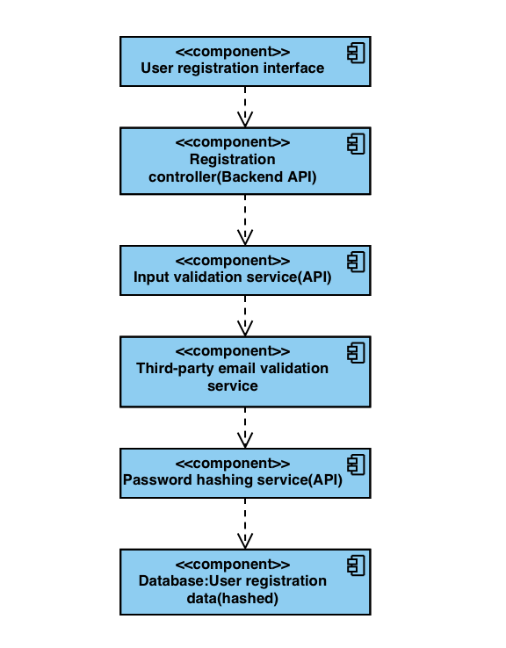

* **User Registration Interface**: Represents the user-facing interface where users input their registration data.
* **Registration Controller**: Controls the registration process on the backend, handling requests from the user interface.
* **Input Validation Service**: Validates user input, ensuring that email addresses, phone numbers, and passwords meet required criteria.
* **Third-party Email Validation Service**: Verifies the validity of email addresses provided by users, reducing the risk of fake or mistyped emails.
* **Password Hashing Service**: Safely hashes passwords using strong cryptographic algorithms, ensuring they are securely stored in the database.
* **Database (User Registration Data)**: Stores user registration data securely, including hashed passwords and other details. The data is encrypted to protect against unauthorized access.

**### Asset 2: User Login Credentials**

#### Threats:

1. **Brute Force Attacks**: Repeated login attempts with different credentials to guess passwords.

2. **Account Takeover**: Unauthorized access to user accounts through stolen or leaked credentials.

3. **Man-in-the-Middle Attacks**: Intercepting communication between the user's browser and the server to steal login credentials.

#### Vulnerabilities:

1. **Weak Passwords**: Users choosing easily guessable or common passwords.

2. **Password Reuse**: Using the same password for multiple accounts, increasing the risk of credential stuffing attacks.

3. **Insecure Communication**: Transmission of login credentials over unencrypted channels.

#### Mitigation Strategies:

1. **Account Lockout**: Implement mechanisms to lock accounts after a certain number of failed login attempts.

2. **Strong Password Policies**: Enforce minimum complexity requirements for passwords.

3. **HTTPS Encryption**: Ensure all communication between the user's browser and the server is encrypted.

#### Design Review:

**User Interface Design:**

- Intuitive login form with clear instructions and error messages.

- Account lockout notification if multiple failed login attempts occur.

- Option to request password reset in case of forgotten credentials.

**User Interface Design for Security Indicators:**

- Visual cues for secure connections (e.g., padlock icon) prominently displayed.

- Two-factor authentication (2FA) activation prompt for enhanced security.

- Error messages without revealing specific details about login failures to prevent enumeration attacks.

Components diagram:

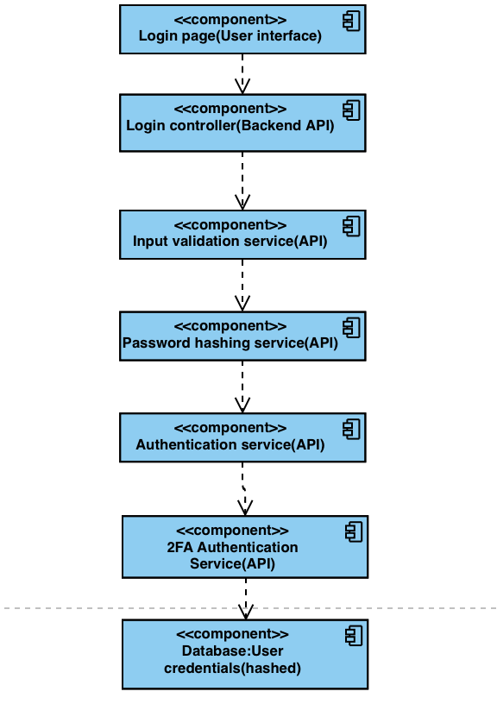

* **Login Page (User Interface):** Represents the user-facing login interface where users input their credentials.
* **Login Controller (Backend API):** Controls the login process on the backend, handling requests from the login page.
* **Input Validation Service (API):** Validates user input, ensuring that email addresses and passwords meet required criteria.
* **Password Hashing Service (Secure Module**): Safely hashes passwords using strong cryptographic algorithms before storing them in the database.
* **Authentication Service (Secure Module):** Authenticates user credentials against stored data in the database.
* **2FA Authentication Service (Secure Module):** Handles the two-factor authentication process, verifying the authenticity of TOTP tokens generated by the user's device.
* **Database (User Credentials Data):** Stores encrypted user credentials data, including hashed passwords and 2FA secret keys.

**### Asset 3: Email Address Login**

#### Threats:

1. **Email Enumeration**: Attackers attempt to enumerate valid email addresses through the login interface.

2. **Magic Link Interception**: Intercepting or tampering with the magic link during transmission to gain unauthorized access.

3. **Email Account Compromise**: Unauthorized access to the user's email account to intercept the magic link.

#### Vulnerabilities:

1. **Weak Email Verification**: Inadequate validation of email addresses, allowing attackers to bypass verification.

2. **Insecure Magic Link Generation**: Flaws in the generation or validation of magic links, enabling unauthorized access.

3. **Email Phishing**: Users falling victim to phishing emails masquerading as legitimate magic links.

#### Mitigation Strategies:

1. **Email Validation**: Validate email addresses against a list of registered and verified emails before sending magic links.

2. **Secure Magic Link Generation**: Use cryptographically secure random token generation and expiration time limits for magic links.

3. **Email Security Awareness**: Educate users about email security best practices and how to identify phishing attempts.

#### Design Review:

**User Interface Design:**

- Clear and intuitive interface for entering email addresses and requesting magic links.

- Prominent display of instructions on how to use magic links securely.

- Option to resend magic links in case of email delivery issues.

**User Interface Design for Security Indicators:**

- Visual confirmation of email address validation status before sending the magic link.

- Confirmation message upon successful magic link generation.

- Warning messages for suspicious email activity or phishing attempts.

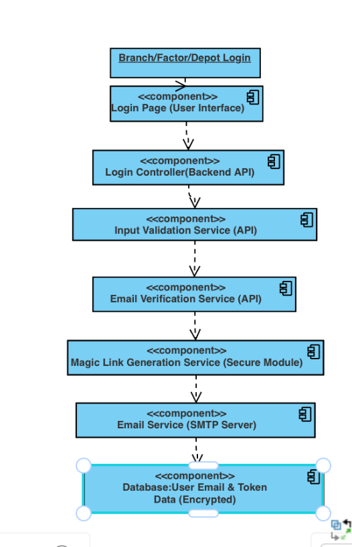

* **Login Page (User Interface):** Represents the user-facing login interface where users input their registered email addresses.
* **Login Controller (Backend API):** Controls the login process on the backend, handling requests from the login page.
* **Input Validation Service (API):** Validates user input, ensuring that email addresses are in the correct format.
* **Email Verification Service (API):** Verifies the authenticity of the provided email address against registered and verified emails.
* **Magic Link Generation Service (Secure Module):** Generates unique and time-limited magic links associated with user emails for authentication.
* **Email Service (SMTP Server):** Sends emails containing magic links to users' registered email addresses.
* **Database (User Email & Token Data):** Stores encrypted user email addresses and associated magic tokens for authentication.

**### Asset 4: Password Reset Process**

#### Threats:

1. **Email Interception**: Attackers intercepting the password reset email to gain unauthorized access.

2. **Brute Force Attacks**: Attempting to guess or brute-force the password reset token.

3. **Phishing**: Sending fake password reset emails to trick users into revealing sensitive information.

#### Vulnerabilities:

1. **Weak Token Generation**: Insecure generation of password reset tokens, making them susceptible to guessing attacks.

2. **Inadequate Validation**: Lack of validation on the password reset link, allowing unauthorized access.

3. **Password Policy Bypass**: Users bypassing password policy requirements during password reset.

#### Mitigation Strategies:

1. **Secure Token Generation**: Use cryptographically secure random number generators (CSPRNGs) to generate unique and unpredictable tokens.

2. **Token Expiry**: Set a short expiration time for password reset tokens to limit the window of opportunity for attackers.

3. **Password Policy Enforcement**: Validate new passwords against password policies to ensure compliance with security standards.

#### Design Review:

**User Interface Design:**

- Clear and intuitive interface for initiating the password reset process.

- Provide informative messages throughout the process to guide users and reassure them about the security of the process.

- Include an option for users to report suspicious emails or activities related to password reset.

**User Interface Design for Security Indicators:**

- Display visual cues in the email (e.g., company logo) to authenticate the legitimacy of the password reset email.

- Provide clear instructions on how to recognize and safely use the password reset link.

- Avoid embedding sensitive information in the email and ensure that links are presented in plain text format for improved security.

Component diagram:

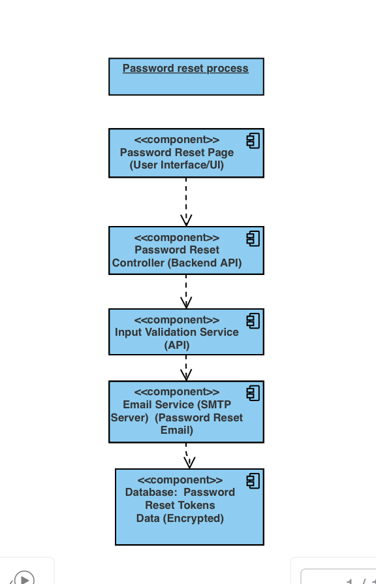

* **Password Reset Page (User Interface/UI):** Represents the user-facing interface where users initiate the password reset process by providing their email address.
* **Password Reset Controller (Backend API):** Controls the password reset process on the backend, handling requests from the password reset page.
* **Input Validation Service (API):** Validates user input, ensuring that the email address provided is in the correct format.
* **Email Service (SMTP Server):** Sends password reset emails containing unique and time-limited tokens or links to users' registered email addresses.
* **Database (Password Reset Tokens Data):** Stores encrypted password reset tokens associated with user email addresses, ensuring their security and integrity.

**### Asset 5: User Logout Functionality**

#### Threats:

1. **Session Hijacking**: Attackers attempting to hijack a user's session after they log out.

2. **CSRF Attacks**: Malicious entities exploiting Cross-Site Request Forgery vulnerabilities to force users to log out.

3. **Open Redirection**: Redirecting users to malicious websites after logout through unvalidated redirection URLs.

#### Vulnerabilities:

1. **Session Data Retention**: Failure to clear all session data upon logout, leaving sensitive information accessible.

2. **CSRF Vulnerabilities**: Lack of CSRF protection on the logout endpoint, allowing attackers to forge logout requests.

3. **Open Redirection Flaws**: Allowing arbitrary redirection URLs without proper validation, exposing users to phishing attacks.

#### Mitigation Strategies:

1. **Complete Session Clearance**: Ensure that all session data, including cookies and tokens, is cleared upon logout to prevent session hijacking.

2. **CSRF Protection**: Implement CSRF tokens in logout requests and validate them on the server side to mitigate CSRF attacks.

3. **Authentication Revocation**: Invalidate authentication tokens upon logout to prevent unauthorized access to protected resources.

4. **Redirection URL Validation**: Validate redirection URLs on the server side to prevent open redirection vulnerabilities.

#### Design Review:

**User Interface Design:**

- Place the "Logout" button in a prominent location, such as the user profile or navigation menu, for easy access.

- Provide a confirmation dialog or message when users click on the "Logout" button to prevent accidental logouts.

- Ensure that the logout process is intuitive and straightforward for users of all technical levels.

**User Interface Design for Security Indicators:**

- Display visual cues, such as a padlock icon, to indicate that the logout process is secure.

- Include informative messages or tooltips to educate users about the importance of logging out and the security measures in place.

- Avoid using open redirections or unvalidated redirection URLs to protect users from phishing attempts.

Component diagram:

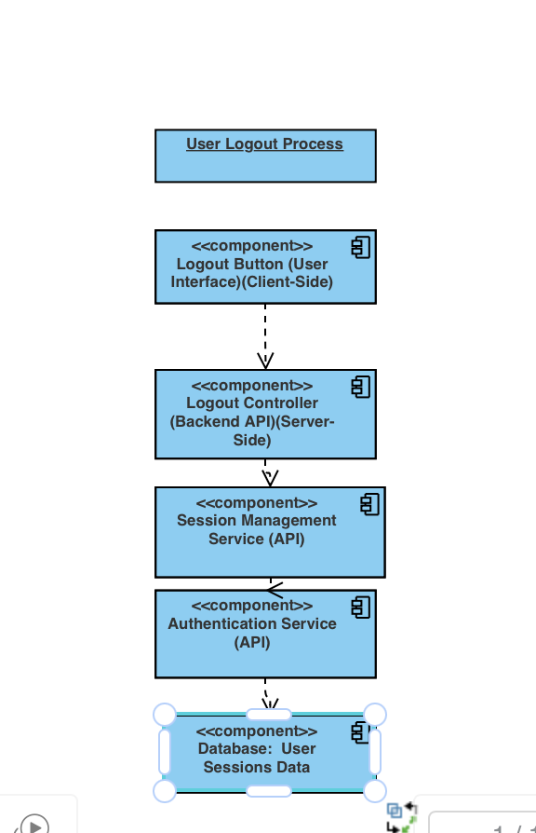

* **Logout Button (User Interface):** Represents the client-side interface where users click on the "Logout" button to initiate the logout process.
* **Logout Controller (Backend API):** Controls the logout process on the server-side, handling requests from the logout button.
* **Session Management Service (API):** Manages user sessions, including clearing session data upon logout and revoking authentication tokens.
* **Authentication Service (API):** Handles user authentication, including the revocation of authentication tokens during logout.
* **Database (User Sessions Data):** Stores information about user sessions, including session tokens and authentication status.

**### Asset 6: 2FA Activation and Deactivation Functionality**

#### Threats:

1. **Unauthorized Access**: Attackers attempting to gain unauthorized access to user accounts by bypassing or disabling 2FA.

2. **Tampering with 2FA Setup**: Malicious actors trying to manipulate the 2FA setup process to gain control of user accounts.

3. **Insufficient Logging**: Inadequate logging of 2FA activation and deactivation events, leading to a lack of visibility into security-related actions.

#### Vulnerabilities:

1. **Insecure 2FA Setup**: Lack of integrity checks during the 2FA setup process, allowing attackers to manipulate QR codes or TOTP inputs.

2. **Weak Confirmation Mechanism**: Weak or non-existent confirmation mechanisms for disabling 2FA, leading to unauthorized deactivation.

3. **Inadequate Authentication**: Insufficient authentication requirements during 2FA deactivation, enabling attackers to disable 2FA without proper verification.

#### Mitigation Strategies:

1. **Secure 2FA Setup**: Implement integrity checks for QR codes and TOTP inputs to ensure the authenticity and integrity of 2FA setup.

2. **Strong Confirmation Mechanism**: Require multi-factor confirmation, such as password authentication and confirmation codes, for disabling 2FA.

3. **Comprehensive Logging**: Log all 2FA activation and deactivation events, including timestamps, user identifiers, and outcomes, for auditing and monitoring purposes.

#### Design Review:

**User Interface Design:**

- Clearly label and distinguish between the options to activate and deactivate 2FA in the user account settings section.

- Provide informative tooltips or help sections to guide users through the 2FA setup and deactivation processes.

- Include confirmation dialogs or multi-step verification processes to prevent accidental or unauthorized actions.

**User Interface Design for Security Indicators:**

- Use visual indicators, such as lock icons or green/red flags, to signify the security status of 2FA (enabled or disabled).

- Display clear notifications or alerts when 2FA settings are modified, informing users about changes to their account security.

- Ensure that the interface for managing 2FA settings is user-friendly and accessible, with intuitive navigation and clear instructions.

Component diagram:

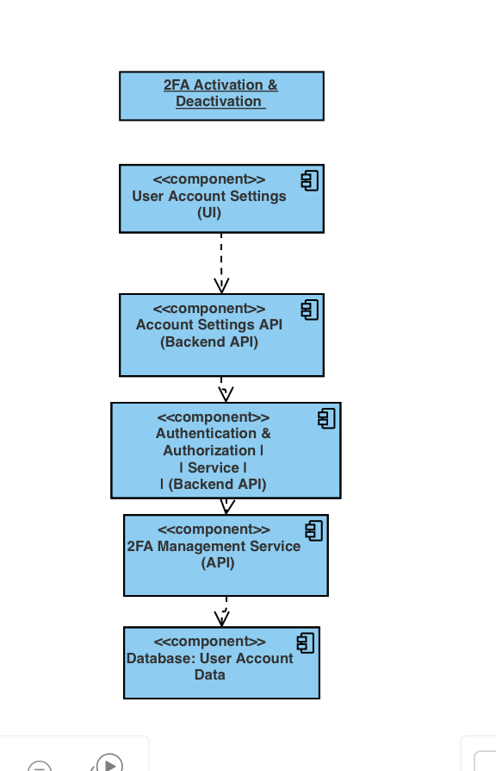

* **User Account Settings (UI):** Represents the user interface where administrators can navigate to manage their account settings, including activating or deactivating 2FA.
* **Account Settings API (Backend API):** Handles requests from the user interface to enable or disable 2FA, as well as other account-related actions.
* **Authentication & Authorization Service (Backend API):** Manages user authentication and authorization, including verifying credentials during 2FA deactivation.
* **2FA Management Service (API):** Responsible for handling the activation and deactivation of 2FA, including generating and verifying TOTPs, and updating user account settings accordingly.
* **Database (User Account Data):** Stores user account data, including settings related to 2FA activation status and secret keys for TOTP generation.

**### Asset 7: Password Reset Feature**

#### Threats:

1. **Unauthorized Password Reset**: Attackers attempting to reset the password of a company administrator account without proper authentication.

2. **Weak Verification Process**: Inadequate verification methods that could be bypassed by attackers to gain unauthorized access to the password reset functionality.

3. **Interception of Password**: Potential interception of the new password during transmission if not sent securely over HTTPS.

#### Vulnerabilities:

1. **Insufficient Verification**: Lack of strong verification mechanisms, such as multi-factor authentication or rate limiting, making it easier for attackers to bypass the verification process.

2. **Insecure Transmission**: Sending password change requests over an unencrypted connection, leading to the interception or tampering of sensitive data.

3. **Weak Password Policies**: Lack of password strength requirements or not enforcing password policies such as minimum length, complexity, or history checks.

#### Mitigation Strategies:

1. **Strong Verification Mechanisms**: Implement multi-factor authentication or additional security checks, such as email verification or security questions, to ensure the identity of the user before allowing a password reset.

2. **Secure Transmission**: Ensure that all password change requests and sensitive data are transmitted securely over HTTPS to prevent interception or tampering.

3. **Enforce Password Policies**: Implement strict password policies, including minimum length, complexity requirements, and history checks, to ensure that new passwords meet security standards.

4. **Rate Limiting**: Apply rate limiting on verification attempts to prevent brute-force attacks and limit the number of password reset attempts within a specific time frame.

#### Design Review:

**User Interface Design:**

- Clearly label and distinguish the option for password reset within the account settings section of the dashboard.

- Provide clear instructions and guidance on the verification process, including what information is required and how to proceed.

- Use user-friendly error messages to inform users of any issues encountered during the password reset process.

**User Interface Design for Security Indicators:**

- Use HTTPS protocol throughout the password reset process to indicate a secure connection.

- Provide visual cues, such as lock icons or green address bars, to reassure users that their data is being transmitted securely.

- Avoid displaying sensitive information, such as detailed error messages or confirmation messages, to prevent potential attackers from gaining insights into the system's security mechanisms.

Component diagram:

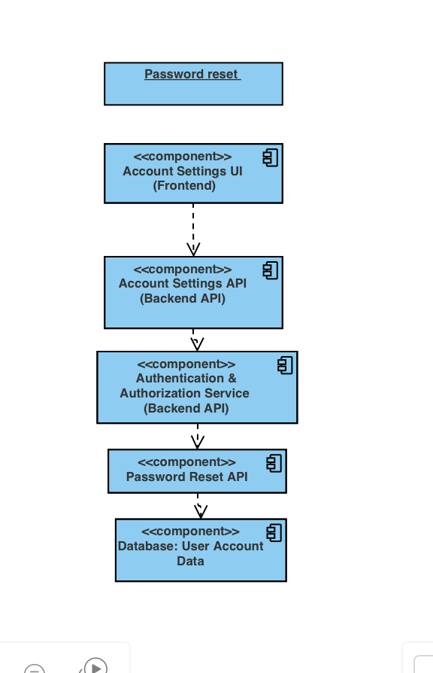

* **Account Settings UI (Frontend):** Represents the user interface where company administrators can access their account settings and initiate the password reset process.
* **Account Settings API (Backend API):** Handles requests from the frontend UI for password reset, including verification of user identity and updating the password in the database.
* **Authentication & Authorization Service (Backend API):** Manages user authentication and authorization, ensuring that only authenticated users can access the password reset functionality.
* **Password Reset API (API):** Handles the password reset process, including verification of identity, validation of new passwords, and updating the user's password in the database.
* **Database (User Account Data):** Stores user account data, including hashed passwords and other account settings.

**### Asset 8: Company Data Update Feature**

#### Threats:

1. **Injection Attacks**: Attackers attempting to manipulate input fields to inject malicious code or SQL queries into the system.

2. **Data Manipulation**: Unauthorized modification or deletion of company-related data by malicious actors.

3. **Data Leakage**: Exposure of sensitive company information due to insufficient input validation or improper error handling.

#### Vulnerabilities:

1. **Lack of Input Validation**: Failure to validate user inputs properly, allowing attackers to inject malicious code or manipulate data.

2. **Inadequate Error Handling**: Poor error handling mechanisms that may expose sensitive information or provide insufficient feedback to users.

3. **Insufficient Authentication and Authorization**: Lack of proper authentication and authorization checks, allowing unauthorized users to access or modify company-related data.

#### Mitigation Strategies:

1. **Input Validation**: Implement robust input validation techniques, such as whitelist validation, to ensure that only expected characters and formats are accepted. Reject any input that does not adhere to the expected format to prevent injection attacks.

2. **Secure Error Handling**: Implement detailed error messages for users in case of invalid inputs or unexpected errors. Avoid exposing sensitive information in error messages, and provide informative guidance on how to resolve issues.

3. **Authentication and Authorization**: Ensure that only authenticated and authorized company administrators can access and modify company-related data. Implement role-based access control (RBAC) to restrict access to authorized users only.

#### Design Review:

**User Interface Design:**

- Design a user-friendly interface for updating company-related data, with clear labels and instructions for each input field.

- Provide descriptive error messages to guide users in correcting invalid inputs or resolving any issues encountered during the data update process.

- Include confirmation prompts before saving or updating changes to prevent accidental modifications.

**User Interface Design for Security Indicators:**

- Implement security headers such as Content Security Policy (CSP) and X-Content-Type-Options to protect against common web vulnerabilities.

- Display visual indicators, such as lock icons or green address bars, to reassure users that their data is being transmitted securely.

- Avoid displaying detailed error messages that could potentially expose sensitive information or aid attackers in exploiting vulnerabilities.

Component diagram:

Component diagram:

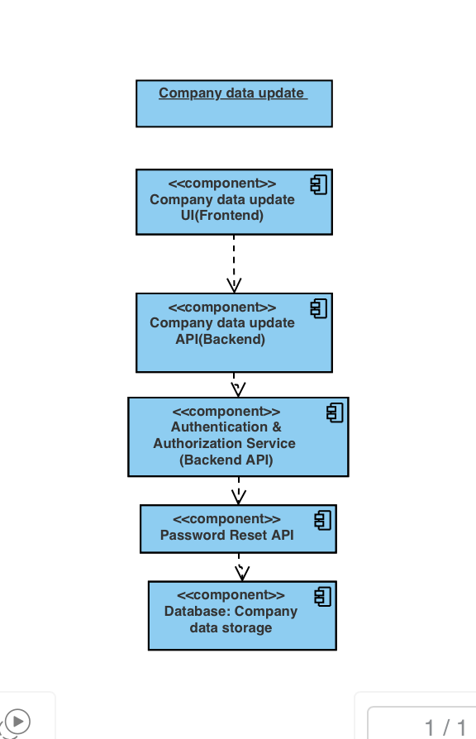

* **Company Data Update UI (Frontend):** Represents the user interface where company administrators can access and update company-related data.
* **Company Data Update API (Backend API):** Handles requests from the frontend UI for updating company data, including input validation and interaction with the database.
* **Authentication & Authorization Service (Backend API):** Manages user authentication and authorization, ensuring that only authenticated and authorized company administrators can access and modify company data.
* **Database (Company Data Storage):** Stores company-related data, including information such as company name, address, contact details, and other relevant data.

**### Asset 9: Depot Management Feature**

#### Threats:

1. **Injection Attacks**: Malicious users attempting to inject malicious code or SQL queries into the system via input fields.

2. **Unauthorized Access**: Attackers trying to access or manipulate depot-related data without proper authentication and authorization.

3. **Data Breaches**: Unauthorized access or disclosure of sensitive depot information due to inadequate security measures.

4. **Data Loss**: Accidental deletion or loss of depot data due to improper handling or lack of backup mechanisms.

#### Vulnerabilities:

1. **Input Validation**: Lack of proper input validation allowing injection attacks and data manipulation.

2. **Insufficient Authentication and Authorization**: Failure to enforce proper authentication and authorization checks, leading to unauthorized access.

3. **Insecure Data Storage**: Storing depot data without encryption, making it vulnerable to unauthorized access or disclosure.

4. **Inadequate Error Handling**: Poor error handling mechanisms exposing sensitive information or providing insufficient feedback to users.

#### Mitigation Strategies:

1. **Input Validation**: Implement strict input validation to sanitize and validate all user-provided data, preventing injection attacks and ensuring data integrity.

2. **Authentication and Authorization**: Enforce robust authentication and authorization mechanisms to ensure that only authenticated and authorized users can access and manage depot-related functionalities.

3. **Encryption**: Encrypt depot-related data both in transit and at rest using strong encryption algorithms to protect it from interception or unauthorized access.

4. **Secure Data Storage**: Implement secure storage mechanisms, such as encryption and access controls, to safeguard depot data stored in the database from unauthorized access or disclosure.

5. **Error Handling**: Implement comprehensive error handling mechanisms to provide informative feedback to users in case of invalid inputs or unexpected errors, without disclosing sensitive information.

#### Design Review:

**User Interface Design:**

- Design a user-friendly interface for depot management with clear navigation and intuitive controls for adding, listing, and removing depots.

- Include confirmation prompts for critical actions like deleting depots to prevent accidental data loss.

- Implement pagination, filtering, and searching functionalities to enhance user experience and facilitate efficient depot management.

**User Interface Design for Security Indicators:**

- Display visual indicators, such as padlock icons or HTTPS protocol, to reassure users that their data is transmitted securely.

- Avoid displaying detailed error messages that could expose sensitive information or aid attackers in exploiting vulnerabilities.

- Use appropriate encoding techniques to render user input harmless and prevent Cross-Site Scripting (XSS) attacks in the user interface.

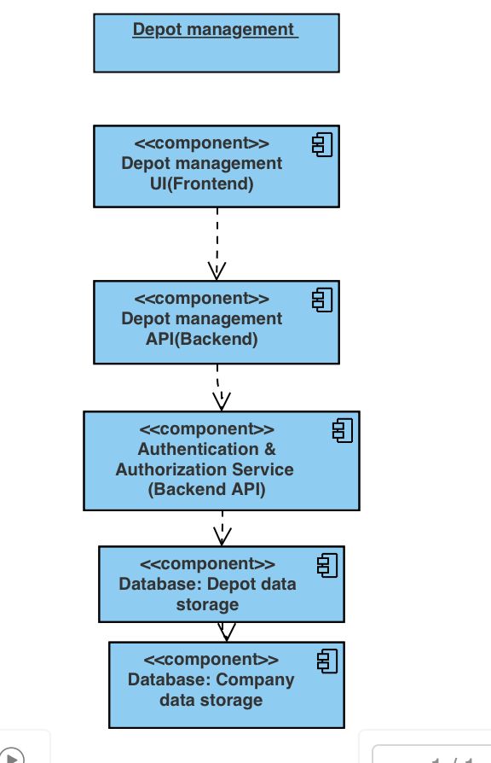Component diagram:

* **Depot Management UI (Frontend):** Represents the user interface where users can interact with the depot management features, including adding, listing, and removing depots.
* **Depot Management API (Backend API):** Handles requests from the frontend UI for depot management functionalities, including input validation, authentication, authorization, and interaction with the database.
* **Authentication & Authorization Service (Backend API):** Manages user authentication and authorization, ensuring that only authenticated and authorized users can access and manage depot-related functionalities.
* **Database (Depot Data Storage):** Stores depot-related data, including information such as depot locations, inventory details, and other relevant data. It should implement security measures such as encryption and access controls to protect depot data from unauthorized access or disclosure.

**### Asset 10: Factory Management Feature**

#### Threats:

1. **Injection Attacks**: Malicious users may attempt to inject malicious code or SQL queries into the system via input fields.

2. **Unauthorized Access**: Attackers might try to access or manipulate factory-related data without proper authentication and authorization.

3. **Data Breaches**: Unauthorized access or disclosure of sensitive factory information due to inadequate security measures.

4. **Data Loss**: Accidental deletion or loss of factory data due to improper handling or lack of backup mechanisms.

#### Vulnerabilities:

1. **Input Validation**: Lack of proper input validation may allow injection attacks and data manipulation.

2. **Insufficient Authentication and Authorization**: Failure to enforce proper authentication and authorization checks may lead to unauthorized access.

3. **Insecure Data Storage**: Storing factory data without encryption could make it vulnerable to unauthorized access or disclosure.

4. **Inadequate Error Handling**: Poor error handling mechanisms could expose sensitive information or provide insufficient feedback to users.

#### Mitigation Strategies:

1. **Input Validation**: Implement strict input validation to sanitize and validate all user-provided data, preventing injection attacks and ensuring data integrity.

2. **Authentication and Authorization**: Enforce robust authentication and authorization mechanisms to ensure that only authenticated and authorized users can access and manage factory-related functionalities.

3. **Encryption**: Encrypt factory-related data both in transit and at rest using strong encryption algorithms to protect it from interception or unauthorized access.

4. **Secure Data Storage**: Implement secure storage mechanisms, such as encryption and access controls, to safeguard factory data stored in the database from unauthorized access or disclosure.

5. **Error Handling**: Implement comprehensive error handling mechanisms to provide informative feedback to users in case of invalid inputs or unexpected errors, without disclosing sensitive information.

#### Design Review:

**User Interface Design:**

- Design a user-friendly interface for factory management with clear navigation and intuitive controls for adding, listing, and removing factories.

- Include confirmation prompts for critical actions like deleting factories to prevent accidental data loss.

- Implement pagination, filtering, and searching functionalities to enhance user experience and facilitate efficient factory management.

**User Interface Design for Security Indicators:**

- Display visual indicators, such as padlock icons or HTTPS protocol, to reassure users that their data is transmitted securely.

- Avoid displaying detailed error messages that could expose sensitive information or aid attackers in exploiting vulnerabilities.

- Use appropriate encoding techniques to render user input harmless and prevent Cross-Site Scripting (XSS) attacks in the user interface.

Component diagram:

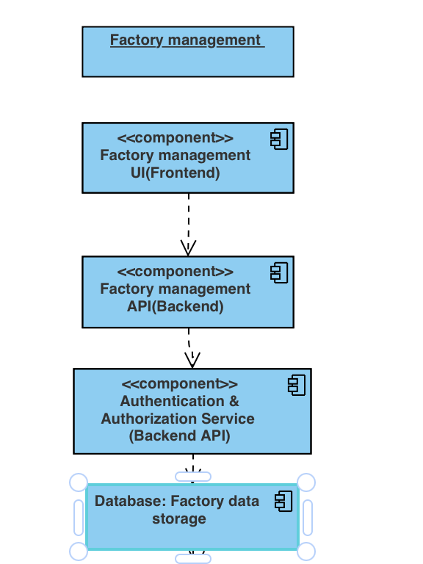

* **Factory Management UI (Frontend):** Represents the user interface where users can interact with the factory management features, including adding, listing, and removing factories.
* **Factory Management API (Backend API):** Handles requests from the frontend UI for factory management functionalities, including input validation, authentication, authorization, and interaction with the database.
* **Authentication & Authorization Service (Backend API):** Manages user authentication and authorization, ensuring that only authenticated and authorized users can access and manage factory-related functionalities.
* **Database (Factory Data Storage):** Stores factory-related data, including information such as factory locations, inventory details, and other relevant data. It should implement security measures such as encryption and access controls to protect factory data from unauthorized access or disclosure.

**### Asset 11: Store Management Functionality**

#### Threats:

1. **Injection Attacks**: Malicious users may attempt to inject malicious code or SQL queries into the system via input fields.

2. **Unauthorized Access**: Attackers might try to access or manipulate store-related data without proper authentication and authorization.

3. **Data Breaches**: Unauthorized access or disclosure of sensitive store information due to inadequate security measures.

4. **Data Loss**: Accidental deletion or loss of store data due to improper handling or lack of backup mechanisms.

#### Vulnerabilities:

1. **Input Validation**: Lack of proper input validation may allow injection attacks and data manipulation.

2. **Insufficient Authentication and Authorization**: Failure to enforce proper authentication and authorization checks may lead to unauthorized access.

3. **Insecure Data Storage**: Storing store data without encryption could make it vulnerable to unauthorized access or disclosure.

4. **Inadequate Error Handling**: Poor error handling mechanisms could expose sensitive information or provide insufficient feedback to users.

#### Mitigation Strategies:

1. **Input Validation**: Implement strict input validation to sanitize and validate all user-provided data, preventing injection attacks and ensuring data integrity.

2. **Authentication and Authorization**: Enforce robust authentication and authorization mechanisms to ensure that only authenticated and authorized users can access and manage store-related functionalities.

3. **Encryption**: Encrypt store-related data both in transit and at rest using strong encryption algorithms to protect it from interception or unauthorized access.

4. **Secure Data Storage**: Implement secure storage mechanisms, such as encryption and access controls, to safeguard store data stored in the database from unauthorized access or disclosure.

5. **Error Handling**: Implement comprehensive error handling mechanisms to provide informative feedback to users in case of invalid inputs or unexpected errors, without disclosing sensitive information.

#### Design Review:

**User Interface Design:**

- Design a user-friendly interface for store management with clear navigation and intuitive controls for adding, listing, and removing stores.

- Include confirmation prompts for critical actions like deleting stores to prevent accidental data loss.

- Implement pagination, filtering, and searching functionalities to enhance user experience and facilitate efficient store management.

**User Interface Design for Security Indicators:**

- Display visual indicators, such as padlock icons or HTTPS protocol, to reassure users that their data is transmitted securely.

- Avoid displaying detailed error messages that could expose sensitive information or aid attackers in exploiting vulnerabilities.

- Use appropriate encoding techniques to render user input harmless and prevent Cross-Site Scripting (XSS) attacks in the user interface.

Component diagram:

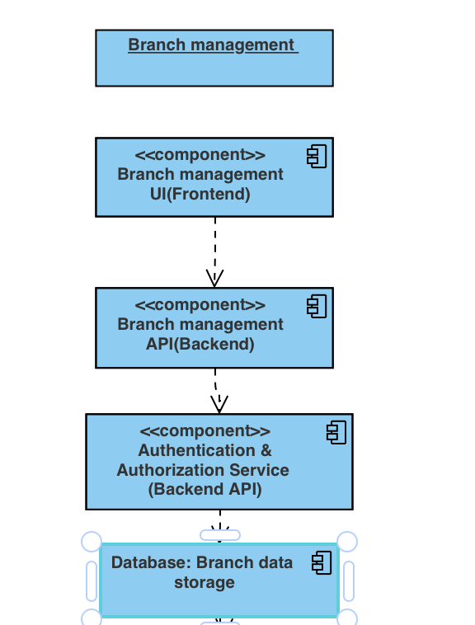

* **Store Management UI (Frontend):** Represents the user interface where users can interact with the store management features, including adding, listing, and removing stores.
* **Store Management API (Backend API):** Handles requests from the frontend UI for store management functionalities, including input validation, authentication, authorization, and interaction with the database.
* **Authentication & Authorization Service (Backend API):** Manages user authentication and authorization, ensuring that only authenticated and authorized users can access and manage store-related functionalities.
* **Database (Store Data Storage):** Stores store-related data, including information such as store locations, inventory details, and other relevant data. It should implement security measures such as encryption and access controls to protect store data from unauthorized access or disclosure.

**### Asset 12: Product Management Functionality**

#### Threats:

1. **Injection Attacks**: Malicious users may attempt to inject malicious code or SQL queries into the system via input fields.

2. **Unauthorized Access**: Attackers might try to access or manipulate product-related data without proper authentication and authorization.

3. **Data Breaches**: Unauthorized access or disclosure of sensitive product information due to inadequate security measures.

4. **Data Loss**: Accidental deletion or loss of product data due to improper handling or lack of backup mechanisms.

#### Vulnerabilities:

1. **Input Validation**: Lack of proper input validation may allow injection attacks and data manipulation.

2. **Insufficient Authentication and Authorization**: Failure to enforce proper authentication and authorization checks may lead to unauthorized access.

3. **Insecure Data Storage**: Storing product data without encryption could make it vulnerable to unauthorized access or disclosure.

4. **Inadequate Error Handling**: Poor error handling mechanisms could expose sensitive information or provide insufficient feedback to users.

#### Mitigation Strategies:

1. **Input Validation**: Implement strict input validation to sanitize and validate all user-provided data, preventing injection attacks and ensuring data integrity.

2. **Authentication and Authorization**: Enforce robust authentication and authorization mechanisms to ensure that only authenticated and authorized users can access and manage product-related functionalities.

3. **Encryption**: Encrypt product-related data both in transit and at rest using strong encryption algorithms to protect it from interception or unauthorized access.

4. **Secure Data Storage**: Implement secure storage mechanisms, such as encryption and access controls, to safeguard product data stored in the database from unauthorized access or disclosure.

5. **Error Handling**: Implement comprehensive error handling mechanisms to provide informative feedback to users in case of invalid inputs or unexpected errors, without disclosing sensitive information.

#### Design Review:

**User Interface Design:**

- Design a user-friendly interface for product management with clear navigation and intuitive controls for adding, listing, and removing products.

- Include confirmation prompts for critical actions like deleting products to prevent accidental data loss.

- Implement pagination, filtering, and searching functionalities to enhance user experience and facilitate efficient product management.

**User Interface Design for Security Indicators:**

- Display visual indicators, such as padlock icons or HTTPS protocol, to reassure users that their data is transmitted securely.

- Avoid displaying detailed error messages that could expose sensitive information or aid attackers in exploiting vulnerabilities.

- Use appropriate encoding techniques to render user input harmless and prevent Cross-Site Scripting (XSS) attacks in the user interface.

Component diagram:

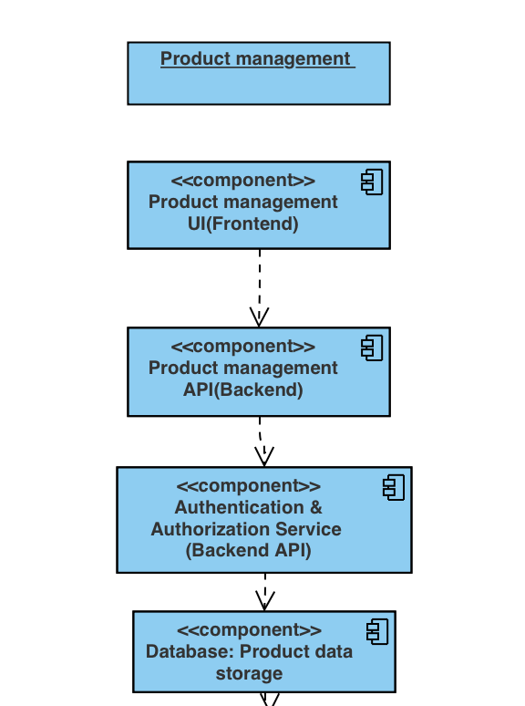

* **Product Management UI (Frontend):** Represents the user interface where users can interact with the product management features, including adding, listing, and removing products.
* **Product Management API (Backend API):** Handles requests from the frontend UI for product management functionalities, including input validation, authentication, authorization, and interaction with the database.
* **Authentication & Authorization Service (Backend API):** Manages user authentication and authorization, ensuring that only authenticated and authorized users can access and manage product-related functionalities.
* **Database (Product Data Storage):** Stores product-related data, including information such as product names, sizes, colors, and other relevant details. It should implement security measures such as encryption and access controls to protect product data from unauthorized access or disclosure.

**### Asset 13: Branch Dashboard Product Listing**

#### Threats:

1. **Unauthorized Access**: Unauthorized users may attempt to access the branch dashboard and view product information.

2. **Data Manipulation**: Malicious users might try to manipulate product counts or data displayed on the branch dashboard.

3. **Data Leakage**: Exposure of sensitive product information to unauthorized individuals or competitors.

4. **Injection Attacks**: Attackers may attempt to inject malicious code or SQL queries to manipulate the product listing data.

#### Vulnerabilities:

1. **Insufficient Authentication and Authorization**: Lack of proper authentication and authorization mechanisms may allow unauthorized users to access the branch dashboard.

2. **Insecure Data Transmission**: Product information transmitted between the centralized database and branch dashboard may be vulnerable to interception or tampering.

3. **Lack of Input Validation**: Inadequate validation of user inputs or product counts may lead to injection attacks or data manipulation.

4. **Inadequate Logging and Auditing**: Insufficient logging and auditing of product count updates and dashboard access activities could hinder detection of unauthorized access or data manipulation.

#### Mitigation Strategies:

1. **Authentication and Authorization**: Implement robust authentication mechanisms to ensure only authenticated branch users with appropriate permissions can access the branch dashboard and view product information.

2. **Encryption**: Encrypt data transmitted between the centralized database and branch dashboard using secure protocols such as HTTPS to prevent interception or tampering.

3. **Input Validation**: Validate all user inputs and product count updates to prevent injection attacks and ensure data integrity.

4. **Logging and Auditing**: Enable auditing and logging features in the database management system to track all database activities, product count updates, and branch dashboard accesses. Regularly review logs for any suspicious activities.

5. **Dual Verification**: Require dual verification or approval for critical inventory transactions to prevent unauthorized changes to product counts.

6. **Data Minimization**: Limit the amount of product information displayed on the branch dashboard to only essential details, minimizing the risk of data leakage.

7. **Access Controls**: Implement strict access controls to restrict access to sensitive product information and dashboard functionalities based on user roles and permissions.

#### Design Review:

**User Interface Design:**

- Design a clean and intuitive user interface for the branch dashboard, displaying product lists along with their counts in a clear and organized manner.

- Include features for filtering, searching, and sorting product lists to facilitate easy navigation and product management.

- Implement role-based access controls to ensure that only authorized users can access the branch dashboard and view product information.

**User Interface Design for Security Indicators:**

- Display clear indicators of secure connections, such as HTTPS protocol and padlock icons, to assure users of secure data transmission.

- Avoid displaying sensitive product information or details that could potentially aid attackers in exploiting vulnerabilities.

- Provide minimal feedback for authentication failures to prevent attackers from guessing valid user credentials.

Component diagram:

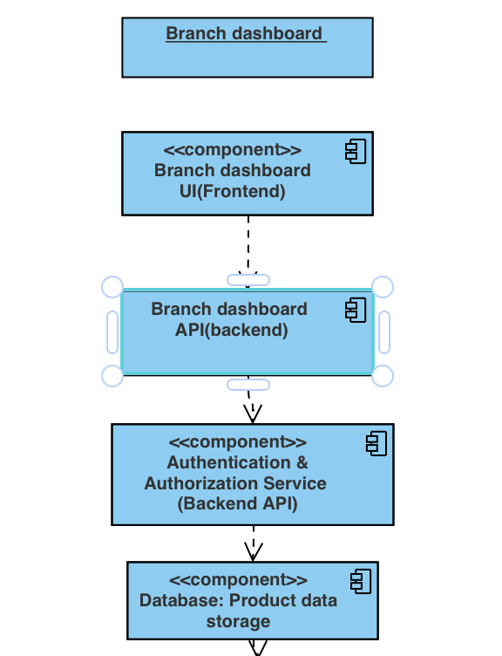

* **Branch Dashboard UI (Frontend):** Represents the user interface where authenticated branch users can view the list of products along with their counts at the branch.
* **Branch Dashboard API (Backend API):** Handles requests from the frontend UI for retrieving product information specific to the branch, interacting with the authentication & authorization service, and accessing the database.
* **Authentication & Authorization Service (Backend API):** Manages user authentication and authorization, ensuring that only authenticated branch users with the appropriate permissions can access the branch dashboard and view product information.
* **Database (Product Data Storage):** Stores product-related data, including information such as product names, sizes, colors, and available counts. It also stores branch-specific product counts, reflecting the quantity available at each branch. The database should implement security measures such as encryption and access controls to protect product data from unauthorized access or disclosure.

**### Asset 14: Depot Dashboard Product Listing**

#### Threats:

1. **Unauthorized Access**: Unauthorized users may attempt to access the depot dashboard and view product information.

2. **Data Leakage**: Exposure of sensitive product information to unauthorized individuals or competitors.

3. **Data Manipulation**: Malicious users might try to manipulate product data displayed on the depot dashboard.

4. **Cross-Site Scripting (XSS) Attacks**: Attackers may inject malicious scripts into the depot dashboard interface, leading to the execution of unauthorized actions in users' browsers.

#### Vulnerabilities:

1. **Insufficient Authentication and Authorization**: Lack of proper authentication and authorization mechanisms may allow unauthorized users to access the depot dashboard.

2. **Insecure Data Transmission**: Product information transmitted between the centralized database and depot dashboard may be vulnerable to interception or tampering.

3. **Overexposure of Information**: Displaying excessive product information on the depot dashboard may increase the risk of data leakage.

4. **Lack of Input Validation**: Inadequate validation of user inputs or product data may lead to XSS vulnerabilities.

5. **Lack of Integrity Verification**: Failure to verify the integrity of transmitted product information may result in data tampering during transit.

#### Mitigation Strategies:

1. **Authentication and Authorization**: Implement robust authentication mechanisms to ensure only authenticated depot users with appropriate permissions can access the depot dashboard and view product information.

2. **Encryption**: Encrypt data transmitted between the centralized database and depot dashboard using secure protocols such as HTTPS to prevent interception or tampering.

3. **Least Privilege Access**: Grant users access only to the product information relevant to their roles and responsibilities within the depot.

4. **Data Minimization**: Limit the amount of product information displayed on the depot dashboard to only essential details required for depot operations, minimizing the risk of data leakage.

5. **Input Validation**: Implement strict input validation to prevent XSS attacks. Sanitize user inputs to remove or encode any potentially malicious scripts.

6. **Content Security Policy (CSP)**: Implement a CSP to specify trusted sources for loading scripts, stylesheets, and other resources, mitigating the risk of XSS attacks by restricting the execution of unauthorized scripts.

7. **Integrity Verification**: Implement mechanisms to verify the integrity of transmitted product information. Use cryptographic hash functions to generate checksums or hashes of the data before transmission and verify these hashes upon receipt to ensure data integrity.

8. **Logging and Monitoring**: Monitor depot dashboard activities and log access attempts, modifications, and other relevant events for auditing and security analysis.

#### Design Review:

**User Interface Design:**

- Design a user-friendly interface for the depot dashboard, displaying product information in a clear and organized manner, preferably in a tabular format.

- Include features for filtering, searching, and sorting product lists to facilitate easy navigation and product management.

**User Interface Design for Security Indicators:**

- Display clear indicators of secure connections, such as HTTPS protocol and padlock icons, to assure users of secure data transmission.

- Avoid displaying sensitive product information that is not necessary for depot operations to minimize the risk of data exposure.

- Implement error handling mechanisms to provide informative error messages to users in case of invalid inputs or unexpected errors, without revealing sensitive information.

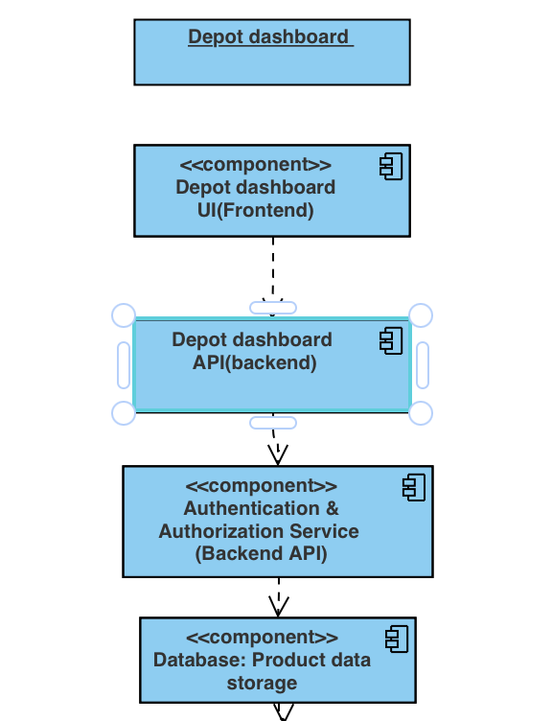Component diagram:

* **Depot Dashboard UI (Frontend):** Represents the user interface where authenticated depot users can view the list of products in the depot, including their names, sizes, and colors.
* **Depot Dashboard API (Backend API):** Handles requests from the frontend UI for retrieving product information specific to the depot, interacting with the authentication & authorization service, and accessing the database.
* **Authentication & Authorization Service (Backend API):** Manages user authentication and authorization, ensuring that only authenticated depot users with the appropriate permissions can access the depot dashboard and view product information.
* **Database (Product Data Storage):** Stores product-related data, including information such as product names, sizes, colors, and quantities available in the depot. The database should implement security measures such as encryption, input validation, and data minimization to protect product data from unauthorized access, manipulation, or leakage.

**### Asset 15: Factory Dashboard Product Listing**

#### Threats:

1. **Unauthorized Access**: Unauthorized users may attempt to access the factory dashboard and view product information.

2. **Data Leakage**: Exposure of sensitive product information to unauthorized individuals or competitors.

3. **Data Manipulation**: Malicious users might try to manipulate product data displayed on the factory dashboard.

4. **Cross-Site Scripting (XSS) Attacks**: Attackers may inject malicious scripts into the factory dashboard interface, leading to the execution of unauthorized actions in users' browsers.

#### Vulnerabilities:

1. **Insufficient Authentication and Authorization**: Lack of proper authentication and authorization mechanisms may allow unauthorized users to access the factory dashboard.

2. **Insecure Data Transmission**: Product information transmitted between the centralized database and factory dashboard may be vulnerable to interception or tampering.

3. **Overexposure of Information**: Displaying excessive product information on the factory dashboard may increase the risk of data leakage.

4. **Lack of Input Validation**: Inadequate validation of user inputs or product data may lead to XSS vulnerabilities.

5. **Lack of Integrity Verification**: Failure to verify the integrity of transmitted product information may result in data tampering during transit.

#### Mitigation Strategies:

1. **Authentication and Authorization**: Implement robust authentication mechanisms to ensure only authenticated factory users with appropriate permissions can access the factory dashboard and view product information.

2. **Encryption**: Encrypt data transmitted between the centralized database and factory dashboard using secure protocols such as HTTPS to prevent interception or tampering.

3. **Least Privilege Access**: Grant users access only to the product information relevant to their roles and responsibilities within the factory.

4. **Data Minimization**: Limit the amount of product information displayed on the factory dashboard to only essential details required for factory operations, minimizing the risk of data leakage.

5. **Input Validation**: Implement strict input validation to prevent XSS attacks. Sanitize user inputs to remove or encode any potentially malicious scripts.

6. **Content Security Policy (CSP)**: Implement a CSP to specify trusted sources for loading scripts, stylesheets, and other resources, mitigating the risk of XSS attacks by restricting the execution of unauthorized scripts.

7. **Integrity Verification**: Implement mechanisms to verify the integrity of transmitted product information. Use cryptographic hash functions to generate checksums or hashes of the data before transmission and verify these hashes upon receipt to ensure data integrity.

8. **Logging and Monitoring**: Monitor factory dashboard activities and log access attempts, modifications, and other relevant events for auditing and security analysis.

#### Design Review:

**User Interface Design:**

- Design a user-friendly interface for the factory dashboard, displaying product information in a clear and organized manner, preferably in a tabular format.

- Include features for filtering, searching, and sorting product lists to facilitate easy navigation and product management.

**User Interface Design for Security Indicators:**

- Display clear indicators of secure connections, such as HTTPS protocol and padlock icons, to assure users of secure data transmission.

- Avoid displaying sensitive product information that is not necessary for factory operations to minimize the risk of data exposure.

- Implement error handling mechanisms to provide informative error messages to users in case of invalid inputs or unexpected errors, without revealing sensitive information.

Component diagram:

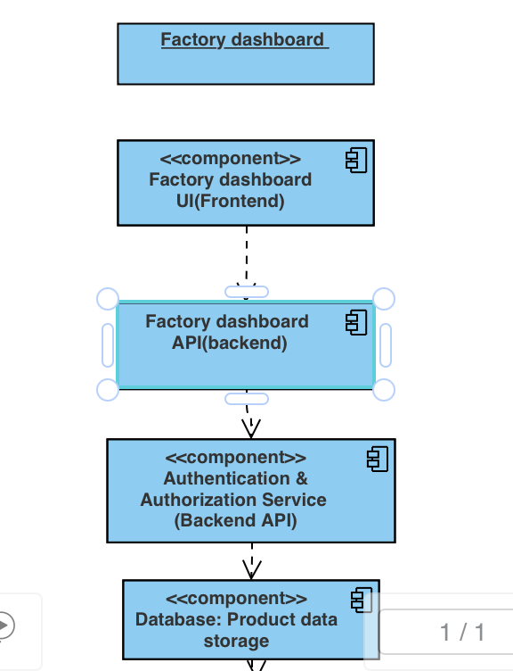

* **Factory Dashboard UI (Frontend):** Represents the user interface where authenticated factory users can view the list of products in the factory, including their names, sizes, and colors.
* **Factory Dashboard API (Backend API):** Handles requests from the frontend UI for retrieving product information specific to the factory, interacting with the authentication & authorization service, and accessing the database.
* **Authentication & Authorization Service (Backend API):** Manages user authentication and authorization, ensuring that only authenticated factory users with the appropriate permissions can access the factory dashboard and view product information.
* **Database (Product Data Storage):** Stores product-related data, including information such as product names, sizes, colors, and quantities available in the factory. The database should implement security measures such as encryption, input validation, and data minimization to protect product data from unauthorized access, manipulation, or leakage.

**### Asset 16: Product Request Handling**

#### Threats:

1. **Unauthorized Access**: Unauthorized users may attempt to access or manipulate product request data.

2. **Data Breach**: Exposure of sensitive product request details, including payment information, to unauthorized individuals.

3. **Payment Fraud**: Malicious actors may attempt to make fraudulent payments or manipulate payment processes.

4. **Data Tampering**: Unauthorized modification of product request details or payment information during transmission.

5. **Geolocation Spoofing**: Manipulation of geolocation data to influence depot selection or product fulfillment.

#### Vulnerabilities:

1. **Insufficient Authentication and Authorization**: Weak authentication mechanisms may allow unauthorized access to product request functionalities.

2. **Insecure Communication**: Lack of encryption in data transmission channels may expose sensitive information to interception or tampering.

3. **Input Validation**: Inadequate validation of user inputs may lead to injection attacks or data manipulation.

4. **Third-Party Integration Risks**: Integration with third-party payment processing platforms may introduce vulnerabilities if not properly secured.

5. **Geolocation Data Trustworthiness**: Reliance on geolocation data without sufficient validation may lead to inaccurate depot selection or product fulfillment.

#### Mitigation Strategies:

1. **Robust Authentication**: Implement strong authentication mechanisms to verify the identity of users accessing product request functionalities.

2. **Encryption**: Encrypt data transmission channels using secure protocols such as HTTPS to prevent interception or tampering.

3. **Input Validation**: Validate all user inputs, including product details and payment information, to prevent injection attacks or data manipulation.

4. **Third-Party Security**: Ensure that third-party payment processing platforms adhere to industry-standard security practices and compliance requirements.

5. **Geolocation Validation**: Implement geolocation validation mechanisms to verify the authenticity and integrity of geolocation data used for depot selection.

6. **Real-Time Monitoring**: Monitor product request transactions in real-time to detect suspicious activities or anomalies, triggering alerts for immediate investigation.

7. **Payment Security**: Secure payment processing mechanisms by encrypting sensitive payment information during transmission and storage.

8. **Transaction Integrity**: Verify the integrity of product request and payment transaction data using cryptographic techniques such as digital signatures.

9. **Rate Limiting**: Implement rate limiting mechanisms to prevent excessive or malicious product request queries, reducing the risk of denial-of-service attacks.

10. **Data Minimization**: Collect and retain only the minimum amount of data necessary for product request processing and compliance purposes to reduce the impact of data breaches.

#### Design Review:

**User Interface Design:**

- Design user-friendly interfaces for branch and company dashboards, guiding users through the product request process with clear instructions and intuitive controls.

- Include error handling mechanisms to provide informative feedback to users in case of invalid inputs or transaction failures.

**User Interface Design for Security Indicators:**

- Display security indicators such as HTTPS protocol and padlock icons to assure users of secure data transmission during product requests and payments.

- Limit the display of sensitive information to authorized users only, minimizing the risk of data exposure to unauthorized individuals.

Component diagram:

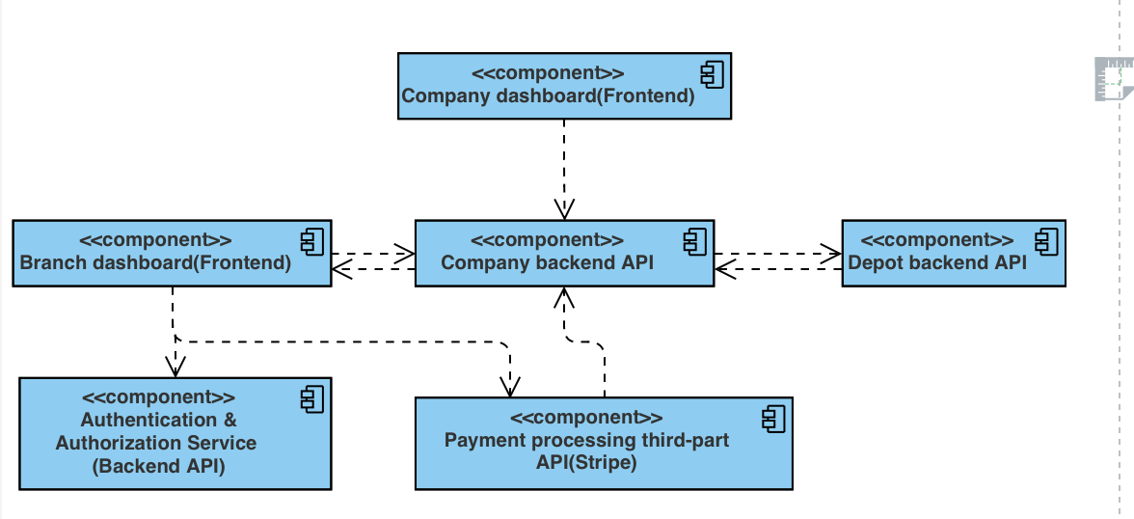

* **Company Dashboard (Frontend):** Provides the user interface for managing product requests, initiating payments, and monitoring request statuses.
* Branch Dashboard (Frontend): Allows branches to initiate product requests and view request statuses.
* **Company Backend API:** Handles requests from the company and branch dashboards, orchestrating the processing of product requests, depot selection, and payment processing.
* **Depot Backend API:** Manages depot operations, including inventory management, product fulfillment, and communication with the company backend API.
* **Authentication & Authorization Service:** Verifies user identities and authorizes access to product request functionalities.
* **Payment Processing (Stripe):** Facilitates secure payment processing for product requests, integrating with the company backend API to handle payment transactions securely.

**### Asset 17: Statistical Data Presentation**

#### Threats:

1. **Unauthorized Access**: Unauthorized users may attempt to access statistical data, leading to data breaches or privacy violations.

2. **Data Interception**: Intercepting statistical data during transmission may expose sensitive information to unauthorized parties.

3. **Data Tampering**: Malicious actors may attempt to alter statistical data to manipulate analysis results or mislead administrators.

4. **Injection Attacks**: Injection attacks such as SQL injection or cross-site scripting (XSS) may compromise the integrity of statistical data or expose vulnerabilities in the system.

5. **Insufficient Authentication**: Weak authentication mechanisms may allow unauthorized individuals to access statistical data on the company dashboard.

#### Vulnerabilities:

1. **Insecure Data Transmission**: Lack of encryption in data transmission channels may expose statistical data to interception or tampering.

2. **Insufficient Input Validation**: Failure to validate user inputs may expose the system to injection attacks, allowing malicious actors to manipulate statistical data.

3. **Data Storage Security**: Inadequate encryption of statistical data at rest may lead to unauthorized access or data breaches.

4. **Weak Authentication**: Weak authentication mechanisms may allow unauthorized users to access sensitive statistical data on the company dashboard.

5. **Third-Party Integration Risks**: Integration with external services or APIs for payment processing or data retrieval may introduce vulnerabilities if not properly secured.

#### Mitigation Strategies:

1. **Encryption**: Encrypt statistical data both at rest and in transit to prevent unauthorized access or interception.

2. **Secure Authentication**: Implement strong authentication mechanisms, such as multi-factor authentication (MFA), to ensure only authorized administrators can access statistical data.

3. **Input Validation**: Validate all user inputs to prevent injection attacks and ensure data integrity.

4. **Secure Communication**: Use secure communication protocols such as HTTPS to protect data transmission channels from interception or tampering.

5. **Data Minimization**: Collect and retain only the minimum amount of statistical data necessary for analysis to reduce the impact of data breaches.

6. **Access Control**: Implement strict access controls to ensure that only authorized individuals can access statistical data on the company dashboard.

7. **Third-Party Security**: Ensure that third-party services or APIs used for statistical data processing comply with industry-standard security practices and regulations.

8. **Data Integrity Checks**: Implement data integrity checks to detect and prevent unauthorized modifications to statistical data.

9. **Regular Auditing**: Conduct regular audits of statistical data handling processes to identify and address security vulnerabilities or compliance issues.

10. **User Education**: Educate administrators on best practices for handling statistical data and potential security risks associated with data analysis and presentation.

#### Design Review:

**User Interface Design:**

- Design intuitive and user-friendly interfaces for presenting statistical data on the company dashboard, allowing administrators to easily navigate and analyze data.

- Include interactive features such as filters, date selectors, and drill-down options to allow administrators to customize analysis according to their requirements.

**User Interface Design for Security Indicators:**

- Display security indicators such as HTTPS protocol and encryption icons to assure users of secure data transmission and storage.

- Limit access to sensitive statistical data to authorized administrators only, with clear authentication and access control mechanisms in place.

Component diagram:

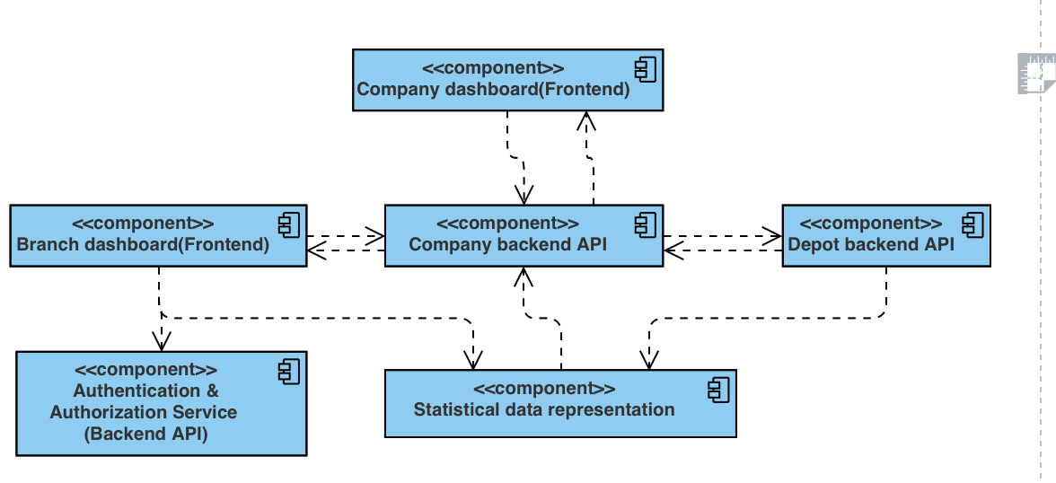

* **Company Dashboard (Frontend):** Provides the user interface for presenting statistical data to company administrators.
* **Branch Dashboard (Frontend):** Allows branches to access relevant statistical data.
* **Company Backend API:** Manages requests from the company dashboard and interacts with the statistical data presentation module.
* **Depot Backend API:** Handles depot-related operations and interactions with the statistical data presentation module.
* **Authentication & Authorization Service:** Ensures secure access to statistical data presentation functionalities.
* **Statistical Data Presentation Module:** Responsible for collecting, aggregating, and presenting statistical data to users, ensuring encryption of data both at rest and in transit.

**### Asset 18: Handling Defective Product Refunds**

#### Threats:

1. **Fraudulent Refund Requests**: Malicious actors may attempt to initiate fraudulent refund requests to obtain unauthorized refunds.

2. **Data Interception**: Sensitive refund request data transmitted between the branch and company systems may be intercepted by unauthorized parties.

3. **Data Tampering**: Refund request data may be tampered with during transmission or processing, leading to unauthorized refunds or data integrity issues.

4. **Unauthorized Access**: Unauthorized individuals may attempt to access refund processing systems to manipulate refund requests or steal sensitive information.

5. **Insufficient Verification**: Lack of proper document verification procedures may result in acceptance of forged or falsified documents, leading to fraudulent refunds.

#### Vulnerabilities:

1. **Insecure Data Transmission**: Lack of encryption in data transmission channels may expose refund request data to interception or tampering.

2. **Weak Authentication**: Weak authentication mechanisms may allow unauthorized individuals to access refund processing systems and initiate fraudulent refund requests.

3. **Insufficient Input Validation**: Failure to validate refund request inputs may expose the system to injection attacks or data manipulation.

4. **Third-Party Dependency Risks**: Dependency on third-party payment processing platforms such as Stripe may introduce vulnerabilities if not properly secured or monitored.

5. **Inadequate Document Verification**: Lack of robust document verification procedures may result in acceptance of forged or falsified documents during refund processing.

#### Mitigation Strategies:

1. **Anti-Fraud Measures**: Implement anti-fraud measures such as monitoring refund patterns, transaction histories, and user behavior for anomalies to detect and prevent fraudulent refund requests.

2. **Encryption**: Encrypt refund request data both at rest and in transit to protect it from unauthorized access or interception.

3. **Strong Authentication**: Implement strong authentication mechanisms, such as multi-factor authentication (MFA), to ensure only authorized individuals can access refund processing systems.

4. **Input Validation**: Validate all refund request inputs to prevent injection attacks and ensure data integrity.

5. **Secure Communication**: Use secure communication protocols such as HTTPS to protect data transmission channels from interception or tampering.

6. **Document Verification**: Implement robust document verification procedures to ensure the authenticity and validity of documents provided during refund processing.

7. **Audit Logging**: Maintain detailed audit logs of all refund processing activities, including user actions, timestamps, and transaction details, for accountability and traceability.

8. **Third-Party Security**: Ensure that third-party payment processing platforms such as Stripe comply with industry-standard security practices and regulations.

9. **Approval Workflow**: Implement an approval workflow for refund requests, where requests must be reviewed and approved by authorized personnel before processing.

10. **Regular Monitoring**: Continuously monitor refund processing systems for unusual activities or suspicious behavior to detect and mitigate potential security threats.

#### Design Review:

**User Interface Design:**

- Design intuitive and user-friendly interfaces for initiating and processing refund requests, guiding branch personnel through the process step by step.

- Include clear instructions and error messages to help users provide accurate and complete information when submitting refund requests.

**User Interface Design for Security Indicators:**

- Display security indicators such as HTTPS protocol and encryption icons to assure users of secure data transmission and storage.

- Implement role-based access control to ensure that only authorized personnel can access refund processing features on the company dashboard.

- Include notifications or alerts to inform users of the status of their refund requests and any additional actions required on their part.

Component diagram:

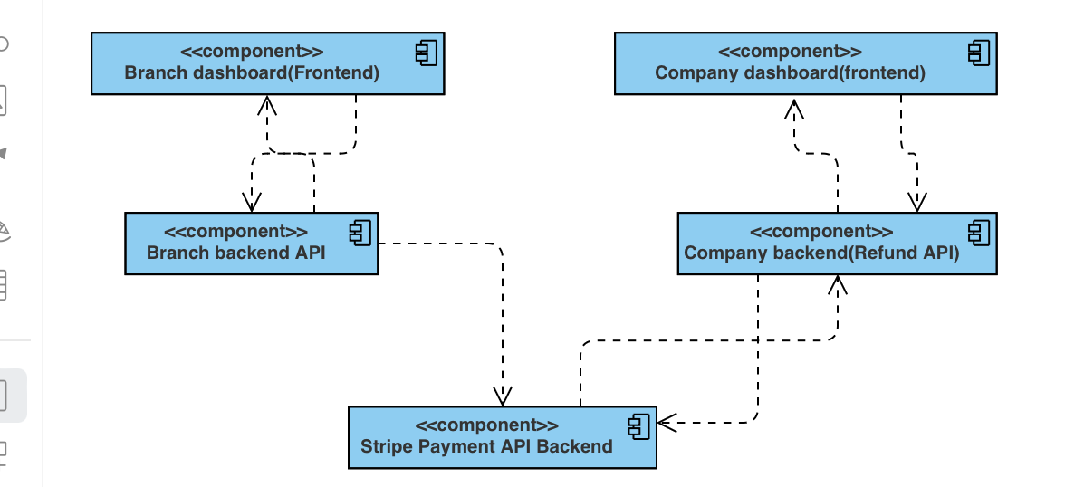

* **Branch Dashboard (Frontend):** Allows branches to initiate refund requests for defective products.
* **Company Dashboard (Frontend):** Provides a user interface for company personnel to review and process refund requests.
* **Branch Backend API:** Handles refund request submission and synchronization of inventory data with the company's system.
* **Company Backend API:** Facilitates communication between the company's backend refund system and the frontend dashboards.
* Company Backend Refund System: Manages the refund process, including verification, calculation, and interaction with the Stripe payment API.
* **Stripe Payment API:** Processes refund transactions securely, ensuring that refunded amounts are transferred to the branch's payment account.

## Use Case diagram:

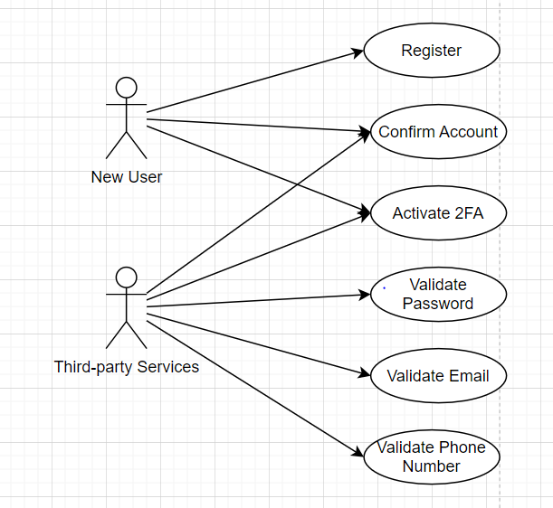

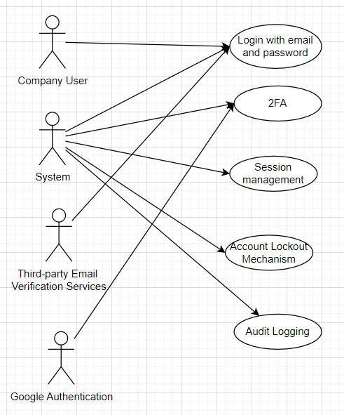

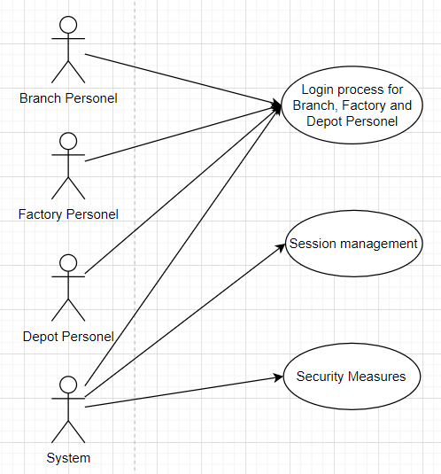

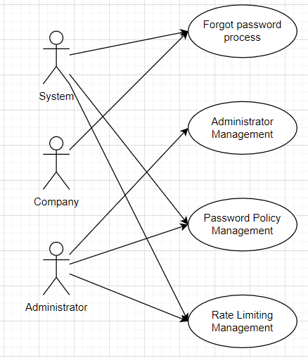

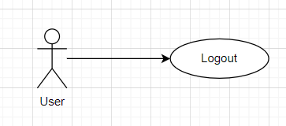

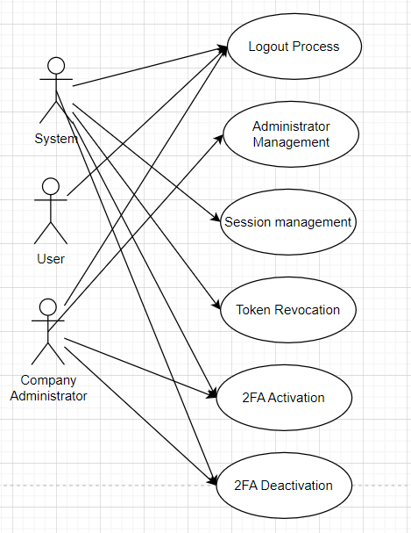

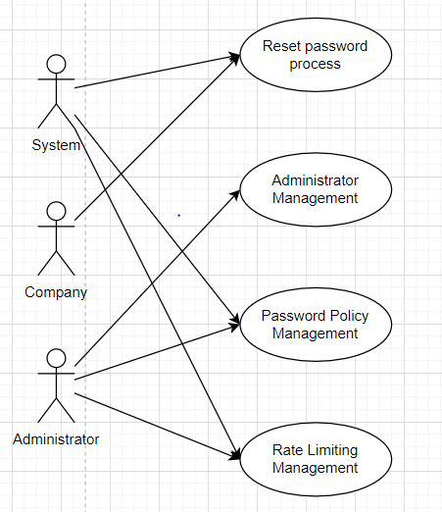

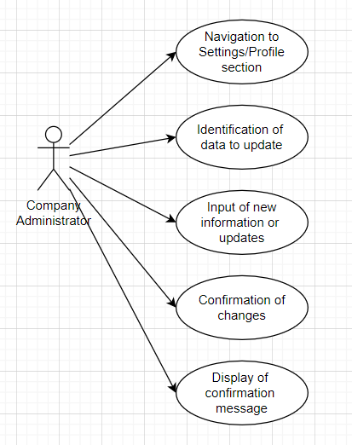

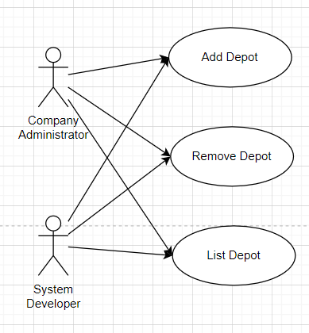

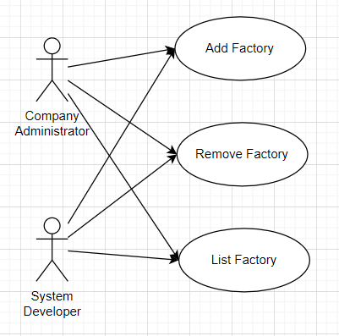

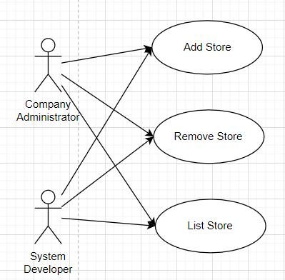

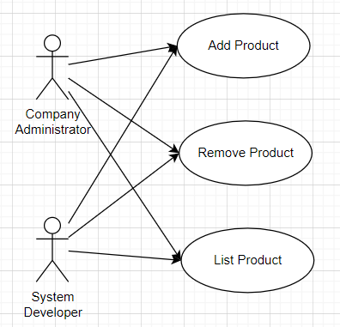

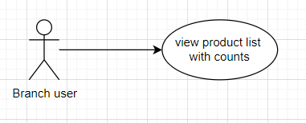

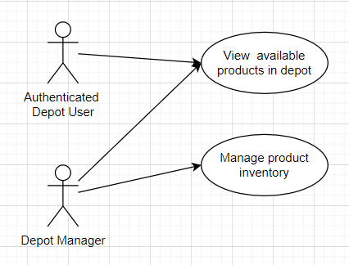

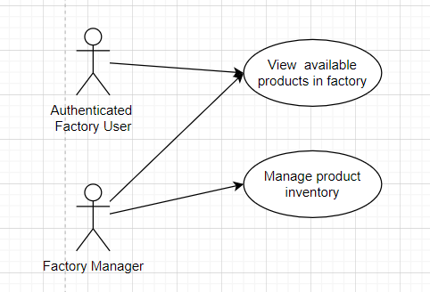

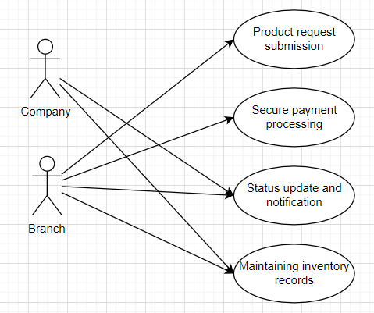

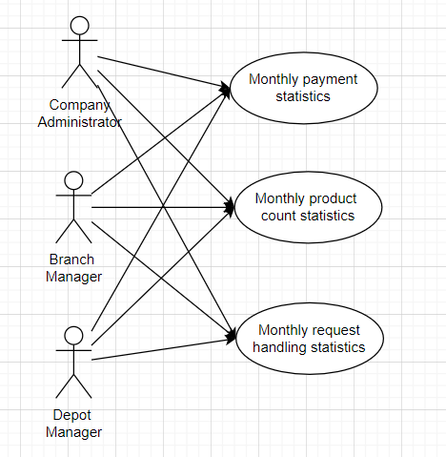

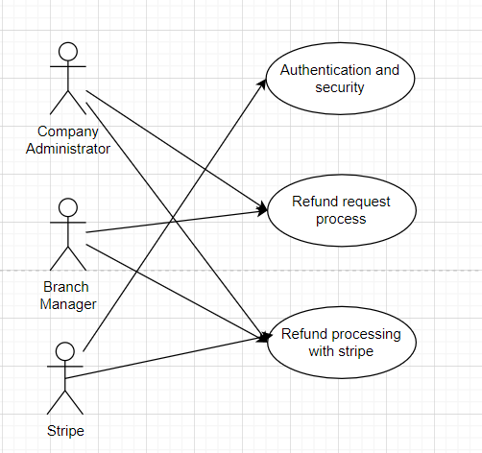

## Activity diagram:

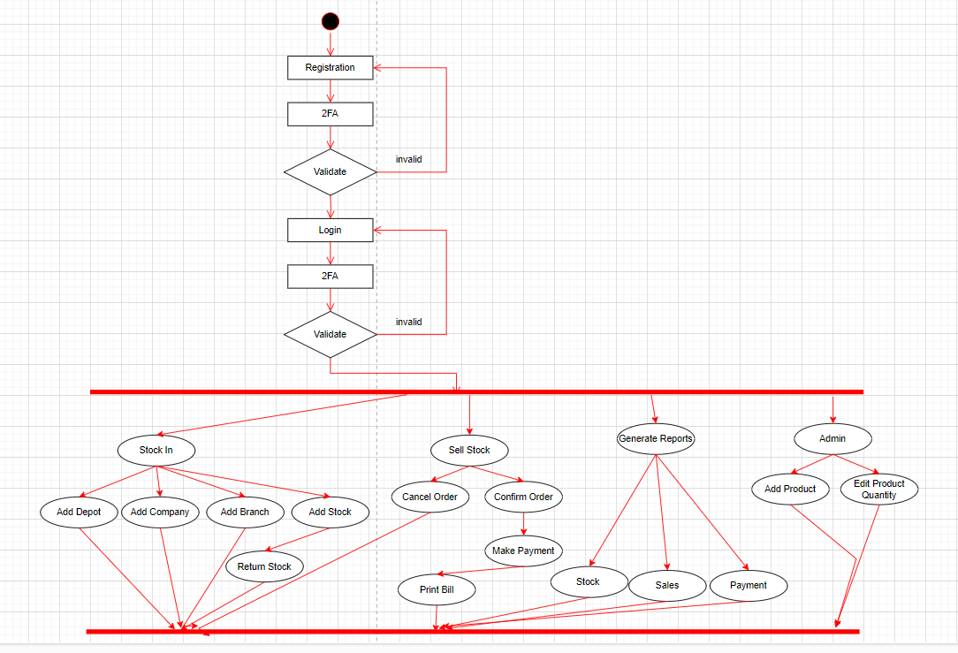

## Sequence diagram:

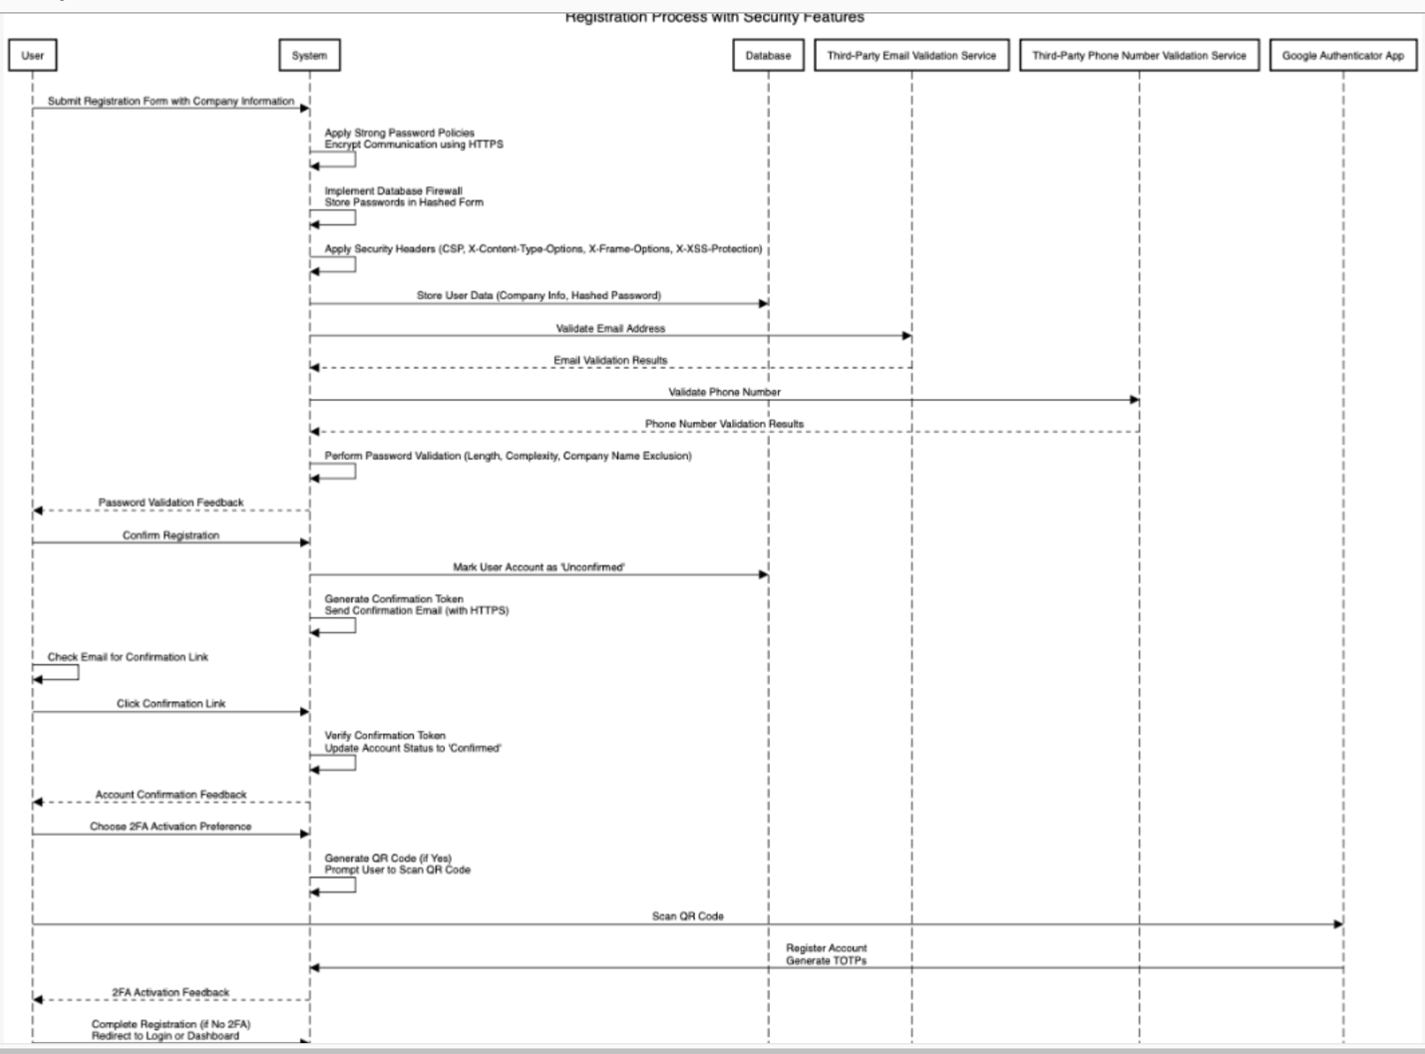

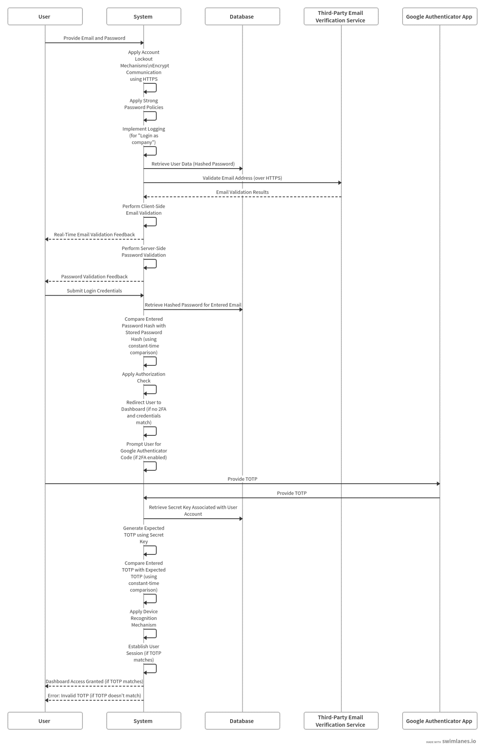

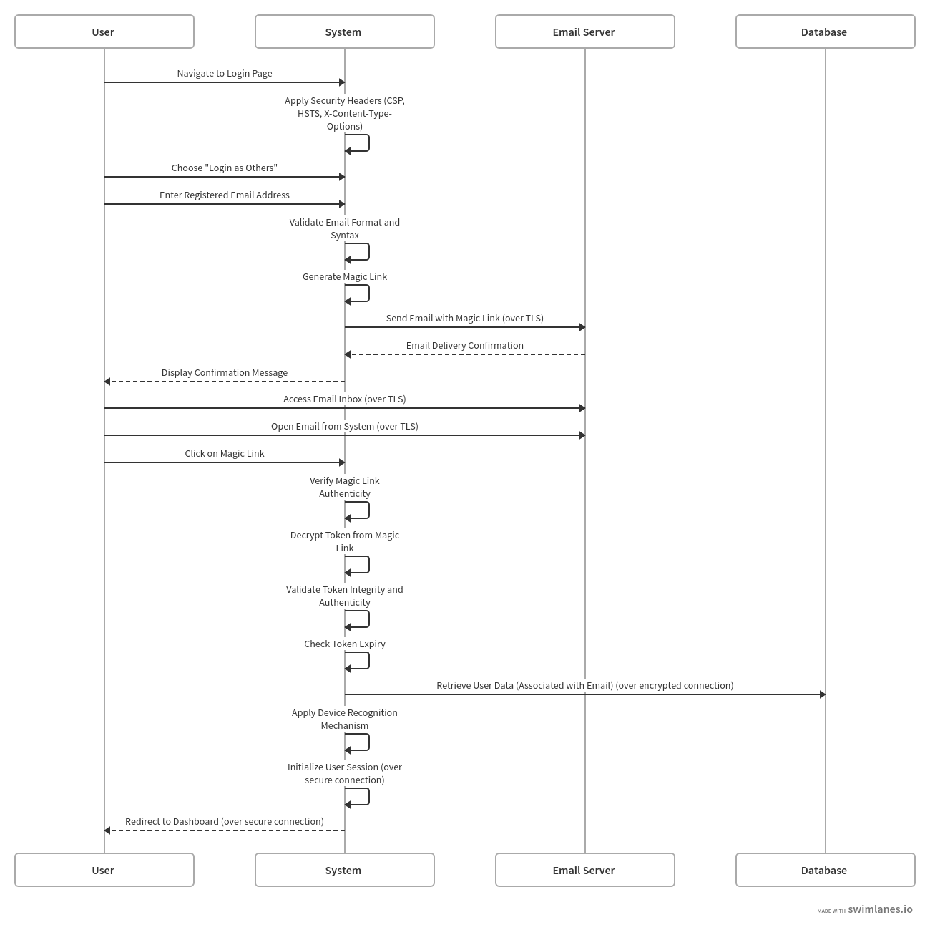

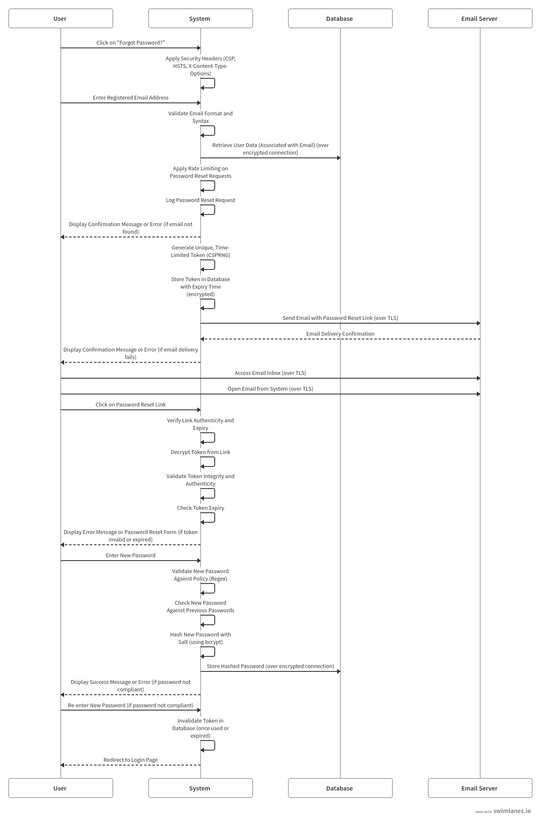

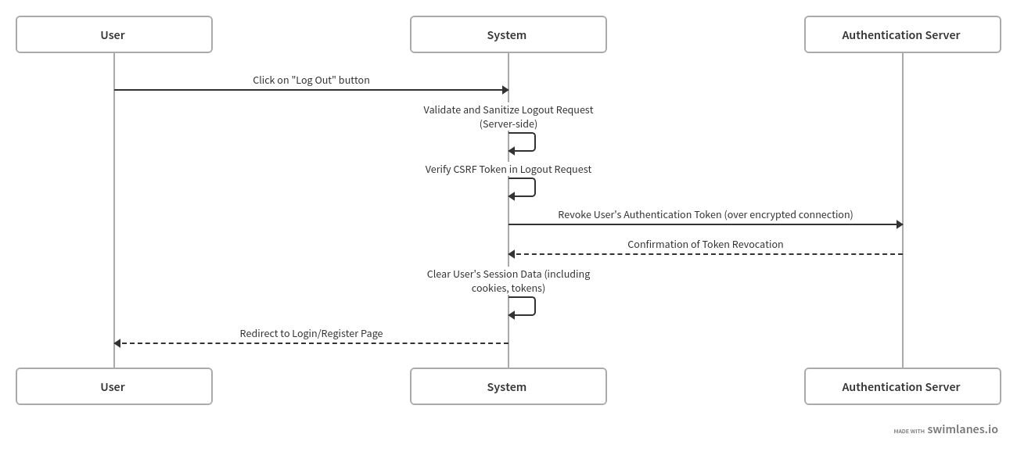

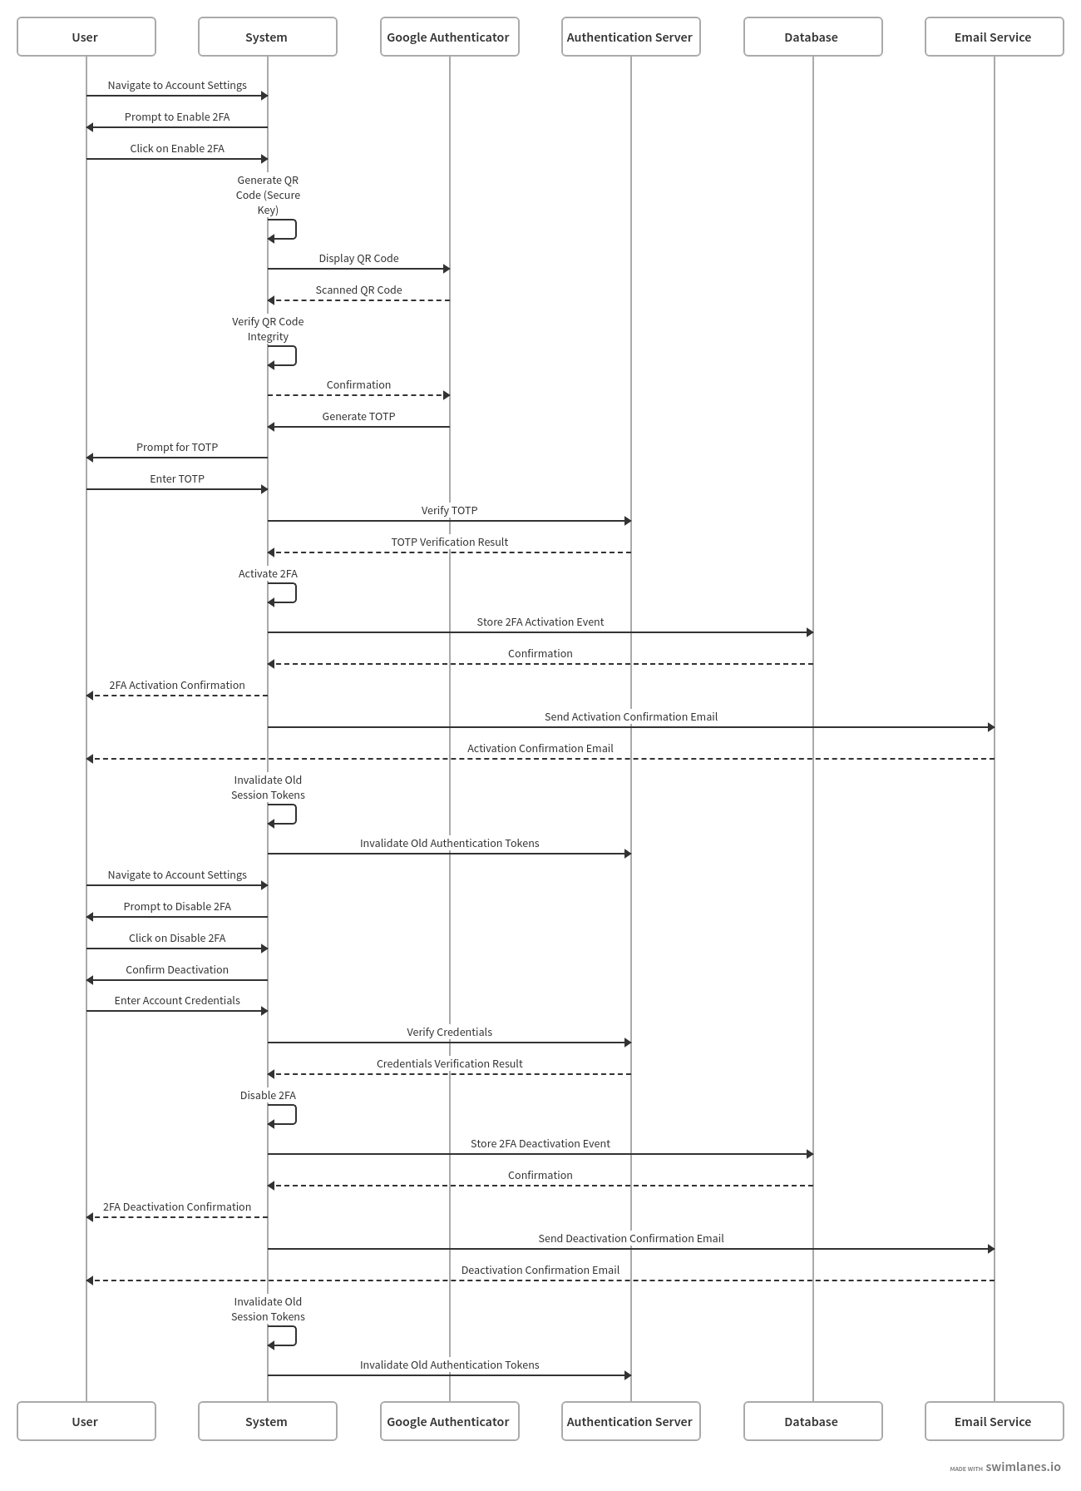

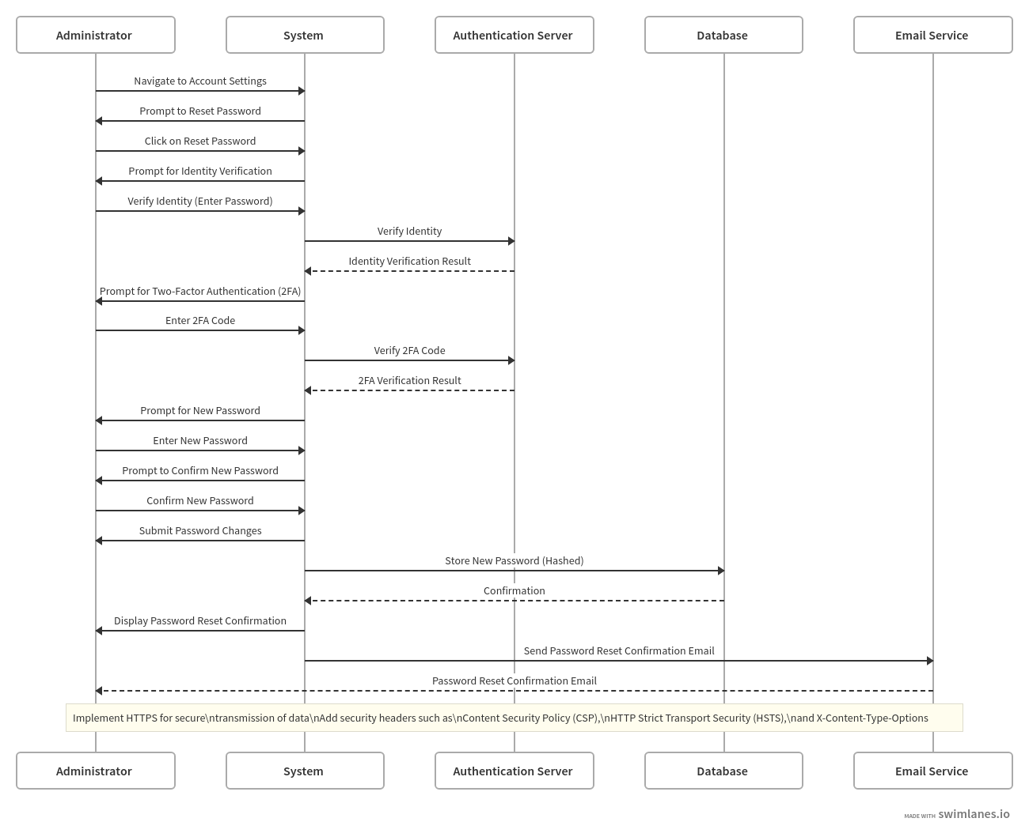

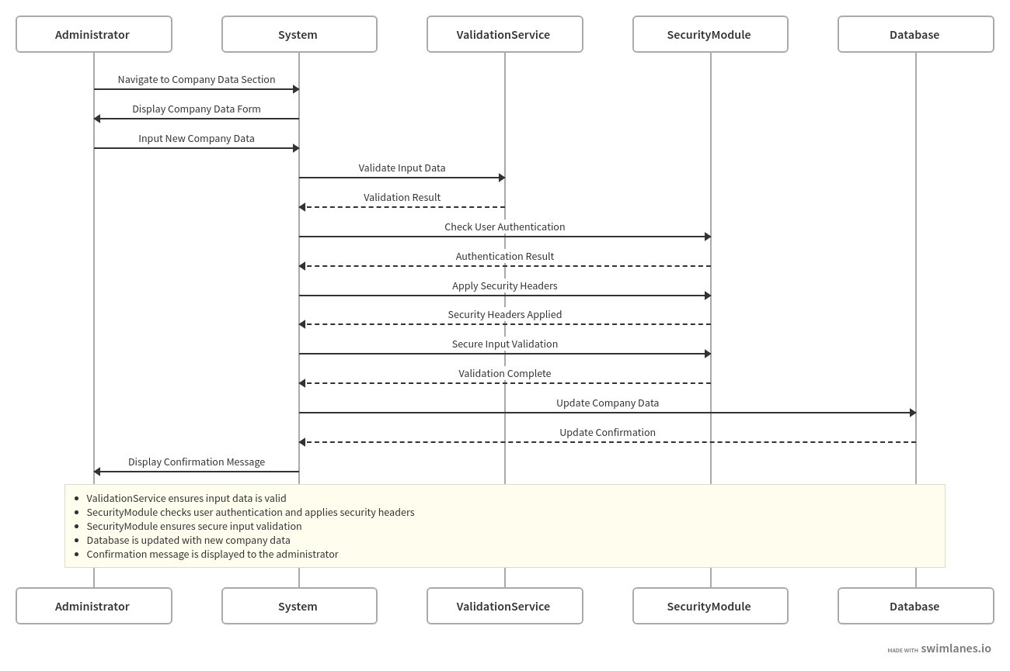

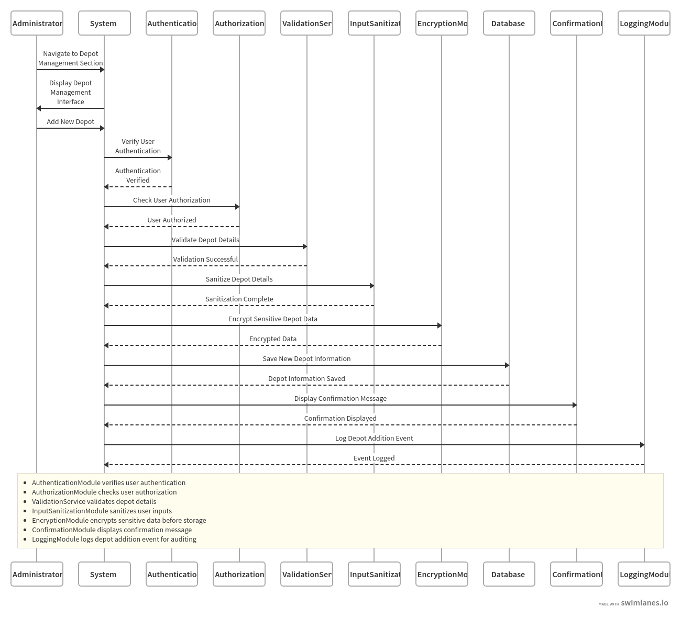

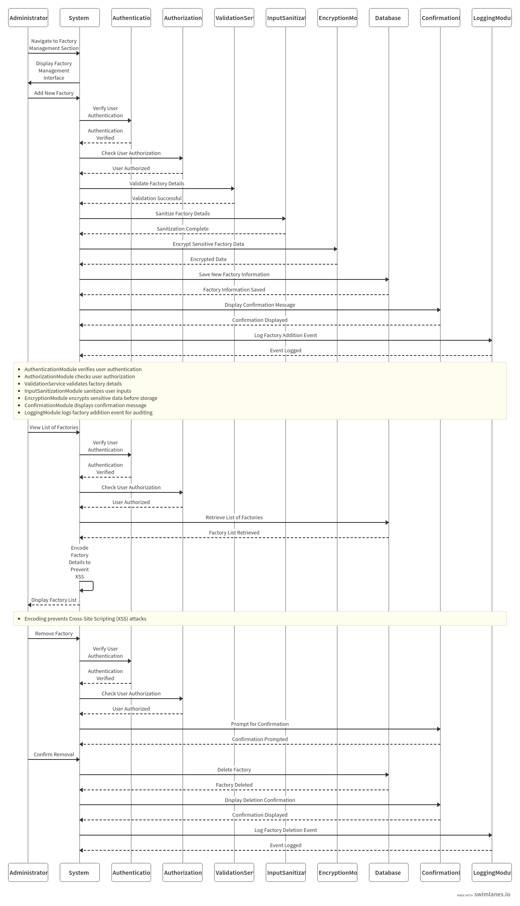

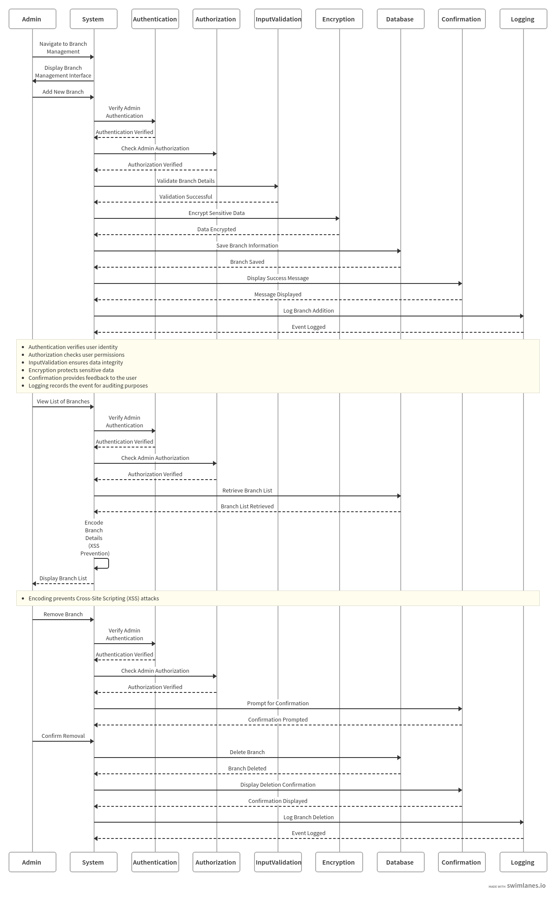

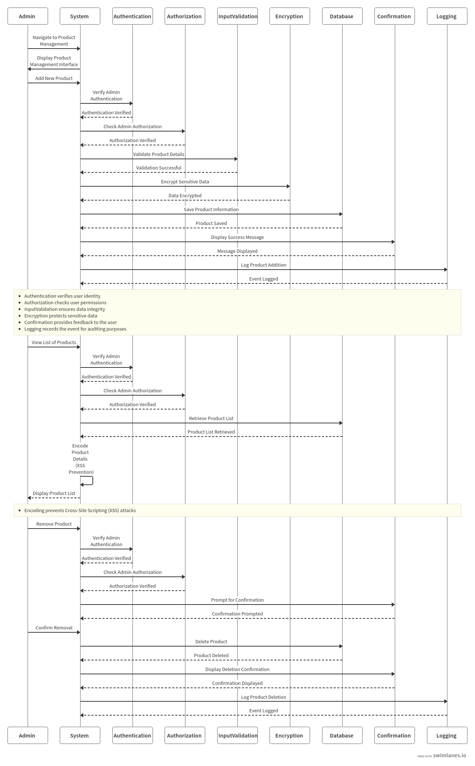

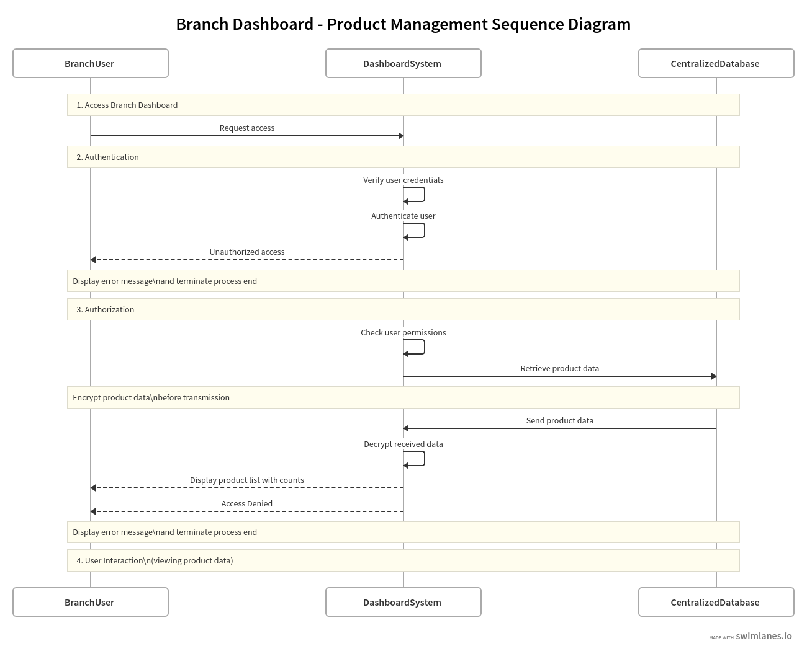

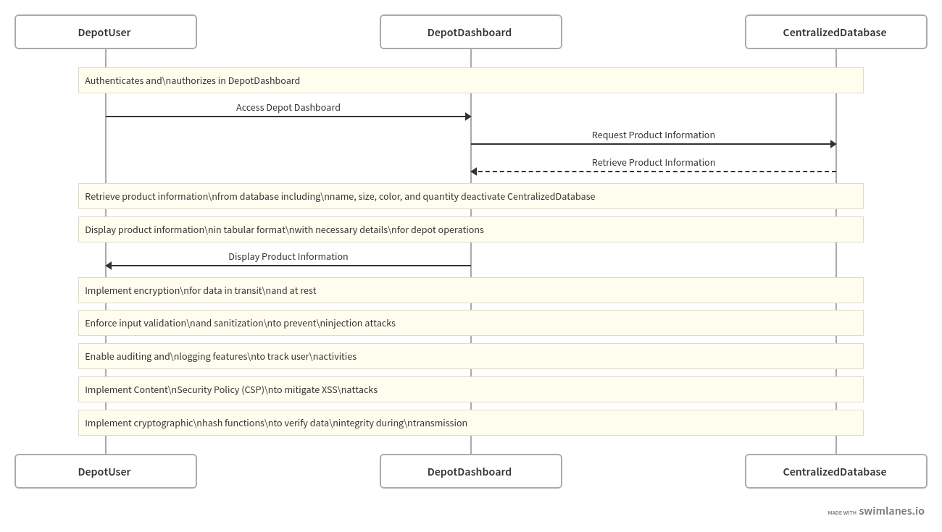

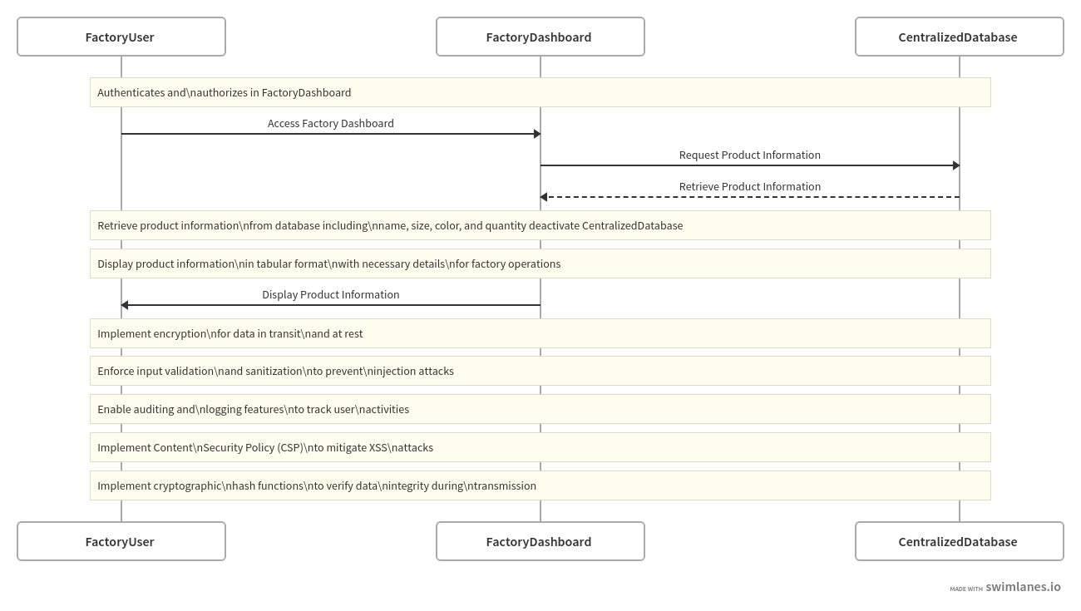

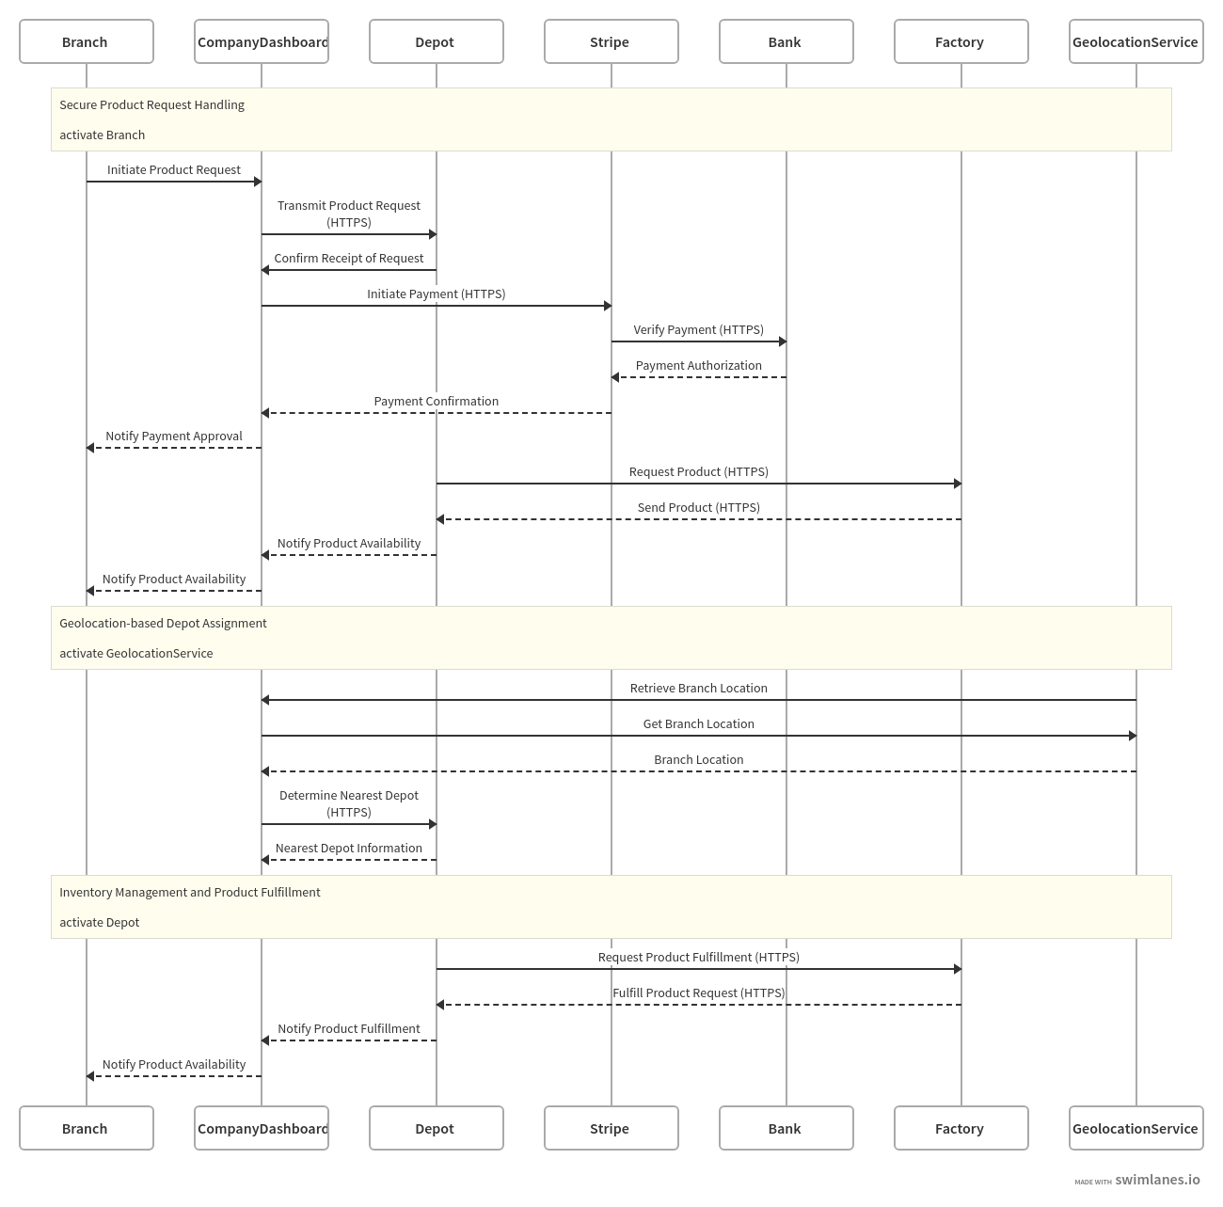

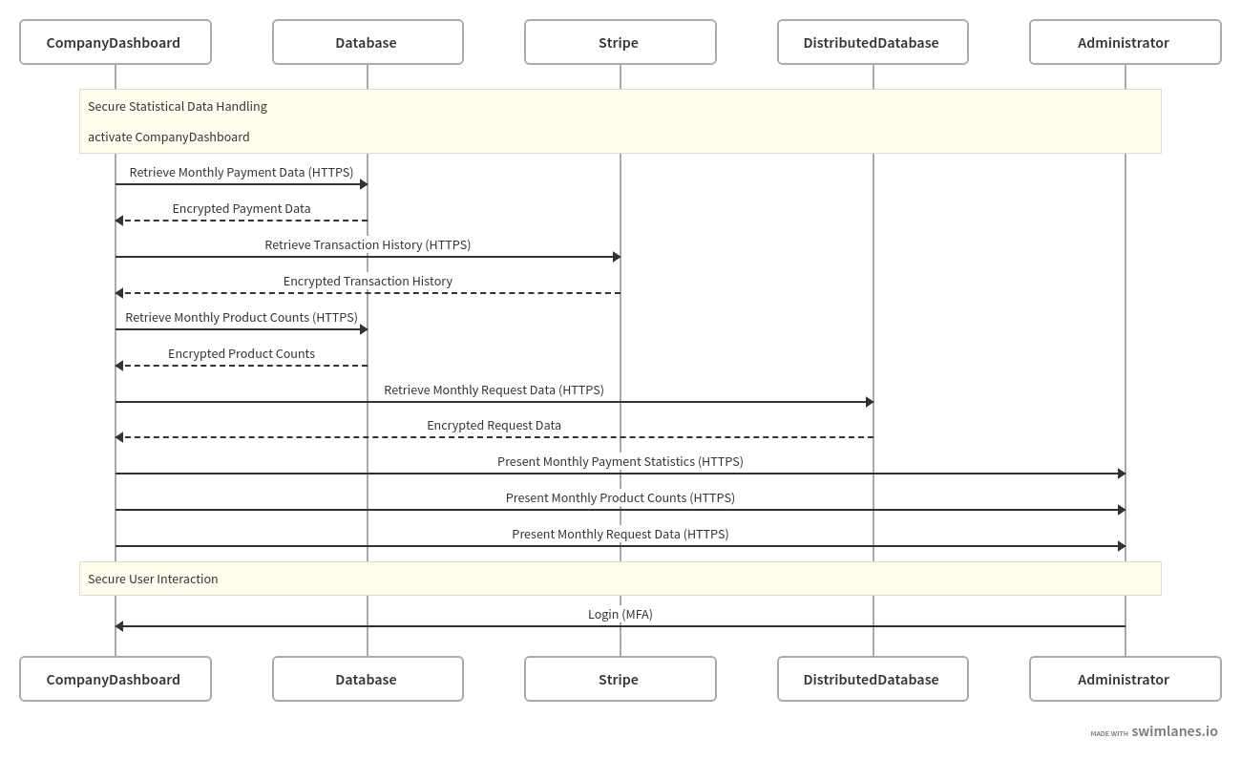

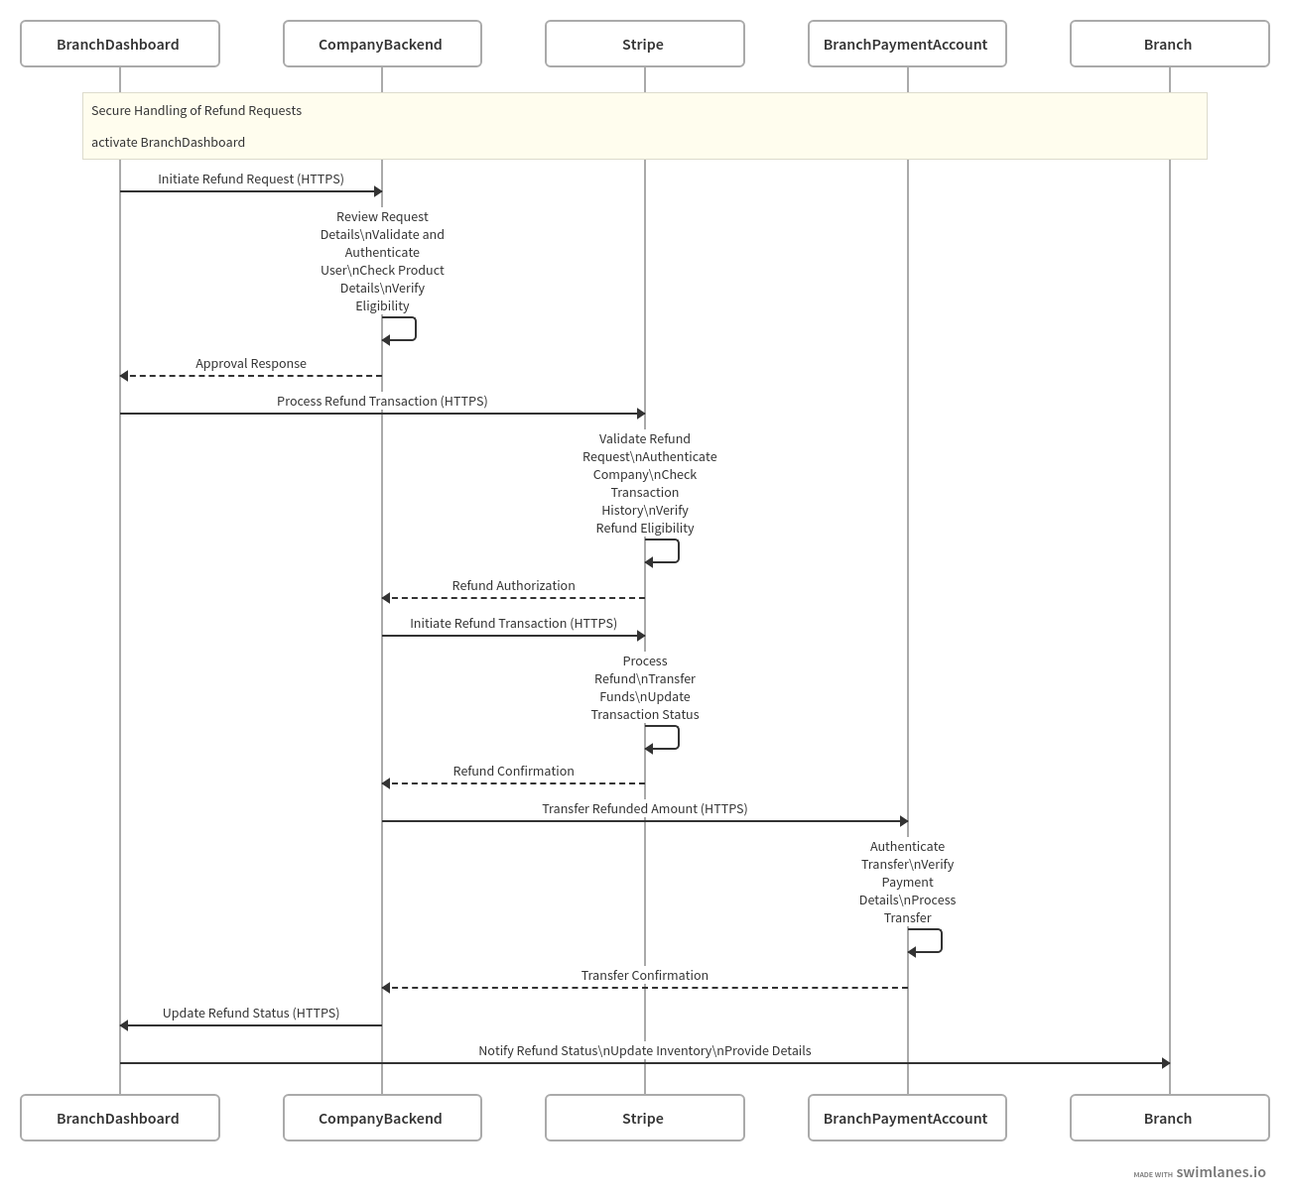

## Class diagram:

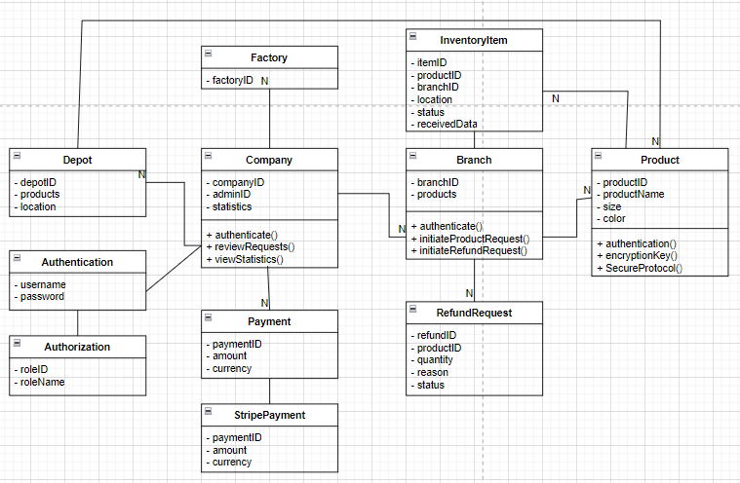

## ER diagram:

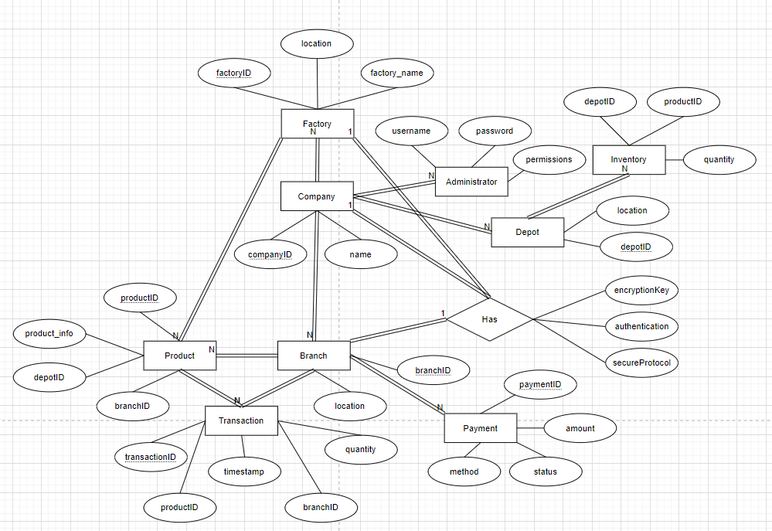

# Cryptography (encryption methods)

A complex network of several application development platforms, database management systems, systems software, and network infrastructure are all necessary for the effective operation of product management system security. To secure sensitive data during transactions, our product management web application employs several cryptographic methods and encryption protocols. These algorithms have been applied to secure database encryption, and email verification.

1. We have used HTTPS protocol for our app, which mainly uses SSL/TLS certificate to encrypt communication between the user’s web browser and ecommerce server. As we have used https, data transferred between the server and user is encrypted and cannot be seen by anyone. (which prevents Man-In-The-Middle Attack). They offer several benefits, such as encryption, authentication, integrity, trust, and compliance. Encryption helps to protect data in transit from interception and eavesdropping. Authentication ensures that both the client and server are verified, which helps to prevent impersonation and unauthorized interception of data. Integrity ensures that data transmitted between the client and server is not tampered with. Trust is established using digital certificates issued by trusted Certificate Authorities (CAs) to ensure that the parties are who they claim to be. Finally, SSL/TLS helps organizations comply with regulations, such as the Payment Card Industry Data Security Standard (PCI-DSS). Overall, SSL/TLS provides a secure and reliable way to transmit data over the internet, which is essential for online transactions and other sensitive communications.

2. Employing Argon2 to hash administrator passwords is a strong security feature that emphasizes a dedication to protecting key access credentials inside corporate structures. Hashing—the process of converting passwords into irreversible, fixed-length sequences of characters—is carried out with a high level of cryptographic strength when Argon2 is utilized. This reduces the possibility of unauthorized access to vital systems and data by guaranteeing that, in the event of a data breach, the original passwords stay hidden.

Company administrators wield significant authority and access privileges within corporate infrastructures, making the security of their login credentials paramount. The decision to employ Argon2 for hashing these passwords reflects a proactive approach to fortifying the authentication mechanisms governing administrative access. Moreover, by storing these hashed passwords within a dedicated page in Appwrite, an open-source backend server renowned for expediting application development, an additional layer of security is enforced. Appwrite's robust features, including user authentication and database management, complement the encryption prowess of Argon2, fostering a holistic approach to password security.

Password management processes are made more efficient by the combination of Appwrite's password storage page and Argon2 hashing, which also strengthens the general robustness of the authentication architecture. Appwrite's centralization of password storage improves operational effectiveness and makes it easier to follow security best practices. This all-encompassing strategy not only reduces the possibility of unwanted access but also gives stakeholders assurance about the strength of the security controls put in place to protect vital business assets.

3. In our authentication part for company administrators, we've implemented Google Authenticator, leveraging the Time-Based One-Time Password (TOTP) algorithm, which is rooted in cryptography principles. This algorithm works by using a secret key that is safely held on the user's device and on the authentication server to generate time-sensitive, unique codes at regular intervals, usually every 30 seconds. The one-time code is generated using this secret key and the current time, guaranteeing that each code is distinct and only good for a short period of time. The integrity and confidentiality of the secret key and the generated codes are maintained by utilizing cryptographic techniques within the TOTP algorithm, such as hash functions and cryptographic hashing. Our authentication approach is based on a strong cryptographic foundation that provides an extra layer of protection over conventional password-based authentication techniques, hence improving security.

# Testing

## Unit testing

**Use cases:**

|  |  |  |
| --- | --- | --- |
| **Use Case ID** | **Title** | **Description** |
| UC-01 | Register new company | The process of registering a new company in the system by providing valid information. |
| UC-02 | Company login | The process of a registered company logging into the system using their credentials, with optional Two-Factor Authentication (2FA). |
| UC-03 | Login with email | The process of branch/factory/depot logging to the system with email address |
| UC-04 | Forgot password for company accounts | The process of changing password on the login page. |
| UC-05 | User logout | Confirm the logout with proper session termination. |
| UC-06 | Managing 2FA for company accounts | The process of activating or deactivating 2FA for company account. |
| UC-07 | Reset password for company accounts | Company administrators should reset their password from their account page. |
| UC-08 | Company data update | Updating company-related data from company account |
| UC-09 | Depot management in company dashboard | Company administrators manage depots from their account |
| UC-10 | Factory management in company dashboard | Company administrators manage factories from their account |
| UC-11 | Branch management in company dashboard | Company administrators manage branches(stores) from their account |
| UC-12 | Product management in company dashboard | Company administrators manage products from their account |
| UC-13 | Item management in branch dashboard | Branches manages available items from their account |
| UC-14 | Item management in depot dashboard | Depots manages available items from their account |
| UC-15 | Item management in factory dashboard | Factory manages available items from their account |
| UC-16 | Order management | Responsible for handling request coming from branches |
| UC-17 | Analytics management | Company administrators could track monthly statistics |
| UC-18 | Refund management | The system is responsible for handling refund process between company and branch |

**Test cases:**

UC ID=Use case ID

TC ID=Test case ID

|  |  |  |  |  |  |  |  |
| --- | --- | --- | --- | --- | --- | --- | --- |
| **UC ID** | **TC ID** | **Test Case Title** | **Test Case Description** | **Prerequisites for Test Case Execution** | **Execution Steps** | **Expected Results** | **Result** |
| UC-01 | TC-01 | Password validation | verifies that the password validation function correctly identifies whether a password meets the specified criteria. | Password validation function implemented. | Provide a password that meets the criteria (minimum length, contains uppercase and lowercase letters, numbers). | The validation function should return true, indicating that the password is valid and the system should continue the register process. | The system continues the register process. |
| UC-01 | TC-02 | Validate email address | verifies that the email validation function correctly identifies whether an email address is valid. | Email validation function implemented | Provide invalid email address | The system should warn users to enter valid email address. | The system informs users to enter valid email address. |
| UC-02 | TC-03 | Validate password hashing | Verify that passwords are properly hashed before comparison. | Access to the login page (user should be on the login page), valid user credentials. | 1. Fill out the login form with valid credentials.  2.Submit the form | 1.Users could see the entered credentials on the login form.2. Password should be hashed before comparison with the stored hash in the database. | 1.Users s their input on the login page.2. Passwords are hashed before comparison with the stored hash in the database. |
| UC-02 | TC-04 | Validate 2FA Authentication process | Verify that Two-Factor Authentication (2FA) process works correctly. | User should be on the login page. User should have 2FA enabled. User should have Google Authenticator App installed. | 1.Fill out the login form with correct email and password.2. submit the form.3. Enter the verification code from Google Authenticator App. | 1.User could be able to look through, edit entered input before submitting on the login form.2. The system redirects to input field for Google Authenticator code.3.The system should check the validity of the code. | 1.User can see, edit entered input before submitting on the login form.2. The system redirects to input field for Google Authenticator code.3.The system checks the validity of the code. |
| UC-03 | TC-05 | Validate email format on the login page. | Verify that the email entered on the login page follows the correct format. | User should be on the login page. | 1. Navigate to the “Login as others” page. 2. Enter an email address with incorrect format | 1.The system should open “Login as others” page.2. An error message should be displayed indicating that the email format is incorrect. | 1.The system redirects “Login as others” page.2. An error message is displayed indicating that the email format is incorrect. |
| UC-03 | TC-06 | Validate Error Handling for Invalid Token | Ensure that appropriate error message is displayed for invalid or expired tokens. | Access to the magic link authentication page, invalid token. | Click on the magic link from an expired or invalid email. | An error message should be displayed indicating that the token is invalid or expired. | An error message is displayed indicating that the token is invalid . |
| UC-04 | TC-07 | Validate Password Policy Enforcement Functionality | Test whether the password policy enforcement function correctly enforces password strength requirements. | User should be registered on the system and access to the forgot password page. | 1. Input the previously used password.  2.Input the password that is listed most known password list. | 1. The function should return false for passwords not meeting policy requirements.2. The function should return false for passwords not meeting policy requirements. | 1. An error message is displayed indicating that the password do not meet policy requirements.2. An error message is displayed indicating that the password do not meet policy requirements. |
| UC-04 | TC-08 | Validate Password Hashing Functionality | Test whether the password hashing function correctly hashes passwords. | Plain text passwords | Navigate to forgot password page and .input plain text passwords into the password hashing function. | The function should return a hashed representation of the input password. | Appwrite hashes the password |
| UC-05 | TC-09 | Validate Redirection After Logout | Test whether the server redirects the user to the login/register page after successful. | Active user session. | 1. Simulate a logout action by pressing Logout button on account page. | The server should redirect the user to the login/register page. | The server redirects the user to the login/register page. |
| UC-06 | TC-10 | Validate Confirmation Prompt for Deactivation | Test whether the system prompts the user to confirm their intention to deactivate 2FA. | Logged-in company administrator with 2FA already activated. | 1. Navigate to account management.  2.Click 2FA deactivation/activation toggle to deactivate 2FA. | 1.The system should redirect user to account management page.2. The system should display a confirmation prompt asking the user to confirm their intention to deactivate 2FA. | 1.The system redirects  user to account management page.2. The system does not display a confirmation prompt asking the user to confirm their intention to deactivate 2FA. |
| UC-07 | TC-11 | Validate Confirmation Message for Password Reset | Test whether the system displays a proper confirmation message after a successful password reset. | Password reset process completed successfully. | Confirm the password reset process. | The system should display a generic confirmation message indicating that the password reset was successful, without revealing specific details about the reset process. | The system displays a generic confirmation message indicating that the password reset was successful. |
| UC-08 | TC-12 | Validate Updating Company Name | Test whether the system allows the administrator to update the company name. | Logged-in company administrator. | 1. Navigate to the settings or profile section for managing company-related data.  2.Update the company name with a new value.  3. Save or update the changes. | 1.The system should redirect the user to account info page.2. The user should be able to see updated company name on the input field.  3.The system should display new value as a company name | 1.The system redirects the user to account info page.2. The user sees updated company name on the input field.  3.The system displays new value as a company name |
| UC-09 | TC-13 | Validate Listing All Depots | Test whether the system allows the company administrator to list all existing depots. | Logged-in company administrator. | 1.Navigate to the depot management section within the account dashboard.  2.Select the option to list all existing depots. | 1.The system should redirect user to depot management.2. The should retrieve and display the list of depots along with their respective details (name, email address, location). | 1.The system redirects user to depot management.2. The system retrieves and displays the list of depots along with their respective details (name, email address, location). |
| UC-09 | TC-14 | Validate Removing a Depot | Test whether the system allows the company administrator to remove a depot from the database. | Logged-in company administrator. | 1.Navigate to the depot management section within the account dashboard.2. Select the option to remove a depot.3.Confirm he intention to remove the depot. | 1.The system should redirect user to depot management.  2.The system should ask whether they would like to remove the depot or not.3.Once confirmed, the should successfully delete the selected depot from the database and A confirmation message indicating the successful removal of the depot should be displayed. | 1.The system redirects user to depot management.  2.The system asks whether they would like to remove the depot.3.Once confirmed, the system deletes the selected depot from the database . |
| UC-10 | TC-15 | Validate Adding a New Factory | Test whether the system allows the company administrator to add a new factory. | Logged-in company administrator. | 1.Navigate to the factory management section within the account dashboard.2.Select the option to add a new factory.3.Enter necessary details for the new factory, such as email address, password, and location.4.Submit the factory details. | 1.The system should redirect the users factory management dashboard.2.The system should provide the users the form where they should enter factory details.3.After entering factory details,users should see and change factory details on the input form.4.The system should successfully save the new factory information to the database and a confirmation message indicating the successful addition of the factory should be displayed. | 1.The system redirects the users factory management dashboard.2.The system provides the users the form where they should enter factory details.3.After entering factory details,users see and change factory details on the input form.4.The system saves the new factory information to the database. |
| UC-11 | TC-16 | Validate Listing All Branches | Test whether the system allows the company administrator to list all existing branches. | Logged-in company administrator. | 1.Navigate to the branch management section within the account dashboard.  2.Select the option to list all existing branches. | 1.The system should redirect user to branch management.2. The should retrieve and display the list of branches along with their respective details (name, email address, location). | 1.The system redirects user to branch management.2. The retrieves and displays the list of branches along with their respective details (name, email address, location). |
| UC-12 | TC-17 | Validate Removing a Product | Test whether the system allows the company administrator to remove a product from the database. | Logged-in company administrator. | 1.Navigate to the product management section within the account dashboard.2. Select the option to remove a product .3.Confirm he intention to remove the product. | 1.The system should redirect user to product management.  2.The system should ask whether they would like to remove the product or not.3.Once confirmed, the system should successfully delete the selected product from the database and A confirmation message indicating the successful removal of the product should be displayed. | 1.The system redirects user to product management.  2.The system asks  whether they would like to remove the product .3.Once confirmed, the system deletes the selected product from the database. |
| UC-13 | TC-18 | Validate Retrieval of Product List with Counts | Test whether the system retrieves the list of products along with their counts from the centralized database and displays them on the branch dashboard. | Logged-in branch user with appropriate permissions. | 1.Navigate to item management in branch dashboard.  2.Verify that the product list along with their counts is displayed. | 1.The system should redirect users to item management dashboard.2. The system should successfully retrieve and display the list of products with their counts specific to the branch. | 1.The system redirects users to item management dashboard.2. The system retrieves and displays the list of products with their counts specific to the branch. |
| UC-14 | TC-19 | Validate Retrieval of Item List with Counts | Test whether the system retrieves the list of products along with their counts from the centralized database and displays them on the depot dashboard. | Logged-in depot user with appropriate permissions. | 1.Navigate to item management in depot dashboard.  2.Verify that the product list along with their counts is displayed. | 1.The system should redirect users to item management dashboard.2. The system should successfully retrieve and display the list of products with their counts specific to the depot. | 1.The system redirects  users to item management dashboard.2. The system retrieves and displays the list of products with their counts specific to the depot. |
| UC-15 | TC-20 | Validate Retrieval of Item List with Counts | Test whether the system retrieves the list of products along with their counts from the centralized database and displays them on the factory dashboard. | Logged-in factory user with appropriate permissions. | 1.Navigate to item management in factory dashboard.  2.Verify that the product list along with their counts is displayed. | 1.The system should redirect users to item management dashboard.2. The system should successfully retrieve and display the list of products with their counts specific to the factory. | 1.The system redirects users to item management dashboard.2. The system retrieves and displays the list of products with their counts specific to the factory. |
| UC-16 | TC-21 | Validate Payment Processing | Test whether the system successfully integrates with Stripe for secure payment processing. | Payment initiation | 1.initiate a payment transaction with valid payment details.  2.Attempt to initiate a payment transaction with invalid or incomplete payment details. | 1. valid payment transactions should be processed successfully, and payment confirmation should be received from Stripe.2.  Invalid or incomplete payment transactions should be rejected, and appropriate error messages should be displayed. | 1. valid payment transactions are processed and payment confirmation should be received from Stripe.2.  Invalid or incomplete payment transactions are rejected, and appropriate error messages are displayed. |
| UC-17 | TC-22 | Validate Product Count Statistics Retrieval | Test whether product count statistics are retrieved accurately from the distributed database. | Access to product count statistics feature. | Retrieve product count statistics for a specific month. | Product count statistics should be retrieved accurately, and the data should match the distribution records stored in the distributed database. | Product count statistics is retrieved |
| UC-18 | TC-23 | Validate Product Count Synchronization | Test whether the branch dashboard synchronizes the product count after a refund is processed. | Access to product count synchronization feature | 1.Process a refund request successfully.2. Trigger an update to the branch dashboard to synchronize the product count and reflect the reduction in inventory. | 1.The system should indicate that the process is successful.2. The branch dashboard should receive updated product count data from the company's system and display the revised inventory level accurately. | 1.The system indicates that the process is successful.2. The branch dashboard receives updated product count data from the company's system and displays the revised inventory level accurately. |

## Integration test:

**Use cases:**

|  |  |  |
| --- | --- | --- |
| **Use Case ID** | **Title** | **Description** |
| UC-01 | New user registration | A new user (company) registers by providing valid information, including company details, email address, password, and optionally activating Two-Factor Authentication (2FA). |
| UC-02 | Company login | Registered companies should be able to log in using their email and password, with optional Two-Factor Authentication (2FA) activation. |
| UC-03 | Branch, depot, factory login | Branches, factories, and depots personnel should be able to log in using only their registered and verified email address. |
| UC-04 | Forgot password for company accounts | The process of changing password on the login page. |
| UC-05 | User logout | Confirm the logout with proper session termination. |
| UC-06 | Managing 2FA for company accounts | The process of activating or deactivating 2FA for company account. |
| UC-07 | Reset password for company accounts | Company administrators should reset their password from their account page. |
| UC-08 | Company data update | Updating company-related data from company account |
| UC-09 | Depot management in company dashboard | Company administrators manage depots from their account |
| UC-10 | Factory management in company dashboard | Company administrators manage factories from their account |
| UC-11 | Branch management in company dashboard | Company administrators manage branches(stores) from their account |

**Test cases:**

UC ID=Use case ID

TC ID=Test case ID

|  |  |  |  |  |  |  |  |
| --- | --- | --- | --- | --- | --- | --- | --- |
| **UC ID** | TC ID | **Test Case Title** | **Test Case Description** | **Prerequisites for Test Case Execution** | **Execution Steps** | **Expected Results** | **Result** |
| UC-01 | TC-01 | Validate New user registration process | Ensure that new user registration process functions correctly, including secure handling of user data and optional 2FA activation. | Access to registration form | 1.Fill out the registration form with valid company information, email, pas.  2.Click the submit form.  3.Activate 2FA | 1.All form fields are filled correctly without any errors.2.Data is sent securely to the server via HTTPS and stored in database 3.The user will be provided QR code for scanning it for Google Authenticator App | 1.All form fields are filled correctly without any errors.2.Data is sent securely to the server via HTTPS and stored in database 3.The user is be provided QR code for scanning it for Google Authenticator App |
| UC-02 | TC-02 | Validate company login process | Ensure that the company login process functions correctly, including secure handling of credentials and optional 2FA authentication. | Access to company login form.  Access  to Google Authenticator App for TOTP | 1.Navigate to the login page and select "Login as company" option.2.Enter valid email and password.3,Click the login button.4.Enter TOTP(take from Google Authenticator) to the input field. | 1.The system should open “login as company” page.2.The filled input form should be displayed on the page.3The system should authenticate user and redirects the user the page where TOTP should be entered.4.The system should authenticate user 2nd time and redirect to dashboard | 1.The system redirects “login as company” page.2.The filled input form is displayed on the page.3The system authenticates user and redirects the user the page where TOTP should be entered.4.The system authenticates user 2nd time and redirect to dashboard |
| UC-03 | TC-03 | Validate branch, depot, factory login | Ensure that the login process for branches, factories, and depots personnel functions correctly, allowing access only with a registered and verified email address. | Access to the login page.Access to the email inbox associated with the registered email address. | 1.Navigate to “Login as department” page  2.Enter the registered and verified email address into the designated field.3.Click on the "Request Magic Link" button.4.Authenticate with the help of magic link sent to the email. | 1. login page is displayed securely with appropriate security headers.2.The email address format is validated on the client-side.3.Upon clicking the "Request Magic Link" button, the system generates a unique and time-limited magic link associated with the email addres and sends it to the email address.4.The user clicks on the magic link within the email to authenticate their login, a user session is created securely over HTTPS | 1. login page is displayed securely with appropriate security headers.2.The email address format is validated on the client-side.3.Upon clicking the "Request Magic Link" button, the system generates a unique and time-limited magic link associated with the email addres and sends it to the email address.4.The user clicks on the magic link within the email to authenticate their login, a user session is created securely over HTTPS |
| UC-04 | TC-04 | Validate forgot password process | Ensure that the password reset process functions correctly, allowing users to reset their password securely | Access to the "Forgot Password" feature on the login page.  Access to the email inbox associated with the registered email address. | 1.Navigate to the login page and locate the "Forgot Password"2. Click on the "Forgot Password" 3. Enter the registered email address into the designated field.  4.Click on the "Submit" | 1.The system should open login page.  2.The system should redirect to forgot password page.  3.The email address should be validated on the client-side.  4.The system will send reset password link to the registered email address with instructions | 1.The system redirects  login page.  2.The system redirects to forgot password page.  3.The email address is validated on the client-side.  4.The system sends reset password link to the registered email address with instructions |
| UC-05 | TC-05 | Validate logout process | Ensure that users can logout from the application securely, and all session data associated with the user's session is cleared from the server-side. | Active session logged in to the application. | 1.Navigate to the user profile or navigation menu.  2.Click on the "Logout" button or equivalent option. | 1.The "Logout" button or equivalent option is accessible from the user profile or navigation menu.  2.Upon clicking the "Logout" button, a request is sent to the server to initiate the logout process,  the server clears all session data associated with the user's session and redirects user to login/register page | 1.The "Logout" button or equivalent option is accessible from the user profile or navigation menu.  2.Upon clicking the "Logout" button, a request is sent to the server to initiate the logout process,  the server clears all session data associated with the user's session and redirects user to login/register page |
| UC-06 | TC-06 | Activate 2FA(Two-factor authentication) | Ensure that company administrators can successfully activate two-factor authentication (2FA) for their account. | Company administrator logged in to their account successfully.. | 1.Navigate to the account settings section of the company dashboard.2.Select the option to enable two-factor authentication (2FA).3.Confirm the action and proceed.4.Scan the generated QR code with the Google Authenticator app.5.Enter the current Time-Based One-Time Password (TOTP) generated by the Google Authenticator app into the corresponding field on the dashboard. | 1.The system should redirect to account settings.2.The system should ask the user whether they would like to activate 2FA.3.The system will display QR code.4.The App will display TOTP.5.The system will check the validity of the TOTP and activates 2FA. | 1.The system redirects to account settings.2.The system asks the user whether they would like to activate 2FA.3.The system displays QR code.4.The App displays TOTP.5.The system checks the validity of the TOTP and activates 2FA. |
| UC-07 | TC-07 | Reset password process | Ensure that company administrators can successfully reset their password from the account dashboard. | Company administrator logged in to their account successfully. Access to the account settings section of the company dashboard. | 1. Navigate to the account settings section of the company dashboard2.Select the option to reset the password.3.Enter a new password that meets the specified requirements (e.g., minimum length, special characters).4.Submit the changes to reset the password. | 1. The system should redirect company dashboard.2.The system should open designated page for reset password.3.The system check the validity of the password.4.The system replaces the password with the new one on the database | 1. The system redirects company dashboard.2.The system opens designated page for reset password.3.The system checks the validity of the password.4.The system replaces the password with the new one on the database |
| UC-08 | TC-08 | Update company-related data | Ensure that company administrators can successfully update company-related data from the account dashboard. | Company administrator logged in to their account successfully.Access to the settings or profile section designated for managing company-related data. | 1.Navigate to the settings or profile section designated for managing company-related data.  2. Enter new information or update the existing data.3.Confirm the intention to save or update the changes. | 1.Redirect the user account info.2.The entered data should be displayed on the form 3.The system asks whether to continue to save or not. | 1.The system redirects the user account info.2.The entered input is displayed on the form 3.The system asks whether to continue to save or not |
| UC-09 | TC-09 | Update depot-related data | Ensure that company administrators can successfully update depot-related data from the account dashboard. | Company administrator logged in to their account successfully. Access to the settings or profile section designated for managing depot-related data | 1.Navigate to the settings or profile section designated for managing depot-related data.  2. Enter new information or update the existing data.3.Confirm the intention to save or update the changes. | 1.Redirect the depot management .2.The entered data should be displayed on the form 3.The system asks whether to continue to save or not. | 1.The system redirects the depot management .2.The entered input is displayed on the form 3.The system asks whether to continue to save or not |
| UC-10 | TC-10 | Update factory-related data | Ensure that company administrators can successfully update factory-related data from the account dashboard. | Company administrator logged in to their account successfully. Access to the settings or profile section designated for managing factory-related data | 1.Navigate to the settings or profile section designated for managing factory-related data.  2. Enter new information or update the existing data.3.Confirm the intention to save or update the changes. | 1.Redirect the factory management .2.The entered data should be displayed on the form 3.The system asks whether to continue to save or not. | 1.The system redirects the factory management .2.The entered input is displayed on the form 3.The system asks whether to continue to save or not |
| UC-11 | TC-11 | Update store-related data | Ensure that company administrators can successfully update factory-related data from the account dashboard. | Company administrator logged in to their account successfully. Access to the settings or profile section designated for managing branch-related data | 1.Navigate to the settings or profile section designated for managing branch-related data.  2. Enter new information or update the existing data.3.Confirm the intention to save or update the changes. | 1.Redirect the branch management .2.The entered data should be displayed on the form 3.The system asks whether to continue to save or not. | 1.The system redirects the branch management .2.The entered input is displayed on the form 3.The system asks whether to continue to save or not |

## Penetration test:

**Use cases:**

|  |  |  |
| --- | --- | --- |
| **Use Case ID** | **Title** | **Description** |
| UC-01 | New user registration | The penetration testing of the user registration system to identify and exploit vulnerabilities related to user input validation, data storage, and security measures. |
| UC-02 | Company login | The penetration testing of the user login system to identify and exploit vulnerabilities related to authentication, session management, and security measures. |
| UC-03 | Branch, depot, factory login | The penetration testing of the login system for branches, factories, and depots to ensure secure authentication and access control. |
| UC-04 | Forgot password for company accounts | the penetration testing of the "Forgot Password" feature to ensure secure password reset functionality. |
| UC-05 | User logout | The penetration testing of the logout functionality to ensure secure session management and user logout process. |
| UC-06 | Company data update | the penetration testing of the feature allowing company administrators to update company-related data in the company account dashboard |
| UC-07 | Order management | The penetration testing of the system's ability to handle product requests from branches, including secure communication, payment processing, and inventory management. |
| UC-08 | Analytics management | The penetration testing of the system's ability to provide statistics-related data on the company dashboard, focusing on payments, product counts, and requests made from branches monthly. |

**Test cases:**

UC ID=Use case ID

TC ID=Test case ID

|  |  |  |  |  |  |  |  |  |
| --- | --- | --- | --- | --- | --- | --- | --- | --- |
| **UC ID** | TC ID | **Test Case Title** | **Test Case Description** | **Prerequisites for Test Case Execution** | **Execution Steps** | **Expected Results** | **Result** | **Remediation steps** |
| UC-01 | TC-01 | Injection Vulnerability Testing | Test for injection vulnerabilities in user input fields (e.g., SQL injection, XSS). | Understanding of the user registration process and associated security measures | Input malicious SQL or XSS payloads into the registration form fields (e.g., company name, email address).  Submit the form and observe the response. | The system should not redirect user to the page that users are not allowed. | The system does not implement any malicious activity and shows invalid data related error. |  |
| UC-02 | TC-02 | Brute Force Attack Simulation | Simulate a brute force attack on the user login system. | Utilize automated tools or scripts to attempt login with a large number of password guesses.(hydra, Burp Suite) | Attempt to login with a large number of password guesses with the help of tools | should detect and respond to brute force attacks appropriately (e.g., account lockout, rate limiting). | The system stops responding to other normal requests | Device specific lockout should be implemented. Rate limiting mechanism should be applied |
| UC-03 | TC-03 | Magic Link Expiration | Test the expiration of magic links after a designated time limit. | Access to registered department’s email. | Obtain a magic link and delay its usage beyond the expiration time. Attempt to use the expired magic link for authentication. | The system should reject the expired magic link and prompt the user to initiate the login process again. | The system reject the expired the magic link |  |
| UC-03 | TC-04 | Cross-Site Scripting (XSS) Protection | Test for protection against Cross-Site Scripting attacks. | Malicious XSS payloads | Inject malicious script payloads into the login page fields.  Submit the form and observe the system response. | The system should sanitize input and prevent execution of injected scripts. | The system does not take malicious input as command. |  |
| UC-04 | TC-05 | Password Hashing and Storage | Test the hashing and storage of the new password in the database. | Registered company email | Submit a valid new password through the password reset form and monitor the system for password hashing and database storage operations. | The system should hash the new password using a strong cryptographic hashing algorithm and store the hashed password in the database securely. | The system stores passwords in Argon2 hash in Appwrite db. |  |
| UC-05 | TC-06 | Protection Against CSRF Attacks | Test the implementation of protection against Cross-Site Request Forgery (CSRF) attacks during the logout process. | Users should be logged in to their account successfully. Malicious payloads | Craft and send a malicious logout request with a spoofed CSRF token and observe the server's response to the malicious request. | System should reject the malicious logout request due to invalid or missing CSRF token. | System rejects missing CSRF token and invalid logout requests |  |
| UC-06 | TC-07 | Input Validation for Company Data Update | Test the input validation mechanism to prevent injection attacks during company data update. | Access to the company administrator account.  Malicious payloads for SQL injection and XSS attacks | Attempt to inject malicious SQL or XSS payloads into the input fields for company-related data.  Submit the form with the injected payloads. | The system should detect and reject the malicious input. | The system rejects invalid input and display error messages. |  |
| UC-07 | TC-08 | Payment Processing Security | Test the security of payment processing mechanisms, including encryption and integration with Stripe. | Wireshark for traffic tracking | Initiate a payment transaction for requested products and monitor network traffic to inspect communication between the system and Stripe. | Payment information should be encrypted during transmission and storage. | The payment data is encrypted and cannot be identified. |  |
| UC-08 | TC-09 | GDPR Compliance Check | Test the compliance of the company dashboard and statistical data handling with GDPR regulations. | Being logged in as company administrator | Review the system's privacy policy and data protection measures and verify if user consent is obtained for data collection and processing. | System should comply with GDPR regulations regarding data protection, privacy, and user consent. | Privacy policy has not been implemented | Privacy policy should be applied to the system. |

## Automated testing:

We've incorporated Cypress into our automated testing suite to cover a wide range of testing needs, including end-to-end (e2e), unit, and integration testing. With Cypress, we're able to delve deep into how our application APIs interact with each other, ensuring smooth communication and data exchange throughout our system. This robust testing approach helps us catch any potential issues early on, maintaining the reliability and functionality of our application.

Additionally, we've leveraged Cypress to check certain components of our UI, such as dark/light mode. By doing so, we ensure that our application's visual elements remain consistent and functional across different themes, providing a seamless experience for our users regardless of their preferences. Cypress has been instrumental in empowering us to conduct thorough testing across both backend API interactions and frontend UI components, ultimately enhancing the overall quality and user satisfaction of our application.

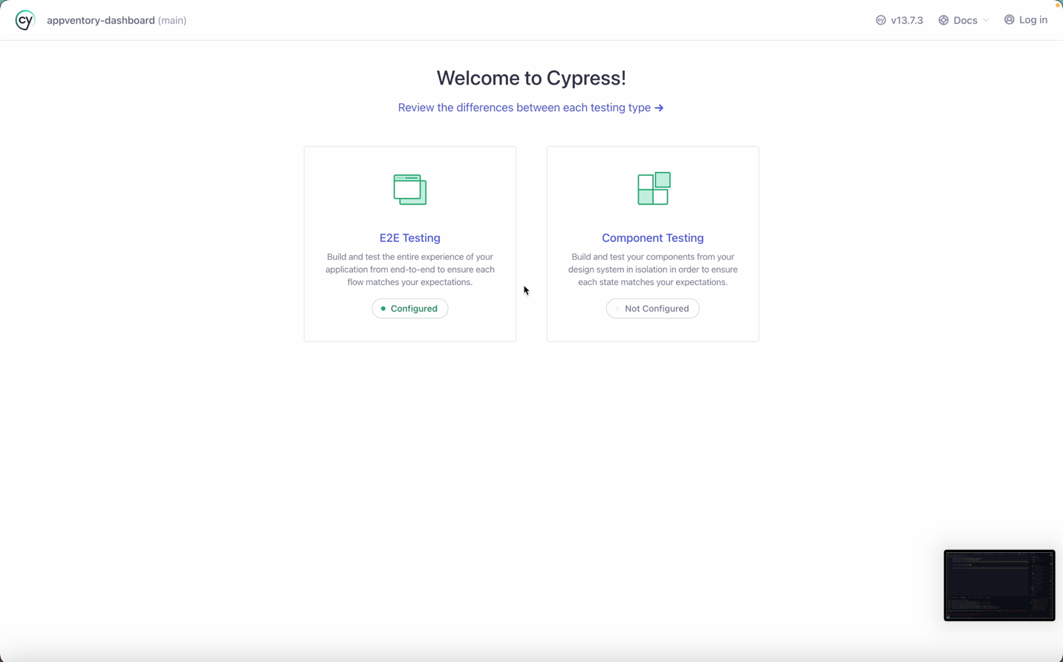

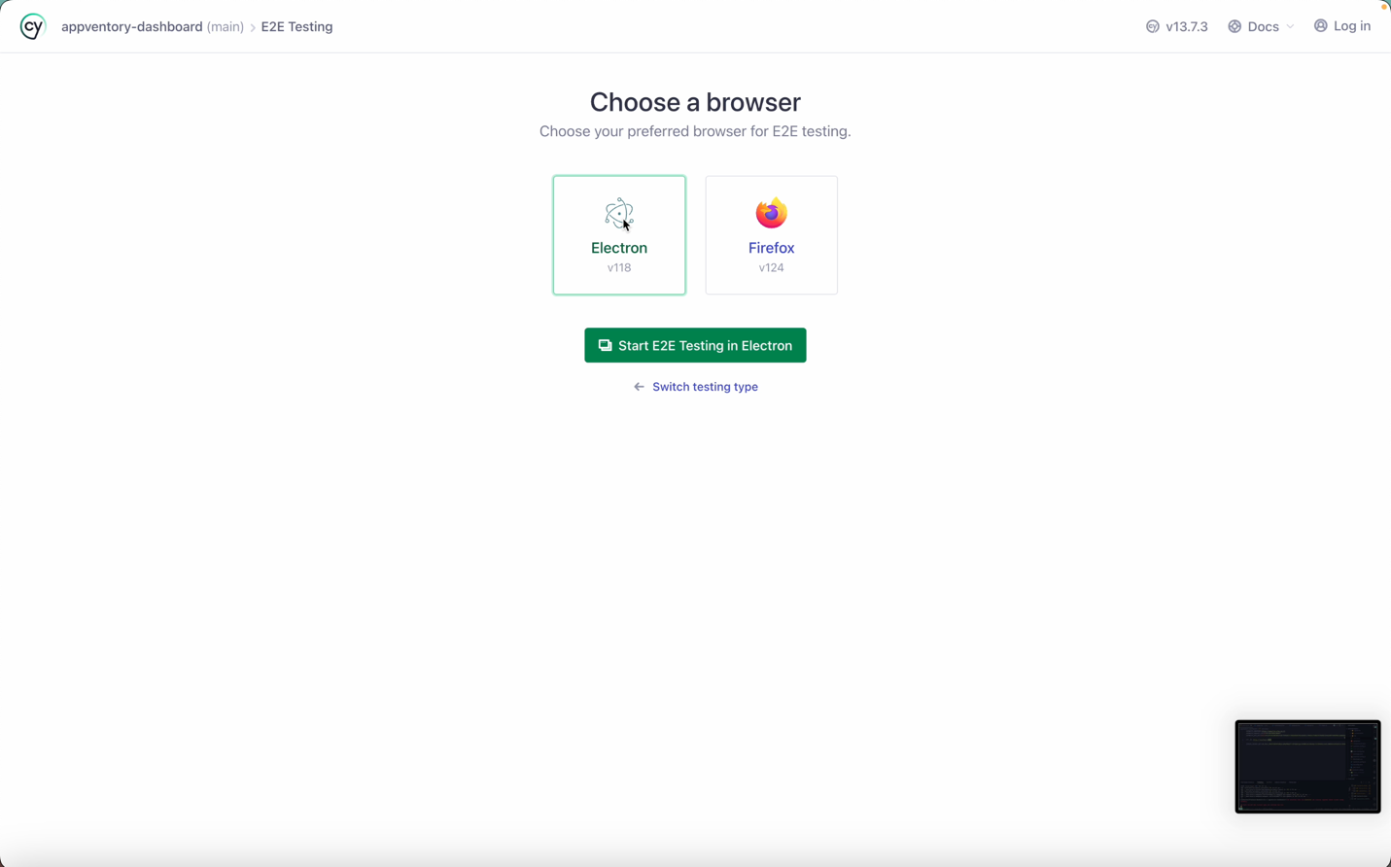

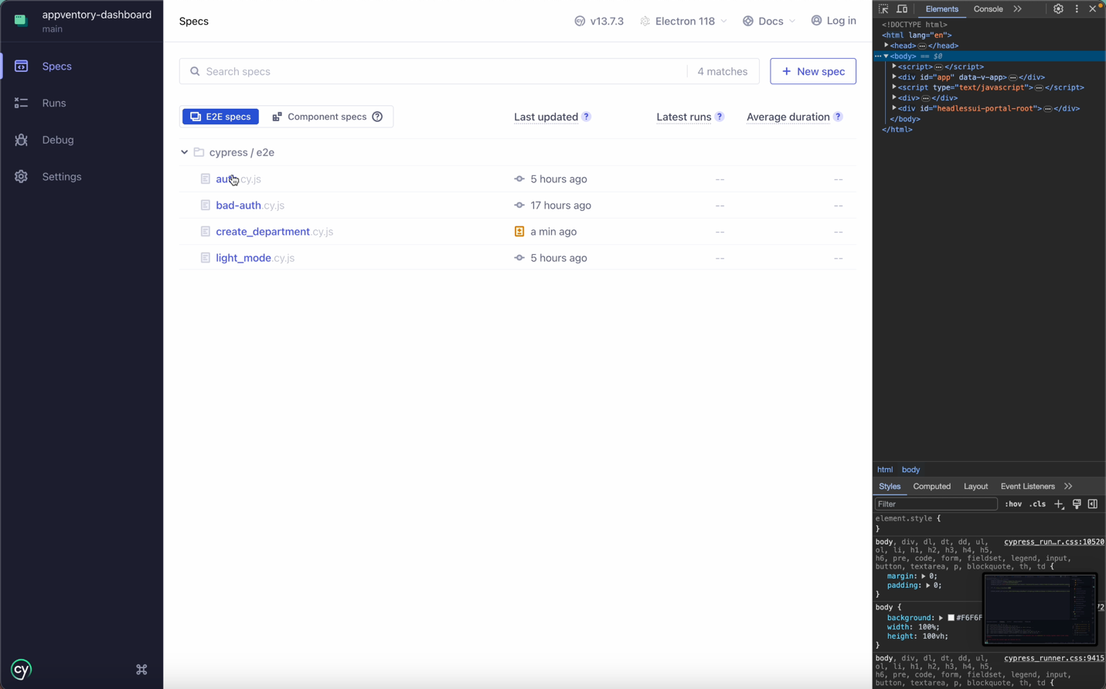

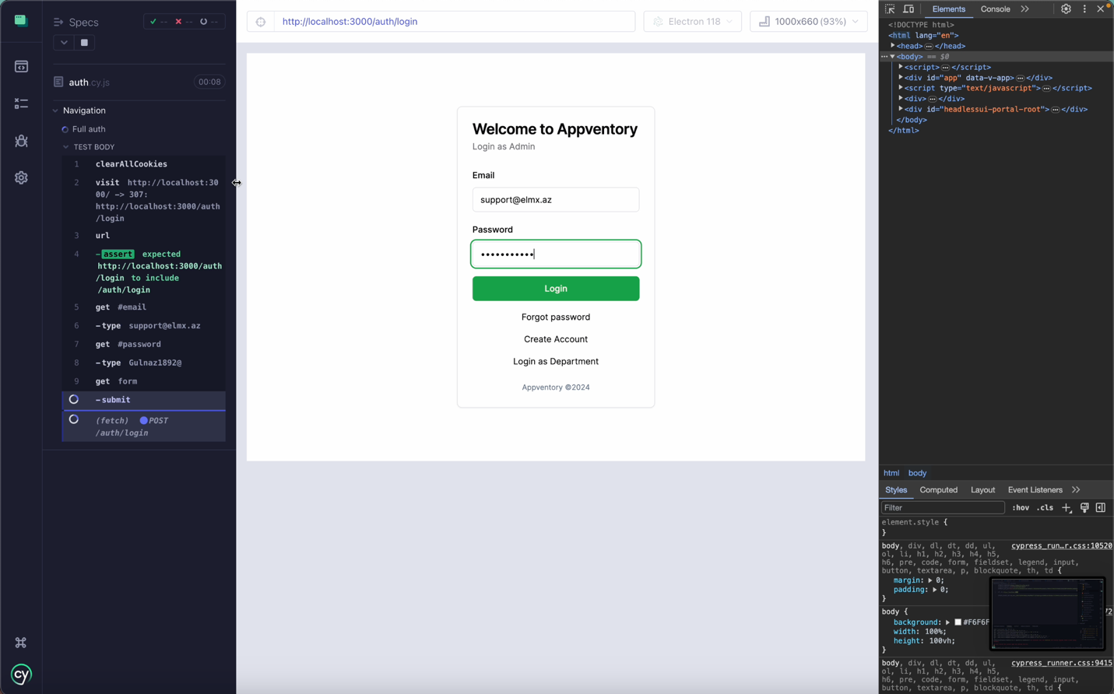

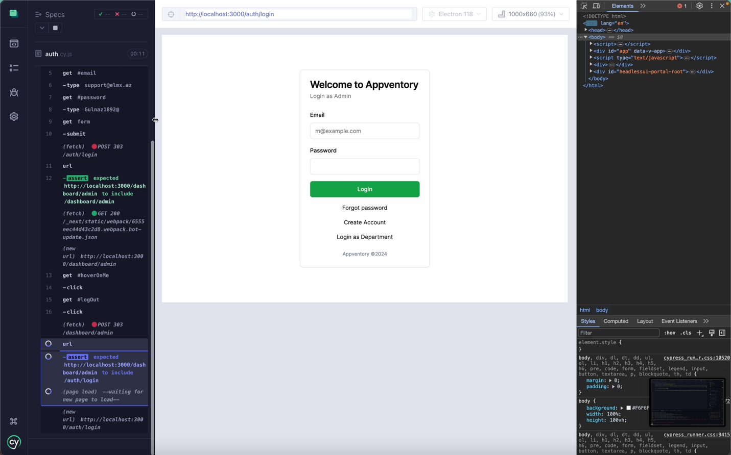

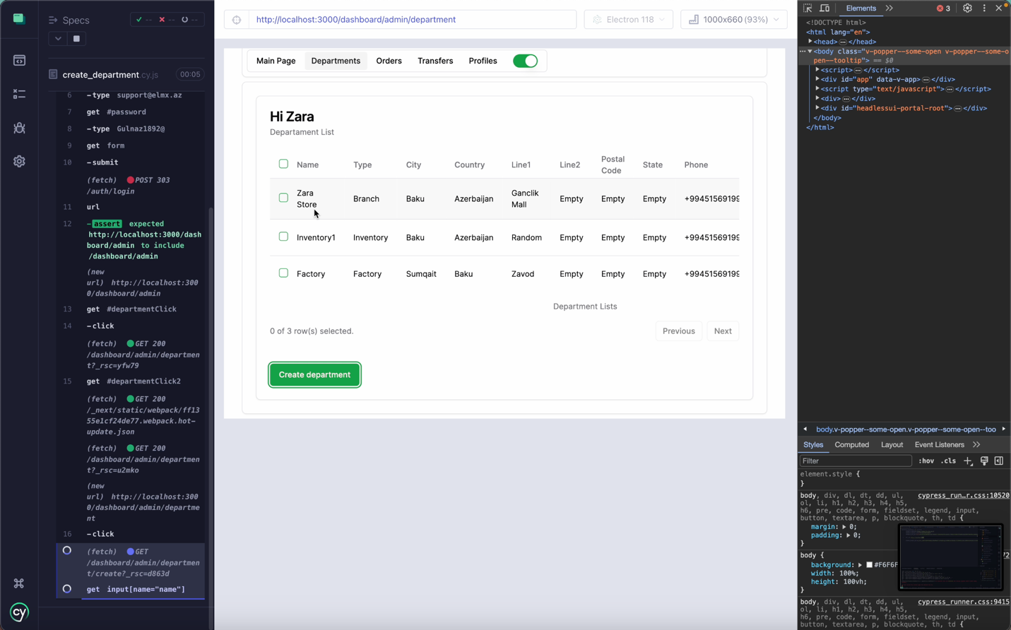

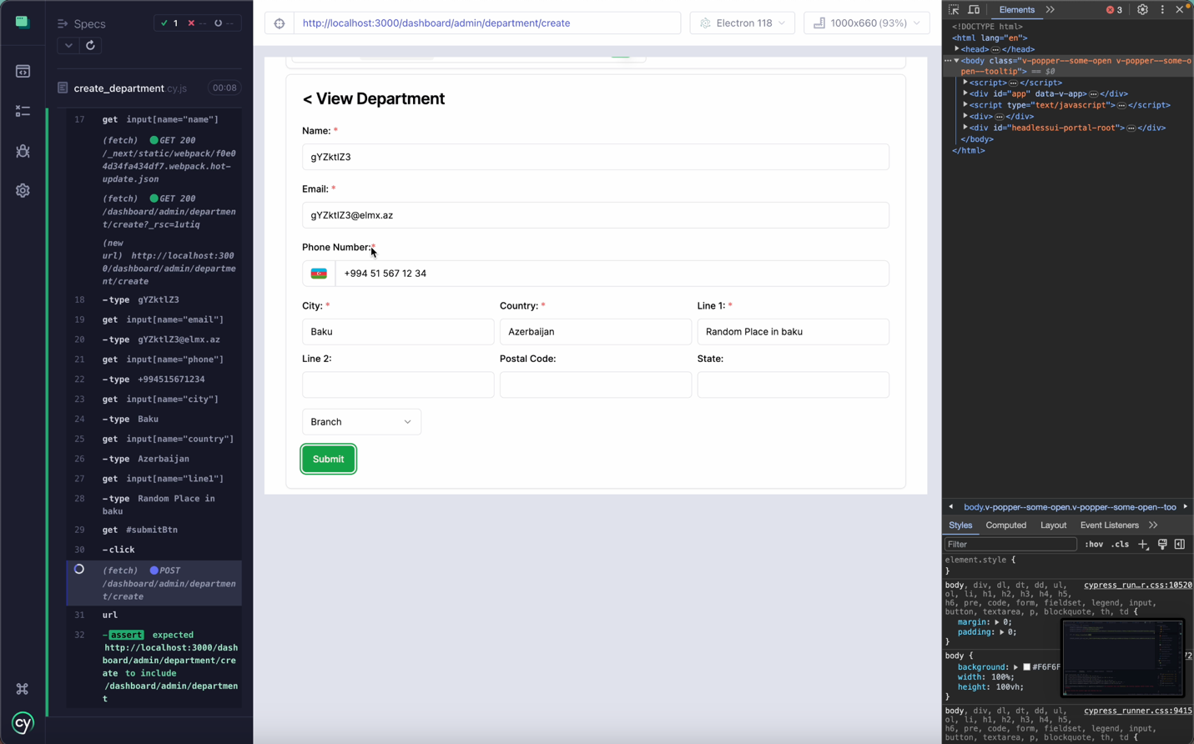

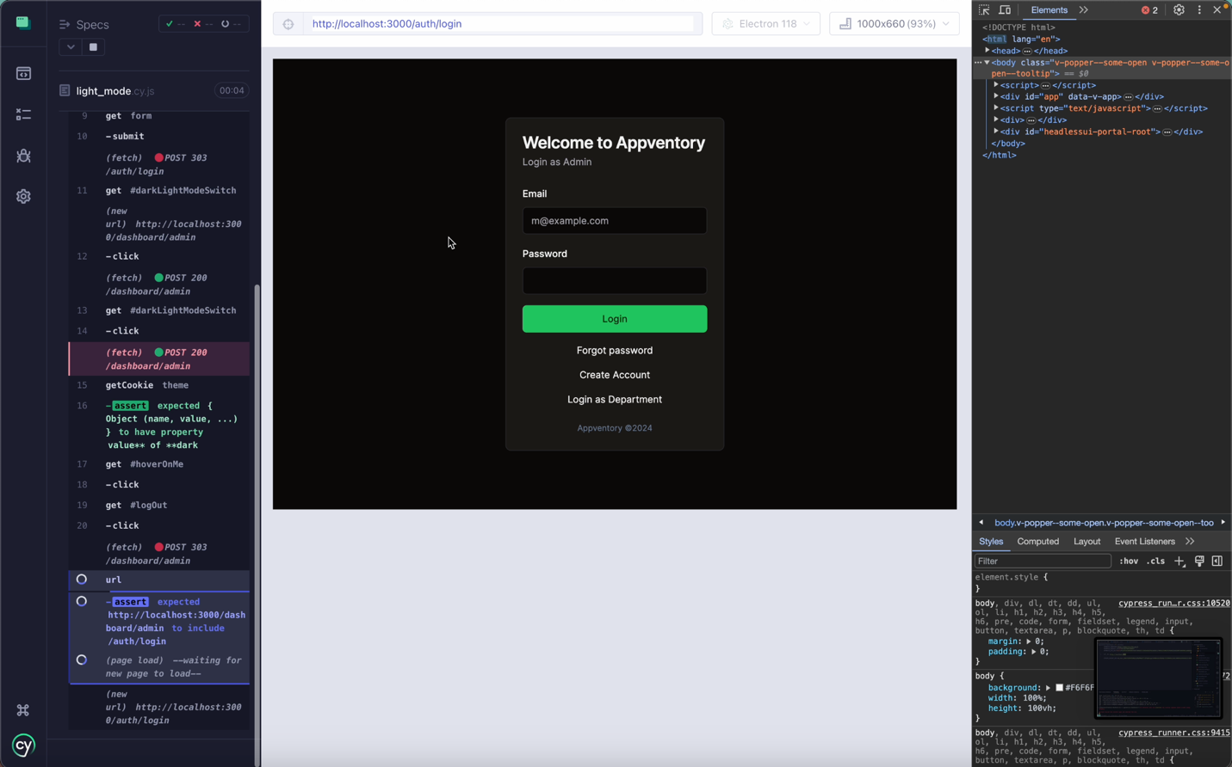

# Screenshots of application

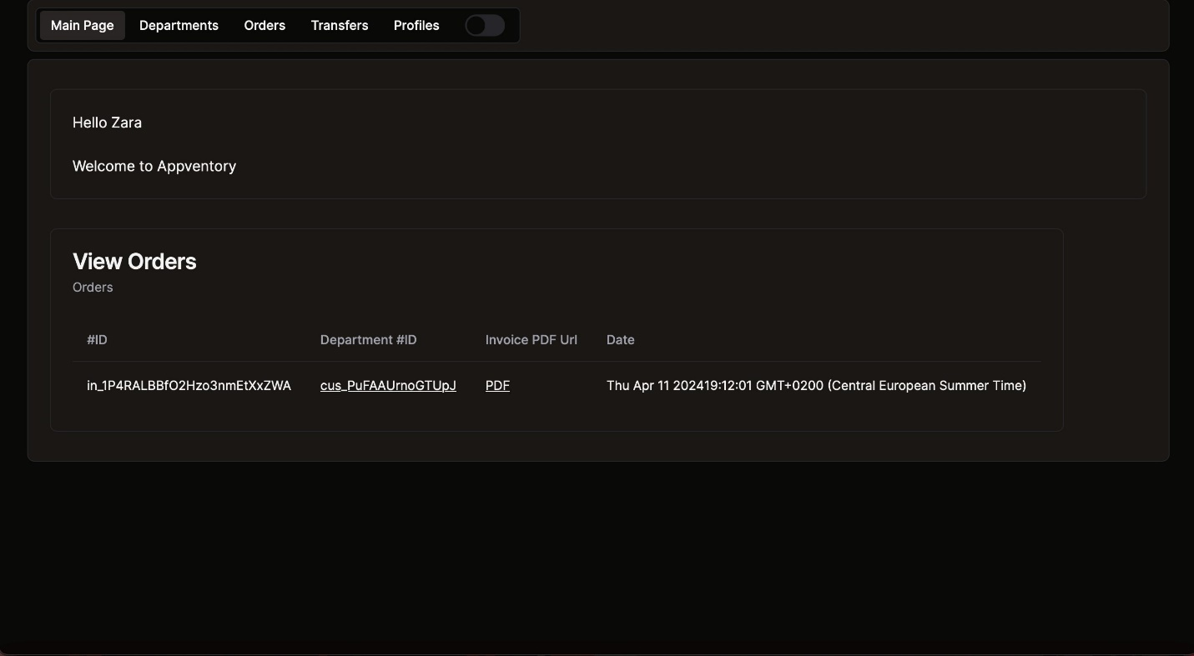

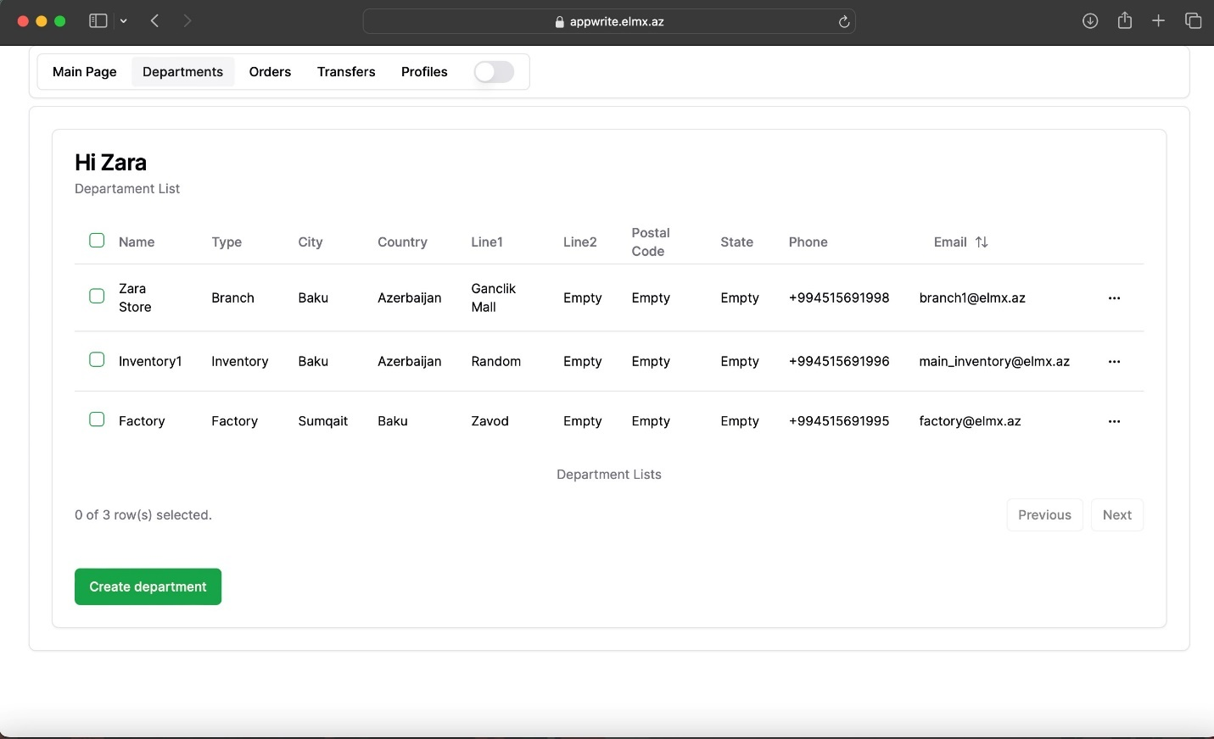

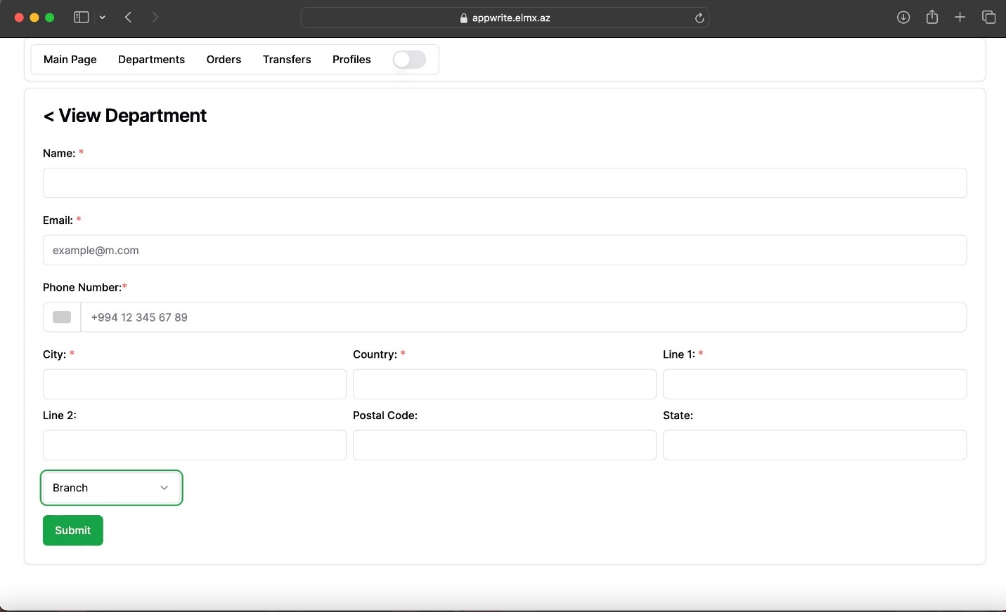

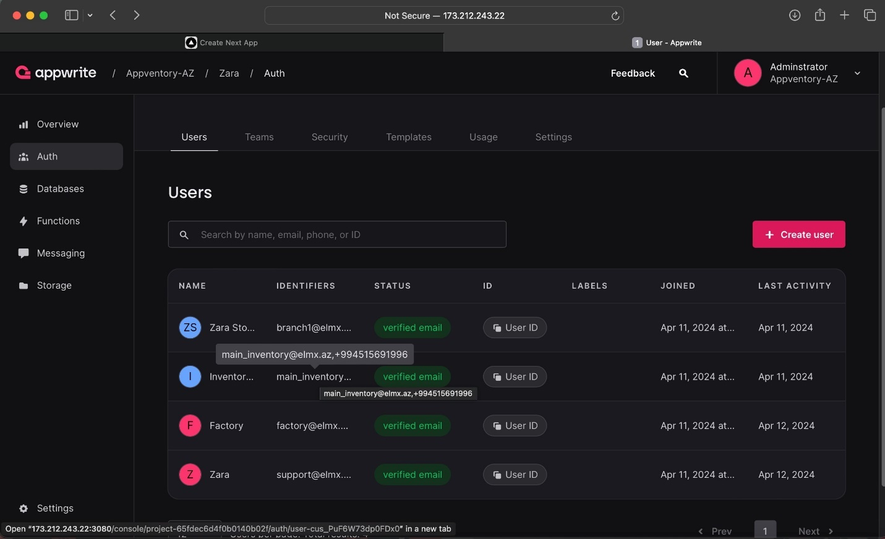

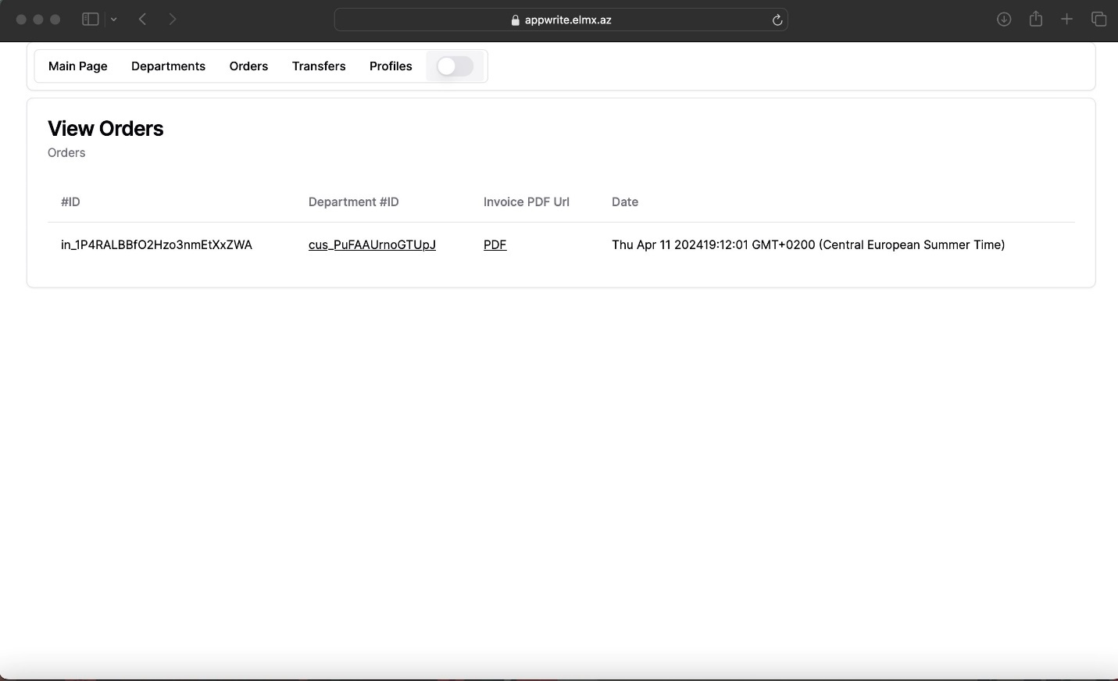

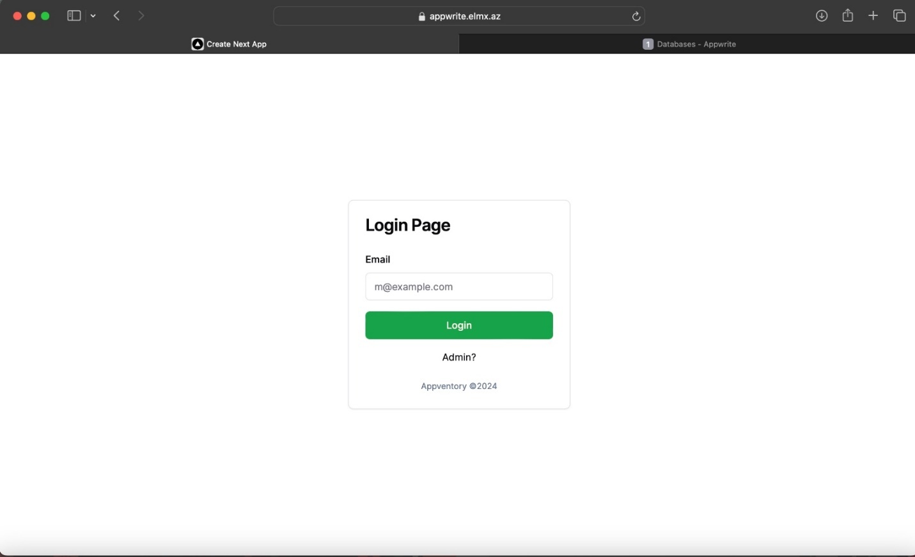

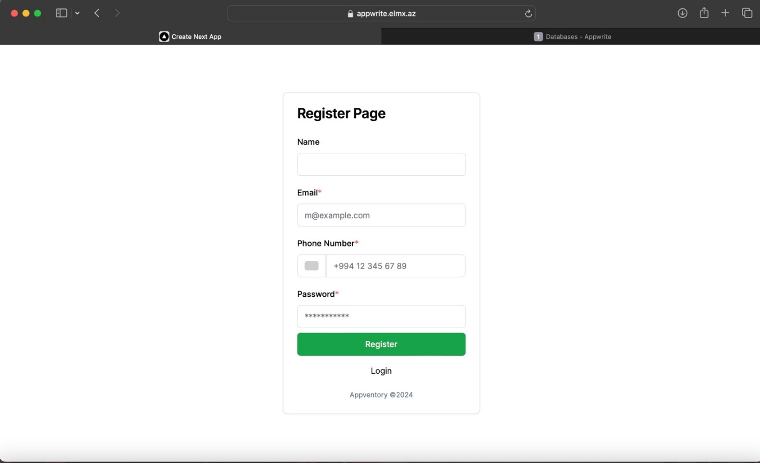

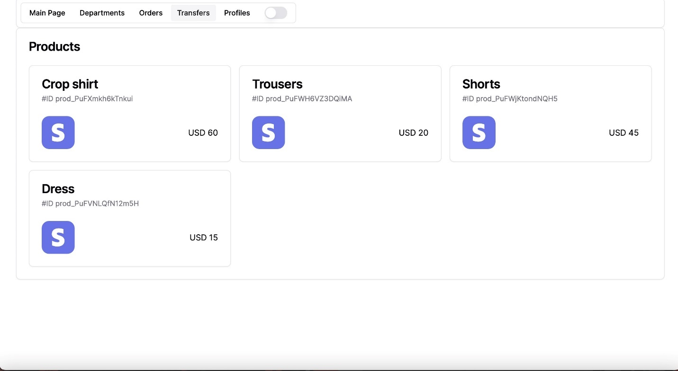

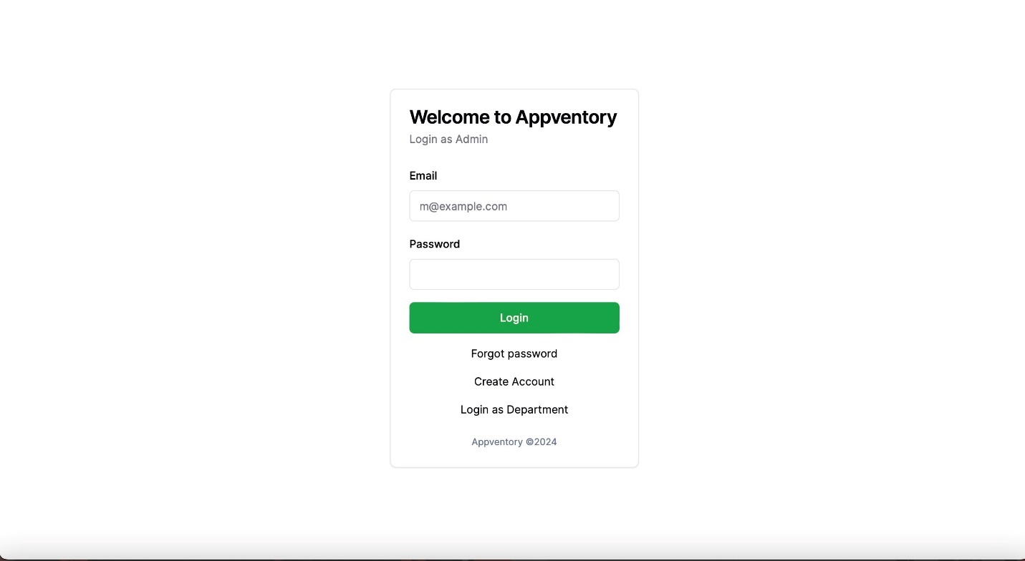

# Source Code

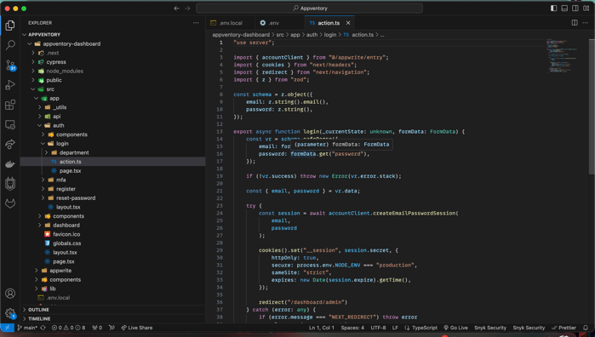

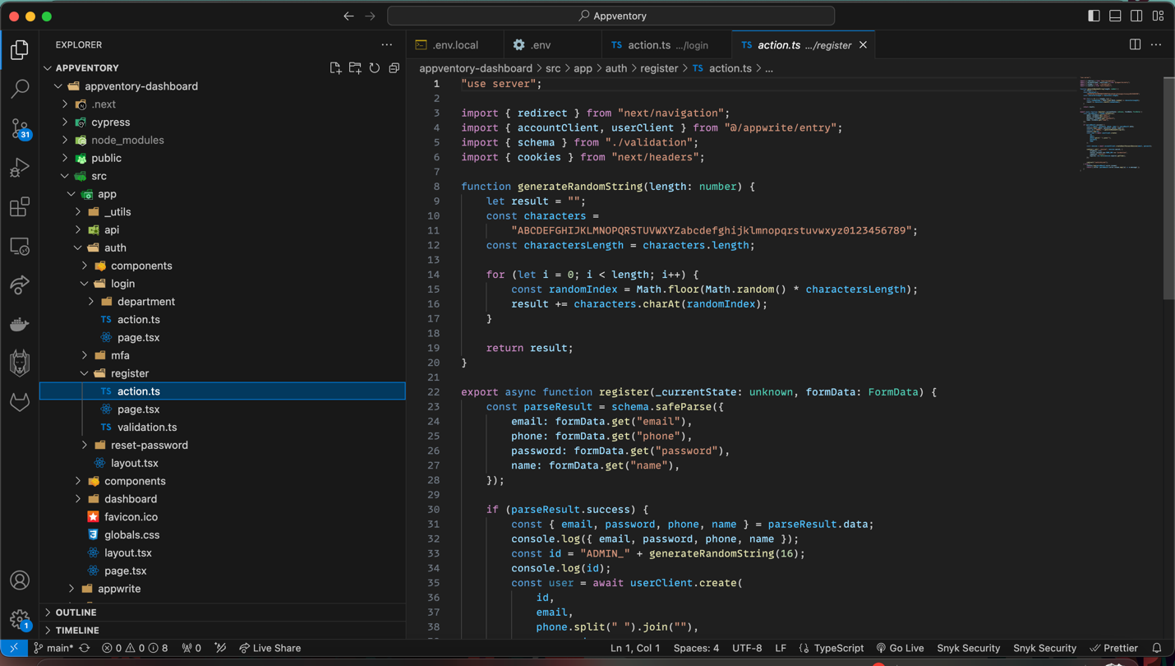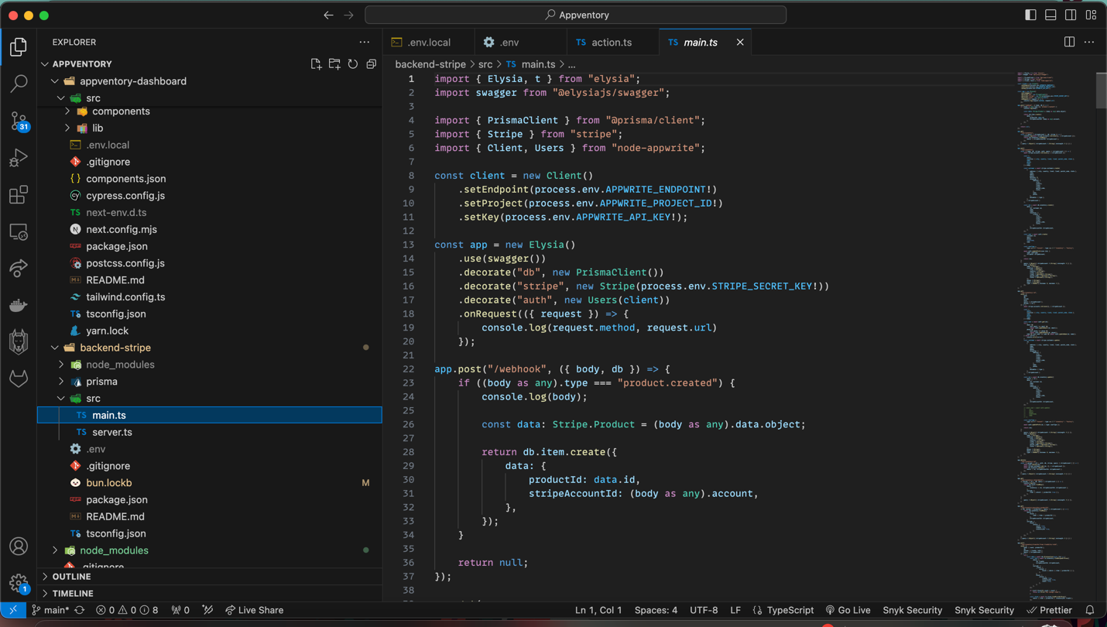

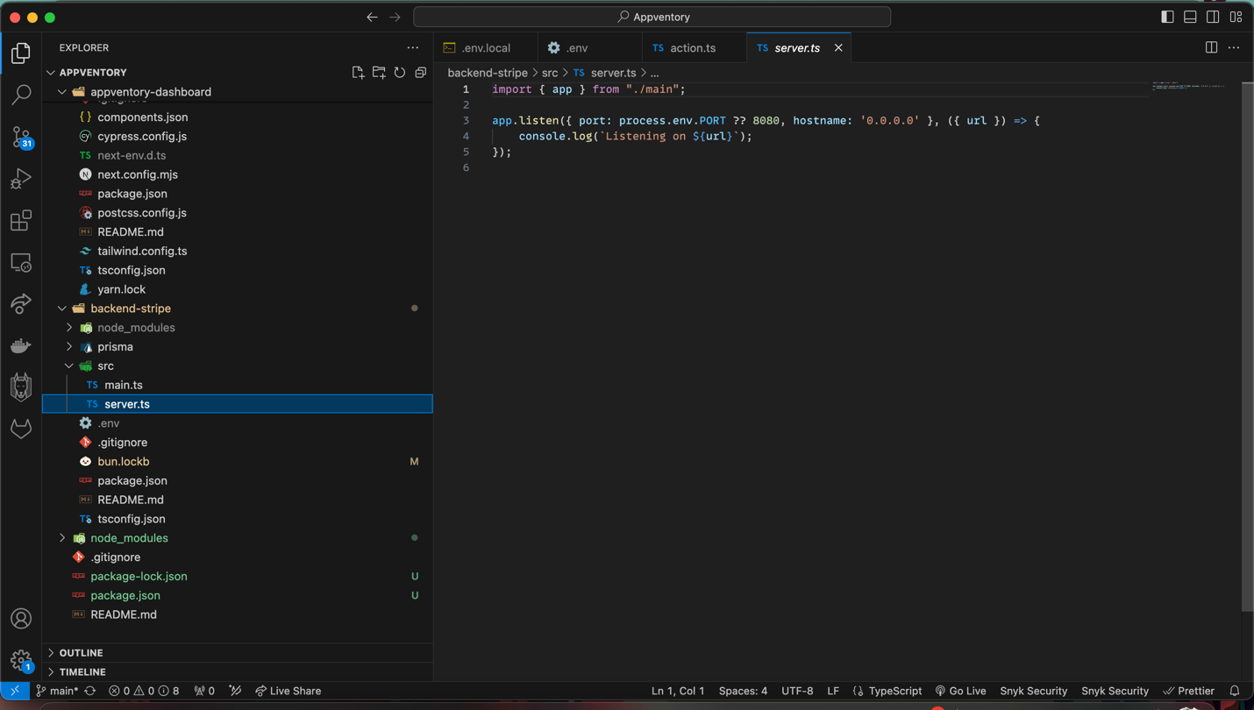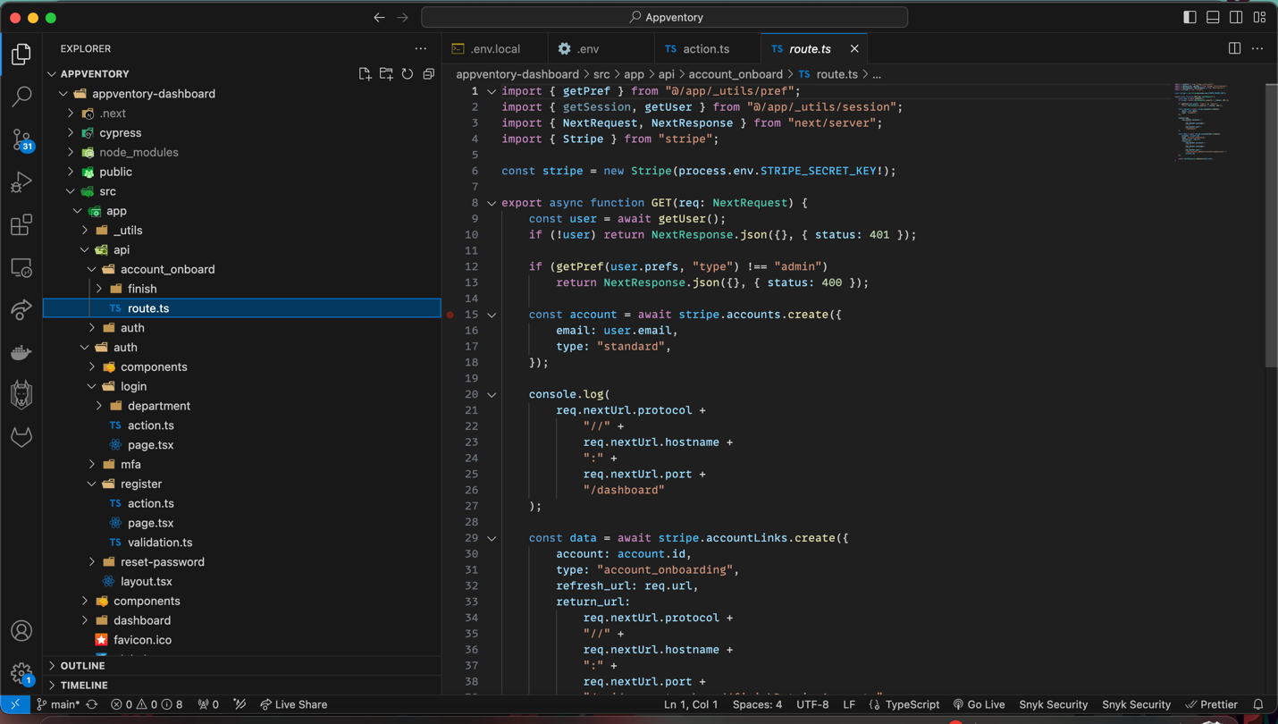

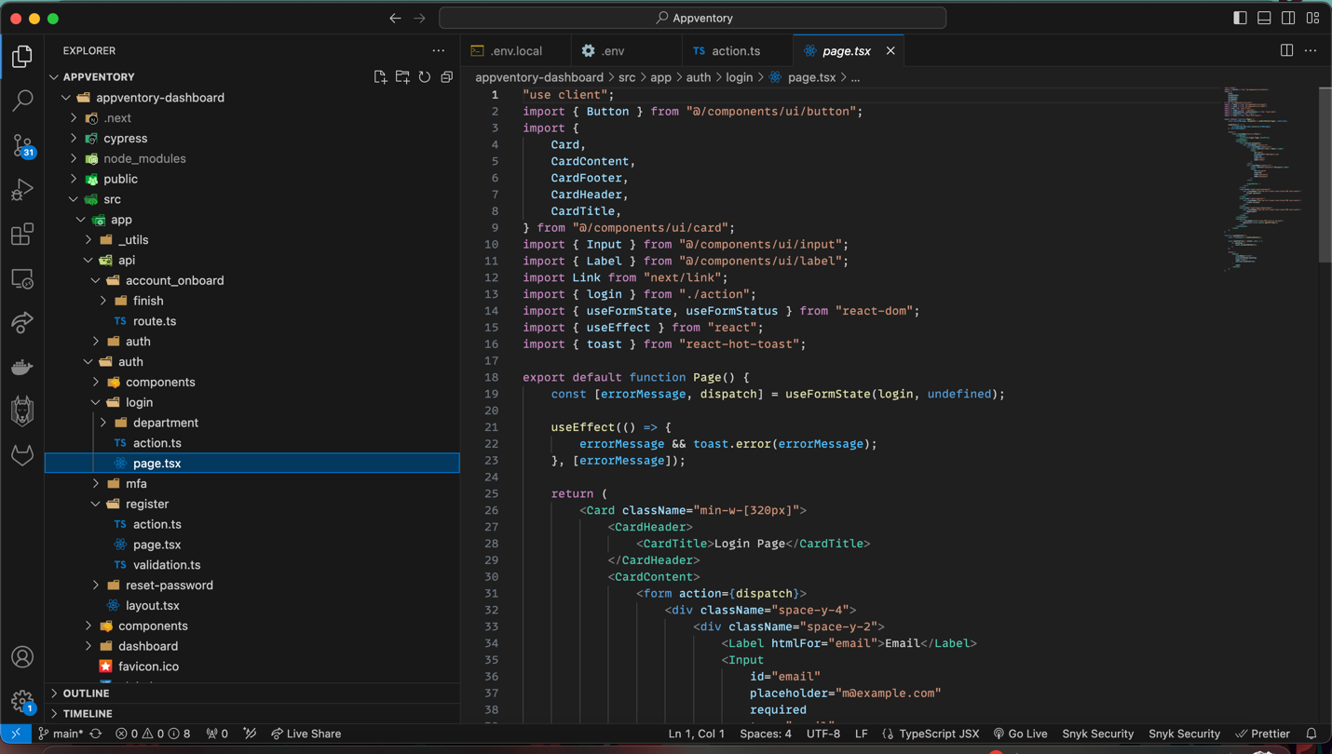

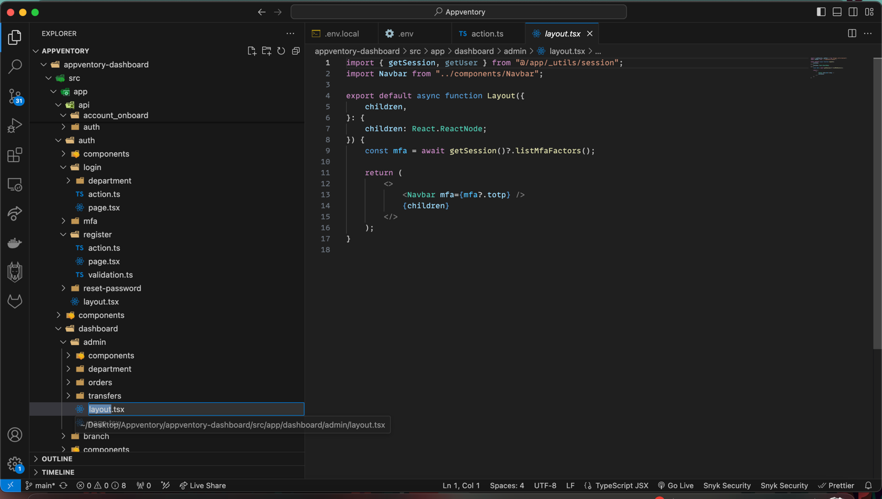

# Links

Github repo: <https://github.com/glynzr/Appventory>

App URL: <https://appwrite.elmx.az>

# References

<https://www.unleashedsoftware.com/inventory-management-guide/inventory-management-systems#:~:text=An%20inventory%20management%20system%20(or,inventory%20management%20for%20your%20business>.

<https://www.netsuite.com/portal/resource/articles/inventory-management/inventory-management.shtml>

<https://meeraacademy.com/activity-diagram-for-stock-management-system/>

<https://online.visual-paradigm.com/diagrams/templates/use-case-diagram/inventory-management-system-/>

<https://www.lucidchart.com/pages/landing/wbs-diagram-software?utm_source=google&utm_medium=cpc&utm_campaign=_chart_ol_tier2-tier3_desktop_search_nb_exact-phrase_&km_CPC_CampaignId=12085241482&km_CPC_AdGroupID=117216423275&km_CPC_Keyword=creating%20a%20work%20breakdown%20structure&km_CPC_MatchType=e&km_CPC_ExtensionID=&km_CPC_Network=g&km_CPC_AdPosition=&km_CPC_Creative=491717702771&km_CPC_TargetID=kwd-628964330065&km_CPC_Country=1000998&km_CPC_Device=c&km_CPC_placement=&km_CPC_target=&gad_source=1&gclid=CjwKCAjwt-OwBhBnEiwAgwzrUv8_wJliwc9wdWlQ2aGS2voJuzdscBrHsS6bpINZgt3-Y98tFlLCYBoCpn4QAvD_BwE>

<https://inventorsoft.co/blog/inventory-management-requirements-and-features/>

<https://katanamrp.com/blog/inventory-management-system-requirements/>

<https://reliability.thenonstopgroup.com/requirements-for-effective-inventory-management/>

<https://www.manageengine.com/products/desktop-central/features.html?network=g&device=c&keyword=systems%20management%20software&campaignid=9129223175&creative=611533448611&matchtype=p&adposition=&placement=&adgroup=92760797179&targetid=kwd-11456581&gad_source=1&gclid=CjwKCAjwt-OwBhBnEiwAgwzrUlbHzjweuSwJaZrv_LZnIGQc8rWKxaGs82LlSI5euX-2wQbCS5J4mBoCr2wQAvD_BwE>

<https://www.linkedin.com/advice/0/how-do-you-secure-protect-your-inventory-data>

<https://www.netsuite.com/portal/resource/articles/inventory-management/inventory-management-system-features.shtml>